OUTLOOK E-MAIL CLEANUP

This guide will show you how you use built-in Outlook tools to perform some bulk clean up on a user’s mailbox.
The cleanup consist of 4 parts:
- Optimize Outlook Settings.
- Create a view of the messages as a single list.
- Run the conversation cleanup tool.
- Remove redundant, obsolete, trivial (R.O.T.) messages from the mailbox.

Optimize Outlook Settings
To perform the cleanup effectively across all of the messages, regardless of age, a couple of changes to Outlook settings need to be made.
Load All Mail into View
- Click File > Account Settings > Account Settings
- Click Change.
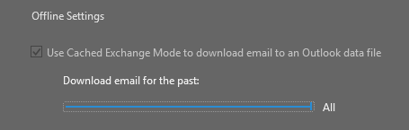
- Drag slider for Download email for the past option to All.
- Click Next > Done.
Change Search Result Options
- Click File > Options > Search
- Include results only from: All Mailboxes.
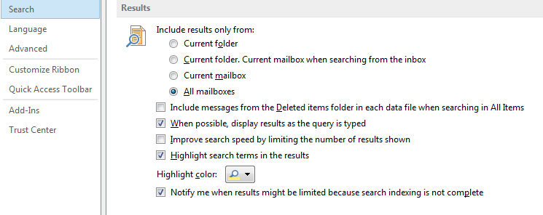
- Uncheck Improve search speed by limiting the number of results shown.

Create a Search Folder for All-Mail
The most efficient way to perform a cleanup on all of your messages—especially including Sent Mail—is to create a search to display all of the messages in one list using a Search Folder.
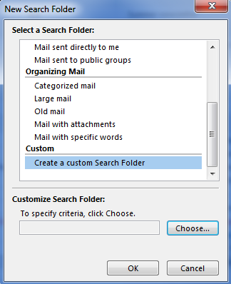
A Search Folder is a virtual folder that provides a view of e-mail items that match specific search criteria.
- Right-click on Search Folders > New Search Folder.
- Select Create a custom Search Folder.
- Click Choose.
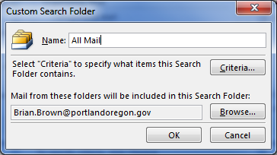
- Type All Mail.
- Click Browse.
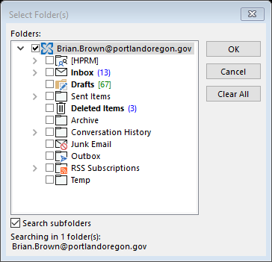
- Check the top box next to the account name.
- Check Search subfolders option.
- Click OK > OK
- You have not specified…
Click Yes.
- Click OK.
Note:
Depending on the amount of messages, the search folder results may take several minutes or longer to complete. Messages remain in their original location. Messages are not copied, but are displayed in this virtual folder.

Conversation Cleanup Overview
Conversation Clean Up is a built-in Outlook tool to reduce the number of messages in your mailbox by getting rid of redundant messages that are captured in a later email. It is possible to reduce an email conversation to one message because it captures the entire string.

Set Conversation Cleanup Options
- Click File > Options > Mail
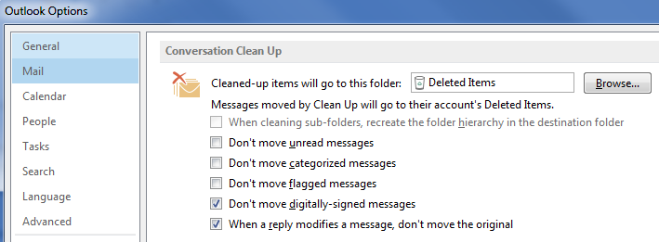
- Scroll down to Conversation Clean Up options
- Set Cleaned-up items to go to Deleted Items
- Uncheck other options as needed. [See screenshot for recommended settings.]
- Check option for When a reply modifies a message, don’t move the original.

Run Conversation Clean Up
- Go to Search Folders > All Mail (created from the steps above)
- Click Home > [button] Clean Up > Clean Up Folder
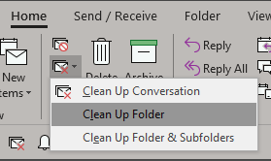
- Once the Clean Up starts running you should notice the total number of messages decreasing.
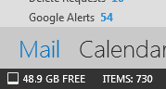

Removing R.O.T. (redundant, obsolete, or trivial) messages.
Many of the messages in a mailbox are not emails that a user is responsible for keeping. These emails include FYI type emails, listserv messages, citywide messages, or automated response messages.
- Copy Search 1 onto your clipboard:
SEARCH 1
from:(linkedin) OR from:(bts helpdesk) OR from:(info@twitter) OR from:(facebook) OR from:(google) OR from:(googlegroups.com) OR from:(worksnoreply@works.com) OR from:(noreply@portlandoregon.gov) OR to:(citywide all employees) OR MessageClass:IPM.Schedule OR from: (voicemail@portlandoregon.gov)

SEARCH 2
subject:”automatic reply” OR subject:”out of the office” OR subject:”out of office” OR subject:”Summary of junk emails blocked” OR MessageClass:IPM.Note.IMC.Notification OR MessageClass:IPM.Task OR from:( info@flashalert.net)OR "benefits@portlandoregon"

- Paste this text into the All Mail search Folder search box > ENTER
- Review the Results. **Some messages may need to be retained.**
To select all of the messages for deletion:
Ctrl+A [select all]
Deselect messages if they need to be retained:
After selecting all, de-select a message by holding the Ctrl + Clicking the message.
Press Delete to move the rest to Deleted Items.
- Repeat at step 2 with Search 2

