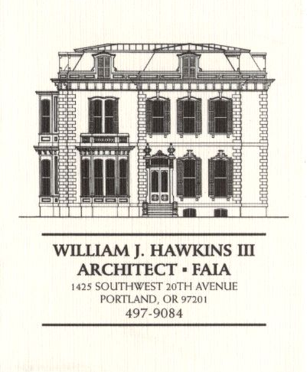 | Muller – Dhillon Residence  Addition & Remodel  3425 SW Heather Lane  Portland, Oregon 97201  MEETING MINUTES | Job #03-20  By: Paul Klein  Meeting #25  5 September 2006

Distribution (*attendees) | Phone | Fax | E-mail
*Roger Muller | 503-957-6873 |  | roger.muller@gmail.com
Daisy Dhillon |  | 503-669-8328 | harpeetd@hotmail.com
*David Saltzberg (J. Frank) | 503-445-4735 | 503-408-8855 | david.saltzberg@jamesfrank.net
*Jake Yamanoha (J. Frank) | 503-347-7911
Bill Hawkins (WJH Architect) | 504-497-9084 | 503-225-9460 | billhawkins@qwest.net
Peder Golberg (J.G. Pierson) | 503-226-1286 | 503-226-3130 | peder@jgpierson.com
*Paul Klein (WJH Architect) | 503-231-1122, ext. 27 | 503-231-0317 | paul@architectLA.com
(New items are shown in blue font. Urgent items are indicated in red. Resolved items are indicated in italics.)

- SCHEDULE:

  - See the updated Contractor’s Schedule published 09/05/06.

- PROGRESS:

  - Siding installation is in progress. (Target date for siding completion is 12 September.)

  - Gypsum wallboard installation & finishing work is in progress.

- MEETING SCHEDULE: Weekly project meetings: 12:15 PM Tuesday (unless noted otherwise).

- Next meeting: 12:15 PM Tuesday, 12 September 2006, at the project site.

- MEETING NOTES:

  - The Contractor distributed shop drawings for the custom cabinets to the Architect and the Owner. The Contractor requested that the shop drawings be reviewed and returned as soon as possible. A cursory review of the drawings resulted in several minor revisions at the direction of the Owner.
    - Master Bath: The top rail at the bench at the west wall will be lowered so as not to align with the lavatory countertop. The back and sides of the bench surround will be covered with a clear Douglas Fir cap. The bench seat will be hinged to allow access to the interior for storage.
    - Master Bath: The far right base cabinet at the west wall Bath will be a bank of drawers.
    - Children’s Bath: The left side of the lavatory base cabinet will be a bank of drawers 10” wide. (Depending on the dimension of the lavatory basin, the top drawer may not be available and may be a fixed face panel.)
    - Stair Landing: The bench will have (3) hinged lids for access to the base cabinet storage space. The bench cabinet will be 24” deep from front to back.
    - Living Room: Due to the location of the flue vent serving the gas fireplace, the top of the recessed shelf units flanking the fireplace will be lowered to 70” above finish floor. Each of the shelf units will have an 18” high base cabinet with a single door. The recessed units will be 16” deep and will each have (3) adjustable glass shelves.
    - Kitchen: Both sides of the peninsula upper cabinets will be glass. Upper cabinets will only have doors on the Kitchen side. The Dining Room and Family Room sides of the upper cabinets will be fixed panels.

  - The Contractor distributed a revised project schedule dated 09/05/06. The Contractor also provided a list of items requiring selections by the Owners indicating due dates for the necessary information.

  - The Owner decided to eliminate the continuous horizontal wood trim aligned with door and window heads from the Main Floor and Second Floor.

  - Gypsum wallboard at the ceilings above the bays at the ends of the Living and Dining Rooms will be removed and replaces with wood T&G deck to match the adjacent ceilings.

  - The pot filler will be located at the wall above the range cook top to allow the clearance necessary for proper operation.

  - The Contractor requested the Owner to provide the source information for the bamboo textured glass to be used at the peninsula upper cabinets at the Kitchen.

  - The Contractor requested that the Architect assist with completion of the Door Hardware Schedule as soon as possible.

- ACTION ITEMS:

- The Contractor inquired about the specification for the Car Deck structural steel to be galvanized. The Architect will revisit the requirement.

- The Contractor recommends that the exterior guardrails at the decks and Car Deck be powder-coated. The Architect will investigate the feasibility as the design of the railings proceeds.

- Locate the new condensing unit for Second Floor HVAC unit. The tentative location is at the adjacent grade on the north side of the house in the vicinity of the existing condensing unit.
02-21-06 It is an option to relocate the existing condensing unit to a new concrete pad at the east side of the structure. This will allow finish grading to be adjusted along the north wall for easier access into the Crawlspace. The final location of the condensing units is yet to be determined.

