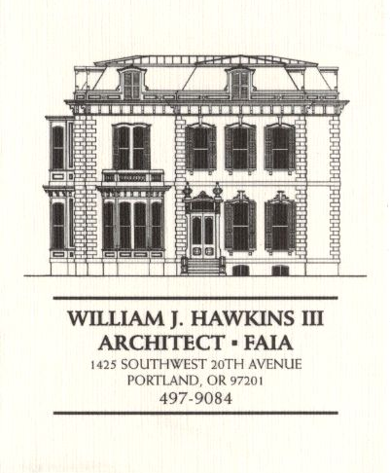 | Muller – Dhillon Residence  Addition & Remodel  3425 SW Heather Lane  Portland, Oregon 97201  MEETING MINUTES | Job: #03-20  By: Paul Klein  Meeting: #24  Date: 1 August 2006

Distribution (*attendees) | Phone | Fax | E-mail
Roger Muller | 503-957-6873 |  | roger.muller@gmail.com
*Daisy Dhillon |  | 503-669-8328 | harpeetd@hotmail.com
*David Saltzberg (J. Frank) | 503-445-4735 | 503-408-8855 | david.saltzberg@jamesfrank.net
*Jake Yamanoha (J. Frank) | 503-347-7911
Bill Hawkins (WJH Architect) | 504-497-9084 | 503-225-9460 | billhawkins@qwest.net
Peder Golberg (J.G. Pierson) | 503-226-1286 | 503-226-3130 | peder@jgpierson.com
*Paul Klein (WJH Architect) | 503-231-1122, ext. 27 | 503-231-0317 | paul@architectLA.com
(New items are shown in blue font. Urgent items are indicated in red. Resolved items are indicated in italics.)

- SCHEDULE:

  - See the updated Contractor’s Schedule published 07/24/06.

- PROGRESS:

  - The underground conduit for the new electrical service upgrade is in place.

  - Interior surfaces and windows are masked in preparation for the application of the lacquer finish to interior wood surfaces.

  - Installation of the metal roofing at the entry canopy roofs is in progress.

- MEETING SCHEDULE: Weekly project meetings: 12:15 PM Tuesday (unless noted otherwise).

- Next meeting: 12:15 PM Tuesday, 8 August 2006, at the project site.

- MEETING NOTES:

  - Framing inspection is scheduled for the end of the week. Upon acceptance by the building official installation of thermal insulation will commence.

  - The Contractor directed the Owners to the Edelen Door website for the selection of a new insulated sectional overhead garage door. The garage door model needs to be selected to allow application of exterior wood siding to the outside face.

  - The junction box for the receptacle at the stair landing needs to be relocated as required to clear the built-in bench.

- ACTION ITEMS:

- The Contractor requested that the Architect prepare a flashing/sleeve detail for the downspout penetration through the entry canopy roofs at the South Elevation.

- The Contractor requested that the Architect review the roof edge flashing detail shown on detail 3/A12 for resistance to the penetration of wind-driven rain and installation sequencing.

- The Contractor inquired about the specification for the Car Deck structural steel to be galvanized. The Architect will revisit the requirement.

- The Contractor recommends that the exterior guardrails at the decks and Car Deck be powder-coated. The Architect will investigate the feasibility as the design of the railings proceeds.

- Locate the new condensing unit for Second Floor HVAC unit. The tentative location is at the adjacent grade on the north side of the house in the vicinity of the existing condensing unit.
02-21-06 It is an option to relocate the existing condensing unit to a new concrete pad at the east side of the structure. This will allow finish grading to be adjusted along the north wall for easier access into the Crawlspace. The final location of the condensing units is yet to be determined.

