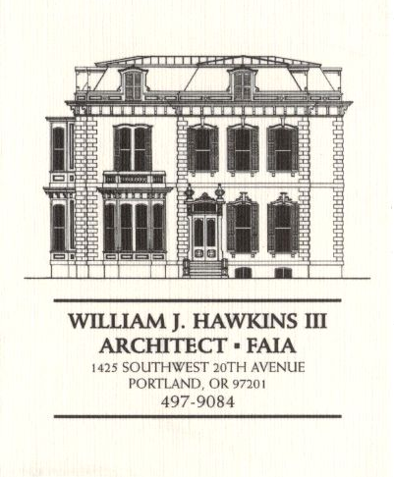 | Muller – Dhillon Residence  Addition & Remodel  3425 SW Heather Lane  Portland, Oregon 97201  MEETING MINUTES | Job: #03-20  By: Paul Klein  Meeting: #23  Date: 25 July 2006

Distribution (*attendees) | Phone | Fax | E-mail
*Roger Muller | 503-957-6873 |  | roger.muller@gmail.com
*Daisy Dhillon |  | 503-669-8328 | harpeetd@hotmail.com
*David Saltzberg (J. Frank) | 503-445-4735 | 503-408-8855 | david.saltzberg@jamesfrank.net
*Bill Hawkins (WJH Architect) | 504-497-9084 | 503-225-9460 | billhawkins@qwest.net
Peder Golberg (J.G. Pierson) | 503-226-1286 | 503-226-3130 | peder@jgpierson.com
*Paul Klein (WJH Architect) | 503-231-1122, ext. 27 |  | paul@architectLA.com
(New items are shown in blue font. Urgent items are indicated in red. Resolved items are indicated in italics.)

- SCHEDULE:

  - See the updated Contractor’s Schedule published 07/24/06.

- PROGRESS:

  - Boring for the new underground electrical service is in progress.

  - Metal roofing is installed at the upper roof. The metal roof panels for the south canopy roofs are on site.

  - Gutters are installed at the perimeter of the main roof.

  - The Contractor has started the installation of the exterior siding. Moisture barrier and vertical lath for the rain screen siding assembly are being installed.

- MEETING SCHEDULE: Weekly project meetings: 12:15 PM Tuesday (unless noted otherwise).

- Next meeting: 12:15 PM Tuesday, 1 August 2006, at the project site.

- MEETING NOTES:

  - The Architect reviewed the design of the stair railings with the Owners.

  - The Architect delivered copies of Sheets A21 Kitchen Interior Elevations & A22 Master Bath Interior Elevations to the Contractor & Owners.

  - The Owners requested that the design of the railing assembly at the Second Floor Balcony be revised to be the same as the metal railing assembly detailed for the Main Floor Balcony. The Architect will make the necessary revisions to supplemental architectural drawing Sheets A16, A17, A18, A19 & A20. (Revised structural drawings Sheets S4, S5, S6 & S7 dated 5 July 2006 will not be updated since there are no structural impacts to the design revision.)

  - The Contractor delivered a concept detail sketch to the Architect of a flashing assembly for the downspout penetrations through the south canopies. The Architect will prepare a supplementary architectural detail for the required flashing assembly.

- ACTION ITEMS:

- The Contractor inquired about the specification for the Car Deck structural steel to be galvanized. The Architect will revisit the requirement.

- The Contractor recommends that the exterior guardrails at the decks and Car Deck be powder-coated. The Architect will investigate the feasibility as the design of the railings proceeds.

- Locate the new condensing unit for Second Floor HVAC unit. The tentative location is at the adjacent grade on the north side of the house in the vicinity of the existing condensing unit.
02-21-06 It is an option to relocate the existing condensing unit to a new concrete pad at the east side of the structure. This will allow finish grading to be adjusted along the north wall for easier access into the Crawlspace. The final location of the condensing units is yet to be determined.

