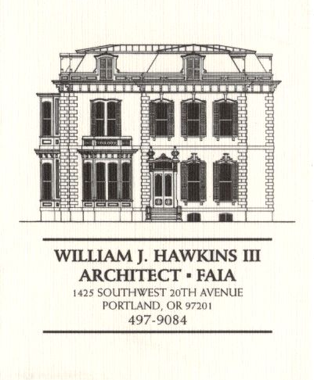 | Muller – Dhillon Residence  Addition & Remodel  3425 SW Heather Lane  Portland, Oregon 97201  MEETING MINUTES | Job: #03-20  By: Paul Klein  Meeting: #22  Date: 11 July 2006

Distribution (*attendees) | Phone | Fax | E-mail
Roger Muller | 503-957-6873 |  | roger.muller@gmail.com
*Daisy Dhillon |  | 503-669-8328 | harpeetd@hotmail.com
*David Saltzberg (J. Frank) | 503-445-4735 | 503-408-8855 | david.saltzberg@jamesfrank.net
Bill Hawkins (WJH Architect) | 504-497-9084 | 503-225-9460 | billhawkins@qwest.net
Peder Golberg (J.G. Pierson) | 503-226-1286 | 503-226-3130 | peder@jgpierson.com
*Paul Klein (WJH Architect) | 503-231-1122, ext. 27 |  | paul@architectLA.com
(New items are shown in blue font. Urgent items are indicated in red. Resolved items are indicated in italics.)

- SCHEDULE:

  - See the updated Contractor’s Schedule published 06/20/06.

- PROGRESS:

  - Final electrical rough-in work is continuing. The Contractor has scheduled the necessary rough framing inspections over the next week.

  - Gutters and roof installation are scheduled for the next week.

- MEETING SCHEDULE: Weekly project meetings: 12:15 PM Tuesday (unless noted otherwise).

- Next meeting: 12:15 PM Tuesday, 25 July 2006, at the project site.

- MEETING NOTES:

  - The Owners are continuing research and selection of interior and exterior light fixtures.

  - The Owner and contractor discussed the level of finish at the new gypsum drywall surfaces. The Contractor will attempt to bring samples of finish options to assist with the Owner’s decision.

- ACTION ITEMS:

- The Architect will prepare revised interior elevations for the Kitchen and the Master Bath for review with the Owners targeting a final approved design for the new cabinetry.
06-06-06 The Architect will arrange to meet with the Owners to review the revised Kitchen elevations.
06-13-06 The owner and Architect will meet Thursday 15 June to review the layout of the Kitchen, the Master Bath, and other locations scheduled to receive built-in cabinetry. Revised Kitchen elevations will be provided for the Owner’s approval as soon as possible after the meeting.
07-11-06 The Contractor requested the necessary final Owner-approved architectural design drawings as soon as possible in order to prepare the custom cabinet shop drawings. The Architect and Owner will meet this week to finalize the cabinetry configurations as soon as possible.

- Locate the new condensing unit for Second Floor HVAC unit. The tentative location is at the adjacent grade on the north side of the house in the vicinity of the existing condensing unit.
02-21-06 It is an option to relocate the existing condensing unit to a new concrete pad at the east side of the structure. This will allow finish grading to be adjusted along the north wall for easier access into the Crawlspace. The final location of the condensing units is yet to be determined.

- The Contractor inquired about the specification for the Car Deck structural steel to be galvanized. The Architect will revisit the requirement.

- The Contractor recommends that the exterior guardrails at the decks and Car Deck be powder-coated. The Architect will investigate the feasibility as the design of the railings proceeds.

