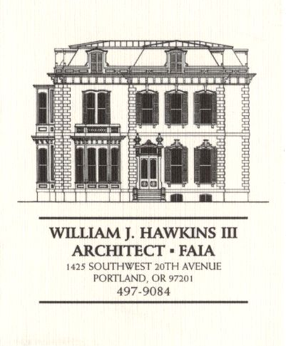 | Muller – Dhillon Residence  Addition & Remodel  3425 SW Heather Lane  Portland, Oregon 97201  MEETING MINUTES | DRAFT  Job: #03-20  By:  Meeting: #19  Date: 20 June 2006

Distribution (*attendees) | Phone | Fax | E-mail
*Roger Muller | 503-957-6873 |  | roger.muller@gmail.com
*Daisy Dhillon |  | 503-669-8328 | harpeetd@hotmail.com
*David Saltzberg (J. Frank) | 503-445-4735 | 503-408-8855 | david.saltzberg@jamesfrank.net
Bill Hawkins (WJH Architect) | 504-497-9084 | 503-225-9460 | billhawkins@qwest.net
Peder Golberg (J.G. Pierson) | 503-226-1286 | 503-226-3130 | peder@jgpierson.com
(New items are shown in blue font. Urgent items are indicated in red. Resolved items are indicated in italics.)

- SCHEDULE:

  - See the updated Contractor’s Schedule published 05/06/06.

- PROGRESS:

- MEETING SCHEDULE: Weekly project meetings: 12:15 PM Tuesday (unless noted otherwise).

- Next meeting: 12:15 PM Tuesday 27 June 2006, at the project site.

- MEETING NOTES:

- ACTION ITEMS:

- Exterior siding installation will be delayed until the remaining shear wall inspection issues are resolved. Siding installation is currently scheduled to begin Monday 12 June. The Architect will contact the Structural Engineer to inquire into the schedule for responding to the remaining Building Inspector’s shear wall checklist items.
06-08-06 The Structural Engineer and Contractor met at the site to review the necessary work to satisfy the Building Inspector. The Structural Engineer will follow up with a letter describing the work.

- The handrail design at the upper & lower decks needs to be completed. The architectural details and structural calculations will be provided to the Contractor for delivery to the City for review and approval.

- The Architect will prepare revised interior elevations for the Kitchen for review by the owners and final design of the new cabinetry.
06-06-06 The Architect will arrange to meet with the Owners to review the revised Kitchen elevations.
06-13-06 The owner and Architect will meet Thursday 15 June to review the layout of the Kitchen, the Master Bath, and other locations scheduled to receive built-in cabinetry. Revised Kitchen elevations will be provided for the Owner’s approval as soon as possible after the meeting.

- The Architect will consult with the Structural Engineer to strategize alternatives to framing the Main Floor Balcony so that the beams do not obstruct views from the Basement below.
    - The Architect met with the Structural Engineer to discuss options for framing the two decks. The Owner elected to revise the deck posts from 8x8 wood posts to be rectangular section steel posts. Upon receipt of the revised structural design and calculations, the Architect will draft the necessary drawing revisions and reissue the Main Floor and Second Floor Framing Plans.

- There are concerns about the capacity of the half-round gutters to handle the volume and velocity of storm water runoff from the large low sloped area at the center of the roof along the south roof edge. The Architect will review the condition and consider the option of substituting larger custom formed rectangular gutters for the half-round gutters indicated in the roof details.
06-06-06 The Contractor explained that due to the schedule for the installation of the metal roofing, a decision regarding the gutters is urgent so that roof eave flashing can be fabricated and installed properly. The Architect will resolve the gutter size and profile issue as soon as possible.

- Locate the new condensing unit for Second Floor HVAC unit. The tentative location is at the adjacent grade on the north side of the house in the vicinity of the existing condensing unit.
02-21-06 It is an option to relocate the existing condensing unit to a new concrete pad at the east side of the structure. This will allow finish grading to be adjusted along the north wall for easier access into the Crawlspace. The final location of the condensing units is yet to be determined.

- The Contractor inquired about the specification for the Car Deck structural steel to be galvanized. The Architect will revisit the requirement.

- The Contractor recommends that the exterior guardrails at the decks and Car Deck be powder-coated. The Architect will investigate the feasibility as the design of the railings proceeds.

