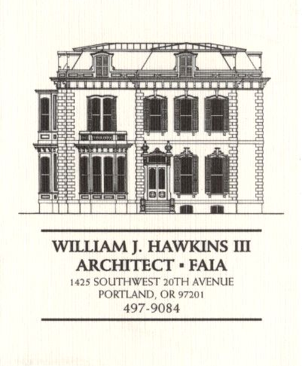 | Muller – Dhillon Residence  Addition & Remodel  3425 SW Heather Lane  Portland, Oregon 97201  MEETING MINUTES | Job: #03-20  By: Paul Klein  Meeting: #16  Date: 30 May 2006

Distribution (*attendees) | Phone | Fax | E-mail
*Roger Muller | 503-957-6873 |  | roger.muller@gmail.com
*Daisy Dhillon |  | 503-669-8328 | harpeetd@hotmail.com
*David Saltzberg (J. Frank) | 503-445-4735 | 503-408-8855 | david.saltzberg@jamesfrank.net
Bill Hawkins (WJH Architect) | 504-497-9084 | 503-225-9460 | billhawkins@qwest.net
*Paul Klein (WJH Architect) | 504-497-9084 | 504-497-9084 | paulklein@qwest.net
Peder Golberg (J.G. Pierson) | 503-226-1286 | 503-226-3130 | peder@jgpierson.com
(New items are shown in blue font. Urgent items are indicated in red. Resolved items are indicated in italics.)

- SCHEDULE:

  - See the updated Contractor’s Schedule published 05/01/06.

- PROGRESS:

  - The Weather Shield windows are on site. The Contractor has scheduled the window installation.

  - Preparations are being made for the installation of the Westview window wall system at the north side of the Living & Dining Rooms.

  - Roof framing is 90% complete. Roof sheathing will be finished after the electrician has placed necessary wiring over the vaulted roof areas.

- MEETING SCHEDULE: Weekly project meetings: 12:15 PM Tuesday (unless noted otherwise).

- Next meeting: 12:15 PM Tuesday 6 June 2006, at the project site.

- MEETING NOTES:

  - The recessed can lights at the west bay of the Master Bedroom has been revised from (3) fixtures to (2) fixtures. The fixtures will be placed in the soffit to align with the posts between the windows (similar to fixture locations at the east bay of the Master Bathroom).

  - In a measure to reduce the cost of wiring, an electrical sub-panel will be provided to serve the Second Floor. The panel will be located at the south wall of the Child’s Multi-Purpose Room 206.

  - The Owners have made a decision regarding the redesign of the Entry Canopy at the South Elevation. The canopy will have hips at the east and west corners. The portion of the canopy over the entry doors will be raised up and will also be a hipped roof. The Architect will provide a revised sketch of the south Elevation for the Owner to review and approve.

  - The Owner has decided to eliminate the deck at the Main Floor between Grid 3 & Grid 5. The Architect will consult with the Structural Engineer to strategize ways to frame the Main Floor Balcony so that the beams do not obstruct views at the Basement level.
05-31-06 The Architect met with the Structural Engineer to discuss options for framing the two decks. The Owner elected to revise the deck posts from 8x8 wood posts to be rectangular section steel posts. The Architect will make the necessary drawing revisions and reissue the Main Floor and Second Floor Framing Plans as soon as possible.

  - The Contractor expressed concerns about the capacity of the half-round gutters to handle the volume and velocity of storm water runoff from the large low sloped area at the center of the roof along the south roof edge. The Architect will review the condition and consider the option of substituting larger custom formed rectangular gutters for the half-round gutters indicated in the roof details.

- ACTION ITEMS:

- The handrail design at the upper & lower decks needs to be completed. The architectural details and structural calculations will be provided to the Contractor for delivery to the City for review and approval.

- The Architect will prepare revised interior elevations for the Kitchen for review by the owners and final design of the new cabinetry.

- Locate the new condensing unit for Second Floor HVAC unit. The tentative location is at the adjacent grade on the north side of the house in the vicinity of the existing condensing unit.
02-21-06 It is an option to relocate the existing condensing unit to a new concrete pad at the east side of the structure. This will allow finish grading to be adjusted along the north wall for easier access into the Crawlspace. The final location of the condensing units is yet to be determined.

- The Contractor inquired about the specification for the Car Deck structural steel to be galvanized. The Architect will revisit the requirement.

- The Contractor recommends that the exterior guardrails at the decks and Car Deck be powder-coated. The Architect will investigate the feasibility as the design of the railings proceeds.

