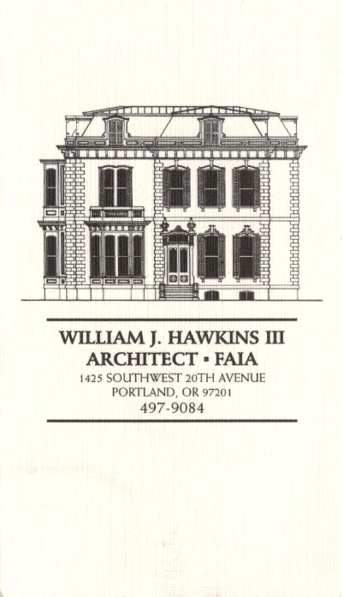 | Muller – Dhillon Residence  Addition & Remodel  3425 SW Heather Lane  Portland, Oregon 97201  MEETING MINUTES | Job: #03-20  By: Paul Klein  Meeting: #14  Date: 16 May 2006

Distribution (*attendees) | Phone | Fax | E-mail
Roger Muller | 503-957-6873 |  | roger.muller@gmail.com
*Daisy Dhillon
*David Saltzberg (J. Frank) | 503-445-4735 | 503-408-8855 | david.saltzberg@jamesfrank.net
Bill Hawkins (WJH Architect) | 504-497-9084 | 503-225-9460 | billhawkins@qwest.net
*Paul Klein (WJH Architect) | 504-497-9084 | 504-497-9084 | paulklein@qwest.net
Peder Golberg (J.G. Pierson) | 503-226-1286 | 503-226-3130 | peder@jgpierson.com
(New items are shown in blue font. Urgent items are indicated in red. Resolved items are indicated in italics.)

- SCHEDULE:

  - See the updated Contractor’s Schedule published 05/01/06.

- PROGRESS:

  - The T&G decking and plywood sheathing is in place at the timber framed vaults. Gang-nail trusses are installed. The framing crew is working on the areas of over-framing at dormers.

  - The roof over the upper Stair Landing is in place. Work is proceeding on the framing the wall above the Landing.

  - Work is continuing for rough-in plumbing and HVAC ductwork.

- MEETING SCHEDULE: Weekly project meetings: 12:15 PM Tuesday (unless noted otherwise).

- Next meeting: 12:15 PM Tuesday 23 May 2006, at the project site.

- MEETING NOTES:

  - The Architect will research the Code requirements for mounting locations for smoke detectors.

  - The Simpson CS straps shown on details R3 & R3A/S-2 have not been installed due to conflicts with other structural members. The Architect will discuss the necessity of the straps again with the Structural Engineer.

  - The Contractor received more 2x6 T&G decking than necessary for the vaulted ceilings. The Contractor proposes to install the surplus decking at the ceiling of the Entry Court and the Second Floor Hall 207. Additional 6x8 beams will be installed at the skylight opening over the Entry Court to support the ceiling decking. Also, decking will be installed at the ceilings of the bay extensions in the Master Bedroom and Master Bathroom.

  - The Owner has directed the Contractor to revise the configuration of the Master Bathroom:
- The shower will be relocated to the space originally shown for the bath tub.
- The gas stove will be omitted.
- A free-standing tub will be centered in the east bay. (The Owner has selected the tub.)
- The walls of the abandoned shower stall will be removed.
- The vanity cabinet will be located against the west wall. A bench will be built-in across the north wall to conceal the waste pipe serving the lavatories.
- The ceiling above the vanity will be 2x6 T&G decking. The ceiling at the shower will be moisture-resistant gypsum wallboard. The water closet ceiling will be gypsum wallboard.

- ACTION ITEMS:

- The handrail design at the upper & lower decks needs to be completed. The architectural details and structural calculations will be provided to the Contractor for delivery to the City for review and approval.

- The attic access panels indicated at the new Second Floor ceiling need to be revisited. Access panels should not be located in closets where shelving and stored items will block easy access.
03-28-06 The access to the east wing attic space will be determined in the field after the roof trusses have been installed. (The final locations of access openings will be established to fit between the actual locations of truss bottom chords at the Second Floor ceilings.)
05-16-06 Attic access opening locations have been tentatively located. One access opening will be at the ceiling of the Master Bedroom Closet. Another access opening will be located in the ceiling of the Child’s Multi-Purpose Room. It is not certain yet whether another opening will be necessary for the attic space at the east wing of the roof. The decision to add another panel will be made after the remainder of the roof structure is in place. Attic access openings will be not less than 22”x30” clear (per Section R807, 2005 ORSC).

- The final configuration of the Kitchen needs to be determined. The locations of the ovens needs to be resolved, and size of the island cabinet finalized.
04-18-06 The Contractor requested additional dimension information (height & radius) for the layout of the arched soffits at the Kitchen. (The owner expressed a willingness to delete the arches from the project.)
04-25-06 The Architect will prepare updated floor plans for the Kitchen and Laundry Room for coordination of appliances, miscellaneous equipment and casework locations & sizes. The Architect field measured the as-built conditions of the walls for reference while preparing the updated plans.
05-09-06 The Architect and Contractor discussed various floor plan options with the Owner. The Architect will bring a revised Kitchen partial floor plan to the next project for review by the Owners.
05-16-06 The Architect delivered revised floor plans to the Owner. The floor plans represent (2) options for the revised Kitchen layout. The Owner will review the drawings and return with comments & suggestions at the next weekly meeting.

- Locate the new condensing unit for Second Floor HVAC unit. The tentative location is at the adjacent grade on the north side of the house in the vicinity of the existing condensing unit.
02-21-06 It is an option to relocate the existing condensing unit to a new concrete pad at the east side of the structure. This will allow finish grading to be adjusted along the north wall for easier access into the Crawlspace. The final location of the condensing units is yet to be determined.

- The Contractor inquired about the specification for the Car Deck structural steel to be galvanized. The Architect will revisit the requirement.

- The Contractor recommends that the exterior guardrails at the decks and Car Deck be powder-coated. The Architect will investigate the feasibility as the design of the railings proceeds.

