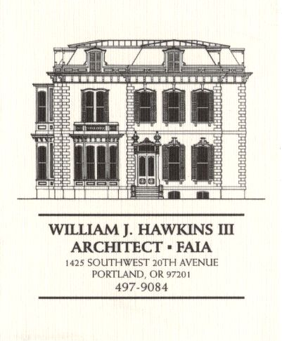 | Muller – Dhillon Residence  Addition & Remodel  3425 SW Heather Lane  Portland, Oregon 97201  MEETING MINUTES | Job: #03-20  By: Paul Klein  Meeting: #13  Date: 9 May 2006

Distribution (*attendees) | Phone | Fax | E-mail
Roger Muller | 503-957-6873 |  | roger.muller@gmail.com
Daisy Dhillon
*David Saltzberg (J. Frank) | 503-445-4735 | 503-408-8855 | david.saltzberg@jamesfrank.net
Bill Hawkins (WJH Architect) | 504-497-9084 | 503-225-9460 | billhawkins@qwest.net
*Paul Klein (WJH Architect) | 504-497-9084 | 504-497-9084 | paulklein@qwest.net
Peder Golberg (J.G. Pierson) | 503-226-1286 | 503-226-3130 | peder@jgpierson.com
(New items are shown in blue font. Urgent items are indicated in red. Resolved items are indicated in italics.)

- SCHEDULE:

  - See the updated Contractor’s Schedule published 05/01/06.

- PROGRESS:

  - The timber roof assemblies are installed. Tongue & groove roof decking is on site. The gang-nail roof trusses are being placed.

  - The framer is installing plywood at the shear wall on the south side of the stairwell in the Basement. The perimeter walls of the Laundry Room have been framed.

  - The mechanical subcontractor is installing ductwork at the Basement.

  - The plumbing subcontractor is installing rough-in piping at locations throughout the house.

- MEETING SCHEDULE: Weekly project meetings: 9:00 AM Tuesday (unless noted otherwise).

- Next meeting: 9:00 AM Tuesday 16 May 2006, at the project site.

- MEETING NOTES:

  - The Contractor requested that the Architect provide additional dimensions for the layout of the shower at the Master Bath.

  - The Architect reviewed the framing conditions shown on Sheets A-11 through A-14 with the Contractor and the framing subcontractor. The Contractor requested that the enclosed space above the soffit at the entry canopy at the South Elevation be ventilated.. The Architect will revise detail 1/A-13 to indicate a continuous soffit vent near the wall at Grid ‘B’.

  - The framing subcontractor requested additional information for the vertical location of the window head rough opening at the Stair Landing shown on Detail 3/A-12.
05-09-06 The Architect provided the requested dimensions to the Contractor via telephone.

- ACTION ITEMS:

- The design of the exterior brackets under the floor of the upper stair landing need to be determined and detailed. (See Section 4/A-7 & Stair Section 1/A-7.)
05-05-06 Supplementary architectural details at the floor of the Stair Landing illustrating the support brackets delivered to the Contractor via Precision Images (Ref. Sheet A-14).

- The handrail design at the upper & lower decks needs to be completed. The architectural details and structural calculations will be provided to the Contractor for delivery to the City for review and approval.

- The Architect and Owner need to resolve the final design of the canopy roofs at the North and South Elevations above the Main Floor. The condition where the downspouts at the south elevation pass through the canopy roof needs to be designed and detailed.
03-28-06 The canopy at the North Elevation at the Second Floor line will be deleted. The Architect will prepare details for construction of the canopy at the South Elevation.
05-05-06 Supplementary architectural details at the new canopy roof at the South Elevation delivered to the Contractor via Precision Images (Ref. Sheet A-13).

- The locations of attic access panels indicated at the Second Floor ceiling need to be revised. Access panels should not be located in closets where shelving and stored items will block easy access. (Ref. 2005 Oregon Residential Specialty Code Section R807 Attic Access.)
03-28-06 The access to the east wing attic space will be determined in the field after the roof trusses have been installed. (The final locations of access openings will be established to fit between the actual locations of truss bottom chords at the Second Floor ceilings.)

- The final configuration of the Kitchen needs to be determined. The locations of the ovens needs to be resolved, and size of the island cabinet finalized.
04-18-06 The Contractor requested additional dimension information (height & radius) for the layout of the arched soffits at the Kitchen. (The owner expressed a willingness to delete the arches from the project.)
04-25-06 The Architect will prepare updated floor plans for the Kitchen and Laundry Room for coordination of appliances, miscellaneous equipment and casework locations & sizes. The Architect field measured the as-built conditions of the walls for reference while preparing the updated plans.
05-09-06 The Architect and Contractor briefly discussed various Kitchen floor plan options with the Owner. The Architect will bring a revised Kitchen floor plan to the next project meeting for review by the Owners.

- Locate the new condensing unit for Second Floor HVAC unit. The tentative location is at the adjacent grade on the north side of the house in the vicinity of the existing condensing unit.
02-21-06 It is an option to relocate the existing condensing unit to a new concrete pad at the east side of the structure. This will allow finish grading to be adjusted along the north wall for easier access into the Crawlspace. The final location of the condensing units is yet to be determined.

- The Contractor inquired about the specification for the Car Deck structural steel to be galvanized. The Architect will revisit the requirement.

- The Contractor requested that the concrete curb at the Car Deck be eliminated to make forming the slab easier. The Architect will revise the detail. (Ref. Detail SD-08.)
05-09-06 Revised Detail SD-08 delivered to the Contractor via fax.

- The Contractor recommends that the exterior guardrails at the decks and Car Deck be powder-coated. The Architect will investigate the feasibility as the design of the railings proceeds.

- The Contractor recommends that the Owner consider the possibility that the new skylight at the Second Floor Hall 05 might be operable. The ability to open this skylight, along with opening other windows in the house, could provide an additional method of ventilation. An operable skylight at this location could also serve as a point of access to the roof.
05-09-06 The Contractor has selected a 4’x4’ operable skylight (Model VSE manufactured by Velux). The skylight will come with a remote control unit.

