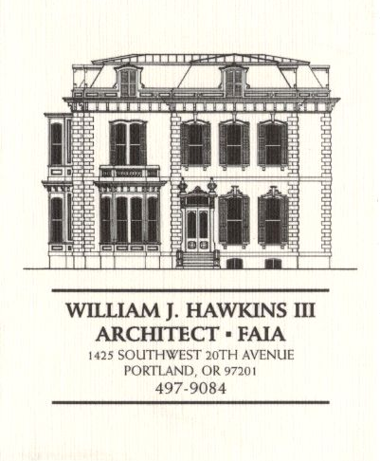 | Muller – Dhillon Residence  Addition & Remodel  3425 SW Heather Lane  Portland, Oregon 97201  MEETING MINUTES | Job: #03-20  By: Paul Klein  Meeting: #10  Date: 18 April 2006

Distribution (*attendees) | Phone | Fax | E-mail
*Roger Muller | 503-957-6873 |  | roger.muller@gmail.com
Daisy Dhillon
*David Saltzberg (J. Frank) | 503-445-4735 | 503-408-8855 | david.saltzberg@jamesfrank.net
Bill Hawkins (WJH Architect) | 504-497-9084 | 503-225-9460 | billhawkins@qwest.net
*Paul Klein (WJH Architect) | 504-497-9084 | 504-497-9084 | paulklein@qwest.net
Peder Golberg (J.G. Pierson) | 503-226-1286 | 503-226-3130 | peder@jgpierson.com
(New items are shown in blue font. Urgent items are indicated in red. Resolved items are indicated in italics.)

- SCHEDULE:

  - See the updated Contractor’s Schedule published 04/10/06.

- PROGRESS:

  - The vertical tie-down system (Simpson TDS) is installed at the east Living Room bay up to the Main Floor line.

  - The special inspection is scheduled to day for the installation of epoxy set threaded rods at the foundation tie downs.

  - The floor infill above the sloped deck has been installed at the Family Room.

  - The layout and framing of the new upper stair and intermediate landing is in progress.

- MEETING SCHEDULE: Weekly project meetings: 9:00 AM Tuesday (unless noted otherwise).

- Next meeting: 9:00 AM Tuesday 25 April 2006, at the project site.

- MEETING NOTES:

  - The Contractor expressed concern with conflicts to the laundry chute routing from the Second Floor to the Basement. The Owner elected to eliminate the laundry chute from the project.

  - The door to the Laundry Room in the Basement will be a pocket door. The east wall of the Laundry Room will be framed with 2x6 studs. The new electrical distribution panel will be recessed facing the hallway at the east Laundry Room wall.

  - The Contractor requested additional dimension information (height & radius) for the layout of the arched soffits at the Kitchen. (The owner expressed a willingness to delete the arches from the project.)

  - The framing subcontractor requested additional dimension information for the layout of new walls at the Second Floor. The framer also requested more information for the attachment of the new stair stringers to the beam at the Main Floor line.

  - The existing fireplace at the Living Room is scheduled to be relocated to the Library at the Second Floor. The fireplace is a wood-burning fireplace that has been converted to natural gas. The mechanical subcontractor expressed doubts whether the fireplace could be reused as a gas fueled appliance since the unit is not labeled for gas conversion. The fireplace will be relocated as a wood-burning appliance only, and will not have a natural gas connection.

  - The 6x12 roof beam on Grid E east of Grid 3 is in conflict with the door heads a the closets below. The framing subcontractor suggested that the beam be lifted to be above the ceiling line. The Architect will contact the Structural Engineer to select a beam hanger to replace the Simpson CJT hangers indicated on the drawings. (Ref. Details 6 & 7 on Sheet S-9.)

  - The Owner and Architect will meet at 9:00 AM, Thursday morning, April 20, at the Architect’s office to review design concerns at the exterior building envelope, Laundry Room and Kitchen layouts, and lighting fixture selection & design. (Meeting time to be confirmed.)

- ACTION ITEMS:

- The design of the horizontal band indicated at the exterior elevations near the Second Floor line needs to be detailed and specified. (See Exterior Elevations on Sheet A-5.)

- The roof over the upper stair landing needs to be detailed, especially the detail of the flashing assembly at the sill of the new windows above the roof line. (See Stair Section 1/A-7).

- The component members and dimensions of the exterior wood cornice assembly need to be established (See Details 5 & 6/A-7.) Also, the relationship of the new Second Floor window heads need to be coordinated with the design of the cornice.

- The design of the exterior brackets under the floor of the upper stair landing need to be determined and detailed. (See Section 4/A-7 & Stair Section 1/A-7.)

- The Architect and Owner need to resolve the final design of the canopy roofs at the North and South Elevations above the Main Floor. The condition where the downspouts at the south elevation pass through the canopy roof needs to be designed and detailed.
03-28-06 The canopy at the North Elevation at the Second Floor line will be deleted. The Architect will prepare details for construction of the canopy at the South Elevation.

- The attic access panels indicated at the new Second Floor ceiling need to be revisited. Access panels should not be located in closets where shelving and stored items will block easy access.
03-28-06 The access to the east wing attic space will be determined in the field after the roof trusses have been installed. (The final locations of access openings will be established to fit between the actual locations of truss bottom chords at the Second Floor ceilings.)

- The roofing material at the low slope roof above the center of the house needs to be selected.
04-11-06 The roofing system at the areas of low slope roofs will be a multi-ply torch down roof membrane with a mineral cap sheet. The Contractor will furnish the Architect with system specification information.

- The final configuration of the Kitchen needs to be determined. The locations of the ovens needs to be resolved, and size of the island cabinet finalized.

- The Architect will calculate the minimum attic ventilation requirement for code compliance.

- Locate the new condensing unit for Second Floor HVAC unit. The tentative location is at the adjacent grade on the north side of the house in the vicinity of the existing condensing unit.
02-21-06 It is an option to relocate the existing condensing unit to a new concrete pad at the east side of the structure. This will allow finish grading to be adjusted along the north wall for easier access into the Crawlspace. The final location of the condensing units is yet to be determined.

- The Contractor recommends that the Owner consider the possibility that the new skylight at the Second Floor Hall 05 might be operable. The ability to open this skylight, along with opening other windows in the house, could provide an additional method of ventilation. An operable skylight at this location could also serve as a point of access to the roof.

