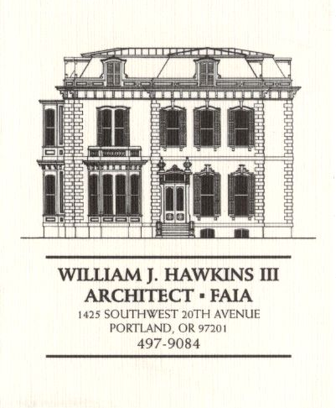 | Muller – Dhillon Residence  Addition & Remodel  3425 SW Heather Lane  Portland, Oregon 97201  MEETING MINUTES | Job: #03-20  By: Paul Klein  Meeting: #09  Date: 11 April 2006

Distribution (*attendees) | Phone | Fax | E-mail
*Roger Muller | 503-957-6873 |  | roger.muller@gmail.com
Daisy Dhillon
*David Saltzberg (J. Frank) | 503-445-4735 | 503-408-8855 | david.saltzberg@jamesfrank.net
Bill Hawkins (WJH Architect) | 504-497-9084 | 503-225-9460 | billhawkins@qwest.net
*Paul Klein (WJH Architect) | 504-497-9084 | 504-497-9084 | paulklein@qwest.net
Peder Golberg (J.G. Pierson) | 503-226-1286 | 503-226-3130 | peder@jgpierson.com
(New items are shown in blue font. Urgent items are indicated in red. Resolved items are indicated in italics.)

- SCHEDULE:

  - See the updated Contractor’s Schedule published 04/10/06.

- PROGRESS:

  - T&G deck a the Second Floor is almost complete.

  - The areas of dryrot damage a the Main Floor have been repaired.

- MEETING SCHEDULE: Weekly project meetings: 9:00 AM Tuesday (unless noted otherwise).

- Next meeting: 9:00 AM Tuesday 18 April 2006, at the project site.

- MEETING NOTES:

  - The Architect returned the Westview Products skylight shop drawings to the Contractor.

  - The Architect delivered the structural detail for the Main Floor ledger to the Contractor. The ledger has already been installed with (3) 3 ½” SDS screws at each stud. The northernmost section of ledger will be removed and replaced with a ledger that spans and intersects the existing ledger. The Architect will confirm the existing condition with the Structural Engineer.

  - The new 4x12 beam on Grid 3 at the south side of the Entry Court was installed by the framing subcontractor as (2) 2x12’s. The Architect will consult with the Structural Engineer to determine whether the substitution is acceptable.

  - The Architect will calculate the minimum attic ventilation requirement for code compliance.

  - The Architect will furnish the Contractor with vertical dimension information for use in framing the new stair landing between the Main Floor and the Second Floor.

- ACTION ITEMS:

- The design of the horizontal band indicated at the exterior elevations near the Second Floor line needs to be detailed and specified. (See Exterior Elevations on Sheet A-5.)

- The roof over the upper stair landing needs to be detailed, especially the detail of the flashing assembly at the sill of the new windows above the roof line. (See Stair Section 1/A-7).

- The component members and dimensions of the exterior wood cornice assembly need to be established (See Details 5 & 6/A-7.) Also, the relationship of the new Second Floor window heads need to be coordinated with the design of the cornice.

- The design of the exterior brackets under the floor of the upper stair landing need to be determined and detailed. (See Section 4/A-7 & Stair Section 1/A-7.)

- The Architect and Owner need to resolve the final design of the canopy roofs at the North and South Elevations above the Main Floor. The condition where the downspouts at the south elevation pass through the canopy roof needs to be designed and detailed.
02-20-06 The design of the canopies has been determined. (See Memorandum Re: Design Coordination Meeting, 20 February 2006, item 7.)
03-20-06 Downspouts from above will not penetrate the canopy roofs. Upper downspouts with leaf clean-outs will discharge onto lower roofs.
03-21-06 The Architect will consult with the Structural Engineer to consider the option of simplifying the at the new canopy roof framing at the north and south elevations.
03-28-06 The canopy at the North Elevation at the Second Floor line will be deleted. The Architect will prepare details for construction of the canopy at the South Elevation.

- The attic access panels indicated at the new Second Floor ceiling need to be revisited. Access panels should not be located in closets where shelving and stored items will block easy access.
03-28-06 The access panel for the west wing attic will be located at the ceiling of the Children’s Multi-Purpose Room 206. The access panel for the attic of the north wing will be located at the ceiling of the Master Dressing Room 209, just inside the pocket door. The access to the east wing attic space will be determined in the field after the roof trusses have been installed. (The final locations of access openings will be established to fit between the actual locations of truss bottom chords at the Second Floor ceilings.)

- The roofing material at the low slope roof above the center of the house needs to be selected.
04-11-06 The roofing system at the areas of low slope roofs will be a multi-ply torch down roof membrane with a mineral cap sheet. The Contractor will furnish the Architect with system specification information.

- The final configuration of the Kitchen needs to be determined. The locations of the ovens needs to be resolved, and size of the island cabinet finalized.

- Locate the new condensing unit for Second Floor HVAC unit. The tentative location is at the adjacent grade on the north side of the house in the vicinity of the existing condensing unit.
02-21-06 It is an option to relocate the existing condensing unit to a new concrete pad at the east side of the structure. This will allow finish grading to be adjusted along the north wall for easier access into the Crawlspace. The final location of the condensing units is yet to be determined.

- The Contractor recommends that the Owner consider the possibility that the new skylight at the Second Floor Hall 05 might be operable. The ability to open this skylight, along with opening other windows in the house, could provide an additional method of ventilation. An operable skylight at this location could also serve as a point of access to the roof.

- The Contractor and Mechanical Subcontractor have worked out a preliminary scheme for routing supply and return ductwork from the existing Basement furnace to serve the Main Floor. The Mechanical Subcontractor will prepare a plan sketch indicating the proposed duct routes for further review and consideration.
04-11-06 The Contractor reviewed the preliminary duct layout drawing with the Owner and the Architect. Final duct routing at the attic space will be determined after the roof framing is in place.

