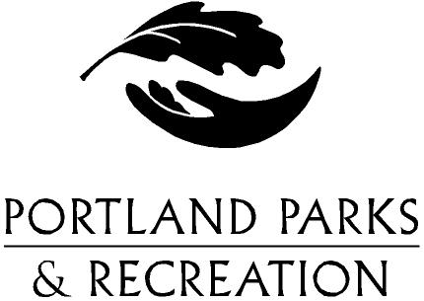
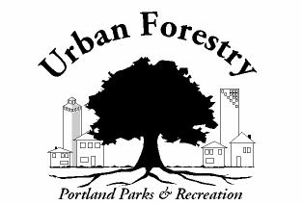
CITY OF
PORTLAND, OREGON

URBAN FORESTRY DIVISION
10910 N Denver
Portland, OR 97217

DATE: April 25, 2008

TO: Suzanne Savin, City of Portland, Land Use Review

FROM: Myles Black, 503-823-4018
City Nature, Urban Forestry
Portland Parks and Recreation

SUBJECT: LU 08-106691 AD
SITE LOCATION:

RESPONSE :

City code Title 20.40 requires a street tree review for new construction projects, improvements to existing structures that exceed $25,000 in value and to all land divisions.

There are right-of-way trees located adjacent to SW 18th Ave. Title 20.40.090 requires a written permit to remove any tree located in the City right-of-way. The applicant will have to file for a tree removal permit before removing any tree located in the City right-of-way.

CONDITIONS OF APPROVAL:

- The applicant must contact the Urban Forestry Division of Portland Parks and Recreation before removing any tree located in the City right-of-way.

