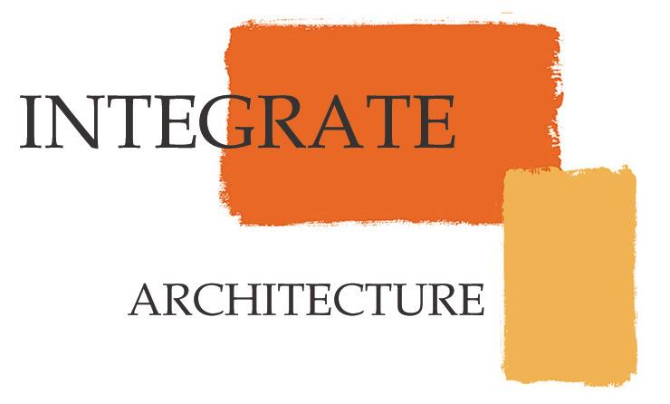

Saint Andrews Condominiums
January 7, 2008
Estimated Project Hours

Design / Permitting = 28 weeks total

Schematic Design = 5 weeks
- Preliminary design completion = 30 hours
- Preliminary documentation completion = 80 hours
- (E) conditions = 20 hours
- Project Coordination – 6 hrs x 4 weeks = 24 hours
- Design Administration – 4hrs x 4 weeks = 16 hours
- Research/ Specifications – 4hrs x 4 weeks = 16 hours
Total = 186 hours

Design Development/ Construction Documents = 18 weeks total
- DD/CD design and Documentation - 25 hrs x 18 weeks = 450 hours
- Project Coordination – 6 hrs x 18 weeks = 108 hours
- Design Administration – 4hrs x 18 weeks = 72 hours
- Research/ Specifications – 4hrs x 18 weeks = 72 hours
- Misc. – 1 hr x 18 weeks = 18 hours
Total = 720 hours

Specifications/ Permitting = 6 weeks total
- Research/ Specifications – 30 hrs x 4 weeks = 120 hours
- Permitting/ City coordination – 30 hrs x 2 weeks = 60 hours
- Design Administration – 4hrs x 6 weeks = 24 hours
- Research/ Specifications – 4hrs x 6 weeks = 24 hours
Total = 228 hours

Total Design / Permitting Hours = 1,134 hours x $60.00 = $68,040
Design Contingency = 100 hours x $60.00 = $6,000
Profit = $68,040 x 10% = $6,800

Construction Administration
- CA – 16 hrs x 47 weeks = 750 hours x $60.00 = $45,000
- CA Contingency = 80 hours x $60.00 = $4,800
- Profit = $45,000 x 10% = $4,500

Total = $135,140

