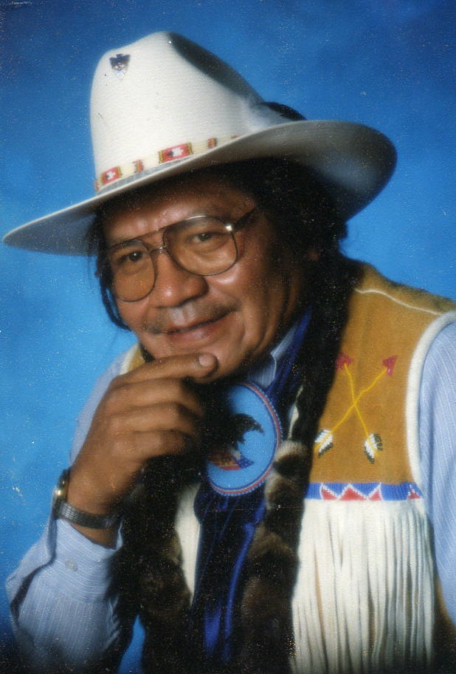

Jerry Meninick
Supsa-Kaan

Jerry Meninick was born and raised on the Yakama Reservation. His ancestral lineage includes a great grandfather, Men-ni-nock, who signed the Treaty of 1855 between the Yakama Nation and the United States Government. Meninick would come to follow the foot steps of family members who served their Nation as Councilmen.

Meninick’s traditional education began at the time of his birth and continues through his obedience to the unwritten laws handed down since time immemorial. Meninick holds his traditional knowledge as a scared gift and as a responsibility to share the wisdom of the Creator's laws and of his peoples' history.

In 1991, Meninick was elected by his people to serve on Yakama Nation’s Tribal Council. Meninick served several years as a Tribal Council member and as Yakama Nation’s Tribal Council Chairman. During his tenure, he worked hard to protect and preserve the Treaty rights of his people.

Meninick is often called upon to conduct prayer services, name giving’s, and family memorials. Meninick serves as a master of ceremonies at numerous powwows and tribal events throughout the Pacific Northwest. In addition, he is invited to speak at several conferences and public events.

Meninick has many insightful stories of the Pacific Northwest and how traditional tribal culture is being threatened by today's environment.

