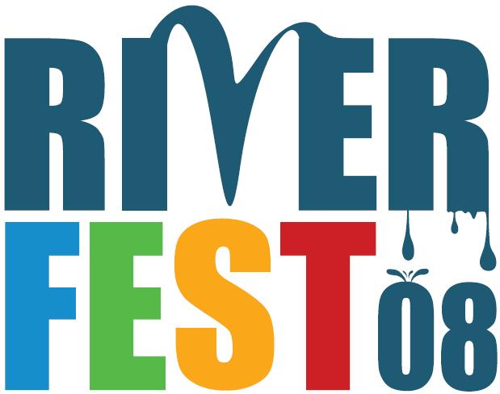

Riverfest Core Group Meeting
February 27, 2008
3:00 – 4:30 p.m.
Discovery Center
680 SW Bancroft St.
(map and driving directions: http://www.southwaterfront.com/discovery_center)

Meeting Objectives:
- Assure success: Zero-in on “keystone” events that are musts for Riverfest (inc. those already-occurring and ones we’ll create).
- Identify additional—but realistic—desired events.
- Identify and assign tasks.
- Identify what other organizations or groups we should be talking with.

Recommended Agenda

1. Introductions

2. Riverfest Recap

3. Event Walk-Through and Planning Update

5. Riverfest Funding

6. Closing comments, news-sharing, and next steps

Comments and Suggestions:
If you have comments you didn’t get a chance to make or preferred to make them off-line, please consider writing them below and/or on the back, and hand them to Rick or one of the Helm members.

Facilitator’s Agenda

Riverfest Core Group Meeting
February 27, 2008
3:00 – 4:30 p.m.
Discovery Center
680 SW Bancroft St.
(map and driving directions: http://www.southwaterfront.com/discovery_center)

Meeting Objectives:
- Assure success: Zero-in on “keystone” events that are musts for Riverfest (inc. those already-occurring and ones we’ll create).
- Identify additional—but realistic—desired events.
- Identify and assign tasks.
- Identify what other organizations or groups we should be talking with.

Recommended Agenda
- Hand out agenda
- Go thru objectives
- Ask if agenda OK
- Ask who will take notes
- comments can be jotted down on bottom/back of agenda

1. Introductions (5m.)
Pass around sign-in sheet (room on back)

2. Riverfest Recap (10 m.)

3. Event Walk-Through and Planning Update (50 m.)
Handout:
- note that calendar is on back of agenda
- task worksheet
Call attention to objectives

5. Riverfest Funding (10 m.)
- Figure we need $115-120K
  - HAND OUT CHEAT SHEET
- City $50K budget request
- Willamette Fun(d) challenge grant
- Healy grant application
- ask Stephanie to note the potential under Vision-to-Action
- ask Rachael to talk about the Port’s interest
ALSO NOTE COMMUNITY BUDGET FORUM

6. Closing comments, news-sharing, and next steps (10 m.)
- set meeting date
- get any written comments

