The League of Women Voters and the Corvallis Benton County Public Library
Invite You to a dialogue on:
Vanishing Waterways
Taking Action to Revitalize Our Local Streams
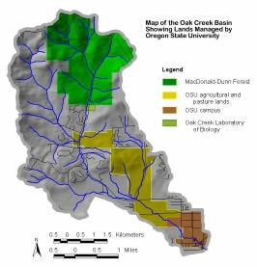

Featuring
Dr. Stan Gregory
Professor of Wildlife and Fisheries
Engaging you in the challenges and actions needed to revitalize life
and natural functions in our
ancient Corvallis streams.

Tuesday, March 4, 2008
7:00 – 9:00
Corvallis-Benton County Public Library
645 NW Monroe Ave.

Followed by discussion and displays on how you can make a difference with:

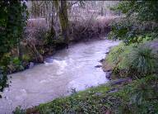
City of Corvallis
Benton County
Marys River Watershed Council
Benton Soil & Water Conservation District
Greenbelt Land Trust
League of Women Voters of Corvallis • 757-2276 • http://www.lwv.corvallis.or.us

