Submitted Riverfest Logos as of January 22, 2008

 | Artist | 1 | 2 | 3 | 4 | 5 | 6
A | Azzcat
B | Nerat
C | Wood(1)
D | Wood(2)
E | Wood  (3&4))
F | Morgan
G | Morgan (cont)
H | Steen |  | 
I | Walsh | 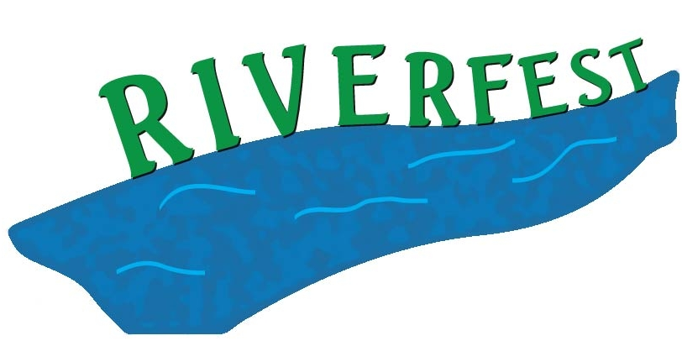 | 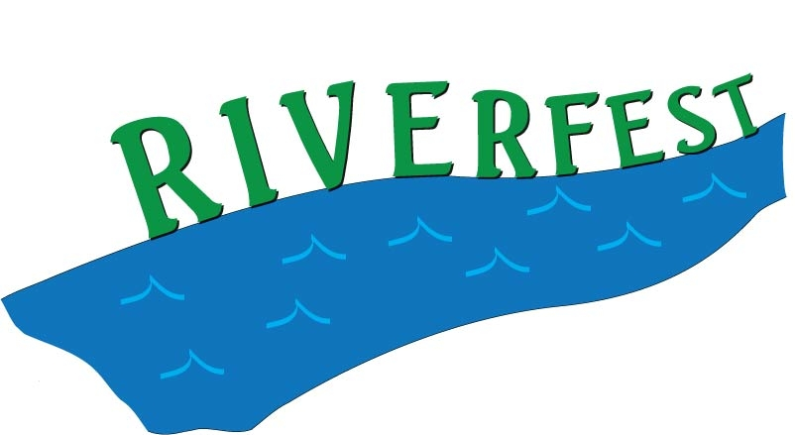 | 

