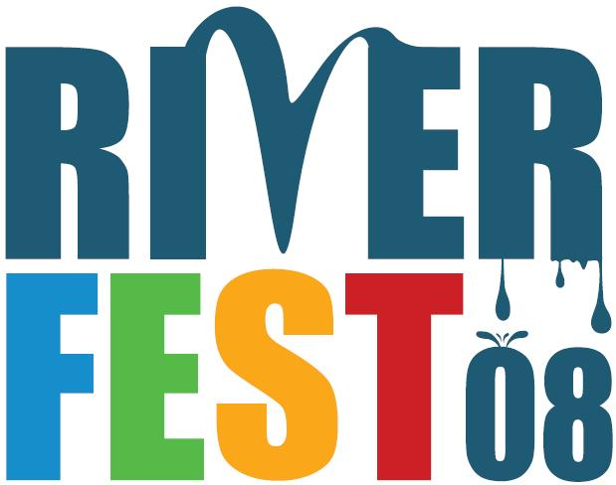  Organizers:  City of Portland  River Renaissance  Parks Bureau  Willamette River Fun(d) of the Oregon Community Foundation  The Bill Healy Foundation  Port of Portland  Oregon Trout  Portland Triathlon  Willamette Riverkeeper  Ecotrust  Columbia Crossing  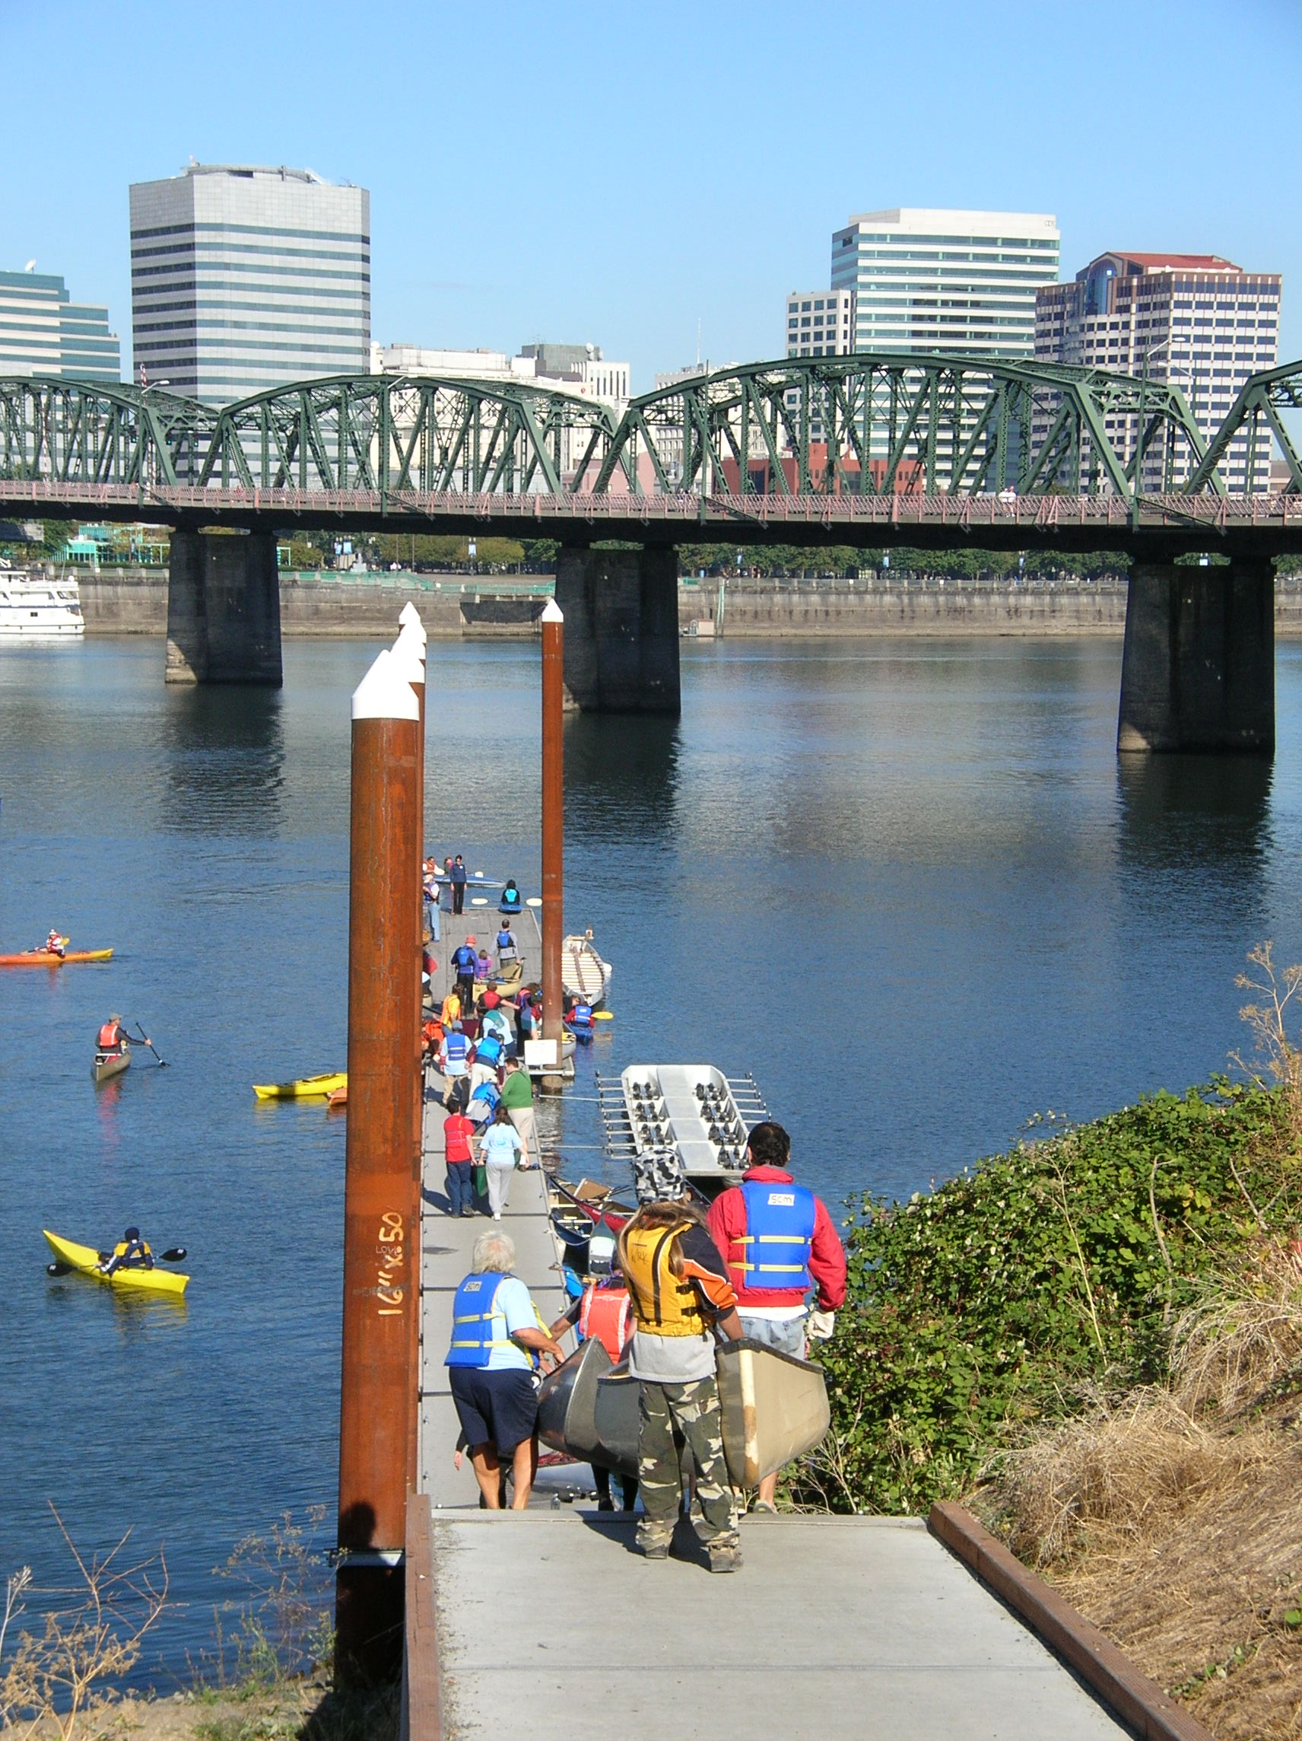 | Community Fair  August 31, 2008 ▪ Waterfront Park  Riverfest ‘08 is a new celebration of the Willamette River’s importance to the region. Scheduled for August 28 to September 7, 2008, the event is a chance to get on and in the water, enjoy live music, learn first-hand about the river’s history and environment, clean-up the riverbank, and enjoy boat parades, sailing regattas, a Willamette species parade, an urban adventure race, and other river spectacles.  Riverfest’s Community Fair will offer a unique opportunity for you to share your organization’s connections to the Willamette. Scheduled for Sunday, August 31, in Waterfront Park’s “Bowl” area, the Fair will complement the day’s jam-packed line-up of river activities that include the 2nd Annual Oregon Trout City of Portland Triathlon, Riverfest’s Opening Ceremony, and the Willamette Boat Parade.  The Fair will promote one key message:  The Willamette: Respect, Reconnect, Renew  To accomplish this, the event will feature four themes to highlight the many benefits the Willamette bestows on our community:  - River Tourism and Recreation  - Working River  - History and Community  - River Renewal/Health  Each theme will be organized under its own tent, with tent sponsorships available at certain levels of Riverfest support.  Riverfest’s organizers invite you to be part of this exciting chance to engage thousands of Portlanders in working together to create a better Willamette. The Fair will be a perfect place to:  - showcase your organization’s success in renewing the River or revitalizing riverside areas;  - spread the word about your business and create a new customer base;  - involve families in river-related activities;  - attract community volunteers for projects;  - gather public input about river and community needs; and  - focus attention on river issues.  See the next page for how to sign-up for the Riverfest Community Fair.  For more information on Riverfest, visit www.portlandriverfest.org, or call Jim Miller, event organizer, at 503-516-1540.

Community Fair Application
August 31, 2008 ▪ Waterfront Park
Riverfest’s organizers welcome your ideas about how to make the Community Fair a success. We’re especially interested in meeting the needs of your organization, even as we strive to achieve the primary objectives of Riverfest:
- Make the Willamette a focus of fun and learning for all ages.
- Actively improve river ecosystems and watershed health through increased citizen engagement.
- Promote increased economic activity on the Riverfront.
Riverfest Community Fair Guidelines
- Be river-specific. Draw a clear connection between your story and the River.
- Support the Riverfest message: The Willamette: Respect, Reconnect, Renew
- Promote interaction. Information should be animated and interactive, with a premium on “do and touch” approaches. Opportunities that allow people to get in and on the river encouraged!
- Be kid- and family-friendly. Ideally, each participant will offer or take part in activities or items that speak to kids and families.

To apply to be part of the Community Fair, please provide the information requested below
NO LATER THAN JUNE 30, 2008.
Riverfest will announce table selections by July 15.
1. Registration Information:
Organization Name:
Address:

Contact Person:
Phone: E-mail:
2. Community Fair Participation Levels: Riverfest will provide tented areas and power, plus tabling areas customized to suit your needs. Tabling costs range from $75 to $350, depending on size, complexity, need for power, observance of guidelines, etc. Once we receive your registration, we’ll contact you to work out the details.
3. Fair Theme: Please indicate which theme best captures your primary interest (we understand many organizations are multidimensional and will work with you to feature your efforts in all themes).
❑ River Tourism and Recreation  Working River
❑ History and Community  River Renewal/Health
4. Describe your offering: Please briefly summarize what type of info you’ll offer and the nature of the materials or displays you’ll bring:
__________________________________________________________________________________________________________________________________________________________________________________________________________________________________________________________________
5. Cool ideas or special needs? Let us know here, on a separate sheet, or by contacting us:
__________________________________________________________________________________________________________________________________________________________________________________________________________________________________________________________________

Email to: ▪ info@portlandriverfest.org ▪ Subject line: Community Fair; or
U.S. Mail to: River Renaissance, 1900 SW 4th Ave., Suite 7100, Portland, OR 97201
Questions? Call: 503-516-1540
Community Fair [Registration sheet option 2]
August 31, 2008 ▪ Waterfront Park
Riverfest’s organizers welcome your ideas about how to make the Community Fair a success. We’re especially interested in meeting the needs of your organization, even as we strive to achieve the primary objectives of Riverfest:
- Make the Willamette a focus of fun and learning for all ages
- Actively improve river ecosystems and watershed health through increased citizen engagement
- Promote increased economic activity on the Riverfront.
Riverfest Community Fair Guidelines
- Be river-specific. Draw a clear connection between your story and the River.
- Support the Riverfest message: The Willamette: Respect, Reconnect, Renew
- Promote interaction. Information should be animated and interactive, with a premium on “do and touch” approaches. Opportunities that allow people to get in and on the river encouraged!
- Be kid- and family-friendly. Ideally, each participant will offer or take part in activities or items that speak to kids and families.

To sign up for the Community Fair, please provide the information requested below NO LATER THAN JUNE 30, 2008.
1. Registration Information:
Organization Name:
Address:

Contact Person:
Phone: E-mail:
2. Community Fair Participation Levels: Please mark your selection and make checks payable to Oregon Trout / Riverfest. Fees help cover site costs. Riverfest will provide tented areas and power. Please call us to discuss your needs and ideas!
Community Fair Participation | Check if you need power. | Cost
❑ Community crossroads (Riverfest will provide an information crossroads as a no-host display area to allow for casual browsing. Space limited to 2ft. X 2ft. or equivalent per organization.) | N/A | Free  (but must register)
❑ Shared table. Name of preferred table-mate, if known: | ❑ | $75
❑ Single table | ❑ | $125
❑ Twin tables | ❑ | $200
❑ Commercial tabling and display | ❑ | $300
3. Fair Theme: Please indicate which theme best captures your primary interest (we understand many organizations are multidimensional and will work with you to feature your efforts in all themes).
❑ River Tourism and Recreation  Working River
❑ History and Community  River Renewal/Health
4. Cool ideas or special needs? Let us know here or by contacting us:
_________________________________________________________________
Send to: Riverfest Community Fair
(Address—Jim PO Box?) ▪ Portland, OR, 972___ ▪ Fax: _____________
or email to: info@portlandriverfest.org ▪ Subject line: Fair
Questions? Call: 503.xxx.xxxx

