DRAFT
Announcing the
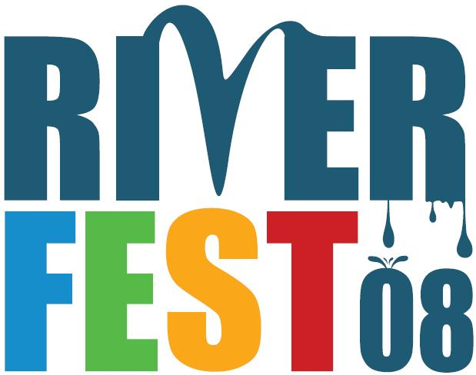
Community Fair

Riverfest (August 28 through September 7, 2008) is a new celebration of the importance of the Willamette River and a chance to come down by the riverside to get out on the water, enjoy live music, learn first-hand about the river’s history and environment, clean-up the riverbank, and enjoy boat parades, sailing regattas, a Willamette species parade, an urban adventure race and other river spectacles.
Riverfest’s Community Fair will offer a unique opportunity to share what your organization offers Willamette-wise. Held on Sunday, August 31, in Waterfront Park’s “Bowl”area, the Fair will complement the day’s jam-packed line-up of river activities that include the 2nd Annual Oregon Trout Portland Triathlon, Riverfest’s Opening Ceremony, and the Willamette Boat Parade.
The Fair will be organized under four themes to highlight the many benefits the Willamette bestows on our community:
- River Tourism and Recreation
- Working River
- History and Community
- River Renewal/Health
…and it will key off the message of this first annual Riverfest:
- The Willamette: Respect, Reconnect, Renew
Riverfest’s organizers invite you to be part of this exciting chance to engage thousands of Portlanders in working together to create a better Willamette. The Fair will be a mini-circus of information, with each theme housed in its own tent.
The Fair will be a perfect place to:
- showcase your organization’s success in renewing the River or revitalizing riverside areas;
- spread the word about your business and create a new customer base;
- involve families in river-related activities;
- attract community volunteers for projects;
- gather public input about river and community needs;
- focus attention on river issues.
See the next page for how to sign-up for the Riverfest Community Fair.
For more information on Riverfest, visit www.portlandriverfest.org, or call _________________.
Community Fair

Riverfest’s organizers welcome your ideas about how to make the Community Fair a success. We’re especially interested in meeting the needs of your organization, even as we strive to achieve the primary objectives of Riverfest:
- Make the Willamette a focus of fun and learning for all ages.
- Actively improve river ecosystems and watershed health through increased citizen engagement
- Promote increased economic activity on the Riverfront.
To help meet these objectives, we offer the following…
Riverfest Community Fair Guidelines
- Be river-specific—draw a clear line between your story and the River. Generic information by itself won’t help the Willamette;
- Connect to the Riverfest message—The Willamette: Respect, Reconnect, Renew
- “No dead tables”—All information should be delivered in an animated fashion, with a premium on “do and touch” approaches.
- Be kid- and family-friendly—ideally, each participant would have activities or items that speak to kids and families—or take part in tent-wide activities appealing to families.
To sign up for the Community Fair, please provide the information requested below NO LATER THAN JUNE X, 2008
1. Registration Information
Organization Name:
Address:

Contact Person:
Phone: E-mail:
2. Community Fair Participation Levels: Please mark your selection and make checks payable to Oregon Trout / Riverfest. (Fees help cover site costs.)
 | Level | Regular Fee | Non-Profit Fee | Fee after June X
❑ | 1. Display space  (e.g., for map, poster, watercraft) | $150 | $100 | $250
❑ | 2. __ x ___ table (small), no power | $225 | $175 | $350
❑ | 3. __ x ___ table (small), WITH power | $300 | $225 | $375
❑ | 4. __ x ___ table (big), no power | $375 | $275 | $400
❑ | 5. __ x ___ table (big), WITH power | $425 | $300 | $500
❑ | 6. __ x ___ table (big), WITH power AND located at tent gateway | $500 | $350 | $600
SAVE 10% OFF THE TOP! Simply attach a letter saying specifically how you will follow the Community Fair guidelines. We’re serious—it’s that simple. (Levels 2-6, only)
3. Fair Theme: Please indicate the one theme that best captures your primary interest (we understand many organizations are multidimensional and will work with you in featuring your efforts in all themes).
❑ River Tourism and Recreation | ❑ Working River
❑ History and Community | ❑ River Renewal/Health
4. Cool ideas or special needs? Let us know here or by contacting us:

Mail to: Riverfest Community Fair OR Email to: info@portlandriverfest.org with Subject line: Fair
(Address—Jim PO Box?)
Portland, OR, 972___
Phone: _____________________

City of Portland, Oregon Trout, Portland Triathlon, Willamette River Fun(d), Willamette Riverkeeper, Ecotrust, Columbia Crossing …
Each tent will be attractively signed, with tent sponsorships available at certain levels of Riverfest support.

