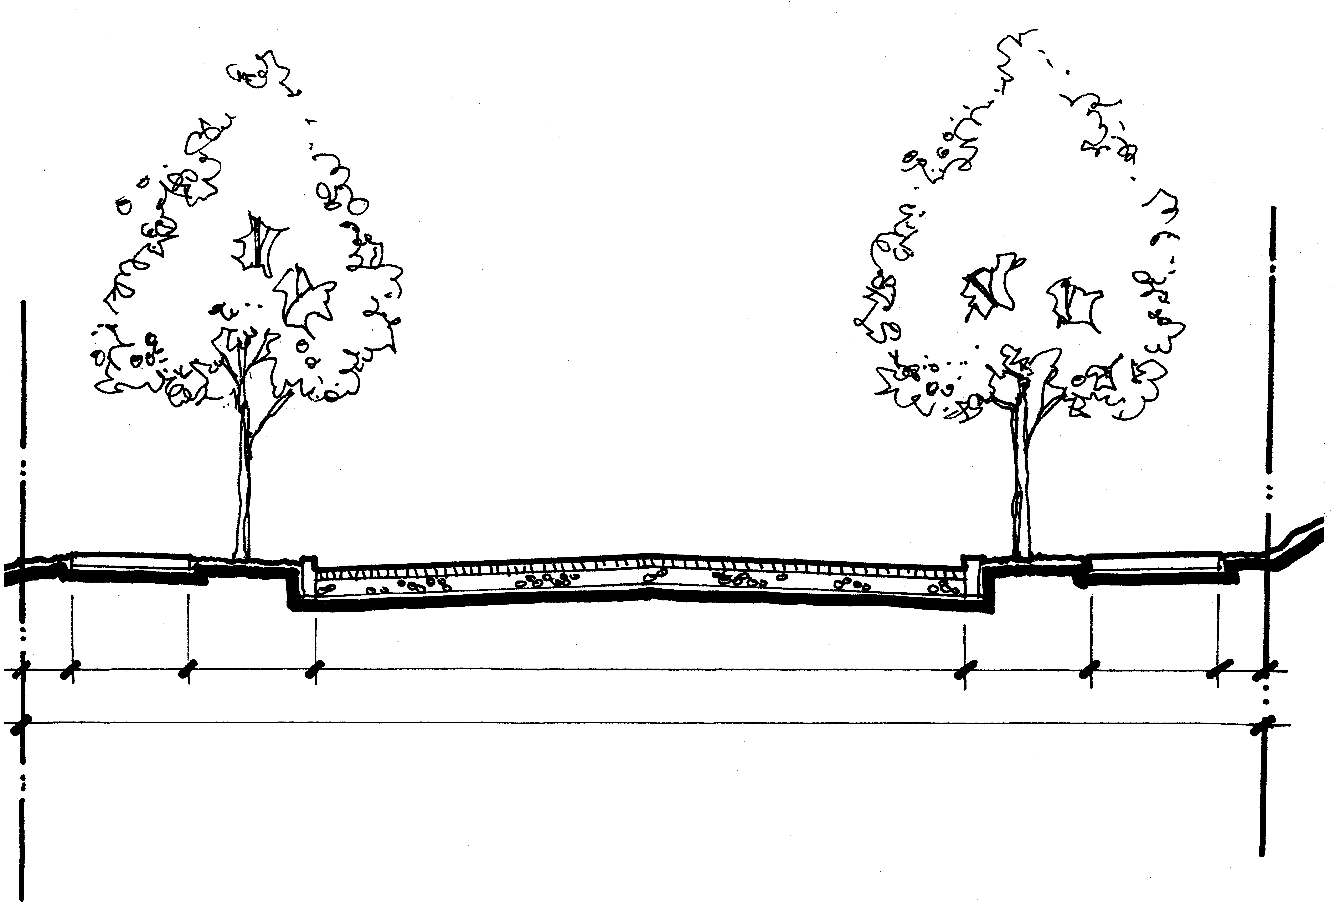
PARKING
SB
SIDEWALK
CURB /
SWALE
TRAVEL LANES
PARKING
CURB/
PLANTER
SIDEWALK
SB
STREET
30'0"
RIGHT-OF-WAY
50’0”

TYPICAL SECTION
NORTH WINCHELL STREET LOCAL IMPROVEMENT DISTRICT

