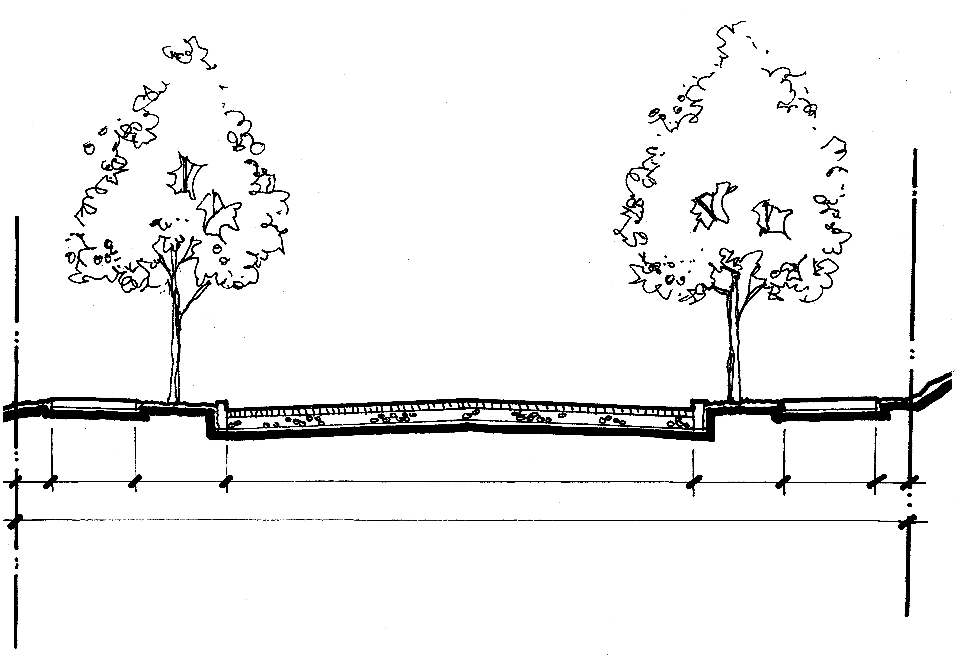
PARKING
7'0"
SB
SIDEWALK
CURB /
SWALE
TRAVEL LANE
12'0"
PARKING
7'0"
CURB/
PLANTER
SIDEWALK
SB
STREET
26'0"
RIGHT-OF-WAY
Varies

TYPICAL SECTION
SE 152nd AVENUE LOCAL IMPROVEMENT DISTRICT

