Amendments to the Cascade Station/Portland International Center Plan District

Recommended Draft - January 2005

Planning Staff Suggested Amendments

# | Page(s) | Proposed Change | Commentary
 |  | Plan District
1. | 19 | - Additional Allowed Uses, replace the bullets under A.3.b.(2) with the following:  - One building may contain a single retail use that occupies up to 90,000 square feet of floor area per story;  - One building may contain a single retail use that occupies up to 185,000 square feet of floor area per story; and  - One building may contain a single retail use that occupies up to 205,000 square feet of floor area per story. | The Planning Commission recommendation permits one retail use with 90,000 square feet (SF) of floor area per story and two individual retail uses with 185,000 SF of floor area per story. This amendment allows the same except that one of the 185,000 SF retail uses would now be allowed to have a 20,000 SF larger building footprint totaling 205,000 SF. The larger building footprint was requested by project developers in anticipation of a desired tenant. The potential tenant evaluated Portland market conditions and the potential growth of its regional-serving business over time, and would like to have the ability to build its medium-size retail store instead of its small sized store at 185,000 SF.
2. | 53 | 33.508.230.D Build-to-Line-Area, subsection D.1.c.(3):  Delete (3) and replace with the following language:  (3) Corner lots. Except as specified in D.1.c (4), buildings with more than one street lot line frontage must meet the standards of D.1.c(1) and (2) on all street lot lines.  (4) Exception. Buildings with street lot line frontage on both NE Cascades Parkway and a Type B street must meet the standards of D.1c.(1) and (2) on the NE Cascades Parkway street lot line frontage, but do not have to meet the standards on the Type B street lot line frontage. However, surface parking is not allowed within 50 feet of the street lot line frontage on the Type B street within the BTLA.  See Figure 508-14.  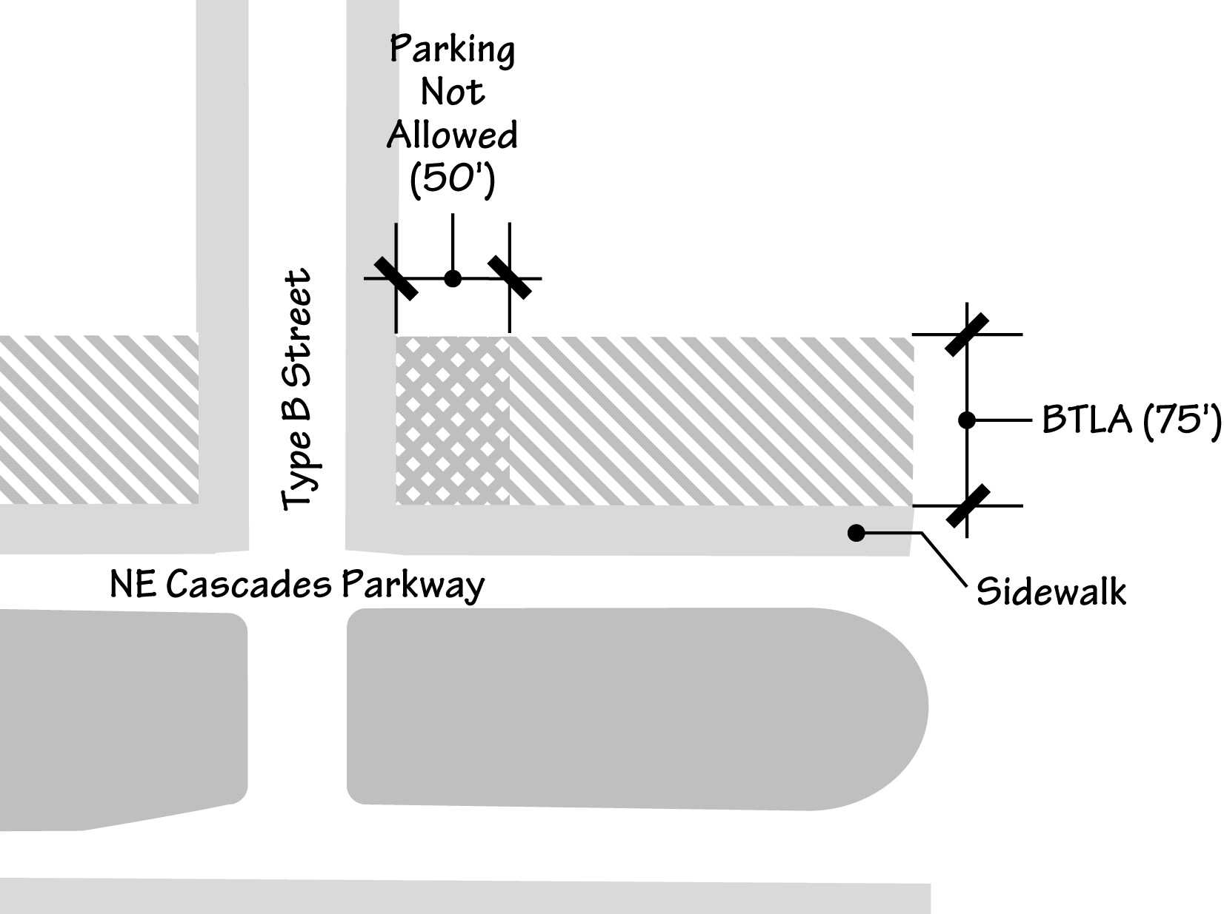  New Figure 508-14  Build-to-Line Area Illustration | The Planning Commission recommends that all (19) corner lots along Cascades Parkway in the Build-To Line Area should have buildings that “come up to the street” along both street frontages. The maximum building setback regulation is one of the urban design features for this plan district; requiring buildings to be located at the corners of most streets that front the park blocks creates an “urban” identity for the park blocks.  The developers have requested reconsideration of this setback requirement. Requiring buildings on all corner lots constrains desired design flexibility, and presents problems in creating a varied and interesting pedestrian environment.  This amendment requires that the setback must be met on about half the intersections. Where a lot fronts on both Cascades Parkway and a Type A, C, or D street, the buildings must come up to the street on both frontages. However, where a lot fronts on both Cascades Parkway and a Type B street, the maximum setback only applies along Cascades; the side street is exempt.
 |  | CS/PIC Master Street Plan
3. | 138 | Replace CS/PIC Master Street Plan with updated figure that deletes loading areas, which were designated on the Recommended Draft figure as streets. Also clarified in the legend is a new citation indicates that D and E streets require pedestrian facilities on one-side of the street. All other identified streets will have sidewalks on both sides of the street. | The location of loading areas will be addressed in the master planning section of the revised Development Agreement.

Cascade Station/PIC Master Street Plan

