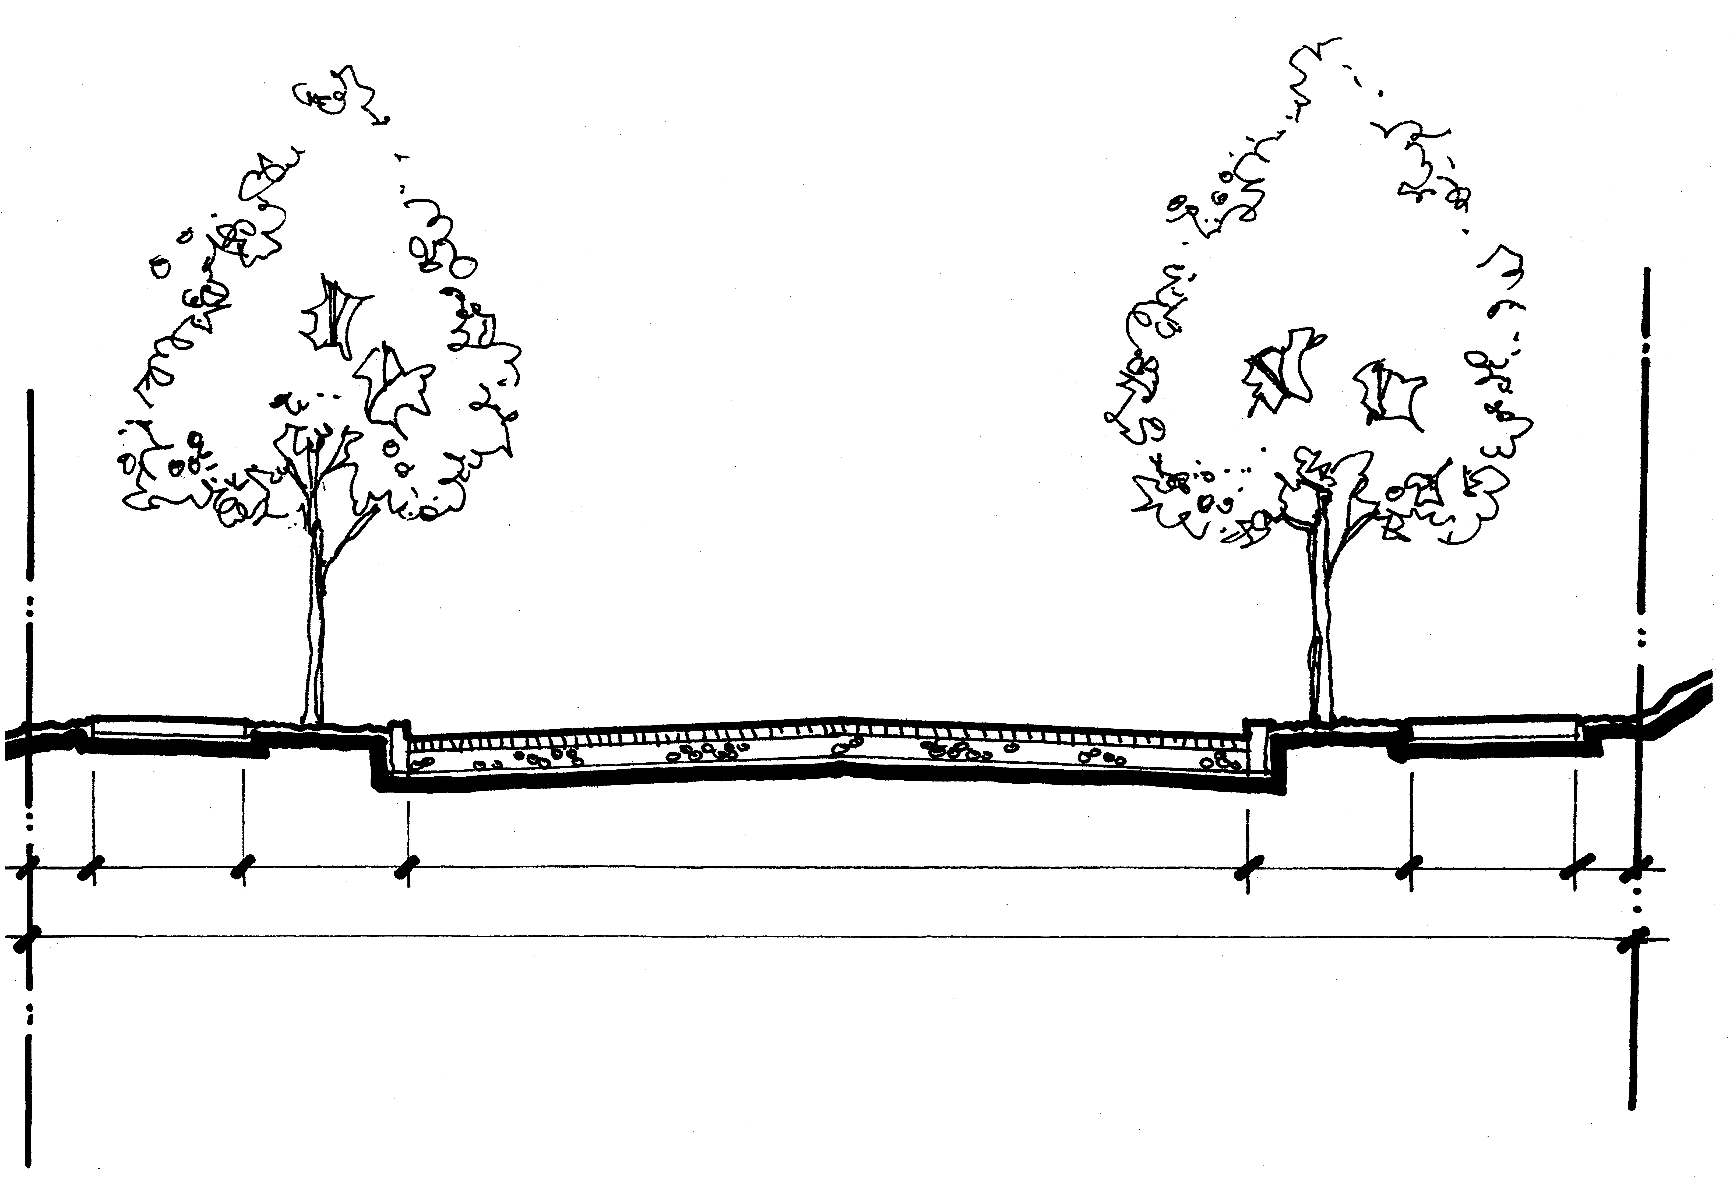
PARKING
7'0"
BW
0'0"
SIDEWALK
6'0"
CURB/PS
4'6"
TRAVEL LANE
9'0"
TRAVEL LANE
9'0"
PARKING
7'0"
CURB
0'6"
SIDEWALK
7'0"
BW
0'0"
STREET
32'0"
RIGHT-OF-WAY
50'0"

TYPICAL SECTION
NE 135TH AVENUE & PRESCOTT COURT LOCAL IMPROVEMENT DISTRICT
- NE 135TH AVENUE FROM PRESCOTT COURT TO WHITAKER WAY
- NE PRESCOTT COURT FROM WEST OF 136TH AVENUE TO 135TH AVENUE

