DATE: June 8, 2004

TO: Mayor Vera Katz
Commissioner Francesconi
Commissioner Leonard
Commissioner Saltzman
Commissioner Sten

FROM: Donald F. Mazziotti 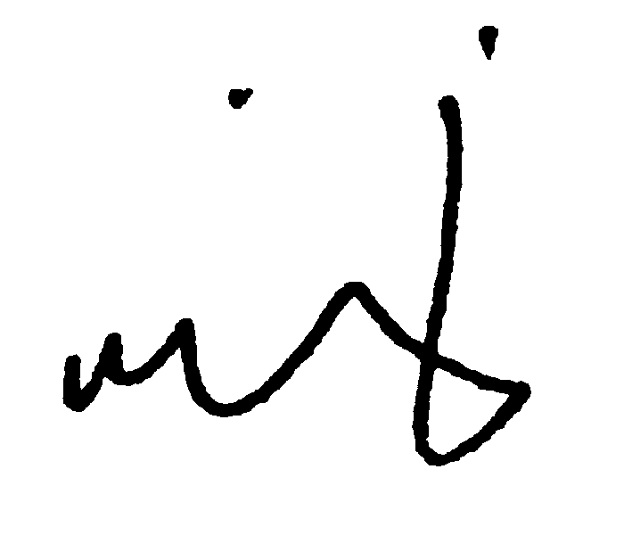

SUBJECT: RESOLUTION TO ACCEPT THIRD AMENDMENT TO THE SOUTH WATERFRONT CENTRAL DISTRICT PROJECT DEVELOPMENT AGREEMENT AND DIRECT IMPLEMENTATION – AMENDED EXHIBIT A TO RESOLUTION (COUNCIL AGENDA ITEM 672 – JUNE 10, 2004)

The purpose of this Memorandum is to provide you with the Third Amendment to the South Waterfront Central District Project Development Agreement, to be attached as an amended Exhibit A to Resolution (Agenda Item 672). Amended Exhibit A includes the final, proposed amendment language to the Development Agreement as well as revised exhibits referenced in the text. All other provisions of the original South Waterfront Central District Project Development Agreement (DA), which was executed August 22, 2003, remain unchanged.

The PDC Board of Commissioners is scheduled to act on the DA Third Amendment at its June 9, 2004 meeting. With authorization of the Commission, staff will execute the Third Amendment after City Council acceptance.

Thank you for your consideration of this request. Please call if you have any questions

cc

cc: Abe Farkas
Cheryl Twete

