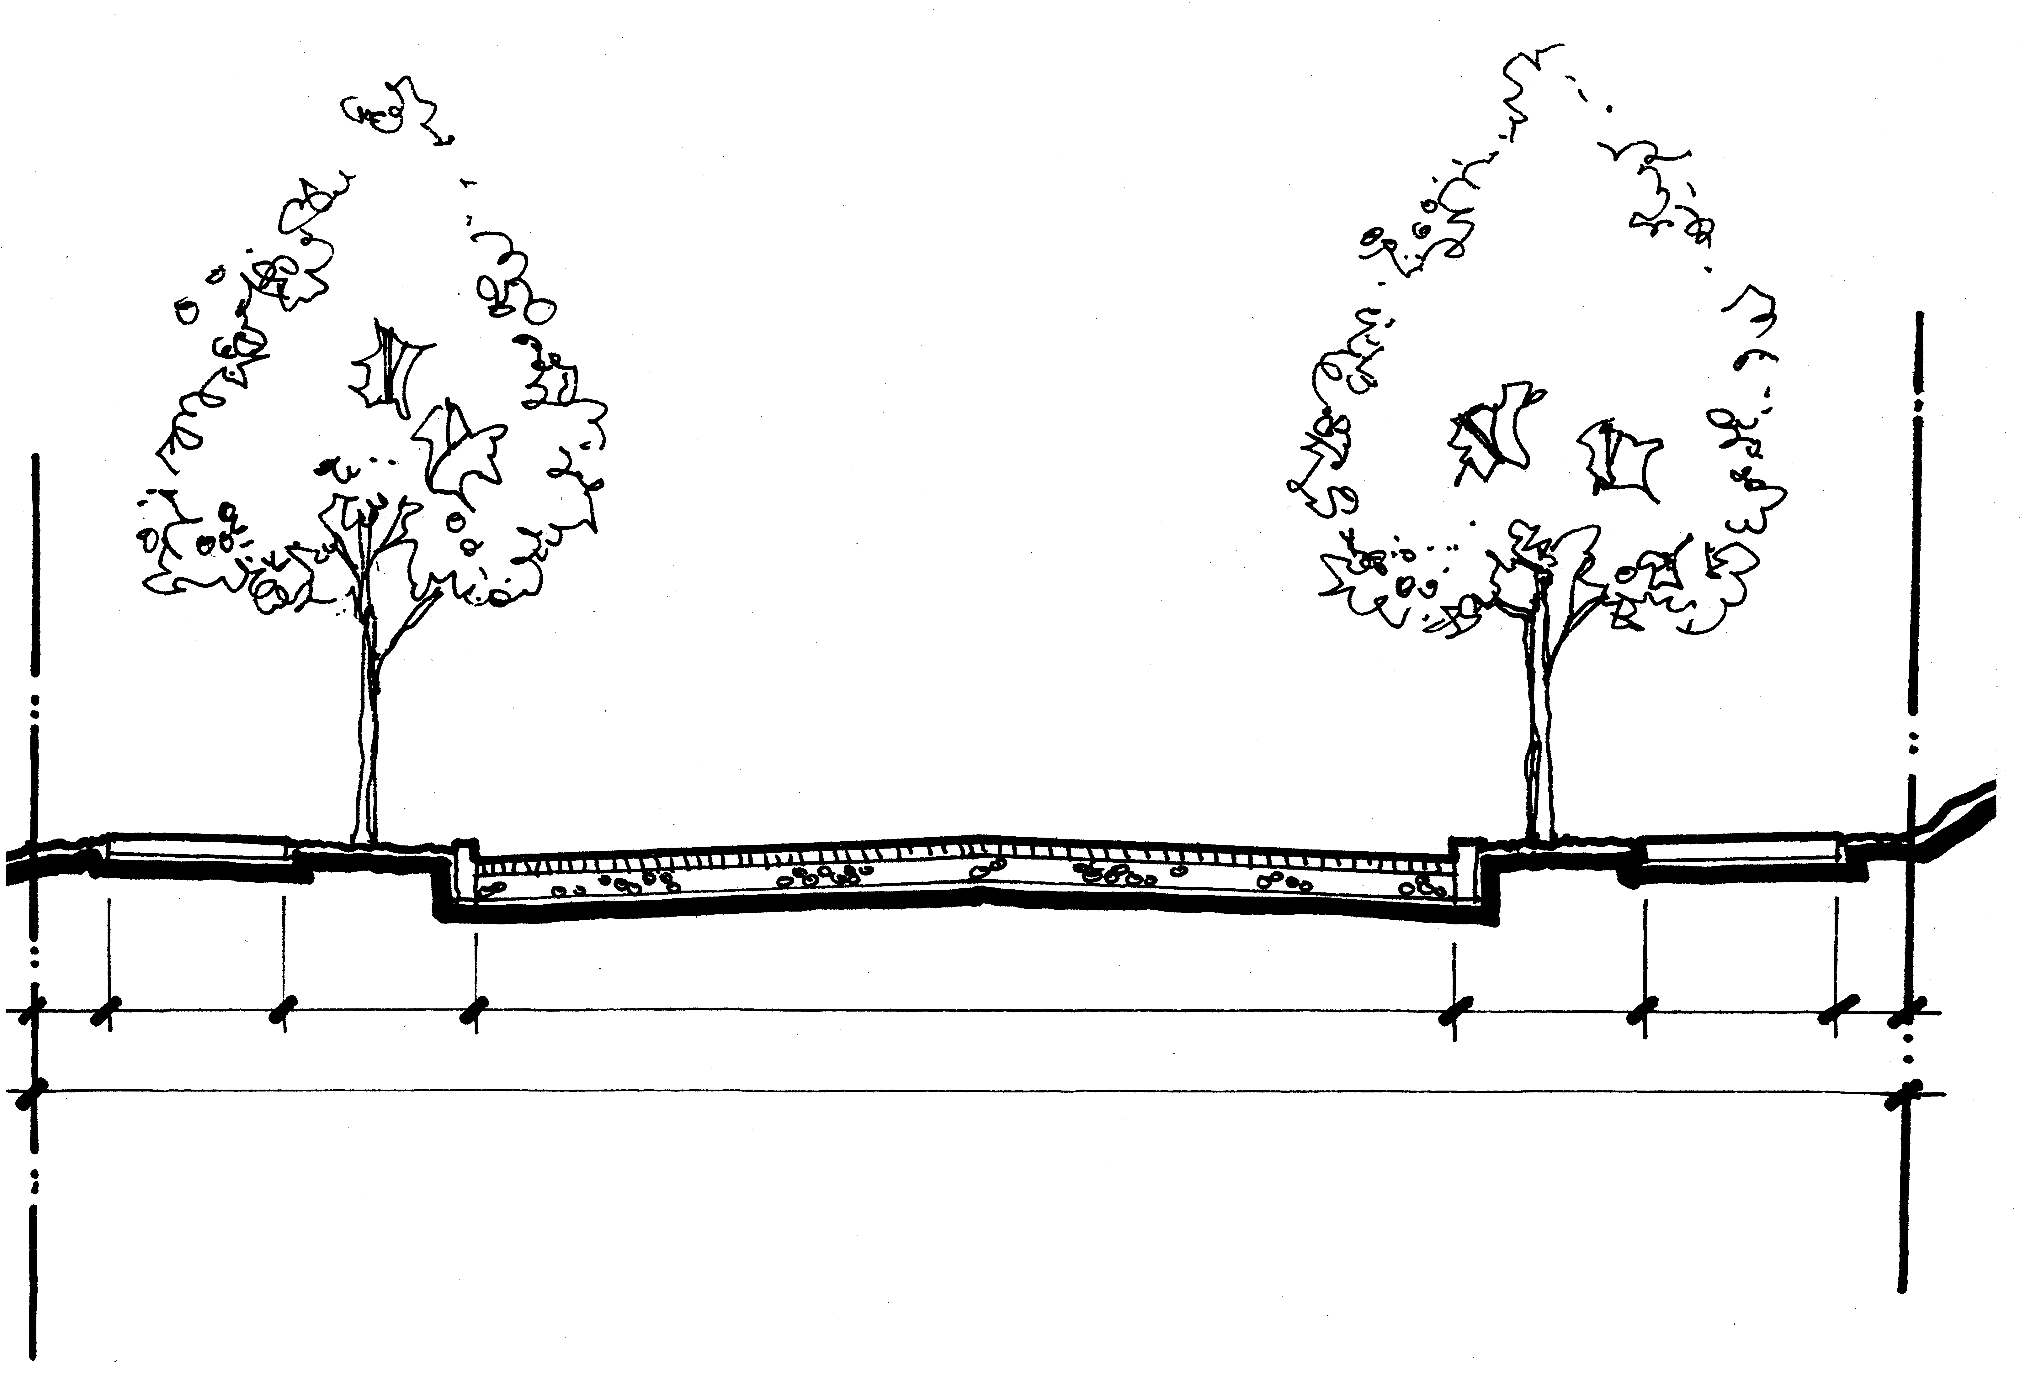
PARKING
7'0"
SB
1'0"
SIDEWALK
6'0"
CURB/PS
5'0"
TRAVEL LANE
12'0"
PARKING
7'0"
CURB/PS
5'0"
SIDEWALK
6'0"
SB
1'0"
STREET
26'0"
RIGHT-OF-WAY
50'0"

TYPICAL SECTION
LENTS III/SE 104th & RAMONA LOCAL IMPROVEMENT DISTRICT
- SE Ellis Street from East Line of 104th to 50’ East
- No combination soakage trench and swale; drains to existing sump

