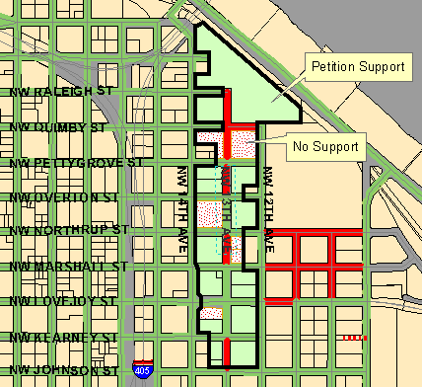NW 13th Ave. Phase II Local Improvement District Map

Support Calculation:
- Petition 72.0%
- Waiver 0.0%
- Total 72.0%

Legend:
- Unimproved/nonmaintained streets in red
- Maintained streets in dark green

