Report on

Nonconforming Commercial Uses

Printed on
September 30, 2003

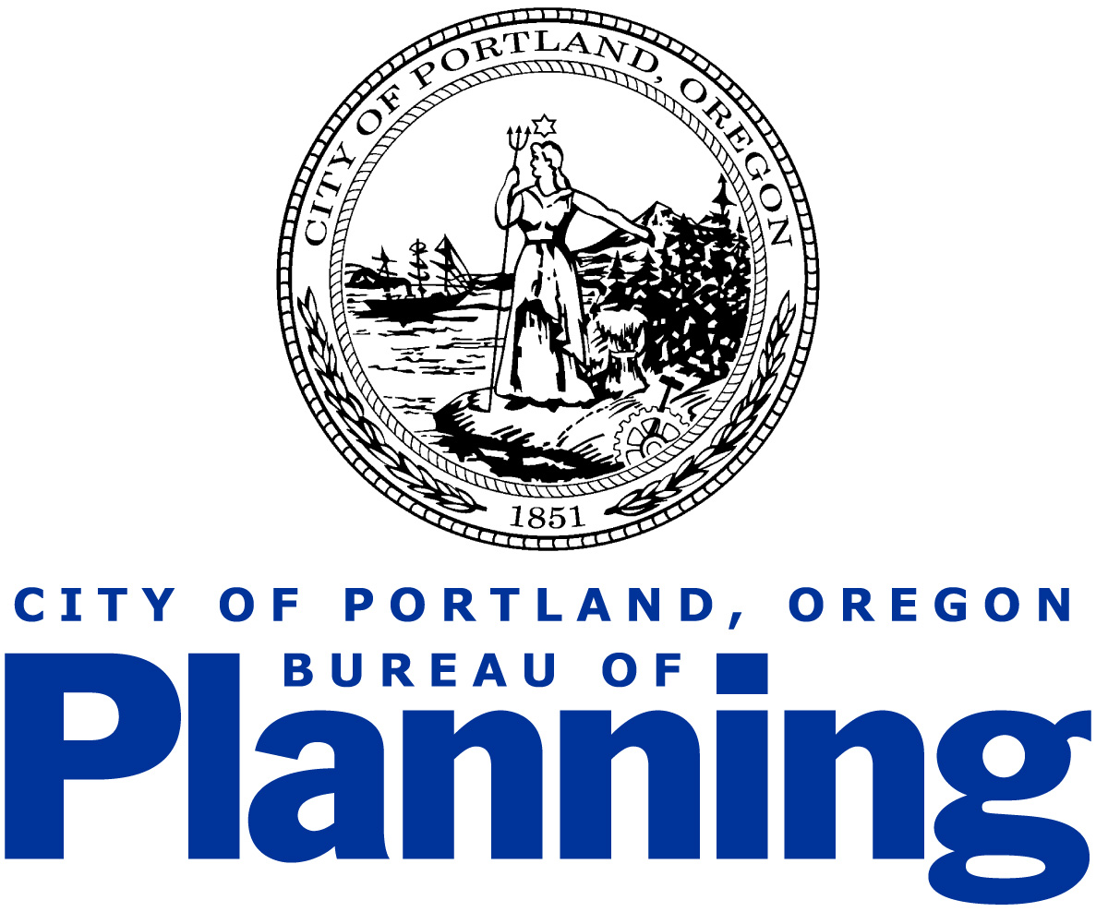

Acknowledgements

Portland City Council

Vera Katz, Mayor
Jim Francesconi, Commissioner
Randy Leonard, Commissioner
Dan Saltzman, Commissioner
Erik Sten, Commissioner

Portland Planning Commission

Ethan Seltzer, President

Richard Michaelson, Vice President

Christine Caruso
Amanda Fritz
Larry Hilderbrand
Paul Schlesinger
Tim Smith
Ingrid Stevens, Vice President

Portland Bureau of Planning

Vera Katz, Mayor, Commissioner-in-charge
Gil Kelley, Planning Director

Project Staff
Joe Zehnder, Principal Planner
Susan Hartnett, Senior Planner
Gary Odenthal, GIS Coordinator
Mark Bello, City Planner
Nicholas Starin, City Planner

With special thanks to:
Susan Feldman, Bureau of Development Services

Copies of the report
For copies of the report please visit the
Bureau of Planning Regulatory Improvement internet site at:
www.planning.ci.portland.or.us/cp_reg_over.html

For more information, please contact Joe Zehnder of the Bureau of Planning,
1900 SW 4th Avenue, Suite 4100, Portland, OR 97201.
Telephone: 503-823-7700, jzehnder@ci.portland.or.us.

Introduction
Item #41 of the Fiscal Year 2002-2003 Regulatory Work Program Top Ten calls for an “evaluation of the existence of nonconforming (both legal and illegal) commercial uses in residential zones.” The problem associated with this item was described as follows:

“In the 80s and 90s, many properties were rezoned from Commercial to Residential zoning. While businesses can remain in operation as legal nonconforming uses on these sites, the residential zoning had created a substantial burden on some of these businesses and the residential zoning discourages further investment in these nonconforming uses. Some believe that the zoning, particularly along major arterial streets, was inappropriately applied and is hurting business development, neighborhood stability and neighborhood livability.”

In response to this question the Bureau of Planning conducted a limited study to assess the prevalence of nonconforming uses and to help define what, if any, follow-up work is needed.

This report provides information about the Bureau’s study. Specifically, it describes the policy and other reasons for the past rezonings that resulted in the non-conforming uses. It describes the study’s methodology and findings. No specific recommendations are made as a result of this study but some generalized suggestions for future use of the information are outlined.

Legislative Rezoning Decisions
Portland, like other cities, periodically adjusts its zoning map as a way to support development, livability and other objectives for particular areas, corridors and neighborhoods. Often these zoning changes are to encourage new types and/or amounts of development or as a way to discourage certain activities. Often community plans and development strategies have objectives that conflict with each other and have to be balanced. Zoning decisions, which have to consider a broad range of factors, bring into sharp focus these conflicts and the trade-offs that are required to meet community objectives.
The factors considered in zoning decisions generally include the following:

- the existing and desired character of the area;
- the desired direction for future development of the area;
- the legal context in place at the time;
- the need to respond to and balance local, citywide and regional policies; and
- the current understanding of demographic, environmental, and economic trends.

A wide range of community interests also always influences planning projects, including zoning changes. Ultimately, since zoning changes require legislative action, all of these factors are considered and balanced by the Planning Commission and City Council.

Legislative planning efforts can lead to rezoning proposals that create nonconforming uses. Occasionally these proposals are made in error. For example, it can be difficult to establish what kind of activity occurs inside a structure by simply looking at it. As a result, a zone that does not allow that specific activity can be applied. Rezoning decisions that create nonconforming uses can also be made intentionally. For example, if a city wishes to encourage redevelopment of an underutilized riverfront industrial area, it might be rezoned for residential uses.

Many of Portland’s past legislative planning efforts have included rezoning decisions. In the early 1980s the creation and adoption of Portland’s Comprehensive Plan and Map may have created the largest number of nonconforming situations because it was a citywide project. (Nonconforming situations include instances where either the use is not allowed, the residential density is not allowed, or a specific aspect of the building or site does not conform to the development standards). More recent legislative planning efforts, including the Albina Community Plan, the Outer Southeast Community Plan, the Southwest Community Plan, and the Hollywood/Sandy Plan, have examined issues related to nonconforming situations and the outcomes have created, as well as eliminated some nonconforming situations, including nonconforming uses. Planning decisions that include the intentional creation of nonconforming uses have almost always included significant discussion by the Portland Planning Commission and City Council before these changes are adopted.

It is important to note that the mere presence of nonconforming uses does not necessarily mean that a mistake was made or that a remedy is needed. This study is not intended to make that assessment either. That kind of effort takes significant resources and must look comprehensively at the factors mentioned above and provide for public comment and input.

Study Methodology
Data collection for legislative planning typically includes a field survey of the land use on each lot. This process is very resource intensive, especially for a citywide analysis, and was not possible for this study. Instead, the citywide incidence of nonconforming uses was measured based on computer analysis of available data on the type of business by address. While less accurate than a field survey, the method is a good measure of the size and location of commercial non-conforming uses.

Portland’s zoning map applies a specific zone to every lot but no data is kept on the conforming or nonconforming status of the use or development on the lot. Since every zone has a range of uses that are allowed, conditional or prohibited, a method was developed that compared any business activity that is occurring on a lot with the lot’s zoning. Bureau staff determined that a GIS (Geographical Information System) analysis using data from the State of Oregon, Department of Labor could be used for this purpose. By comparing the Standard Industrial Code (SIC) reported by employers with the zoning, a presumptive determination of the presence of a nonconforming use was made. The State data includes the significant majority of employers. It is important to note that the results of this analysis provide reasonable evidence of the existence of a nonconforming use but would not be relied upon for decision making such as zoning changes.

The data used for this analysis is reported to the state on a basis of confidentiality. To assure that the confidentiality of this data was maintained, staff determined that reporting the occurrence of nonconforming uses only by specific Region 2040 design type areas (i.e. Central City, Regional Center, Town Center, Station Area, Main Street, Corridor, and Industrial Areas) was appropriate. The attached map shows the general location of these areas. To keep the analysis manageable and to focus on the areas described in the problem statement, the single-dwelling zones were excluded and only businesses with three or more employees were included. (Throughout the rest of this report these employers are simply referenced as employers.)

To perform this analysis, a matrix that compared each multi-dwelling, commercial, employment and industrial zone with each three number SIC code was developed. Based on a general understanding of the types of businesses that could be reported using any given SIC, the matrix noted if that use was allowed, conditional, or prohibited in each zone. The analysis then identified every location where the matrix indicated the reported SIC code was a prohibited use as an occurrence of a nonconforming use. The results were then aggregated to each of the Region 2040 design types.

Study Results
To characterize how often existing businesses have non-conforming zoning, the following table reports the percentage of all employers categorized as a nonconforming use within each of the mixed use design types rounded to the nearest whole number.

 | % Non-conforming in area |  | Area as % of city total Employers** | Approximate number of NC employers
Area | Employers | Employees | Area as % of city total Employers** | Approximate number of NC employers
Central City | 1% | 1% | 30% | 60
Regional Center | 9% | 5% | 3% | 850
Town Center | 18% | 12% | 4% | 10
Station Area | 20% | 6% | 11% | 400
Main Street | 9% | 7% | 25% | 40
Corridor | 35% | 12% | 14% | 370
Industrial Area | 1% | 0% | 13% | 110

** The numbers do not include Residential Areas, which are almost entirely composed of single-dwelling zones.

From this table a few key observations can be made.

- The Central City, which has nearly one-third of the employers in Portland (30%) has only 1% of apparent nonconforming uses (1 %).

- The Industrial Areas also have very few apparent nonconforming employers (1%) and the employees of those nonconforming businesses comprise less than 1% of the total employees in the Industrial Areas.

- The percentage of nonconforming employers in the remaining areas ranges from 9% to 35%, with the highest proportions occurring in Corridors. In the Main Street areas, which account for approximately one-quarter of the employers in Portland, 9% of the employers appear to be nonconforming. In Corridor areas, which account for 14% of the total employers, 35% of employers are nonconforming.

- The database used included a total of 21,253 employers including those in residentially zoned areas. Of this total, approximately 19% were apparent nonconforming uses.

To help determine if there is a relationship between the type of business and the likelihood that it would be a nonconforming use, we categorized employers based on their two digit SIC. The results are provided in the following table:

Design Type | Most Frequent SICs |  | SIC as % NC employers in area
Design Type | SIC # | Description | SIC as % NC employers in area
Central City | 50 | Wholesale Trade - Durable Goods | 20%
 | 80 | Health Services | 12%
Regional Center | 65 | Real Estate | 28%
 | 17 | Construction - Special Trade Contractors | 16%
Town Center | 17 | Construction - Special Trade Contractors | 11%
 | 50 | Wholesale Trade - Durable Goods | 6%
Station Area | 17 | Construction - Special Trade Contractors | 3%
 | 73 | Business Services | 2%
Main Street | 75 | Auto Repair Services and Parking | 3%
 | 17 | Construction - Special Trade Contractors | 2%
Corridor | 17 | Construction - Special Trade Contractors | 1%
 | 73 | Business Services | 1%
Industrial Area | 80 | Health Services | 92%
 | 82 |  | 54%

From this table a few observations can be made.

- The SIC category 17, Construction – Special Trade Contractors appears in 5 of the 7 areas.

- In the Main Street and Corridor areas, the two most frequent SIC codes only account for 1% to 3% of the total nonconforming employers. This would indicate that the nonconforming employers are quite varied and that generalized solutions may not be effective in addressing this issue in these areas.

Recent Related Regulatory Changes

As part of 2002-2003 Regulatory Improvement Workplan: Policy Package 1-A the City Council adopted two Zoning Code amendments that facilitate the continued operation of nonconforming uses. The two amendments were made to Section 33.258.080, Nonconforming Situation Review. A Nonconforming Situation Review is most often necessary when a property owner proposes to change the activities on a site from one nonconforming use to another use in a different use category that is prohibited by the zone. Another example of a Nonconforming Situation Review is when an expansion of floor area or exterior storage or display is proposed for an existing nonconforming use.

The first amendment adopted by Council eliminated the need for a higher level of review, by processing all Nonconforming Situation Reviews through a Type II procedure, instead of a Type III procedure. The change was made in order to reduce the time and expense of the Type III review, as well as to recognize the less discretionary nature of this review than the typical Type III review.

The second amendment changed the approval criteria associated with the review. The previous criteria required the applicant to demonstrate that, with mitigation measures, the proposed change will result in a net decrease in any detrimental impacts the existing development has on the surrounding area. The amendment changed this criterion so that the applicant would demonstrate that the proposed change will not result in a net increase in any detrimental impacts.

Study Summary

While the study results indicate that some design type areas have a fairly high percentage of nonconforming employers, they cannot necessarily be used as an indicator that this is a zoning or land use problem that can or needs to be addressed through a blanket response. For example, the Town Center areas have 18% nonconforming employers but, with the exception of St. Johns, these areas have all been the recent subjects of planning projects. Since these areas were reviewed so recently, it is likely that the rezonings are based on the comprehensive study and community development objectives that were done as part of those legislative planning projects. By their actions as part of the public process, the Planning Commission and City Council either created or allowed to remain a significant number of nonconforming business uses. It can also be inferred that they took that action for specific reasons.

The largest concentrations of apparent nonconforming business uses are on the city’s “corridors”. These areas include many of the city’s traditional neighborhood commercial streets such as Glisan, Burnside and Foster. No particular type of business seems more prone to nonconforming use status based on this study, which implies that this is a more generalized issue on the streets that requires closer examination. Specific area plan projects are the most thorough way to decide if zoning changes that eliminate nonconforming uses are warranted. This is because, as already described, of the number of policy and other factors that need to be considered and balanced in the evaluation of nonconforming uses. The Bureau of Planning typically has at least one such project underway each year. In the current year the St Johns/Lombard Plan, Gateway Plan and NW District Plan will be completed.

In the coming year there are several work program activities that will address the evaluation of nonconforming uses and businesses.

Division Vision Project

In 2002, the Division Vision Coalition, a community-organized group of SE Portland residents and organizations, put out a policy plan for SE Division Street from 6th to 60th Avenues called “Division Vision”. The plan envisions Division as a “Green” Main Street.

The City of Portland and Division Vision, a coalition of community and business groups, are undertaking a State funded project called Division Green Street/Main Street. The purpose of the project is to identify how to use Division Street’s land uses, transportation function, buildings and urban design to convert the corridor into one that is more community-oriented, economically vibrant and environmentally sustainable.

In addition to transportation and community design objectives, the project will specifically address the presence of businesses that became nonconforming uses due to legislative rezoning projects in recent decades. The project will identify actions, including potential zoning changes that attempt to balance objectives including the following:

- Balancing the transportation demands competing for Division Street, including local and through traffic, transit, automobiles, trucks, pedestrians, and cyclists.

- Supporting the economic vitality of Division Street for businesses and residences.
- Promoting the understanding of and use of “green” approaches to design and construction that improve the long-term environmental performance of Division Street and the uses along it.
- Improving the design quality and urban form of Division Street and the buildings and spaces that line it.
- Preserving the distinct identity, history and ties to community life found at the different places along Division Street.

Main Streets Project

As part of the Bureau of Planning’s District Planning program, Bureau staff will undertake an assessment of the city’s designated main streets and other traditional commercial corridors. The assessment will focus on the physical and economic condition of the various corridors as well as an understanding of the market areas, conditions and functions of different commercial centers. It will include meetings with businesses and community groups to build their insights and understanding of the corridors and their issues into the assessment.

Through the project, the Bureau hopes to identify solutions to issues that are shared across similar commercial corridors. These solutions may involve changes to zoning code provisions or creation of a new type of commercial corridor overlay. With these types of solutions, the Bureau will be able to affect more of the city than is typically possible through area specific planning alone.

The analysis also will be the foundation for the Bureau’s neighborhood planning and development work in the next few years. It will help identify quick response projects to address specific issues or problems. It will be the basis for setting priorities among follow-up community development and zoning projects. It will be part of the Bureau’s approach to area and neighborhood planning that emphasizes understanding and affecting the neighborhood quality and livability across multiple spheres – land use and the built environment, the economy, the environment and community life.

Conclusion

The study points to a level of incidence of nonconforming uses in several types of areas in the city that warrants closer examination. The highest incidence on a percentage basis occurs on corridors and in transit station communities. It is likely that there is a policy basis for the existence of the nonconforming status in the station communities, especially those that have been subject to recent plans and zoning studies. Typically in these areas, the objective is to move to more pedestrian oriented and intense development. The level of incidence of nonconforming uses on the corridors will be examined in the Bureau’s upcoming work through the Division Vision and Main Streets projects.
Attachment

