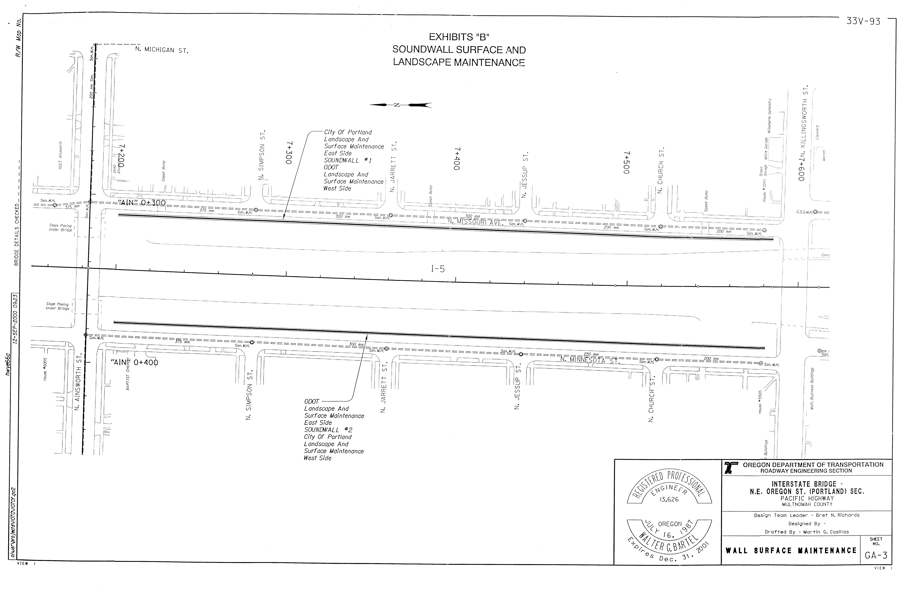

REVISED EXHIBIT B

REVISED EXHIBIT B

REVISED EXHIBIT B

REVISED EXHIBIT B
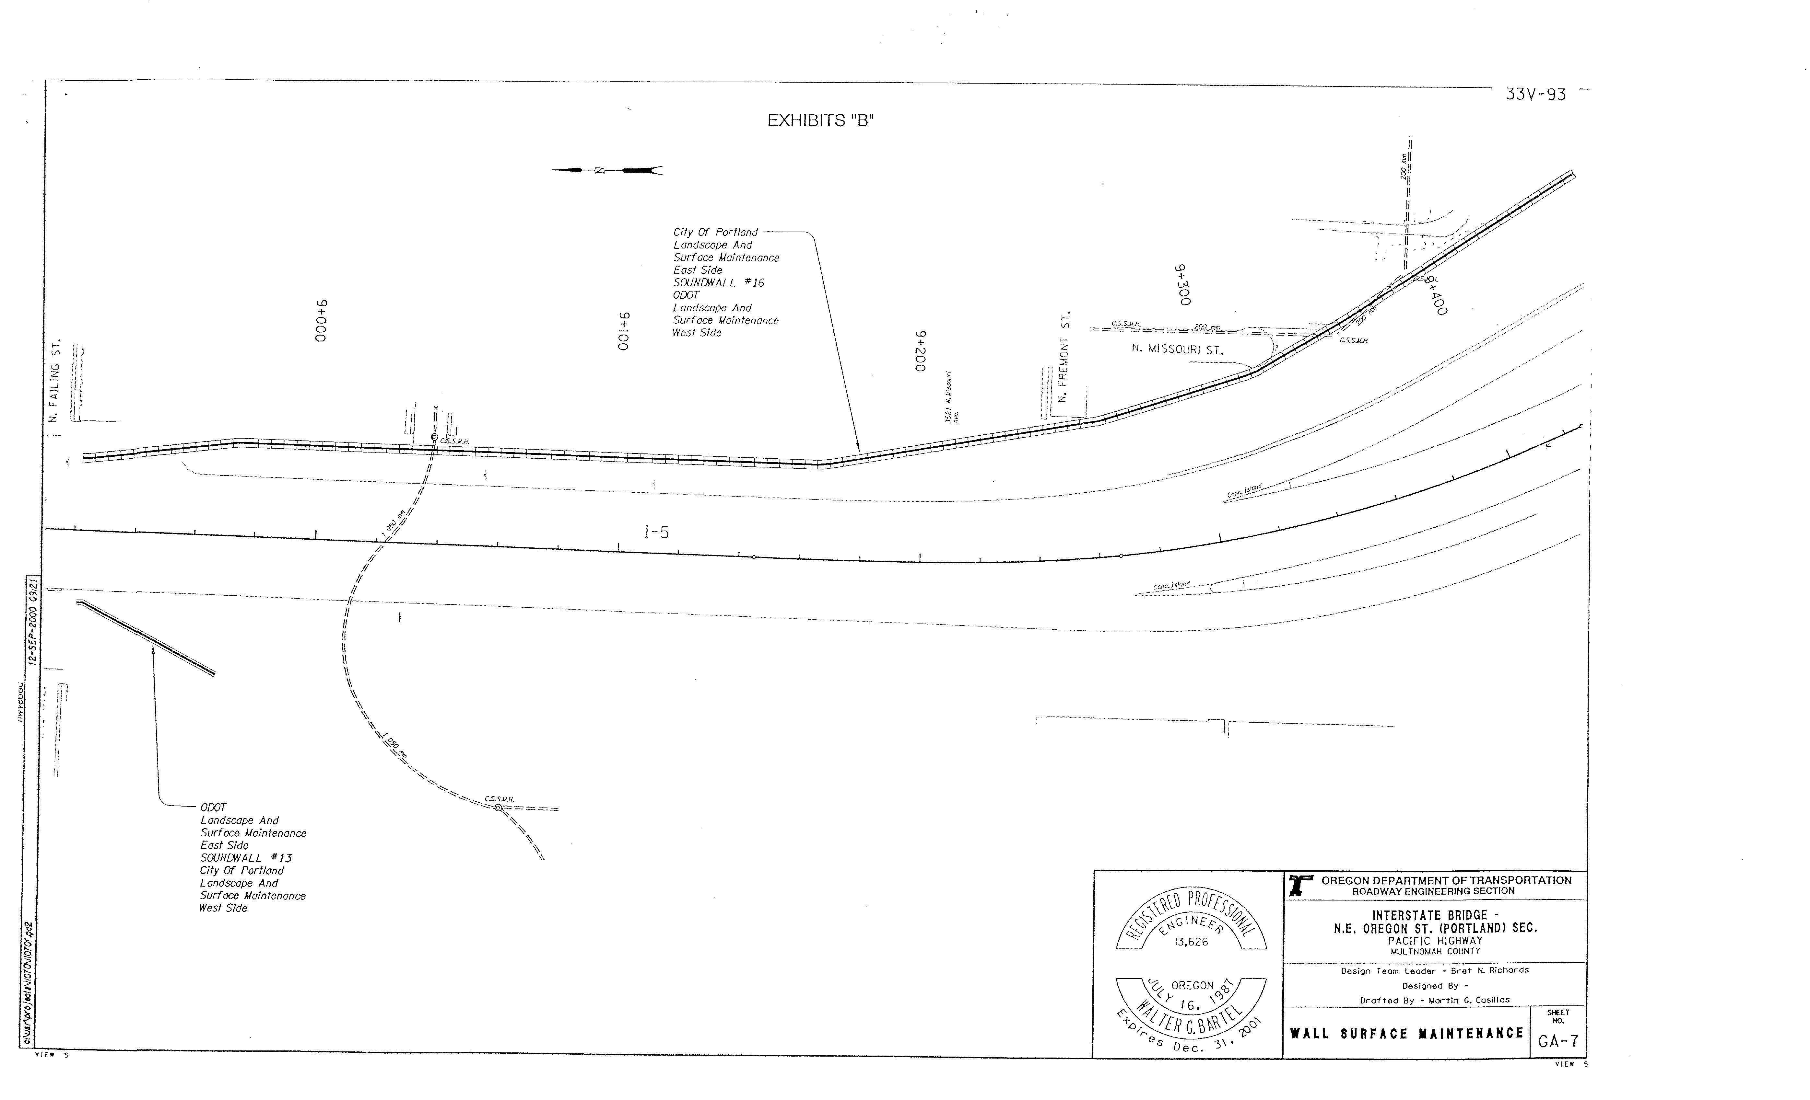

REVISED EXHIBIT B
REVISED EXHIBIT B

REVISED EXHIBIT B

