Agreement for ‘Innovations in Affordable Housing’ Grant

Exhibit 1

The grantee agrees to design and install the following sustainable measures in the Station Place project:

1. Rainwater Harvesting System

Station Place is a high-rise, three-tower elderly housing facility. The three connected towers consist of a 14-story, 12-story, and 9-story structure. The approximate impervious surface area is 12,000ft². The City of Portland is permitting use of rainwater to flush tank-type toilets. The completed facility will contain approximately 175 units, with a minimum of 75 toilets being supplied with harvested rainwater.

The complete rainwater harvesting system consists of several interconnected components, including roofing, drains, roof washer, storage cistern, cleaning devices, pumps, controls, and piping. Should any of these components or connections be omitted the system will not be functional. The schematic drawing below shows the basic components and assembly of the system.

All components will be designed and constructed in conformance with plans and specifications and applicable regulations. The rainwater harvesting system will undergo testing and adjustments as appropriate to ensuring its proper function.

It is not anticipated that rainwater storage capacity will be sufficient for the entire year so the system will tie into City water as a backup source during the dry season. The system will include a monitoring capability such that the building manager can track and quantify use of rainwater and City water.
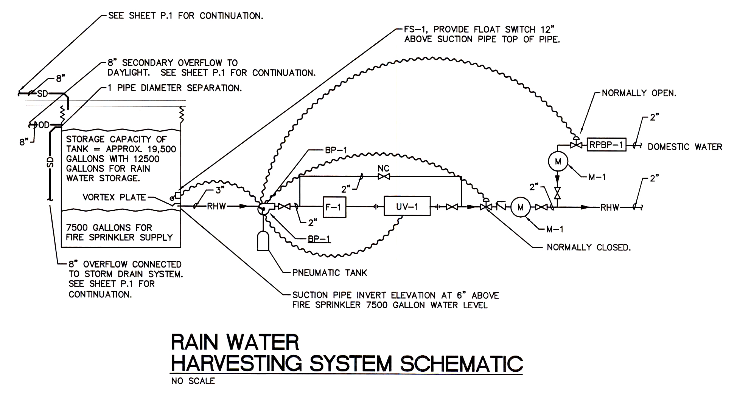

- Site Inventory
a) Maximize southern exposure, minimize west exposure in tower orientation.
b) Locate parking garage to block noise from trains.
c) Cap contaminated soil with 5 feet of clean soil.

3. Soil & Vegetation Protection
a) Complete Level I and Level II environmental studies.

4. Building Design & Orientation
a) Maximize solar exposure by tower orientation.

5. Stormwater Management
a) Control soil erosion on site.
b) Maximize on-site stormwater management.

6. Transportation
a) Provide bicycle parking.

7. Building Envelope
a) Install high recycled content insulation to meet Oregon energy code.
b) Install windows with U-value = 0.35 or less.
c) Flashing and seal exterior envelope against water penetration.

8. Heating Systems
a) Install radiant cove heaters in dwelling units.

9. Electrical & Lighting
a) Install Energy Star rated appliances.
b) Install energy-efficient outdoor lighting.

10. Plumbing
a) Install water-conserving plumbing fixtures.
b) Install energy-efficient water heating.
c) Insulate hot water components.

11. Irrigation
a) Install native, hardy and low-maintenance plantings.

12. Waste Management & Recycling
a) Develop waste minimization plan for C&D wastes.

13. Roof & Skin
a) Install durable roofing and cladding.

14. Materials & Finishes
a) Acoustical ceiling panels have recycled content.

15. Flooring
a) Use alternative to sheet vinyl.
b) Install low-emitting carpet and cushion.

16. Finishes
a) Use solvent-free interior paint.
b) Use low-toxicity adhesives and sealants.

17. Fresh Air Ventilation
a) Install continuous exhaust ventilation.
b) Ventilate building prior to occupancy.

18. Operations Manual.
a) Provide space for tenant recycling.
b) Prepare Operations & Maintenance Plan.
c) Eliminate pesticides and herbicides use on site.
d) Use low-toxic cleaning supplies.
e) Provide ventilated storage area for maintenance supplies.

