Design Advice Request DISCUSSION MEMO

## Date: August 9, 2024

**To: Historic Landmarks Commission**

**From: Tim Heron, Design / Historic Review Team**

503-823-7726 | [tim.heron@portlandoregon.gov](mailto:tim.heron@portlandoregon.gov)

**Re: EA 24-060617 DA –** **Earthquake Ready Burnside Bridge, Type 4 Demolition Review**

**August 19, 2024 Design Advice Request Meeting**

As discussed at the June 10, 2024 Joint Briefing with Design Commission and the Historic Landmarks Commission (HLC), since 2016 Multnomah County has been working to create an Earthquake Ready Burnside Bridge (EQRB). The proposed project would replace the existing Burnside Bridge with a new movable bridge in approximately the same location and length as the existing bridge. The project area is shown on the figure below.

Attached is a Cover Memo and PPT presentation from Multnomah County for this Design Advice Request (DAR) meeting scheduled on August 19, 2024, for the Earthquake Ready Burnside Bridge, Type 4 Demolition Review. Also attached are several relevant documents including Approval Criteria, National Register Nominations, and past Type 4 Demolition Review cases.

*Please contact me with any questions or concerns.*

# PROGRAM OVERVIEW

Because the existing Burnside Bridge is a historic landmark, its removal requires a Type IV Demolition Review for which the HLC will be providing their own advice in the form of a letter and/ or testimony to Portland City Council. At this DAR, the Project Team is seeking guidance from the HLC on the application of the approval criteria to this Project.

In addition, as discussed at the briefing, the applicant will also be sharing what was heard through the public engagement process in July. However, the focus of this DAR will not be on the design. At a separate land use review following City Council’s decision on the demolition review, the HLC will consider the details of the proposed new bridge elements within the Portland Skidmore/Old Town Historic District, and the Project Team will schedule a second DAR with the HLC to discuss that Type III Historic Resource Review application.

## FUTURE TYPE 4 DEMOLITION REVIEW APPROVAL CRITERIA:

## 33.846.080 Demolition Review.

## A. Purpose. Demolition review protects landmarks and contributing resources in districts. Demolition review recognizes that historic resources are irreplaceable assets significant to the region’s architectural, cultural, and historical identity and their preservation promotes economic and community vitality, resilience, and memory. In the event that demolition of a historic resource is approved, demolition review also addresses the potential for mitigation of the loss.

Type 4 Demolition Review Approval Criteria:

* [Portland Zoning Code section 33.846.080.C.1.a-f](https://www.portland.gov/sites/default/files/code/846-historic-reviews_0.pdf) *[January 2022]*
* [Portland Comprehensive Plan 2035](https://www.portland.gov/bps/planning/comp-plan-2035) *[May 2023]*
* [Portland Central City 2035](https://www.portland.gov/bps/planning/central-city/central-city-documents#toc-cc2035-as-adopted-plan) *[April 2020]*
  + - *Please note* [*Central City 2035, Vol 1 – Goals and Policies*](https://efiles.portlandoregon.gov/record/14355703) *is the primary goals and policy document of Central City 2035, and the only printed copy provided for those that request print. The remainder of the documents are used as background documents that support Vol 1 Goals and Policies.*

# DEVELOPMENT TEAM BIO

**Owner’s Representative** Megan Neill | Multnomah County

**Project Valuation** $ 825 million

# STAFF ANALYSIS & RECOMMENDED DAR DISCUSSION TOPICS

This is a unique DAR as its primary focus is advice for the future Type 4 Demolition Review approval criteria, not the presumed new bridge design. A second DAR is planned for the presumed future scope of the portion of a new bridge west of the Willamette River seawall in the Skidmore/ Old Town Historic District, as a future Type 3 Historic Review would be required should City Council support a Type 4 Demolition Review of the current bridge.

Staff has coordinated closely with the applicant to provide **a list of focused discussion topics (attached PPT presentation pages 33-37)** walking through each of the Approval Criteria of [Portland Zoning Code section 33.846.080.C.1.a-f](https://www.portland.gov/sites/default/files/code/846-historic-reviews_0.pdf), pasted below for ease of reference, and advice on how to review to the relevant area plan Goals and Policies.

* + - [*Portland Comprehensive Plan 2035*](https://www.portland.gov/bps/planning/comp-plan-2035). It’s all a good read, but Goals and Policies are pages 59-276, and
    - 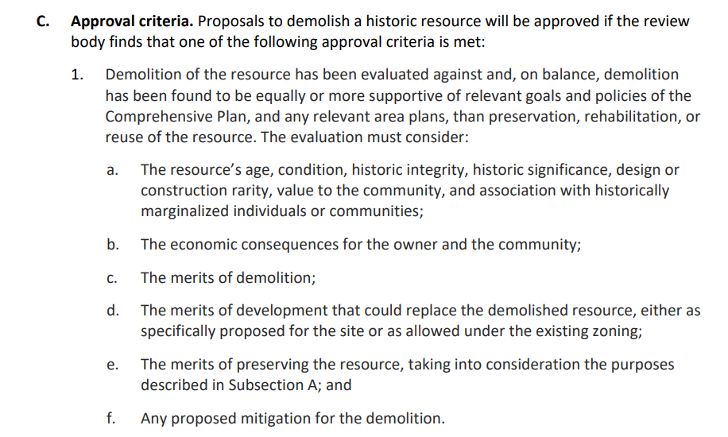[*Portland Central City Plan 2035, Vol 1 Goals and Policies*](https://efiles.portlandoregon.gov/record/14355703). Again, great read, but Goals and Policies are pages 28-86.

Staff also recommends reviewing these two reference documents that could further support the narrative response for context and background, but are not the approval criteria:

* National Register Nomination of Burnside Bridge 11-14-2012
* National Register Nomination for the Skidmore/ Old Town Historic District 9-30-1975

Lastly, Staff recommends reviewing two previous Type 4 Demolition Reviews as examples of Type 4 Demolition Reviews with a ***critical note:*** *the Type 4 Demolition Review Approval Criteria has been updated since these two Type 4 Demolition Review examples were processed.* However, they may provide helpful background on how City Council has applied the wide scope of Type 4 Demolition Review Approval Criteria.

* LU 09-171258 DM - Kiernan Building Type 4 Demolition Review City Council Final Findings and Decision
  + *Note pages 8-23 which address the previously adopted Comprehensive Plan Goals and previously adopted Central City Plan.*
* LU 14-249689 DM - Washington Park Reservoirs Type 4 Demolition Review City Council Final Findings and Decision
  + *Note pages 15-30 which address the previously adopted Comprehensive Plan Goals and Policies*

*Attached:*

* Zone Map
* EQRB HLC DAR Cover Memo FINAL 08-19-2024
* EQRB HLC DAR Presentation FINAL 08-19-2024
* [Portland Comprehensive Plan 2035](https://www.portland.gov/bps/planning/comp-plan-2035) *[May 2023]*
* [Portland Central City 2035, Vol 1 – Goals and Policies](https://efiles.portlandoregon.gov/record/14355703) *[April 2020]*
* National Register Nomination of Burnside Bridge [11-14-2012]
* National Register Nomination for the Skidmore/ Old Town Historic District [9-30-1975]
* Kiernan Building Type 4 Demolition Review, City Council Final Findings and Decision [2009]
* Washington Park Reservoirs Type 4 Demolition Review, City Council Final Findings and Decision [2014]