EXHIBIT B

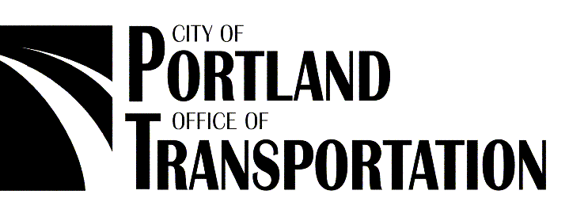
March 3, 2003

D. Robert Lohn
Regional Administrator
National Oceanic and Atmospheric Administration Fisheries
525 NE Oregon St.
Portland OR 97232-2737

Dear Mr. Lohn:

With this letter, the City of Portland, Office of Transportation (PDOT), is applying for a limit 10(i) (routine road maintenance) under the 4(d) rule for threatened salmon and steelhead (65 FR 42422, July 10, 2000) by adopting ODOT’s Routine Road Maintenance Water Quality and Habitat Guide Best Management Practices (July 1999), as an interim guidance document (herein referred to as ODOT Manual). Not all of the activities performed by PDOT are included in the ODOT Manual. Therefore, PDOT is also developing a comprehensive manual that will cover all activities specific to PDOT. Upon completion, this manual (herein referred to as PDOT Manual) will be submitted to NOAA Fisheries for review and upon approval, will replace the ODOT Manual as the guidance document.

While PDOT proposes to adopt the ODOT Manual for interim guidance, the City’s transportation program differs from ODOT’s in three areas: surface work, street sweeping/ flushing, and snow/ice removal/sanding. These are described in Part 1 of this submittal along with an explanation as to how the City’s practice meets or exceeds the ODOT standard. Appropriate environmental baseline information and other supporting documents have also been included as part of this submittal package.

This program has been adopted by the Portland City Council and is being implemented immediately. This letter serves as the City’s formal written commitment to consistently apply the management practices outlined in this program. The elements of this package will demonstrate that the City has the necessary personnel and budget resources to effectively implement this program. In addition to this PDOT effort, City staff is also developing a City-wide strategy to assist in the recovery of listed species.

We look forward to working with you to conserve salmon and steelhead, as well as their habitat, within the City of Portland. If you have questions about this submittal or the city’s street maintenance program, please contact Liane Welch, PDOT’s Environmental Engineer, at 503-823-2044, or Jim Middaugh, Endangered Species Act Program Manager, at 503-823-7032. We want to specifically thank Nancy Munn for her assistance in helping us to prepare this submittal.

Sincerely,

_______________________________________ | _______________________________________
Commissioner Jim Francesconi | Commissioner Erik Sten

Enclosures

Cc: Nancy Munn
Habitat Conservation Division
Oregon State Branch Office, NOAA Fisheries
525 NE Oregon St., Suite 500
Portland, Oregon 97232-2778
Part 1: Below is a detailed description of the program to be considered and all covered activities, including identification of responsible entity and legal authority for program.

1a. Responsible entity and legal authority for program:

The City’s Portland Office of Transportation (PDOT) is organized into 4 bureaus. All of the activities described below are carried out by city street maintenance staff (and/or contractors) housed in the Bureau of Maintenance (BOM), one of the 4 transportation bureaus. The bureau’s activities are performed under the supervision of Ms. Jeanne Nyquist, Director of the Bureau of Maintenance. Ms. Nyquist, who manages the day-to-day bureau operations, will be responsible for the implementation of the best management practices to protect fish. Ms. Nyquist reports to the city’s Director of Transportation, Mr. Brant Williams. Mr. Williams reports to the Commissioner-in-Charge of Transportation, Jim Francesconi. Organization charts are included in Section 5 of this submittal.

1b. Description of program:

In addition to its other responsibilities, PDOT is charged with preserving the public investment of over $5.5 billion in transportation facilities and $1.5 billion in sewer infrastructure. Over 400 BOM employees perform the inspection, cleaning, maintenance, and repairs for all the transportation and sewer-related infrastructure within the City of Portland. The infrastructure consists of streets, the sewer collection system, sidewalks, bridges, curbs, intersections, street corners, retaining walls, guardrails, stairways, traffic signals, traffic control devices, and parking meters. BOM also performs around-the-clock response to emergencies such as storms, floods, and other incidents that inhibit safe transportation.

The City of Portland covers 130 square miles in area with a population of approximately 540,000. Over 20% of the city is contained within Environmental Overlay zones (or E-zones). These zones provide the highest level of protection to the most important resources and functional values within the city. Maintenance and development in these zones must be carefully designed and performed in a manner as to be sensitive to the environment and protective of the resources within the zones. For example, if PDOT crews are working in close proximity to a stream crossing, crewmembers will consider using dechlorination tablets or other best management practices depending on the type of work being performed.

PDOT has reviewed all of ODOT’s Minimization and Avoidance Best Management Practices for its roadside activities as described in the ODOT Manual. Not all of the activities performed by PDOT are included in the ODOT Manual. Of those PDOT activities that are also performed by ODOT and are included in the ODOT Manual, PDOT has determined that its street maintenance program is substantially similar to, and at least as protective as, the ODOT Routine Road Maintenance program approved under the current 4(d) rule. However, PDOT has identified 3 program areas in which the city program differs from ODOT’s program either in organization or in substance. The following matrix identifies those areas. The explanations of variance for the 3 program areas are provided below and describe how city practice meets or exceeds the ODOT standard.

Table 1 – PDOT Program Variances

 | ODOT Program Section | Identical to ODOT Manual?
 | Surface Work | No
 | Shoulder Blading/Rebuilding | Yes
 | Ditch Shaping and Cleaning | Yes
 | Sweeping/Flushing | No
 | Culvert/Inlet Cleaning, repair, miscellaneous hand/minor repair | Yes
 | Erosion Repair | Yes
 | Channel Maintenance | Yes
 | Fish Restoration | Yes
 | Fish Betterment | Yes
 | Bridge Repair | Yes
 | Mowing, Brush mowing, Brush cutting (by hand) | Yes
 | Accident Clean-Up | Yes
 | Guardrail replacement | Yes
 | Snow/ Ice Removal/Sanding | No
 | Emergency Maintenance | Yes
 | Settlements and Slides | Yes
 | Extraordinary Maintenance | Yes
 | Stockpiling | Yes

Explanation for Variances:

A. Surface Work (MMS 100-110):
The ODOT Manual states that “Where possible, ODOT will perform surface work in dry weather, to minimize any runoff of potentially hazardous material.” PDOT conducts surface work throughout the year. During the winter months PDOT performs base repair on localized street failures, grinding and paving localized areas, and patchwork. PDOT protects the environment during these surface work activities. Best Management Practices performed by PDOT during surface work activities, in addition to those described in the ODOT Manual, include:

- Emulsified asphalt (tack coat) is not applied during rain events.
- Catch basin grates are covered with either rubber mats or other appropriate materials to prevent sediment and pollutants from entering the storm sewers during the work activity.
- Street base repair is an activity that is conducted during the rainy season. During Fiscal Year 00-01, PDOT performed 66,000 square yards of base repair. Crewmembers protect catch basins by either covering the inlets with rubber mats, or placing bio-bags in front of them to protect the storm sewer system. When the asphalt and soft sub-grade soils are removed, they are placed directly in the back of a dump truck. Crewmembers sweep up any fallen material back into the excavation. Base rock is placed directly into the excavation. No onsite stockpiling occurs during this activity. As a result of these minimization and avoidance measures, minimal, if any, amounts of any sediment leave the work site.
- Grinding of streets occurs during the winter months in preparation for the paving season, which occurs during the drier months. During Fiscal Year 00-01, PDOT ground approximately 70 lane miles. Minimization and avoidance measures taken include storing the equipment overnight on a geotextile fabric mat to contain any leaks from equipment. PDOT also cleans the grinder several times a week. During the washing activity, a catch basin insert with an oil pillow is placed to minimize the amount of material entering the storm sewer system. The crews carry oil pillows and other spill kit and erosion materials on their trucks.

PDOT proposes that this activity, with these practices outlined above, is as effective as ODOT’s efforts to be protective of fish.

B. Sweeping/Flushing:
The ODOT Manual states that “Where feasible, ODOT Maintenance will schedule sweeping during damp weather, to minimize dust production.” PDOT currently sweeps city streets 6 days of the week, year round, employing both a day and a night shift. The day shift sweeps the residential streets while the night operations crews sweep the arterial streets and the city downtown core area. PDOT has determined that year-round sweeping is more protective of fish since approximately 25,000 cubic yards of street sweepings are collected annually. This street debris, consisting of trash, sediment with pollutants attached, and organics might otherwise make its way to surface waters. Instead, the debris is removed and disposed of properly.

The city’s sweeper machines are also equipped with a spray system to minimize the amount of dust generated from this activity. When possible, streets are preflushed in an effort to mobilize materials from the crown of the road to the gutter line. This improves the effectiveness of the street sweeping process. PDOT proposes that this activity, performed in the manner described above, is as effective as ODOT’s efforts to be protective of fish.

C. Snow/Ice Removal/ Sanding:
After a storm, ODOT states that it sidecast-sweeps the sand, with the sand collecting on the sides of the streets. In contrast, after a storm, PDOT sends out street sweepers that pick up approximately 95% of the sand applied on snow routes. The sand is then brought to the city’s recycling facility where it is washed and made available for reuse during the next snow event. PDOT suggests that this practice is more protective of fish since the sand is removed from city streets and not left in the environment for possible migration to surface waters.

Part 2: Below is a description of the geographic area to which this program applies:

Environmental Baseline

This section describes the environmental baseline within the geographic area of the proposed action. The environmental baseline depicts the existing background conditions relevant to salmonids and their habitat in City watercourses in the proposed action area. The following section summarizes the major environmental factors which may limit salmonid abundance for each watercourse (Tables 2-8). Physical factors include: peak and base flow, channel characteristics, temperature, fish passage and fine sediment. Chemical factors involve the input of toxic materials. Biological factors include riparian zone, nutrients, fish survival, biotic integrity, and food chain. Collectively, these include factors that are most influenced by maintenance activities and most influential on salmonids and their habitats in the proposed action area.

Lower Columbia River
The Columbia River is the second largest river in the contiguous United States in terms of streamflow. Land use within the lower Columbia River watershed is comprised of urban/industrial, residential, and rural/agricultural uses. Many of the region’s heaviest industrial users are present in the lower Columbia watershed. Land uses in the basin upstream of Portland include timber production, grazing, irrigated and dryland agricultural, and urban areas. The lower Columbia watershed has been heavily urbanized and industrialized in the vicinity of Portland for decades and has had many point source and non-point source pollution problems. The south bank of the Columbia River in this area of Portland is moderately urbanized. The banks are a mixture of steep natural cobble and sandbanks and riprap; riparian vegetation is generally sparse to absent and consists mostly of invasive plants and shrubs.

The lower Columbia watershed is primarily in fair condition, based on available environmental baseline data (Table 2). The main channel characteristics do not represent historic conditions. The channel has been diked and dredged throughout the project area. Most of the historic off-channel habitats (i.e. side channels, oxbow lakes, and marshes) have long since been cut off from the channel and filled. The river substrate is dominated by silt and sand. River flow in the project area has been altered from historic conditions as a result of the upstream storage reservoir releases and hydropower operations. There is also a tidal influence on flow in the lower Columbia River.

Water quality in the lower Columbia River is fair to poor in summer (Table 2). Mainstem temperatures often exceed 20°C (68°F). DEQ has listed the lower Columbia River, from the Willamette to the Bonneville Dam as water quality limited for temperature, total dissolved gases and toxics under the 303(d) process. The river receives inputs from many point source and non-point sources.

The current biological conditions in the lower Columbia River have been degraded as a result of development throughout the river basin. Steep, riprapped shorelines along the river in the project have reduced growth of riparian areas and recruitment of large wood. There are many non-native fish species that have been introduced into the Columbia Basin. This has resulted in increased competition and extirpation of some native species. Consequently, the biotic integrity is reduced and the overall productivity of the system is lower than historic conditions.

Table 2. Baseline environmental conditions in the mainstem lower Columbia River within the limits of the City of Portland.
Factor | Baseline Condition | Notes
Habitat
Altered Flow Regime | Not Properly Functioning | The CR basin’s storage reservoir/hydropower system has altered the mainstem river’s natural flow regime, which has affected water temperature and river-floodplain interactions. Portland-area urban activities have had mostly local scale impacts on altered flow regime; bank alterations and floodplain development preclude access of flow to the historic floodplain.
Baseflow | At Risk | The basin storage reservoir/hydropower system has resulted in higher summer flows.
Channel characteristics | Not Properly Functioning | Significant dredging, diking, and channelization of the mainstem Willamette has occurred in the Portland area. The mainstem has been narrowed and deepened, and off-channel habitat has been diked, filled, and eliminated in a large portion of the metropolitan area. Banks have been hardened, precluding bank adjustments and overflow into low-lying areas. Habitat has been simplified and natural cover has been replaced by docks, piers, and abutments.
Riparian Zone | Not Properly Functioning | Large tracts of riparian vegetation have been cleared, banks are hardened, and as a result riparian vegetation is sparse along the river within the City, and the ability of the river to interact with riparian and floodplain vegetation has been minimized through flow and floodplain alterations.
Fish passage | Properly functioning (within city limits) | While there are numerous passage blockages upstream, none exist within city limits.
Water Quality
Temperature | Not Properly Functioning | Temperatures regularly exceed standards through the summer.
Eutrophication – Nutrients, Dissolved Oxygen, and Chlorophyll a | At Risk | Some nutrient enrichment has occurred in the CR from basin development activities (e.g., agricultural land runoff, irrigation return water, treated wastewater effluent). However, nutrient-related effects on salmonids have not been identified in the river near the Portland area. The CR is listed as water quality limited for DO just below Portland.
Toxic materials | At Risk | The CR is listed as water quality limited for toxics. Many of these are for human health threats from toxics in fish tissue, although arsenic in water exceeds WQ standards.
Sediment | At Risk | Fine sediment naturally settles out as the river velocity drops at the head of Hayden Island and portions of the island downriver. However, fine sediment has not been identified as a significant concern for salmonids in the CR near the Portland area.
Biota
Fish survival | Not Properly Functioning | The cumulative impacts of the factors listed above threaten salmonid survival, and salmonid populations locally and upstream have been greatly reduced from historical numbers. The degree to which conditions in the lower Columbia threaten salmonids as compared to conditions in upstream spawning and rearing habitat is not known.
Biotic integrity/  Food Chain | Not Properly Functioning | Biotic integrity of the mainstem Columbia is greatly reduced form historical conditions. Many native species of fish and aquatic insects have been extirpated, and many introduced or nuisance species currently occupy their habitat. Native resident fish populations are probably very low compared to historical numbers, and terrestrial insects which are an important food source for juveniles are greatly reduced because of a lack of riparian vegetation.

Lower Willamette River
The Willamette River is a tributary to the Columbia River at approximately Rkm 164 (RM 102). It is the 13th largest river in the contiguous United States in terms of streamflow. Land use within the lower Willamette River watershed (vicinity of Portland and suburbs) is comprised of urban/industrial, residential, and rural/agricultural uses. Many of the state’s heaviest industrial users are present in the lower Willamette watershed. Land uses in the basin upstream of Portland include timber production, grazing, irrigated and dryland agricultural, and urban areas. In 1990, about 70 percent of Oregon’s population lived in the Willamette Basin.

The lower Willamette watershed has been heavily urbanized and industrialized for decades and has had many point source and non-point source pollution problems. The Willamette River in Portland is heavily urbanized. Within the Portland downtown and harbor areas, the river’s banks are typically steep and are primarily composed of bank stabilization and fill materials, such as sheet pile, riprap and concrete fill. Riparian vegetation is generally sparse to absent, and mostly consists of non-native plants and shrubs.

The lower Willamette watershed is primarily in fair to poor condition based on available environmental baseline data (Table 3). Historically, the Willamette River in the Portland area comprised an extensive and interconnected system of active channels, open slack waters, emergent wetlands, riparian forest, and adjacent upland forests on hill slopes and Missoula Flood terraces. Connectivity of habitat was high both longitudinally along the river and laterally, as areas along the riverbank were probably difficult to distinguish from the surrounding green forested environment.

Gradually, habitats along the Willamette River have been destroyed, degraded, or disconnected through construction of dams throughout the Willamette and Columbia Rivers and from development along the Willamette. Large expanses of black cottonwood/Pacific willow forest and spirea/willow wetland have been filled and developed, leaving small strips of riparian forest, wetland, and associated upland forests. These remnants are few in number or entirely lacking for large reaches through the downtown and industrial segments of the river. Most of the historic off-channel habitats (i.e. side channels, oxbow lakes, and marshes) have long since been cut off from the channel and filled. Access to many tributary habitats is eliminated or reduced by culverts (Fig. 1).

The existing main channel characteristics do not represent historic conditions. The channel has been diked and dredged throughout the Portland Harbor. The channelized characteristics of the Portland harbor area have adversely modified the habitat types and the interaction of the river with its floodplain. In addition, the steep, riprapped shorelines along a channelized river prevent significant recruitment of large wood. The urban setting minimizes presence of riparian vegetation and the input of new large wood from riparian areas. River flow in the Portland harbor area is influenced by a number of factors, including upstream storage reservoirs, lower Columbia River water levels, and tidal effects.

A few small areas of higher quality habitat remain within the highly urbanized reaches of the Willamette. Remnant habitats of high quality – or with the potential to provide important functions if re-connected or restored – include Powers Marine Park, Ross Island, lower Stephens Creek, Oaks Bottom, Willamette Park, Kelly Point Park, the Forest Park watersheds, Smith & Bybee Lakes.

Water quality in the lower Willamette River is fair to poor. The Portland Harbor was recently placed on the National Priorities List ("Superfund") for elevated levels of DDT, PCBs, PAHs, and heavy metals. The Lower Willamette River is listed on the 303(d) list for temperature, bacteria, biological criteria (fish skeletal deformities), and toxics (mercury; arsenic and pentachlorophenol near the McCormick and Baxter site). Mainstem temperatures often exceed 20°C (68°F) and maximum temperatures reach 25°C (77°F). DEQ also identified lead and copper as potential water quality concerns in a 1997 analysis (ODEQ 1997). These parameters are being investigated further to evaluate whether they should be included on the 303(d) list, using ultra-clean sampling and analysis methods and improved detection limits.

The aquatic biota of the lower Willamette River has changed significantly from historic conditions (Table 3). Extirpations of sensitive species have occurred and introductions of non-native species have resulted in increased competition for food and habitat for native species. The existing fish community in the lower Willamette River is comprised of warm-water, cool-water, and cold-water fish. There are several listed salmonid ESUs that use the lower Willamette River. At least 33 other native and introduced species of both warmwater and coolwater fish inhabit the river (ORIS 1994).

Table 3. Baseline environmental conditions in the mainstem lower Willamette River within the limits of the City of Portland.
Factor | Baseline Condition | Notes
Habitat
Altered Flow Regime | Not Properly Functioning | The WR basin’s storage reservoir/hydropower system has altered the mainstem river’s natural flow regime, which has affected water temperature and river-floodplain interactions. Portland-area urban activities have had mostly local scale impacts on altered flow regime; bank alterations and floodplain development preclude access of flow to the historic floodplain.
Baseflow | At Risk | The basin storage reservoir/hydropower system has resulted in higher summer flows.
Channel characteristics | Not Properly Functioning | Significant dredging, diking, and channelization of the mainstem Willamette has occurred in the Portland area. The mainstem has been narrowed and deepened, and off-channel habitat has been diked, filled, and eliminated in a large portion of the metropolitan area. Banks have been hardened, precluding bank adjustments and overflow into low-lying areas. Habitat has been simplified and natural cover has been replaced by docks, piers, and abutments.
Riparian Zone | Not Properly Functioning | Large tracts of riparian vegetation have been cleared, banks are hardened, and as a result riparian vegetation is sparse along the river within the City, and the ability of the river to interact with riparian and floodplain vegetation has been minimized through flow and floodplain alterations.
Fish passage | At risk | There are no blockages to fish passage along the mainstem, but numerous tributaries which could serve as off-channel refugia have culverts at their mouth.
Water Quality
Temperature | Not Properly Functioning | Temperatures regularly exceed standards through the summer.
Eutrophication – Nutrients, Dissolved Oxygen, and Chlorophyll a | At Risk | Some nutrient enrichment has occurred in the WR from basin development activities (e.g., agricultural land runoff, irrigation return water, treated wastewater effluent). However, nutrient-related effects on salmonids have not been identified in the river near the Portland area. Dissolved oxygen regularly drops below 8 mg/L in the summer.
Toxic materials | Not Properly Functioning | The Willamette River is on the 303(d) list for mercury, and for arsenic and pentachlorophenol near the McCormick and Baxter site. There is some indication that natural sources may contribute much of the mercury locally. The Portland Harbor was recently placed on the National Priorities List ("Superfund") for elevated levels of DDT, PCBs, PAHs, and heavy metals. The impacts of these contaminants on salmonids have not been assessed directly.
Sediment | At Risk | Fine sediment naturally settles out as the river velocity drops below the Sellwood Bridge. However, fine sediment has not been identified as significant concerns for salmonids in the WR near the Portland area.
Biota
Fish survival | Not Properly Functioning | The cumulative impacts of the factors listed above threaten salmonid survival, and salmonid populations locally and upstream have been greatly reduced from historical numbers. The degree to which conditions in the lower Willamette threaten salmonids as compared to conditions in upstream spawning and rearing habitat is not known, but is being investigated in a number of ongoing studies.
Biotic integrity/  Food Chain | Not Properly Functioning | Biotic integrity of the mainstem Willamette is greatly reduced form historical conditions. Many native species of fish and aquatic insects have been extirpated, and many introduced or nuisance species currently occupy their habitat. Native resident fish populations are probably very low compared to historical numbers, and terrestrial insects which are an important food source for juveniles are greatly reduced because of a lack of riparian vegetation.

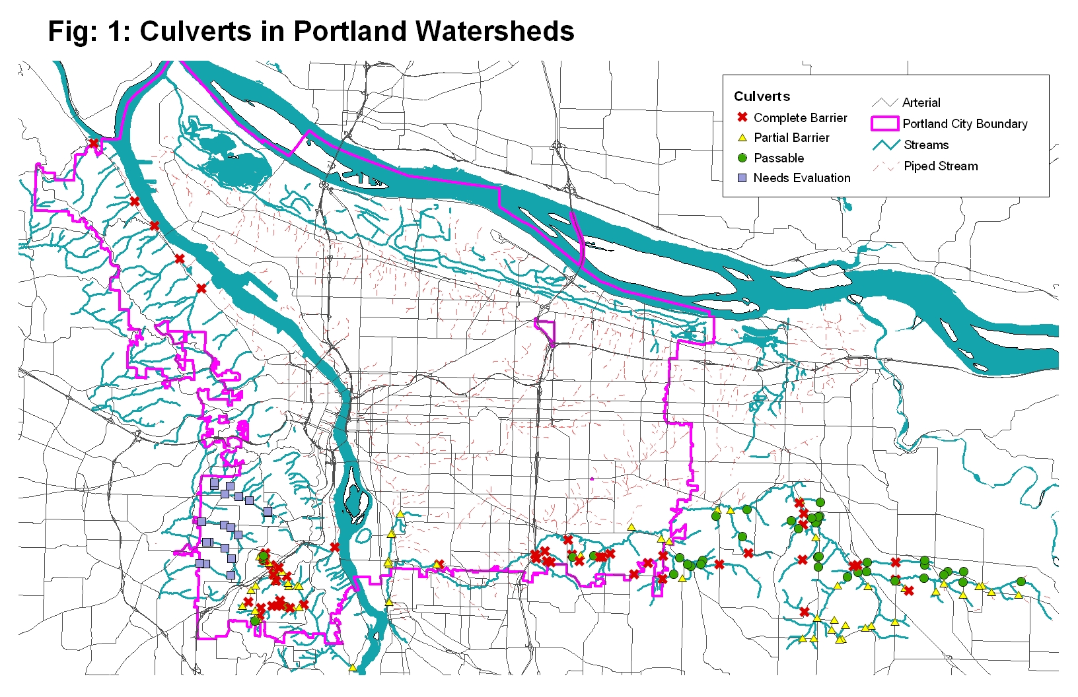

Tributaries

Columbia Slough

The Columbia Slough extends 18 miles between Fairview Lake on the east to the Willamette River at Kelley Point Park on the west. It drains 62.5 square miles, or 40,000 acres, of residential neighborhoods, vegetable farms and industrial areas. The Columbia Slough is the remnant system of marshes, wetlands, lakes, and side channels that historically formed the floodplain of the Columbia River between the mouths of the Willamette and Sandy Rivers. The Columbia Slough has been severely altered from this historic condition, however. It is now a highly managed water conveyance system, with dikes and pumps that provide watershed drainage and flood control, and maintain a highly artificial hydrograph. Over the years extensive urban, agricultural, and industrial development have profoundly altered the watershed, and have resulted in a highly contaminated watershed that has lost a vast percentage of its upland and aquatic habitat.

The Slough’s channel configuration and flow regime have been altered significantly from historic conditions. A large amount of open water areas and wetlands has been eliminated as a result of urban development and the hydrologic connectivity of the entire system has been greatly reduced. The creation of roads such as Marine Drive has blocked the direct connection between the Columbia Slough and the Columbia River system. A pump station at NE 33rd Avenue blocks passage of fish into the upper parts of the Slough. Consequently, juvenile salmonids from the lower Willamette River which are seeking out rearing habitats only have access to the lower section of the Slough.
Water quality in the Columbia Slough watershed is highly degraded. DEQ has placed the Columbia Slough on the 303(d) list for 10 parameters (4 toxics, bacteria, nutrients, pH, dissolved oxygen, chlorophyll a, and temperature).

The biological communities in the Columbia Slough are degraded as a result of the extensive degradation of flow, habitat, and water quality conditions. Fish communities are dominated by non-native warm water fish species such as common carp and bluegill. Benthic macroinvertebrate communities are extremely sparse.

Table 4. Baseline environmental conditions in the Columbia Slough.
Factor | Baseline Condition | Notes
Habitat
Altered Flow Regime | Not Properly Functioning | Watershed development has greatly altered the flow regime of the CS. In particular, water levels in the middle and upper watershed above NE 33rd Ave are artificially maintained through a pump system, and the dike system has cut this historic floodplain system off from the Columbia River. These flow changes have greatly altered the structure and function of this highly degraded watershed.
Baseflow | Not Properly Functioning | The CS historic baseflow is altered from historic conditions. Historically, much of the CS was probably seasonal emergent wetlands. Water levels are now maintained artificially high in summer months for recreational and aesthetic purposes.
Channel characteristics | Not Properly Functioning | The CS channel has been severely modified. Road and infrastructure developments have blocked historic channels and decreased channel complexity throughout the slough. Banks and channel structure have been severely altered, precluding bank adjustments and overflow into low-lying areas. Habitat has been simplified and natural cover has been replaced.
Riparian Zone | Not Properly Functioning | Watershed development and streamside disturbance have reduced riparian vegetation along many sections of the CS. Such reduction is likely a factor contributing to lack of instream cover, increased water temperature, and streambank erosion in the slough. Reduction of peak flows and riparian plantings can stabilize the riparian zone.
Fish Passage | Not properly functioning | The entire middle and upper slough is inaccessible to anadramous salmonids.
Water Quality
Temperature | Not Properly Functioning | Temperatures regularly exceed standards through the summer.
Eutrophication – Nutrients, Dissolved Oxygen, and Chlorophyll a | Not Properly Functioning | The CS is on the 303(d) list for nutrients, chlorophyll, and DO. High nutrient concentrations often occur in sloughs. Excessive nutrient levels contribute to low DO problems and high algae concentrations observed in the CS.
Toxic materials | Not Properly Functioning | Excessive concentrations of certain heavy metals and synthetic organic chemicals present ecological and human health risks. The CS is on the 303(d) list for lead, DDT, PCBs, and dioxin.
Sediment | At Risk | Watershed development has increased the magnitude of soil erosion, resulting in increased instream concentrations of sediments. The CS is not used for spawning, so excessive input of fines will not limit production. Fines in the slough can decrease habitat complexity and reduce the abundance of prey items.
Biota
Fish survival | Not Properly Functioning | The cumulative impacts of the factors listed above threaten salmonid survival, and salmonid use of the CS is greatly limited because of adverse habitat and water quality conditions throughout the watershed
Biotic integrity/  Food Chain | Not Properly Functioning | Biotic integrity of the CS is greatly reduced from historical conditions. Many native species of fish and aquatic insects have been extirpated, and many introduced or nuisance species currently occupy their habitat. Productivity is probably greatly reduced compared to historical levels, resulting in a decrease in prey items for juvenile salmonids.

Johnson Creek
Johnson Creek is a 34,560-acre watershed that originates in the hills east of Portland and flows westward approximately 25 miles to its confluence with the Willamette River. There are several major tributaries that drain Johnson Creek including: Crystal Springs Creek, Kelley Creek, Mitchell Creek, Butler Creek, Hogan Creek, Sunshine Creek, and Badger Creek. Land use ranges from heavily developed urban areas (cities of Portland, Milwaukee, and Gresham) to rural farm and nursery lands (headwaters).

Flow monitoring in Johnson Creek indicates that low flow conditions in Johnson Creek may adversely impact salmonids. ODFW has set minimum flow targets to protect salmonids in Johnson Creek, and has obtained water rights to maintain those flows (Meross 2000). Flows in the middle and upper watershed frequently do not meet those minimum flows, particularly in spring and summer months. Below Crystal Springs, which provides consistent and abundant groundwater flows, minimum instream flows are typically met. Statistical evaluation of flow since 1940 indicates some increase in peak flows over the period of record (Clark 1999). Periods of record at the other flow gauges are insufficient to provide statistical rigor in evaluating temporal trends in flow, and no qualitative trends are evident.

Significant impacts on flows in Johnson Creek have also occurred from alterations in the stream channel and floodplain that change the way floods flow through Johnson Creek. Johnson Creek has been substantially altered from its historical configuration. Diking, channelization, and other alterations of the natural floodplain have eliminated many of the areas that once absorbed and conveyed floods through the watershed. One of the most significant alterations occurred in the 1930s when the Works Progress Administration widened, deepened, rock-lined, and channelized 15 miles of the 25-mile creek in an attempt to control flooding. These alterations have had long-lasting and marked effects on the habitat and hydrology of the watershed. Most significantly, the historical floodplain of Johnson Creek is disconnected or minimally connected through much of its length. The lack of floodplain connection means that flood flows cannot spread out and attenuate on the floodplain, but are instead directed and concentrated into the main channel, increasing scour and degrading instream habitat.

ODFW conducted habitat surveys throughout Johnson Creek (ODFW 2000). Their findings indicate that Johnson Creek has extremely low wood volumes, high percentage of hardened banks, lack of refugia through many reaches, channel incision, and high levels of fine sediment. Riparian vegetation is minimal or lacking throughout much of the watershed. Interestingly, riparian vegetation is as lacking in the upper watershed as it is in the lower watershed.
Fish access to habitat is impaired by culverts throughout the watershed. Although there are no culverts on the mainstem until high in the watershed, they are present on nearly all the tributaries to Johnson Creek. Crystal Springs, an area used by local and migratory Willamette salmonids, has a series of partially impassable culverts along its length, and some of the least developed tributaries along the southern side of the middle watershed also have culverts along their confluences with the mainstem.

Water quality in Johnson Creek is rated as fair to poor. Johnson Creek was placed on the 303 (d) list by DEQ for bacteria, summer temperature, and toxics (DDT and dieldrin). The 303 (d) listing includes the entire stream, from the mouth to headwaters. The numerous investigations of temperature in Johnson Creek over the years have consistently indicated that elevated temperatures are a problem throughout the watershed.

The fish community in Johnson Creek is dominated by redside shiners, reticulate sculpin, and speckled dace (JCCC 1995). Large scale suckers are abundant in the lower reaches. Adult salmonids that have been observed include: coho salmon, chinook salmon, cutthroat trout, and steelhead (ODFW unpublished data, as cited in BES 1999).

Table 5. Baseline environmental conditions in Johnson Creek.
Factor | Baseline Condition | Notes
Habitat
Altered Flow Regime | Not Properly Functioning | Peak flows have increased since the 1940’s. In addition, the historical floodplain of Johnson Creek is minimally accessible or inaccessible through much of its length due to channel alterations. The lack of floodplain access means that flood flows cannot spread out and attenuate on the floodplain, but are instead directed and concentrated into the main channel, increasing scour and degrading instream habitat.
Baseflow | Not Properly Functioning | Summer baseflows do not meet ODFW instream water rights for protection of salmonids.
Channel characteristics | Not Properly Functioning | Significant channelization, downcutting, and bank erosion of JC has occurred. JC has been narrowed and confined by hardened banks. The lower 15 miles was widened, deepened, rock-lined, and channelized in the 1930’s as a WPA project. Banks and channel structure have been severely altered, precluding bank adjustments and overflow into low-lying areas. Habitat has been simplified and natural cover has been replaced.
Riparian Zone | Not Properly Functioning | Watershed development and streamside disturbance has reduced riparian vegetation along many sections of JC and its tributaries. Such reduction is likely a factor contributing to lack of instream cover, increased water temperature, and streambank erosion in JC.
Fish passage | Not properly functioning | Nearly all of the mainstem is accessible to anadromous salmonids, but passage to nearly all of the tributaries is compromised by one or more culverts.
Water Quality
Temperature | Not Properly Functioning | Temperatures regularly exceed standards through the summer.
Eutrophication – Nutrients, Dissolved Oxygen, and Chlorophyll a | At Risk | Nutrient concentrations exceed regional guidelines (Edwards 1992; Reininga 1994). DO concentrations frequently drop below 8.0 mg/L in summer – approximately half the measurements throughout Johnson Creek in August are below this value.
Toxic materials | At Risk | JC is on the 303(d) list for DDT and Dieldrin. Instream DDT concentrations measured in a USGS study are among the highest measured in the region (Edwards 1994).
Sediment | Not Properly Functioning | Fines in certain portions of JC are presently at levels that seriously limit fish food production or embed spawning areas.
Biota
Fish survival | At Risk | The cumulative impacts of the factors listed above threaten salmonid survival, and salmonid populations locally and upstream have been greatly reduced from historical numbers.
Biotic integrity/  Food Chain | At Risk | Biotic integrity of JC is greatly reduced form historical conditions. Many native species of fish have been extirpated or greatly reduced, and many introduced or nuisance species currently occupy their habitat. Diversity of aquatic insects is significantly reduced in comparison to reference sites. Productivity is probably greatly reduced compared to historical numbers, resulting in a decrease in prey items for juvenile salmonids.

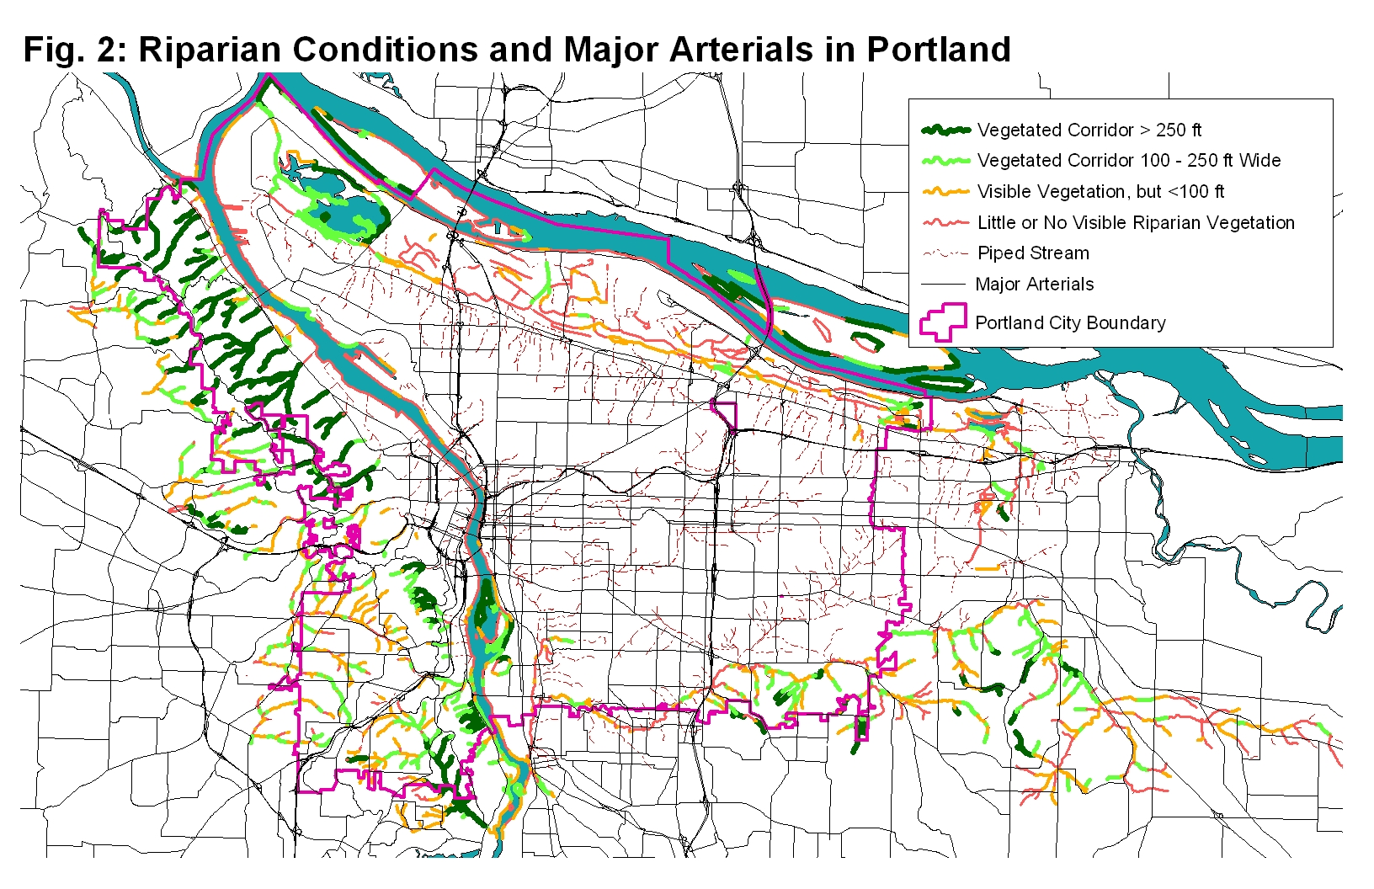

Tryon Creek

Tryon Creek is a seven-mile free-flowing stream located in a 4,237-acre watershed that flows in a southeasterly direction from the West Hills of Portland to the Willamette River near Lake Oswego. It is primarily a moderate gradient stream with steep slopes. The upper watershed has undergone common impacts associated with urban development including increased stream velocities and stream bank erosion (BES 1997). The increased impervious surface in the upper watershed has resulted in higher volume peak flows.

Channel condition is typical of a moderate gradient Cascade stream with steep slopes. Approximately 60 to 75 percent of the slopes within the watershed exceed a 30 percent grade (BES 1997). This results in a high frequency of mass wasting and erosion problems. In addition, soils in the watershed are from a silt loam series (Cascade) which are underlain by a fragipan that impedes water infiltration and root penetration. This results in a high incidence of wind throw, mass wasting, channel incision, and bank erosion. The most serious problems for salmonids resulting from this type of watershed are siltation of spawning gravels and a decrease in substrate and habitat complexity.

Historically, Tryon Creek provided important habitat for sea-run cutthroat, steelhead, coho, and possibly chinook salmon. However, development activities, particularly culvert and road crossings, have resulted in degraded habitat and migration barriers. Habitat in Tryon Creek has been evaluated in ODFW stream surveys (ODFW 2000) as well as in a Tryon Creek Corridor Assessment (City of Portland 1997). Instream habitat ranged from marginal to optimal in a few areas, with most of the marginal habitat within the more heavily urbanized upper watershed. Highest quality habitats were located within Tryon Creek State Park, which had wide and relatively undisturbed riparian buffers. Even within this protected area, however, wood volume was low and channel incision was evident.

Arnold Creek, one of the larger tributaries to Tryon, has good instream habitat within the lower section, with sub-optimal percentages of fines, bank erosion and incision being the primary forms of degradation within the lower reaches. In addition, invasions of non-native plants are evident even within the higher quality areas of Arnold Creek and Tryon Creek State Park.
Water quality in Tryon Creek is good to fair. Tryon Creek is on the DEQ 303(d) list for summer temperature. The City is currently monitoring the concentrations of 13 water quality parameters, but no modeling or analyses have been completed to date (BES 1999). A preliminary examination of the data indicates that with the exception of temperature, water quality generally meets water quality standards.

Impairment of fish access to habitat by culverts is a significant issue throughout the Tryon Creek watershed. A large culvert is present at the mouth of Tryon Creek just above its confluence with the Willamette River (at RM 19.9). Although baffles are present within this culvert, it is likely that the culvert impairs salmonid movements into and out of the watershed. An impassable culvert is present at Boones Ferry Road. Above this, there are many additional impassable culverts on Tryon and Arnold Creeks that limit movements of resident fish through the watershed. A series of waterfalls and rapids are present at Marshall Park (at RM 2.7) that are considered a natural barrier that would have limited anadromous fish access prior to the presence of culverts.

Table 6. Baseline environmental conditions in Tryon Creek.
Factor | Baseline Condition | Notes
Habitat
Altered Flow Regime | Not Properly Functioning | Marked channel incision in Tryon Creek State Park indicates peak flows are degrading habitat.
Baseflow | Unknown | Information on summer baseflows is lacking. The City is initiating flow monitoring and modeling to fill this data gap.
Channel characteristics | At Risk | Significant channelization, downcutting, and bank erosion of TC has occurred. In the upper watershed, tributaries to TC has been narrowed and confined by hardened banks, and others have been covered over and piped.
Riparian Zone | At Risk | Watershed development and streamside disturbance has reduced riparian vegetation along sections of TC and its tributaries.
Fish passage | Not properly functioning | Several culverts are present on the mainstem, and are very numerous on tributaries.
Water Quality
Temperature | Not Properly Functioning | Temperatures in TC are often unsuitable, and TC has been placed on the 303(d) list for summer temperatures.
Eutrophication – Nutrients, Dissolved Oxygen, and Chlorophyll a | At Risk | Nutrient concentrations are probably higher in TC than historic conditions. However, there is no evidence that this altered conditions to the point that salmonids are affected.
Toxic materials | At Risk | There is anecdotal evidence that toxic contamination impacts benthic communities below I-5 and the urbanized upper watershed.
Sediment | At Risk | Watershed development has increased flooding magnitude and frequency and soil erosion, resulting in increased sediments from stream channel and land erosion. In addition, the steep slopes of TC increases the presence of fines in certain areas which probably limit fish food production and embed spawning areas.
Biota
Fish survival | At Risk | The cumulative impacts of the factors listed above threaten salmonid survival, and salmonid populations locally and upstream have been greatly reduced from historical numbers.
Biotic integrity/  Food Chain | At Risk | Biotic integrity of TC is greatly reduced form historical conditions. Many native species of fish have been extirpated or greatly reduced, and many introduced or nuisance species currently occupy their habitat. Diversity of aquatic insects is significantly reduced in comparison to reference sites. Productivity is probably greatly reduced compared to historical numbers, resulting in a decrease in prey items for juvenile salmonids.

Fanno Creek

Fanno Creek is a tributary to the Tualatin River Basin, which drains about 20,500 acres (USA 1997). Land use in Fanno Creek is dominated by residential (69%), industrial (11%), and commercial activities (10%) (FCWMP 1999). Impervious areas, which are connected to a storm water drainage system, comprise 21% of the watershed, and 12% of the watershed contain impervious areas that are not connected to the stormdrain system.

Low gradient, heavy siltation, seasonal flooding, and temperature extremes, especially in the lower reaches characterize Fanno Creek (Ward 1995). Many of the sites surveyed during the 1995 study in the Tualatin River Basin have habitat characteristics that do not meet those required by many native fish species, especially salmonids. Siltation, bank erosion, lack of wood, and insufficient overhead cover are significant factors which affect fish at these sites. Upper Fanno Creek had biotic integrity lower than expected and ODFW recommended that water quality influences be evaluated (Ward 1995).

Most of Fanno Creek within the City of Portland is inaccessible to anadromous fish due to impassable culverts downstream of city limits. Cutthroat trout have been documented in Fanno Creek (Dick Caldwell, ODFW, personal communication). Fanno Creek was placed on the 303(d) list by DEQ for the following parameters: chlorophyll a, dissolved oxygen, temperature, and bacteria (USA 1997). Urban and suburban development within the watershed has contributed to these water quality problems as a result of reduced riparian vegetation, and increased nutrient loading and stream temperatures.

The occurrence of introduced species and parasitic infestations, the low number of intolerant species, relatively low species richness in larger streams, and poor habitat quality indicate that fish populations in Fanno Creek are at least moderately unhealthy (USA 1997).

Table 7. Baseline environmental conditions in Fanno Creek within the limits of the City of Portland.
Factor | Baseline Condition | Notes
Habitat
Altered Flow Regime | Not Properly Functioning | The historic hydrograph is altered as a result of impervious surfaces and a decrease in the infiltration and retention of water in vegetated areas. This results in higher peak flows which increases erosion and decreases channel stability.
Baseflow | At Risk | Summer baseflows are probably low compared to historic conditions.
Channel characteristics | Not Properly Functioning | Significant channelization, downcutting, and bank erosion of FC has occurred. In-stream aggregation and degradation are problems in various areas of the watershed. Increased urbanization also results in changes to the geomorphic features of the stream channel. These include a less complex stream, excessive bank erosion, and channel incision. An average of 78 % of the stream banks are actively eroding.
Riparian Zone | Not Properly Functioning | Watershed development and streamside disturbance has reduced riparian vegetation along sections of FC and its tributaries. Such reduction is likely a factor contributing to lack of instream cover, increased water temperature, and streambank erosion in FC. Reduction of peak flows and riparian replantings can stabilize the riparian zone.
Fish passage | Not properly functioning | Most of Fanno Creek in city limits is inaccessible to anadromous salmonids, and is highly segmented by culverts.
Water Quality
Temperature | Not Properly Functioning | Temperatures regularly exceed standards through the summer.
Eutrophication – Nutrients, Dissolved Oxygen, and Chlorophyll a | Not Properly Functioning | FC infrequently exceeds the TMDL target for ammonia, and frequently exceeds the TMDL target for total phosphorus. FC does not meet DO standards.
Toxic materials | At Risk | Data indicate potential exceedences for total copper, iron, lead, and zinc, and for dissolved lead (Aroner 2000)
Sediment | Not Properly Functioning | Watershed development has increased flooding magnitude and frequency and soil erosion, resulting in increased sediments from stream channel and land erosion.
Biota
Fish survival | Not Properly Functioning | The cumulative impacts of the factors listed above threaten salmonid survival, and salmonid populations locally and upstream have been greatly reduced from historical numbers.
Biotic integrity/  Food Chain | At Risk | Biotic integrity of FC is greatly reduced from historical conditions. Many native species of fish and aquatic insects have been extirpated, and many introduced or nuisance species currently occupy their habitat. Productivity is probably greatly reduced compared to historical numbers, resulting in a decrease in prey items for juvenile salmonids.

Forest Park Streams (Balch, Miller, and Other Tributaries)

The Forest Park streams contain a number of small watersheds such as Balch and Miller creeks. Land use within these subbasins is largely open space, although residential, industrial, and transportation uses also exist in the watersheds.

The Forest Park watersheds are probably among the least altered watersheds when compared to their historic conditions because of the extensive protection provided by Forest Park. The exception to this occurs in the lower reaches, where each stream must pass under Highway 30 and the Port and industrial areas along the banks of the Willamette. The streams typically pass through pipes for considerable lengths through this section, and receive stormwater and combined sewer overflow discharges before discharging to the Willamette.

The hydrographs in these small watersheds are probably reasonably comparable to historic conditions because of low overall percentages of imperviousness and small amounts of stormwater discharge to them. Channel conditions range from mature forested stands with good bank stability to underground pipes which carry the streamflow through industrial areas and then out to the Willamette River via a pipe outlet. As mentioned above, certain areas have mature forest stands with dense undergrowth in the riparian, whereas other areas are completely contained in a pipe. Riparian vegetation has been reduced in other areas due to development.

Limited water quality data are available for these streams. Based on our knowledge of these streams, water quality is probably generally good, with the exception of the lower sections receiving stormwater and CSO discharges. Excessive amounts of fine sediment may occur in sections of these streams near residential or industrial development. Summer temperatures may be unsuitable in certain areas, as a result of reduced and unvegetated riparian areas. Toxic contamination may be an issue in reaches receiving CSO and stormwater discharges.

The biota of the Forest Park streams is likely altered relative to historic conditions. The piping of streams and installation of culverts have blocked habitat access for anadromous fish, which has resulted in the extirpation of native anadromous fish species. Resident cutthroat trout are still present in many of these watersheds.

Table 8. Baseline environmental conditions in the Forest Park watersheds.
Factor | Baseline Condition | Notes
Habitat
Altered Flow Regime | Properly Functioning | Hydrographs in these small watersheds are probably reasonably comparable to historic conditions because of low levels of imperviousness and small amounts of stormwater discharge.
Baseflow | Properly Functioning | Summer baseflows are probably comparable to historic conditions.
Channel characteristics | Not Properly Functioning | Piping of the lower sections has altered channel conditions and severed connections to the Willamette River
Riparian Zone | At Risk | Watershed development and streamside disturbance has reduced riparian vegetation along isolated sections of the tributaries, and extensively along the lower sections which are above ground.
Fish passage | Not properly functioning | Impassable culverts are present at the mouths of these tributaries.
Water Quality
Temperature | At Risk | Temperatures in these watersheds may be unsuitable during parts of the year in areas where riparian vegetation has been removed.
Eutrophication – Nutrients, Dissolved Oxygen, and Chlorophyll a | Properly Functioning | Nutrient concentrations may be somewhat elevated from historic conditions, but are unlikely to be excessively elevated.
Toxic materials | At Risk | The upper watersheds within the Park are probably "Properly Functioning", whereas the lower sections receiving industrial stormwater and CSO discharges are likely degraded.
Sediment | At Risk | Increased sediments from stream channel and land erosion occurs in certain reaches. In addition, the steep slopes of these watersheds increases the presence of fines in certain areas which probably limit fish food production and embed spawning areas.
Biota
Fish survival | Not Properly Functioning | The piping of the lower sections has eliminated anadromous salmonids from these watersheds.
Biotic integrity/  Food Chain | At Risk | Biotic integrity of these watersheds may be reduced from historical conditions. Although the upper portion of these watersheds are largely intact, connectivity to the Willamette River and other surrounding habitats may have reduced biotic integrity

Part 3: Below is a description of listed species that may be affected, their distribution and status within the program area

Evolutionary Significant Units of Threatened Salmonids Potentially Affected by the Routine Road Maintenance Program include:

Chinook salmon (Oncorhynchus tshawytscha); threatened Upper Willamette River (UWR), Lower Columbia River (LCR), Snake River (SR) fall-run, Snake River (SR) spring/summer-run, and Upper Columbia River (UCR) spring-run.
Steelhead (Oncorhynchus mykiss); threatened Upper Willamette River (UWR), Lower Columbia River (LCR), Upper Columbia River (UCR), Snake River basin (SRB), and middle Columbia River (MCR).
Chum salmon (Oncorhynchus keta); threatened Columbia River (CR).
Sockeye salmon (Oncorhynchus nerka); threatened Snake River (SR).

Salmonid Populations in Portland’s Waterways

Salmonid Life Histories in the Lower Willamette River
Hypotheses of salmonid use in the lower Willamette River were formulated and discussed in a workshop sponsored by the City of Portland and the National Marine Fisheries Service in June of 1999 (State of the Science Workshop Draft Summary 1999). Workshop attendees were asked to consider three hypotheses covering the range of possible strategies of adult and juvenile salmonids in the lower Willamette River.

Each of the hypotheses explored the different possible spatial and temporal strategies for each of the salmon species that were expected to use the lower river. These included consideration of adult migration, spawning, juvenile rearing and smolt migration for winter steelhead (Oncorhynchus mykiss) and spring and fall chinook (Oncorhynchus tshawytscha).

The choice to focus on life history strategies as the foundation of the workshop was due to the recognition by some members of the scientific community that these strategies should be considered in the development of salmonid conservation efforts (Carl and Healey 1984, Lichatowich and others 1995, Spence and others 1998). This reflects the belief that the historically high abundance of salmonids in the Pacific Northwest was due to the diversity of life history patterns exhibited.

The hypotheses that the workshop participants considered included:

- Hypothesis One: Adult and juvenile salmon migrate quickly through the lower reach of the river without any use of habitat in the vicinity of the City of Portland. This hypothesis assumed that there was no adult spawning and/or holding and no rearing by juveniles.
- Hypothesis Two: Adult salmonids move quickly through the lower reach of the river while juveniles use this reach for some or all of their freshwater life history phases.
- Hypothesis Three: Both adult and juvenile salmonids use this reach for some or all of their life history phases.
The workshop concluded that the third hypothesis provided the best explanation for both winter steelhead and spring chinook (adult and juvenile) behaviors in the lower river whereas Hypothesis Two provided a better explanation for fall chinook (adult and juvenile).

This produced the following key hypotheses about salmonid use in the lower Willamette River:

- Spring chinook and winter steelhead (adults and juveniles) utilize the reach of the Willamette River within the vicinity of Portland for some or all of their life history phases.
- Fall chinook juveniles exhibit similar near shore and off channel behaviors as spring chinook and steelhead juveniles with a series of migrating and rearing strategies as they move down the Willamette River in the vicinity of Portland.
Winter steelhead and spring chinook juveniles are expected to use habitats available in the shallower margins of the river or off channel sites where available for rearing as they out-migrate through the lower river.

The workshop participants explored the importance of off-channel and near shore environments as habitat for juvenile salmon in depth. Depending on conditions in the main channel, juveniles will seek out these areas either for shelter from high velocity events and protection from predators or for optimal rearing conditions i.e., a steady supply of food.

Adult steelhead and spring chinook have been documented holding in the lower mainstem for a period of time before moving upriver (State of the Science Workshop Draft Summary 1999). Adult spring chinook come in as late as December and hold in the main river before crossing over the Willamette Falls. Adult steelhead have been documented entering the mouth of the Clackamas River with a darkened coloration indicating they have been in freshwater for some time (State of the Science Workshop Draft Summary 1999).

Fall chinook are believed to exhibit more of the traits of Hypothesis Two because of the lack of reliable information on the behaviors of the adults. Juvenile fall chinook exhibit similar near- and offshore behaviors as spring chinook, with a series of migrating and rearing strategies as they move down the river.

Salmonid Life Histories in Portland Tributaries

Since the State of the Science workshop, the Portland ESA program has further investigated the information that currently exists for salmon and trout presence and use of the tributary streams that flow through the City of Portland into the Willamette River. The following section summarizes the findings from these efforts. Studies or observations that have documented salmon and/or trout presence are listed. Where no documentation exists, reasons are given for why salmon or trout are believed to be present in a given tributary. Finally, a justification is given for the hypothesis that “independent” populations of steelhead exist in the Tryon and Johnson Creek watersheds.

Chinook
We postulate the following key hypothesis about chinook salmon use in City of Portland tributaries:

Chinook juveniles that have emerged from spawning sites in the upper Willamette River watershed are utilizing the lower reaches of watersheds as well as other off-channel sites in Portland for temporary rearing as they migrate through the area to reach the ocean.

There has been little documentation of the extended presence of chinook in tributary streams under the City of Portland’s jurisdiction. There is little evidence to suggest that these streams supported self-sustaining populations of chinook. Adult chinook have been documented spawning in lower Johnson Creek over the years but in such small number to prompt Ellis (1994) to speculate that these fish may be strays.

Juvenile chinook have been documented in the lowest reaches of Johnson Creek and Crystal Springs Creek (Ellis 1994; Reed and Smith 2000) and in Smith and Bybee Lakes (Fishman Environmental Services 1987). Due to the limited information that is available regarding the number of adult chinook that have returned to spawn, the evidence suggests the possibility that juveniles that have spawned in other watersheds may be using these areas as temporary off channel sites as they migrate through the area. This hypothesis would be consistent with the observations of the Independent Scientific Group (2000) of chinook juvenile out-migration strategies that consist of movement from upriver tributary spawning sites into mainstem areas downstream where they can rear over the winter (Healey 1991).

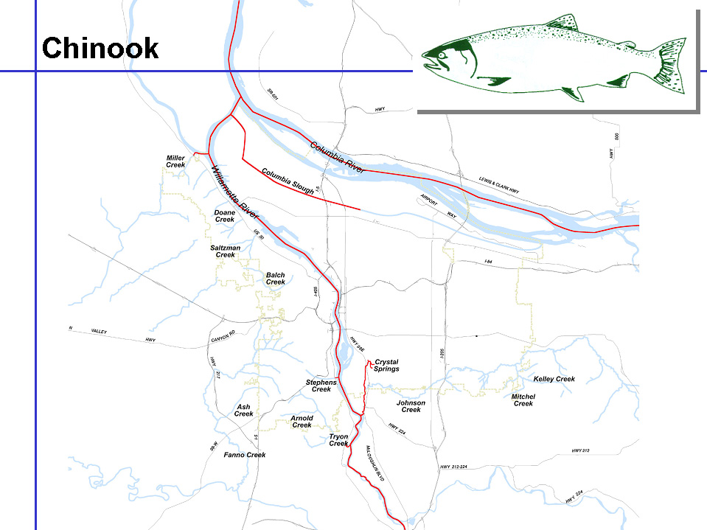

Figure 3
Distribution of Chinook Salmon In Portland’s Waterways.

Steelhead
We postulate the following key hypothesis about steelhead use in City of Portland tributaries:

Two groups of steelhead exist in Portland; self-sustaining independent populations in Johnson and Tryon Creeks and juveniles seeking temporary rearing opportunities as they migrate from areas in the upper watershed to the ocean. Under the National Marine Fisheries Service definition of viable salmonid populations, Johnson and Tryon Creeks support independent populations of steelhead.

Steelhead and/or rainbow trout have been documented in the Crystal Springs Creek tributary to Johnson Creek, the lower 9.6 miles of Johnson Creek (from roughly SE 145th to the confluence with the Willamette River) (Ellis 1994), the Kelley Creek tributary of Johnson Creek (Ellis 1994; Reed and Smith 2000), the Tualatin basin (Friesen and Ward 1996), the lower portion of Miller Creek below St. Helens Rd., and Tryon Creek (City of Portland 1992; Pacific Habitat Services 1997; Reed and Smith 2000).

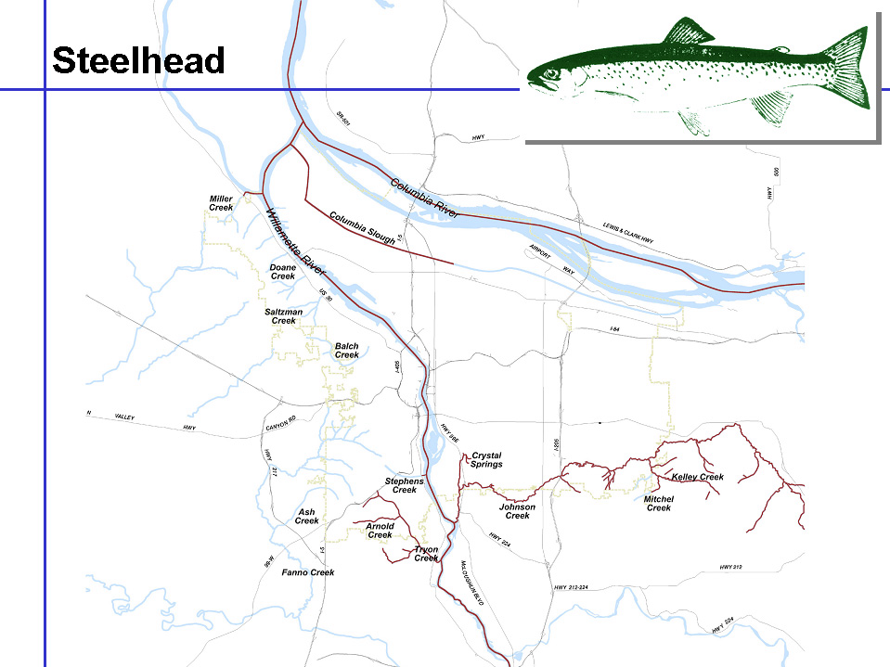

Figure 4
Distribution of Steelhead Trout In Portland’s Waterways.

Due to extensive culverting of streams emptying into the Willamette within the City of Portland there is very little stream habitat that is accessible to salmonids for spawning and rearing. Johnson and Tryon Creeks are the only watersheds within the metropolitan area that do not have their watersheds cut off to migrating steelhead.

Nevertheless, there are several small streams where temporary off-channel rearing of out-migrating juvenile steelhead may be occurring where habitat exists between the culvert and the river. There is documentation of off-channel rearing of steelhead in the lower reaches of Miller Creek. When conditions are appropriate the lower reaches of Stephens Creek, Tryon and Johnson Creek may offer temporary rearing opportunities to out-migrating juvenile steelhead that were spawned in tributaries upstream in the Willamette watershed. This hypothesis would be consistent with the findings of the Independent Scientific Group (2000) that found steelhead juveniles in the Columbia basin appear to move downstream to more productive areas as they grow and require more sustenance. Eventually, they move into the ocean when they reach a suitable size (Independent Scientific Group 2000).

Coastal Cutthroat Trout
We postulate the following key hypothesis about cutthroat trout use in City of Portland tributaries:

Cutthroat trout are found throughout the City of Portland in watersheds such as Johnson and Tryon Creeks where access is unimpeded by culverts as well as Fanno Creek, Stephens Creek and creeks in Forest Park (Balch, Miller, Saltzman, etc.) that have been cut off from the Willamette River by culverts.

The U.S. Fish and Wildlife Service recently announced that they would not be listing coastal cutthroat under the Endangered Species Act. The City of Portland’s ESA Program has determined that it would be useful to analyze the extent of cutthroat presence in streams falling within the City of Portland in order to understand the extent of use in city streams in case of future listings.

Cutthroat trout have been documented in several Portland-area streams that drain into the Willamette River, including Johnson Creek and its tributaries (Crystal Springs, Kelley, Hogan, Badger, Sunshine and Mitchell creeks) (City of Portland 1997; Ellis 1994; Reed and Smith 2000). Cutthroat trout also have been observed in Tryon Creek (Pacific Habitat Services 1997; Reed and Smith 2000) and Miller Creek. No documentation is available to determine if these populations are anadromous or resident.

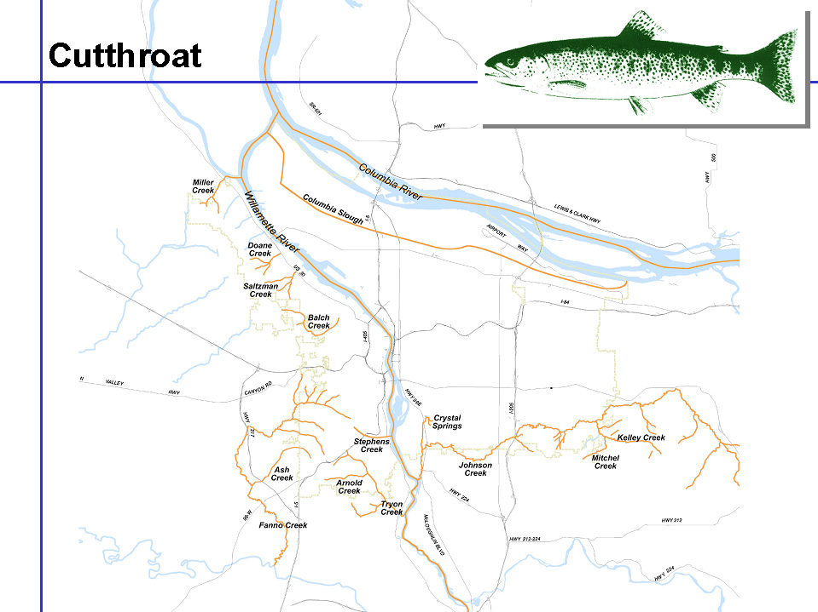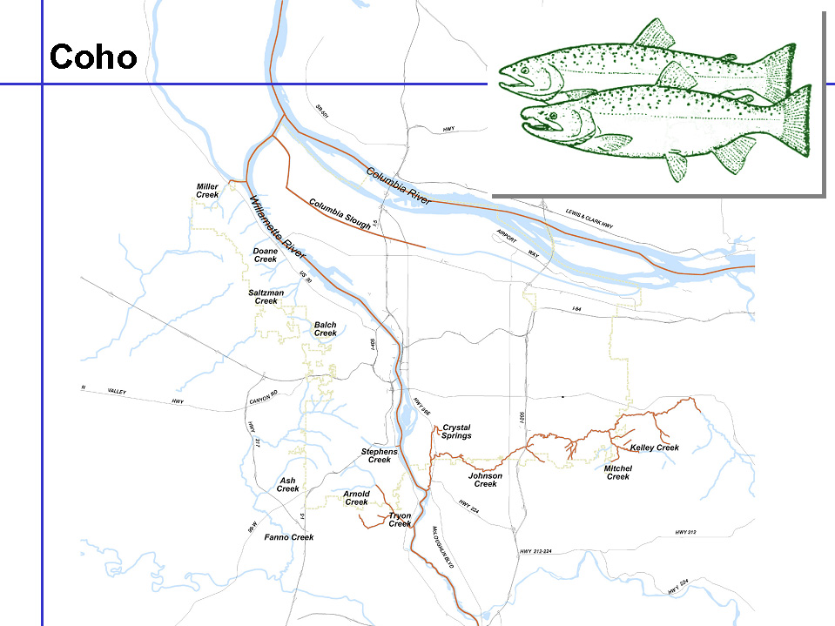

Figure 5
Distribution of Cutthroat Trout In Portland’s Waterways.

Culverts have blocked all of the Forest Park streams that historically flowed into the Willamette River. Balch Creek was isolated in 1921 when the lower part of the creek was diverted and incorporated into the City of Portland’s sewer system and yet it has been documented to contain a small population of resident cutthroat trout population (City of Portland 1992). This evidence suggests that similar isolated populations of cutthroat may exist in Forest Park streams where appropriate flows and habitat exist. This is currently being investigated under a contract with the Oregon Department of Fish and Wildlife.

Chum
It is currently believed that chum are not utilizing habitats in the vicinity of Portland. They are believed to migrate by in the Columbia River to get to areas below Bonneville Dam where there is documented spawning.

Coho
Coho are believed to be extinct across their historic range except for the Clackamas River where a wild population has been documented. There has been some documentation of coho in Tryon and Johnson Creeks but not in any consistency to assume that these are anything but strays. Nevertheless, these and other tributaries may have historically offered suitable habitat for coho.

Figure 6
Distribution of Coho Salmon In Portland’s Waterways.
Part 4: Relevant reports.

4a. Specific reports

Table 9: Reports

Title | Type of Information | Source | Link | Contact/Phone
The City of Portland Framework for Integrated Management of Watershed and River Health | Describes the process City’s to plan, analyze, and implement actions to assist in the protection and ultimate recovery of Salmonids | City of Portland Endangered Species Act Team | http://www.fish.ci.portland.or.us  Framework | Jim Middaugh, Program Manager, 503-823-7032
County Road Maintenance Submittal Template to NMFS for Coverage Under Limit 10 of the 4(d) Rules for Salmon and Steelhead | A template to submit this package | Oregon Association of County Surveyors and Engineers | joshel@orlocalgov.org | Jon Oshel,  Association of Oregon Counties,  503-585-8351

4b. Key watershed references (for complete citations, see the Literature Cited section)

Lower Columbia River
Columbia River Basin Water Quality Summary Report.
Conservation Status of Lower Columbia River Coho Salmon.
Lower Columbia River subbasin (mouth to Bonneville Dam): Salmon and steelhead production plan/Steelhead production plan.
Water quality of the lower Columbia River Basin: analysis of current and historical water-quality data through 1994 U.S. Geological Survey Earth Science Information Center, Open-File Reports.

Lower Willamette References
Analysis of Nutrient and Ancillary Water-quality Data for Surface and Ground Waters of the Willamette Basin, Oregon, 1980-90.
Summary of Information on Aquatic Biota and Their Habitats in the Willamette Basin, Oregon, through 1995.
Water Quality Assessment of Lower Willamette River.
Water Quality in the Willamette Basin, Oregon, 1991-95.
Willamette River Basin Water Quality Study: A Summary of Recent Scientific Reports on the Willamette River.

Columbia Slough References
Columbia Slough Planning Study Background Report.
Columbia Slough Sediment Remedial Investigation/Feasibility Study Final Work Plan.
Columbia Slough Sediment Remedial Investigation/Feasibility Study Screening Level-Risk Assessment Report.
Water body assessment, Columbia Slough TMDL development, Parts I and II.

Johnson Creek References
Aquatic Inventory Project Physical Habitat Surveys.
Assessment of Surface-Water Quality and Water Quality Control Alternatives, Johnson Creek Basin, Oregon. U.S. Geological Survey Water-Resources Investigations Report 93-4090.
Crystal Springs Watershed Assessment.
Johnson Creek Resources Management Plan: Portland, Oregon.
Lents 2040 Technical Memorandum 1: Background, Existing Conditions, and Design Considerations for Flood Management in the Lents 2040 Area.
Salmon Restoration in an Urban Watershed: Johnson Creek, Oregon.
Technical Support Document for the Johnson Creek Resources Management Plan: Portland, Oregon.
Water Quality in Johnson Creek – a Summary of Existing Studies and Data. In: JCCC (1994).

Tryon Creek References
Aquatic Inventory Project Physical Habitat Surveys.
Upper Tryon Creek Corridor Assessment.

Fanno Creek References
Fanno Creek Resources Management Plan.
Fanno Creek Water Quality Status & Trends Report & Monitoring Assessment 1990-1999.
Influence of waterway development on migrational characteristics of juvenile salmonids in the Lower Willamette River, OR.

Forest Park Watershed References
Balch Creek StormwaterManagement Plan.

Part 5: Affirmative conclusion that the program is substantially similar to/at least as protective as ODOT’s program in its implementation.

5a. Training:

Overview
There are almost 700 employees among the 4 bureaus within PDOT. PDOT is responsible for providing training to its employees. Each bureau within PDOT develops its own annual curriculum and includes other PDOT employees as appropriate. Mr. Richard Herington is BOM’s Manager of Training and Employee Development. Mr. Herington is responsible for developing an annual training program for all of BOM’s 400 employees. Part of the bureau’s training program addresses water quality issues and best management practices. All BOM field employees receive training on appropriate best management practices for their work area. Field employees have been provided with a copy of the ODOT Manual. A refresher class on best management practices is included in the bureau’s training plan.

Currently, PDOT contracts out a small portion of maintenance activities. Contracted activities may include street grinding, paving, and sidewalk repair. PDOT currently requires contractors to develop erosion control plans, in compliance with City Code Title X Erosion and Sediment Control, and where appropriate, to develop pollution control plans. Erosion control plans include best management practices to install, maintain, and remove erosion prevention and sedimentation control measures. Pollution prevention plans include best management practices to contain and clean up spills, recycle materials and keep job sites clean. Enforcement is provided by PDOT’s inspectors who have been trained as part of the bureau’s environmental training program. These inspectors have the ability to provide additional oversight and advice. Members of PDOT’s Environmental Team are also available as a resource.

The City recognizes the commitment that ODOT has made to training as described in the Federal Register Volume 65, dated July 10, 2000. NOAA Fisheries has stated clearly that an agency’s commitment to an extensive and ongoing training program for all maintenance employees is crucial. To this end, the BOM has put in place a plan to meet the bureau’s environmental training needs and to show commitment to the protection of endangered species. An outline of the bureau’s Environmental Training Program is attached. Components of the training program include:

Key elements of training:
- New employee orientation
- Monthly Pollution Prevention Manager meetings
- Bi-monthly Pollution Prevention Field Crew meetings
- Erosion and sediment control training
- Spill clean-up kit training
- Participation in professional symposiums/conferences
- Water quality awareness training
- Endangered Species Act Awareness Training
- National Pollutant Discharge Elimination System (NPDES) requirements
- ODOT Manual best management practices

Annual timeline:
Each year, as part of the budget process, training needs for the following fiscal year are identified and a schedule is developed. Training is frequently tailored to meet the needs of the specific divisions, e.g. street cleaning, sewers, and traffic electrical. Some of the training is provided annually while other training is provided on a less frequent basis. In-house staff may provide a portion of the training while outside trainers may be selected, based on expertise and cost, to provide training for which there is no in-house resource. Training opportunities are scheduled throughout the year, depending on the workload demands of the various crews and the availability of trainers. Occasionally, city crews have been invited to attend relevant training provided by other jurisdictions. Whenever possible, PDOT tries to take advantage of training opportunities that are examples of regional partnership and cooperation. Training that meets BOM’s environmental goals is mandatory and crews are released from their regular work to attend the training.

The following list highlights some of the training offered to PDOT employees over the last 2 years:
- BOM’s Pollution Prevention Field Team, composed of supervisors and field staff, continues to meet twice a month year-round to identify and recommend solutions impacting maintenance operations that have environmental or water quality impacts. Other tasks include designing and implementing bureau programs, evaluating and testing new products, materials, tools and techniques, and monitoring developments in the area of pollution prevention.

- The BOM’s Pollution Prevention Managers Team continues to meet monthly to discuss and resolve bureau issues affecting maintenance operations related to environmental, water quality and other livability and sustainability goals.

- 235 BOM employees received Endangered Species Act awareness training focusing on the best management practices that the bureau has committed to in its daily work activities. Training will be repeated on a bi-annual basis. This training covers the best management practices contained in ODOT’s Manual and additional best management practices for those bureau activities not addressed by the ODOT Manual. Office and administrative staff do not receive this training.

- 272 BOM employees received training on water quality awareness including non-point pollution.

- 18 employees from BOM’s Stormwater Maintenance Section participated in a 3-day soil bioengineering class. This class was conceived with the assistance of a landscape designer and city employees. The class concluded with a hands-on training exercise in the field. Techniques learned are now incorporated into the section’s stormwater maintenance procedures.

- 7 BOM employees took part in an 8-hour erosion and sediment control class while 127 BOM employees attended a 4-hour erosion control class. A refresher class in erosion and sediment control is planned for the next fiscal year.

- PDOT’s Environmental Engineer and Environmental Project Manager attended the training provided by ODOT to new employees. This class was held in Bend, Oregon. This was beneficial to learn how ODOT is training its staff on environmental issues. Information learned has been incorporated into the training program.

- PDOT sent 12 employees to the 3 day Pacific Northwest Erosion Control Conference.

- BOM’s March 2002 Management Team Meeting included a 45 minute presentation from the Oregon State Police staff responsible for enforcing the Endangered Species Act. Managers and supervisors were made aware of state regulations and enforcement issues related to protecting fish.

- Over 30 PDOT employees attended an ODOT-sponsored training on the Endangered Species Act. A National Marine Fisheries Services employee based in Lacey, Washington, taught this 3-hour class.

- A biologist with the Oregon Department of Fish and Wildlife trained 20 PDOT employees on the life cycle of turtles and other smaller endangered species. These employees, responsible for cleaning the City’s pollution reduction facilities such as constructed wetlands, have modified their maintenance schedules and procedures to reduce the negative impacts to native species.

In addition to the training given to employees, each section in BOM has regularly scheduled section meetings. At these meetings, section members discuss other environmental issues that arise in-between training. The bureau continues to evaluate its training program, constantly seeking out new opportunities for teaching and learning experiences.

Budget and Staffing:
PDOT is committed to being proactive stewards of the environment and assisting in the recovery of salmonids in the Portland area. To meet this objective, PDOT funds an Environmental Team within the Bureau of Maintenance. The team consists of one full time Environmental Engineer, an Environmental Program Specialist and a part time Project Manager. The Environmental Team is responsible for providing leadership in setting bureau cultural direction and for ensuring that PDOT is in compliance with all federal, state, regional, and local environmental laws and mandates. The Environmental Team is also responsible for working with BOM’s Manager of Training and Employee Development to develop the training program, ensure that training is funded, and to modify the training program as new needs are identified.

Both the Environmental Team and the bureau’s training program are funded by the City’s Transportation Fund. The Transportation Fund is supported by the City’s share of the state gas tax, parking citations and other revenues, including funding from the Sewage System Operating Fund.

5b. Monitoring/Tracking:

As mentioned earlier, the Bureau of Maintenance has two Pollution Prevention (P2) teams. One committee is comprised of field employees and supervisors and is known as the P2 Field Team. The other committee consists of the bureau’s Public Works Managers and is referred to as the P2 Managers Team. Both of these P2 teams were initiated to meet requirements of the City’s National Pollutant Discharge Elimination System (NPDES) permit. The P2 Managers Team provides overall direction while the P2 Field Team tests the efficacy of new or revised materials, evaluates current practices and activities and recommends changes, and monitors runoff management programs and pilot projects. Oftentimes, environmental problems encountered in the field are brought forward to the P2 Field Team for discussion and for recommended action. Both teams serve as a bridge between field operations and management, and support the application of awareness training principles to field operations.

The City of Portland implemented an Erosion and Sediment Control Ordinance (Title 10), which took effect on March 1, 2000. This City Code requires that no visible or measurable (less than ½ cubic foot) of sediment leaves the work site. City employees are responsible for code enforcement.

PDOT staffs a communications center at its Bureau of Maintenance facility. The communication center operates 24 hours, 365 days a year, and receives calls and complaints from the public about problems or emergencies in the field. In addition, managers receive calls from other bureaus and the public regarding additional problems or concerns. Most calls are logged into an electronic tracking system. Staff investigates the calls, determining which calls should be turned into work orders. Staff is able to categorize the calls logged by type. In this way, we are continually monitoring and responding to public feedback regarding our work.

Lastly, the city’s phone number appears is painted on the doors of city vehicles. Citizens are able to call in any complaints, concerns, or even compliments. This is an additional form of communication and a method of tracking PDOT practices.

5c. Documentation/Reporting:

The City of Portland plans to follow the documentation/reporting process included in the ODOT Manual. PDOT currently prepares and submits an annual Operations and Maintenance report as part of the City’s NPDES permit. This annual report summarizes the activities of the prior year including training and new best management practices. The City also plans to combine the annual reports for the Municipal Separated Storm Sewer System (MS4) requirements under the Clean Water Act and for this program under the Endangered Species Act into a single report. The report will document:

- Investigations of complaints received from/by City staff, other agencies, or members of the public on impacts to the environment by maintenance activities.

- Modifications of, or improvements to, any minimization/avoidance actions including summaries of challenges or successes in applications.

- Compliance reviews of any construction projects undertaken by the Bureau of Maintenance.

- Overall summary of contacts and coordination with ODFW, NMFS, and USFWS on specific issues.

5d. Specific information/analyses to support variation from ODOT Manual:

PDOT has reviewed the entire ODOT Manual. Not all of the activities performed by ODOT apply to PDOT. For example, the City does not own nor operate an asphalt plant. As mentioned above, the ODOT Manual also does not include many activities performed by PDOT. PDOT is also developing a comprehensive manual that will cover all of its activities. In the interim, PDOT is adopting the ODOT Manual until the PDOT Manual is completed, reviewed and accepted by NOAA Fisheries.

Figure 7.

Portland Office of Transportation

Organizational Chart
Literature Cited

Aroner, E.R. 2000. Fanno Creek Water Quality Status & Trends Report & Monitoring Assessment 1990-1999. Prepared for the City of Portland, Bureau of Environmental Services.

Bowker, J., D. Brod, C. Fromuth, L. Gailey, J. Gladson, T. Kurtz, K. Wadden. 2000. Lents 2040 Technical Memorandum 1: Background, Existing Conditions, and Design Considerations for Flood Management in the Lents 2040 Area. Technical Memorandum prepared by the Portland Bureau of Environmental Services.

CH2M Hill. 1995. Water body assessment, Columbia Slough TMDL development, Parts I and II.

Chilcote, M.W. 1999. Conservation Status of Lower Columbia River Coho Salmon. Oregon Dept. of Fish and Wildlife.

City of Portland, OR, Bureau of Environmental Services (BES). 1989. Columbia Slough Planning Study Background Report.

City of Portland, OR, Bureau of Environmental Services (BES). 1994. Columbia Slough Sediment Remedial Investigation/Feasibility Study Final Work Plan. Prepared for BES by Parametrix, Inc.

City of Portland, OR, Bureau of Environmental Services (BES). 1995. Columbia Slough Sediment Remedial Investigation/Feasibility Study Screening Level-Risk Assessment Report. Prepared for BES by Parametrix, Inc. Submitted to Oregon Department of Environmental Quality.

City of Portland, OR, Bureau of Environmental Services (BES). 1997. Balch Creek Stormwater Management Plan.

City of Portland, OR, Bureau of Environmental Services (BES). 1997. Upper Tryon Creek Corridor Assessment.

City of Portland, Or, Bureau of Environmental Services (BES). 1998. Crystal Springs Watershed Assessment. Report prepared by Dames and Moore.

City of Portland, OR, Bureau of Environmental Services (BES). 1999. Water Quality Assessment of Lower Willamette River. Prepared by Willamette River CSO Predesign Project.

City of Portland, Bureau of Environmental Services. 1998. Fanno Creek Resources Management Plan.

Edwards, T.K. 1994. Assessment of Surface-Water Quality and Water Quality Control Alternatives, Johnson Creek Basin, Oregon. U.S. Geological Survey Water-Resources Investigations Report 93-4090.

Fuhrer, Gregory J. Water quality of the lower Columbia River Basin: analysis of current and historical water-quality data through 1994 U.S. Geological Survey Earth Science Information Center, Open-File Reports.

Johnson Creek Corridor Committee (JCCC). 1994. Technical Support Document for the Johnson Creek Resources Management Plan: Portland, Oregon. Prepared by Woodward-Clyde Consultants.

Johnson Creek Corridor Committee (JCCC). 1995. Johnson Creek Resources Management Plan: Portland, Oregon. Prepared by Woodward-Clyde Consultants.

Meross, S. 2000. Salmon Restoration in an Urban Watershed: Johnson Creek, Oregon. Prepared for the Portland Multnomah Progress Board.

Oregon Department of Environmental Quality (DEQ)/Tetra Tech. 1995. Willamette River Basin Water Quality Study: A Summary of Recent Scientific Reports on the Willamette River.

Oregon Department of Fish and Wildlife (ODFW). 2000. Aquatic Inventory Project Physical Habitat Surveys. Prepared by ODFW.

Reininga, K. 1994. Water Quality in Johnson Creek – a Summary of Existing Studies and Data. In: JCCC (1994).

U.S. Environmental Protection Agency. 1992. Columbia River Basin Water Quality Summary Report.

U.S. Geological Survey. 1995. Analysis of Nutrient and Ancillary Water-quality Data for Surface and Ground Waters of the Willamette Basin, Oregon, 1980-90. Water-Resources Investigations Report 95-4036.

U.S. Geological Survey (USGS). 1997b. Summary of Information on Aquatic Biota and Their Habitats in the Willamette Basin, Oregon, through 1995. Water Resources Investigations Report 97-4023. Portland, Oregon.

U.S. Geological Survey (USGS). 1998. Water Quality in the Willamette Basin, Oregon, 1991-95.

Ward, D. L., A. A. Nigro, R. A. Farr, and C. J. Knutsen. 1994. Influence of waterway development on migrational characteristics of juvenile salmonids in the Lower Willamette River, OR. North American Journal of Fisheries Management 14: 362-371.

Washington Department of Fisheries. 1990. Lower Columbia River subbasin (mouth to Bonneville Dam): Salmon and steelhead production plan/Steelhead production plan.

Portland Office of Transportation -- Bureau of Maintenance

Environmental Training Program

Why is Environmental Training Important?

- Endangered Species Act: NMFS is more likely to consider a jurisdiction’s request to seek protection under the ESA 4(d) rules and protective of fish if the agency has in place an extensive and regular training program. The components of the training program must be increasingly focused on environmental considerations. Such programs, with comprehensive best management practices, are considered adequate for protection of endangered species.
- National Permit Discharge Elimination System (NPDES) Permit Requirements: In order to meet the legal requirements of the City’s Stormwater Discharge Permit, BOM committed to implementing Pollution Prevention (P2) teams to serve as forums for education, product testing, and the development of best management practices. The P2 Managers Team meets monthly and is composed of BOM Public Works Managers. The P2 Field Team is composed of field employees and supervisors. They meet twice per month to develop procedures, identify training needs, test the efficacy of new or revised materials, and recommend practices and activities that comply with NPDES.
- Erosion Control- Title 10: The City of Portland’s Erosion and Sediment Control Ordinance (Title 10) requires that no visible or measurable (less than ½ cubic foot) of sediment leaves the work site. Training of field employees ensures compliance with the requirements laid out in Title 10.
- Environmental Overlay zones: These zones, described in Title 33, Section 430 of the City Charter, are designated to protect natural resources and functional values that have been identified by the City as providing benefits to the public. Training of field employees gives them the tools to be more environmentally sensitive while performing maintenance activities in these areas.
- Training should reduce the number of complaints received from/by City staff, other agencies, or members of the public on impacts to the environment by maintenance activities.
- Personal Safety- The personal protection and safety of field employees is key to a successful maintenance program.

Table 10

Portland Office of Transportation Training Program
 | Training Component | Target Population | Existing Program | Proposed Program | Frequency | Facilitator/ Trainer | Request | Estimated  AdditionalCost | Comments
 | New employee orientation | New employees | 1 slide is currently included in the PowerPoint presentation shown to new employees. | Expanded orientation and additional slides | As needed for new employees | David Crabtree | Additional slides and expanded explanation during the new employee orientation. | $0 | Hiring frequency is unclear given budget constraints
 | APWA Short School | Varies by topic, budget and interest | Supervisors encourage employees to attend or employees express interest | Status Quo | As offered | Varies | Some funds included in section budgets. | $5,000 | Environmental Team and Supervisors should be more proactive in encouraging employees to attend and in asking APWA to schedule particular classes.
 | Bloodborne Pathogens Training | All employees | Employees attend annual 1-hour class taught by City nurse. | Status Quo | Annual | Laura Herring, R.N. | NA | $0 | Included in BOM’s training program
 | Clean Up (Spill) Kit training | All field employees | Crews are trained on how to use the contents | Annual refresher | Annual | P2 Field team  Members (Liane has done this training in the past) | Covers training and product testing | $3,000 | New products are constantly being tested and evaluated.
 | Competent Person Training | Employees requiring trenching and excavating training. | 1 ½ hour class includes soil analysis, use of protective systems, and the requirements of the standard. | Status Quo | Annual | Either internal or external trainers. | NA | $0 | Included in BOM’s training program.
 | Contaminated Soils | All field employees | None | 4 hour training program is currently being developed- assume 12 classes. | Annual | Contractor | Funds to hire a trainer for this class | $8,000 | Curriculum is currently being developed.
 | Endangered Species Act Awareness Training- includes  - Erosion and Sediment Control techniques  - Water Quality and Runoff Management  - Best Management Practices | All employees- some sections may be targeted for more intensive training. | 235 employees trained by Liane in FY01-02 | 2-4 hour refresher class | Annual | Fred Wright or  Patti Oliver  NMFS Reps | Funds to hire contractor or trainer to teach ODOT Manual | $20,000 | Employees may also attend classes sponsored by other agencies i.e. ODOT, Wash DOT, etc.
 | Endangered Species Act- Enforcement Issues | Supervisors, managers and senior staff | 1- hour training by State Trooper charged with enforcing the Oregon Plan. | 1-hour refresher class on an ad hoc basis. | Biannual | Valerie Hoy, OSP  NMFS Rep | NA | $0 | Best Management Practices are being constantly evaluated and updated.
 | Hazardous Communication | All employees | 1 hour class to teach usage of MSDS system and to highlight specific chemicals of concern. | Status Quo | Annual | Combination of video (35 minutes) and supervisors | NA | $0 | Included in BOM’s training program.
 | Hazardous Materials Awareness | Certain sections are targeted for training |  |  | Annual | Consultant | NA | $0 | Included in BOM’s training program
 | In-house Video and Reference Library | All employees | The bureau has no existing resources that are available to employees upon request. | Create an in-house library of books and videos on environmental subjects related to maintenance bureau activities | Ongoing | NA | Purchase books, videos, and other materials for use by bureau employees as needed. | $500
 | NW Fish Passage Seminars | All employees depending on topic and interest. | Seminars are sponsored by Washington and Clackamas Counties and include both technical and field-based educational opportunities to learn about ESA, erosion control, and fish protection | More regular attendance by field and management staff. | Quarterly from fall to spring (June) | NA | BOM hosts seminars on a rotational basis. | $1,000 | Meeting Supplies
 | Pesticide Certification Program | Employees who apply herbicides (Structures, Roadside Maintenance) | Training as needed for specific employees for certification. | Status Quo | Re-licensing is required every 5 years. | Contract with Parks Bureau or through local community colleges | NA | $0 | Included in BOM’s training program.
 | Pollution Prevention (P2) Field Team. | Representative Field crews members and supervisors from each division | The team has developed a work plan and is tackling many of the identified work tasks. | Status Quo | Two times per month. | Marni Glick | Funds to test products, prepare notebooks and other materials, conduct pilot projects | $3,000
 | Pollution Prevention (P2) Managers Team | All BOM Public Works Managers | PW Managers discuss issues | Status Quo | Monthly | Rotates among PW Managers | NA | $0
 | Participation in professional symposiums/conferences e.g. Pacific Northwest Erosion Control Conference (12 employees) | All employees depending on topic, interest, and budget. | Ad hoc basis | Status Quo | As available | NA | Some funds should be included in section budgets | $5,000
 | Soil Bioengineering Training/ Pilot Projects | Stormwater Management and other sections as appropriate | 18 employees were trained in Fall 2001 | 3-day combined training and field exercise. | Every 2-3 years | Dennis O’Connor | Curriculum has been developed. Need funds to hire Dennis. | $4,000
 | Slope Maintenance & Slope Restoration | Stormwater Maintenance and Street Systems | Federally funded training program |  | Every 3 years |  | NA | $0 | Offered as federal funding is available.
 | Stormwater & Sanitary Collection System Maintenance | Environmental Systems Division | Provided through APWA Short School and local community colleges | Status Quo | As available |  | NA | $0 | Included in BOM’s training program.
 | Wildfire Operations Training | Street Cleaning personnel (supervisors, flusher drivers, and sweeper operators) assigned to operate flushers | Training has varied from year to year, ranging from basic wildland fire fighting techniques to extreme fire behavior to show and tell with city firefighters | Curriculum for refresher class needs to be developed. | Annual | TBD | NA | $0 | Included in BOM’s training program. Should work with Portland Fire Bureau. Kevin Williams is key resource for this training.
 | Wildlife and Pollution Reduction Facilities Maintenance (Turtles) | Stormwater Maintenance | Training to date has been focused on the life cycle and habitat of turtles. | Refresher class | Every 2 years? | Sue Bielke, ODFW | NA | $500 | Materials and supplies

A soil layer, often composed of clays, that can act to slow or impede infiltration of water.
A culvert under Hwy 43 near the mouth of Tryon Creek has been determined to be passable by an Oregon Department of Fish and Wildlife inventory although there has been some speculation that it is impassable at certain times of the year dependent on water levels.

