Exhibit A
Form of Bond

No. R-«BondNumber» | $«PrincipalAmtNumber»

United States of America
State of Oregon
Counties of Multnomah, Washington and Clackamas
City of Portland
Limited Tax Revenue Refunding Bond
2003 Series __

Dated Date: __________, 2003
Interest Rate Per Annum: «CouponRate»%
Maturity Date: __________, «MaturityYear»
CUSIP Number: 736740«CUSIPNumbr»
Registered Owner: -----Cede & Co.-----
Principal Amount: -----«PrincipalAmtSpelled» Dollars-----

The City of Portland, Oregon (the "City"), for value received, acknowledges itself indebted and hereby promises to pay to the Registered Owner hereof, or registered assigns, the Principal Amount indicated above on the Maturity Date indicated above together with interest thereon from the date hereof at the Interest Rate Per Annum indicated above, computed on the basis of a 360-day year of twelve 30-day months. Interest is payable semiannually on the ___ day of _________ and the ___ day of ________ in each year until maturity or prior redemption, commencing ____________, 2003. Payment of each installment of principal or interest shall be made to the Registered Owner hereof whose name appears on the registration books of the City maintained by the City's paying agent and registrar, which is currently U.S. Bank, N.A., in Portland, Oregon (the "Paying Agent"), as of the close of business on the fifteenth day of the calendar month immediately preceding the applicable interest payment date. For so long as this Bond is subject to a book-entry-only system, principal and interest payments shall be paid on each payment date to the nominee of the securities depository for the Bonds. On the date of issuance of this Bond, the securities depository for the Bonds is The Depository Trust Company, New York, New York, and Cede & Co. is the nominee of The Depository Trust Company. Such payments shall be made payable to the order of "Cede & Co."
This Bond is one of a duly authorized series of bonds of the City aggregating $_________ in principal amount designated as Limited Tax Revenue Refunding Bonds, 2003 Series __ (the "Bonds"). The Bonds are issued for the purpose of refunding the City’s outstanding Full Faith and Credit Refunding Obligations, 1993 Series A and Full Faith and Credit Obligations, 1993 Series B. The Bonds are authorized by City Ordinance No. 176750 and issued under City Ordinance No. _____ (collectively, the “Ordinance”) and the Oregon Uniform Revenue Bond Act, in full and strict accordance and compliance with all of the provisions of the Constitution and Statutes of the State of Oregon and the Charter of the City.
The Bonds constitute valid and legally binding obligations of the City. The full faith and credit of the City are pledged for the punctual payment of the principal of and interest on the Bonds and the City has covenanted to pay the Bonds from its “Available General Funds” as defined in the Ordinance. The City is not authorized to levy any additional taxes to pay the Bonds. The Bonds do not constitute a debt or indebtedness of Multnomah, Washington, or Clackamas Counties, the State of Oregon, or any political subdivision thereof other than the City.
The Bonds are initially issued in book-entry-only form with no certificates provided to the beneficial owners of the Bonds. The Depository Trust Company and its participants will maintain records of ownership of beneficial interests in the Bonds.
Should the book-entry only security system be discontinued, the Bonds shall be issued in the form of registered Bonds without coupons in denominations of $5,000 or any integral multiple thereof. Such Bonds may be exchanged for Bonds of the same aggregate principal amount and maturity date, but different authorized denominations, as provided in the Ordinance.
The Bonds mature and are subject to redemption as described in the final Official Statement for the Bonds that is dated_______, 2003.
Unless the book-entry-only system is discontinued, notice of any call for redemption shall be given as required by the Blanket Issuer Letter of Representations to The Depository Trust Company, as referenced in the Ordinance. Interest on any Bond or Bonds so called for redemption shall cease on the redemption date designated in the notice. The Paying Agent will notify The Depository Trust Company promptly of any Bonds called for redemption. If the book-entry-only system is discontinued, notice of redemption shall be given by first-class mail, postage prepaid, not less than thirty days nor more than sixty days prior to the date fixed for redemption to the registered owner of each Bond to be redeemed at the address shown on the Bond register; however, any failure to give notice shall not invalidate the redemption of the Bonds.
Any exchange or transfer of this Bond must be registered, as provided in the Ordinance, upon the Bond register kept for that purpose by the Paying Agent. The exchange or transfer of this Bond may be registered only by surrendering it, together with a written instrument of exchange or transfer which is satisfactory to the Paying Agent and which is executed by the registered owner or duly authorized attorney. Upon registration, a new registered Bond or Bonds, of the same maturity and in the same aggregate principal amount, shall be issued to the transferee as provided in the Ordinance. The City and the Paying Agent may treat the person in whose name this Bond is registered on the Bond register as its absolute owner for all purposes, as provided in the Ordinance.
Unless this certificate is presented by an authorized representative of The Depository Trust Company, a New York corporation (“DTC”) to Issuer or its agent for registration of transfer, exchange or payment, and any certificate issued is registered in the name of Cede & Co. or such other name as is requested by an authorized representative of DTC (and any payment is made to Cede & Co. or to such other entry as is requested by an authorized representative of DTC), ANY TRANSFER, PLEDGE OR OTHER USE HEREOF FOR VALUE OR OTHERWISE BY OR TO ANY PERSON IS WRONGFUL inasmuch as the registered owner hereof, Cede & Co., has an interest herein.
IT IS HEREBY CERTIFIED, RECITED, AND DECLARED that all conditions, acts, and things required to exist, to happen, and to be performed precedent to and in the issuance of this Bond have existed, have happened, and have been performed in due time, form, and manner as required by the Constitution and Statutes of the State of Oregon; and that the issue of which this Bond is a part, and all other obligations of the City, are within every debt limitation and other limit prescribed by such Constitution and Statutes and City Charter.
IN WITNESS WHEREOF, the Council of the City of Portland, Oregon, by ordinance duly passed, has caused this Bond to be signed by facsimile signature of its Mayor and countersigned by facsimile signature of its Auditor, and has caused a facsimile of the corporate seal of the City to be imprinted hereon, all as of the date first above written.
 | City of Portland, Oregon  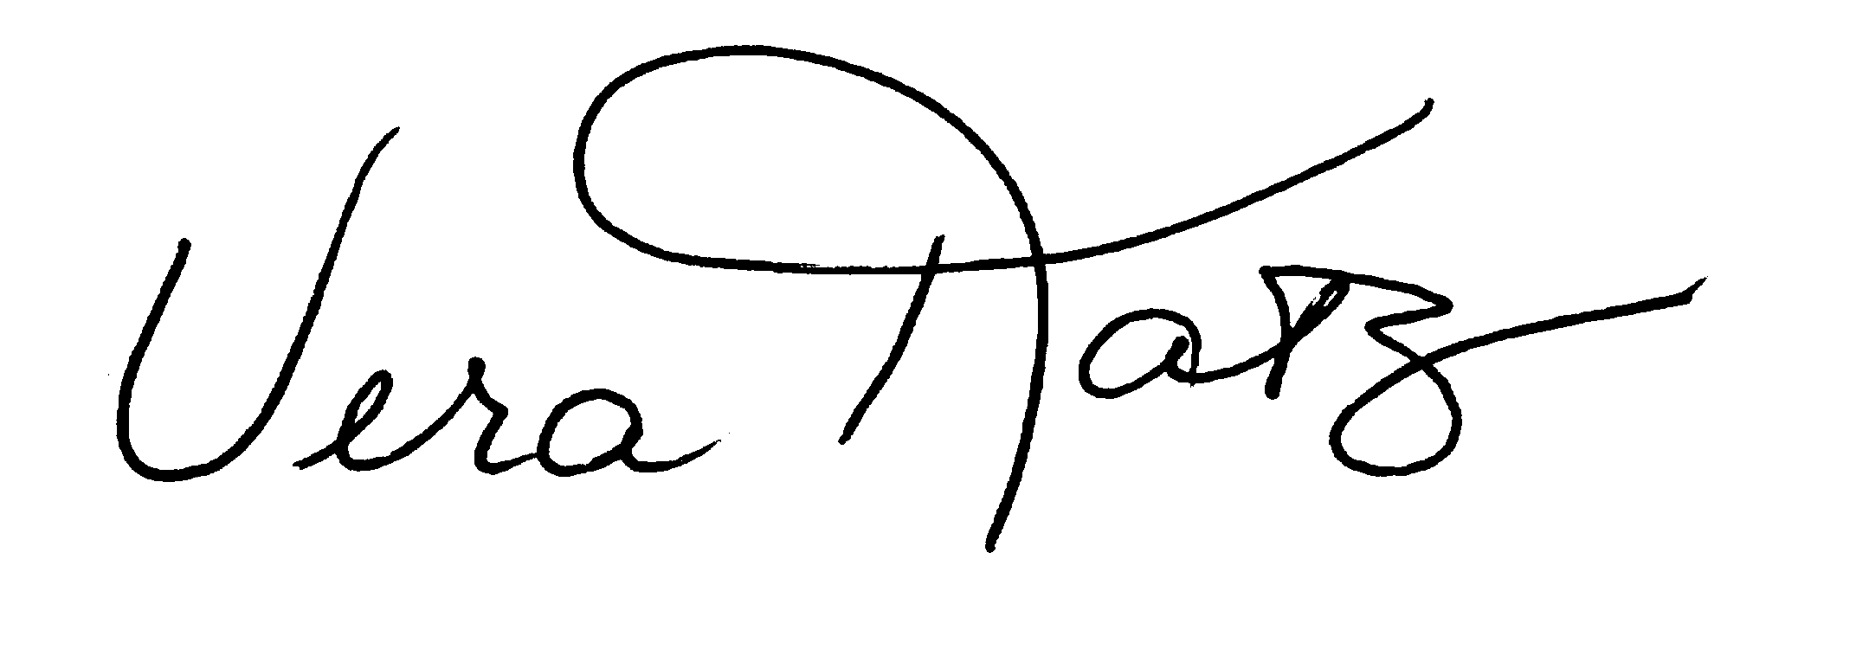  Vera Katz, Mayor  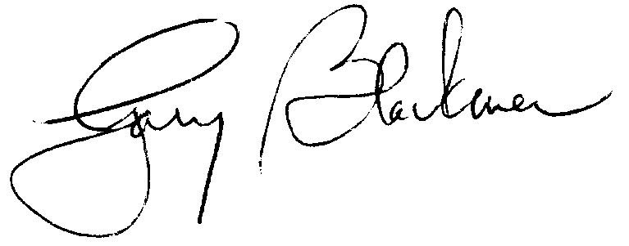  Gary Blackmer, Auditor
THIS BOND SHALL NOT BE VALID UNLESS PROPERLY AUTHENTICATED BY THE PAYING AGENT IN THE SPACE INDICATED BELOW.
CERTIFICATE OF AUTHENTICATION
This Bond is one of a series of $_________aggregate principal amount of City of Portland, Oregon Limited Tax Revenue Refunding Bonds, 2003 Series ___, issued pursuant to the Ordinance described herein.
Date of authentication: _______, 2003.
U.S. Bank, N.A., as Paying Agent

Authorized Officer
ASSIGNMENT

FOR VALUE RECEIVED, the undersigned sells, assigns and transfers unto

(Please insert social security or other identifying number of assignee)
this Bond and does hereby irrevocably constitute and appoint as attorney to transfer this Bond on the books kept for registration thereof with the full power of substitution in the premises.

Dated:
----------------------------------------------
NOTICE: The signature to this assignment must correspond with the name of the registered owner as it appears upon the face of this Bond in every particular, without alteration or enlargement or any change whatever.

NOTICE: Signature(s) must be guaranteed by a member of the New York Stock Exchange or a commercial bank or trust company | Signature Guaranteed  __________________________________  (Bank, Trust Company or Brokerage Firm)  __________________________________  Authorized Officer

The following abbreviations, when used in the inscription on the face of this Bond, shall be construed as though they were written out in full according to applicable laws or regulations.

TEN COM -- tenants in common
TEN ENT -- as tenants by the entireties
JT TEN -- as joint tenants with right of survivorship
and not as tenants in common
OREGON CUSTODIANS use the following
_________________ CUST UL OREG __________________ MIN
as custodian for (name of minor)
OR UNIF TRANS MIN ACT
under the Oregon Uniform Transfer to Minors Act

Additional abbreviations may also be used though not in the list above.

