Asset Identifiers:  14844  _______________________________  Created by & Date:  Rick Davis, 8-17-2021  _______________________________  Revised by & Date: | Facility:  Bell Drive Pump Station | Asset Location:  Bottom of Pump Station
Asset Description:

Primary sludge pump, Former Pump #2

SYMBOL | ENERGY TYPE | X | MAGNITUDE |  | SYMBOL | ENERGY TYPE | X | MAGNITUDE
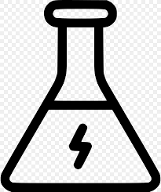 | Chemical |  |  |  |  | Electrical | X | Electrocution
 | Mechanical | X | Accidental Start up |  | 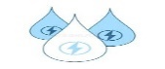 | Hydraulic | X | Engulfment
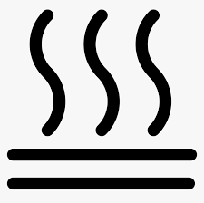 | Thermal |  |  |  | 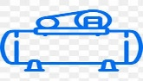 | Pneumatic
 | RF Radiation |  |  |  |  | Gravitational
Check | Lockout Application Process | Check | Lockout Removal Process
 | Notify affected Personnel. |  | Ensure all tools and items have been removed.
 | Properly shut down unit. |  | Confirm all employees are safely located.
 | Isolate all energy sources. |  | Verify controls are in neutral.
 | Apply all lockout devices |  | Remove lockout devices and re-energize the unit.
 | Verify total de-energization of all sources. |  | Notify affected employees servicing is completed.
# | Energy | Lockout Location | Method | Type of Device
1 |  | Local Disconnect or MCC | Open disconnect unplug if possible  and/or open breaker at MCC | Tree, tag, & lock
2 |  | Suction Valve | Close Suction Valve | Tag, lock, tree, & cable
3 |  | Discharge Valve | Close discharge valve | Tag, tree, lock, & cable
4 |  | Seat water | Close seal water valve | Tag
5 |  | Drain Valve | Open drain valve  Bleed off system pressure | N/A

