Background Information on
Amendment Request 17:

Height Change for North of the Marquam Bridge

A request to amend allowed heights north of the Marquam Bridge to decrease allowed height adjacent to the greenway and increase allowed heights away from the greenway.

Companion document to:

North Macadam Project:
Amendments Report
(October 25, 2002)

City Council Hearing
October 31, 2002
2:00 P.M.
Memorandum

Date: October 31, 2002

To: City Council

From: Marie Johnson, Project Leader – North Macadam Plan

Re: Amendment Request 17 – Height Change North of Marquam Bridge

Attached is the Background Information on Amendment Request 17: Height Change North of Marquam Bridge. This document serves as additional background information regarding the Portland Development Commission (PDC) request to amend the required heights near the RiverPlace development north of the Marquam Bridge. A hearing scheduled for 2:00 p.m. on Thursday, October 31, 2002, to allow testimony specific to this proposed amendment.

At the October 9, 2002 City Council hearing on the Recommended North Macadam Plan, the PDC brought forward a modified version of an amendment request originally made to (and denied unanimously by) Planning Commission in August. The amended version would better reflect a step down in height to the river by increasing the area subject to a 35-foot height limit, decreasing height limits from the existing 125/150 feet to 75 feet on a portion of the site, and putting in place a 200-foot height limit on the remainder of the site. The request does not include any increase in allowed floor areas on the site and would result in more open space on the site than development under the existing code.

The Background Information on Amendment Request 17: Height Change for North of Marquam Bridge includes the following maps and illustrations:

- Map 1: Existing Maximum Heights

- Map 2: Properties Proposed for Height Changes

- Map 3: Site of Proposed Development for the South Waterfront Area

- Map 4: Site Map for Proposed Development

- Illustration: Black and white cross section of existing and proposed building heights

Please feel free to contact me or any other North Macadam Plan staff member if you have any questions about this amendment or other elements of the North Macadam project.

Map 1: Existing Maximum Heights in South Waterfront Area

Map 2: Properties Proposed for Height Changes

Map 3: Site of Proposed Development for the South Waterfront Area

Map 4: Site Map for Proposed Development

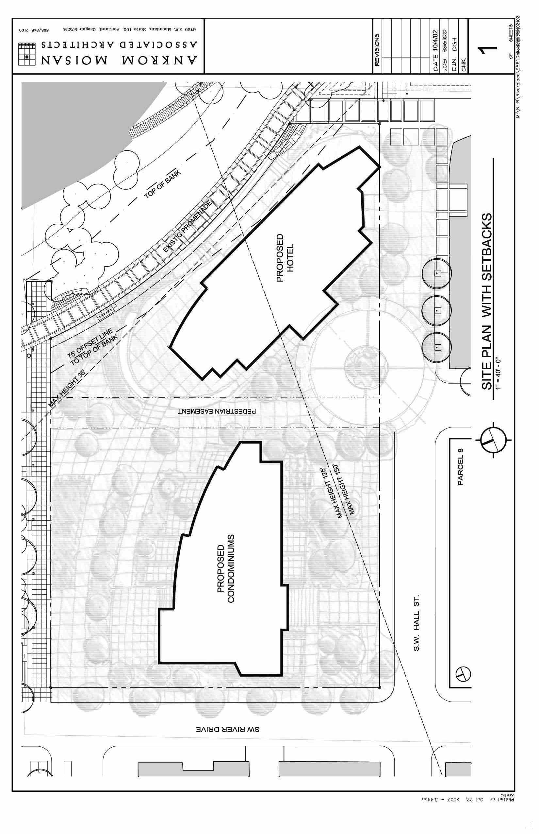

Illustration: Cross-section of existing and proposed building heights

