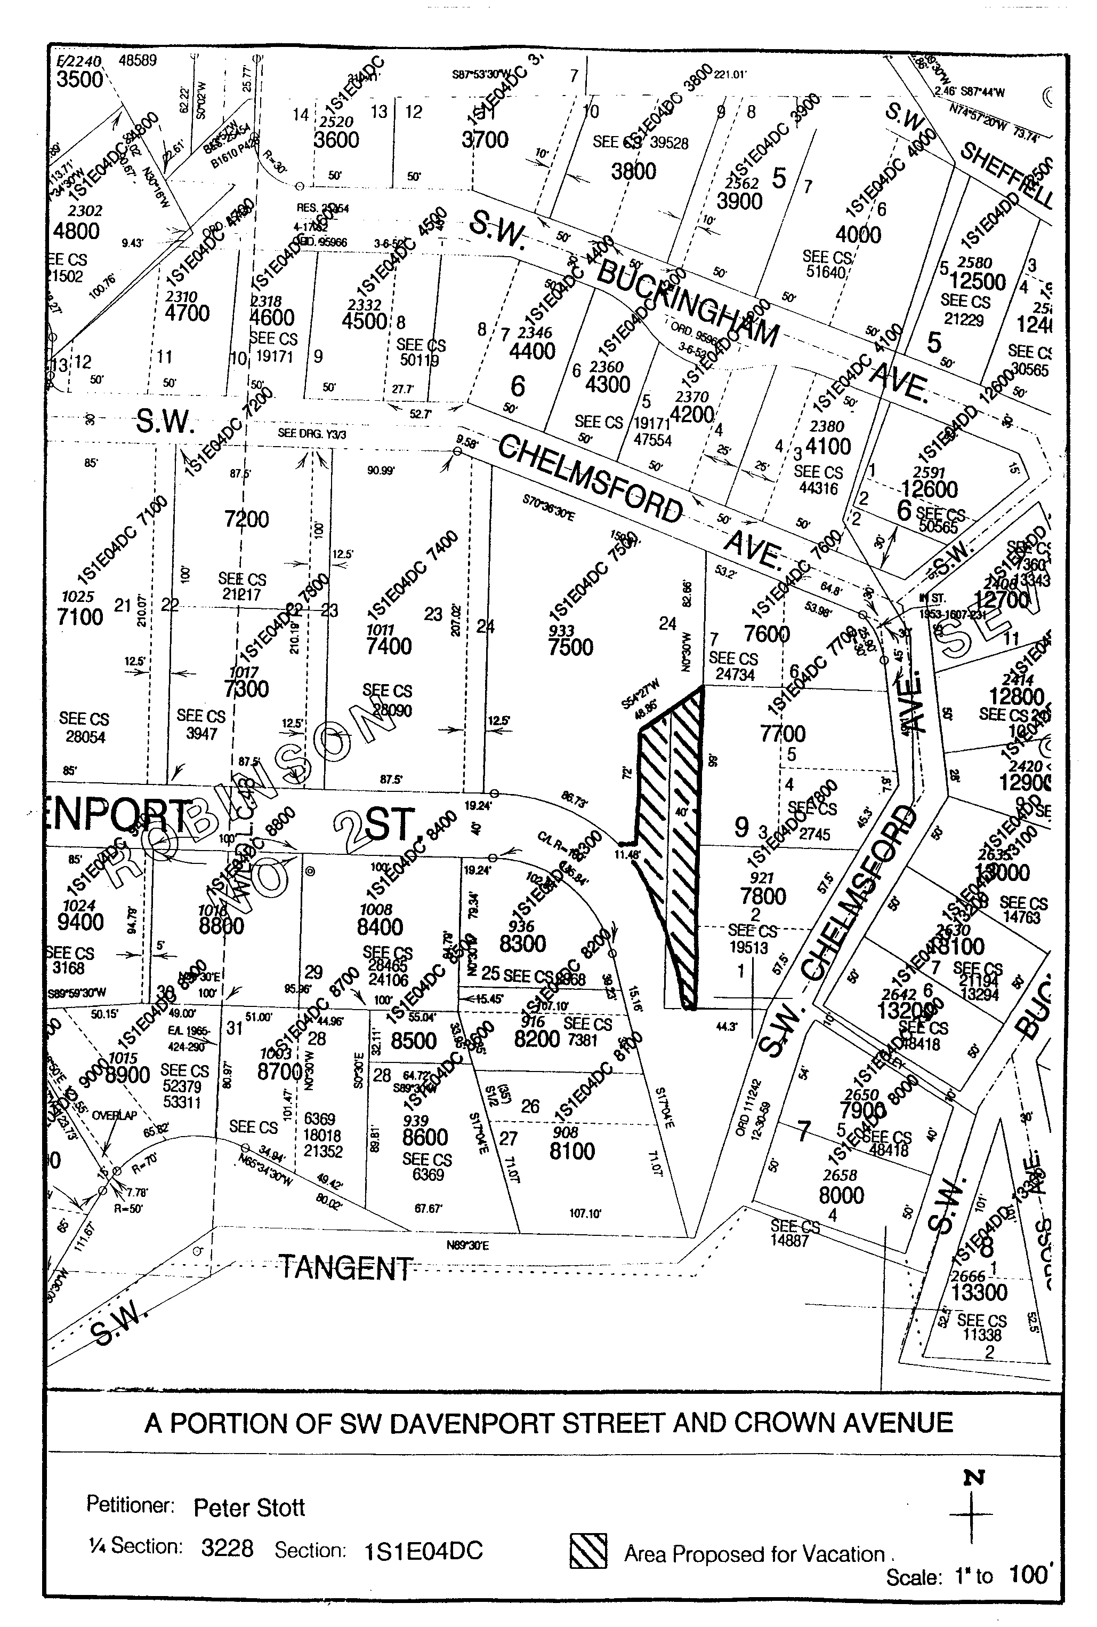Exhibit A
Exhibit A - Page 1
Exhibit A - Page 2
A PORTION OF SW DAVENPORT STREET (CROWN AVENUE)

