EXHIBIT B
Properties Being Assessed

The map below shows properties within the NW Thompson Road LID that will be assessed. Specific lists of properties are identified below. Assessment amounts shown reflect accrued project interest through 9/18/02. Any delay in final assessment beyond this date will result in increased assessments to reflect additional project interest. The reduction in assessed area on the largest parcel reflects a 57.85% buildout rate. All parcels’ property ownership information is as of 5/28/02.

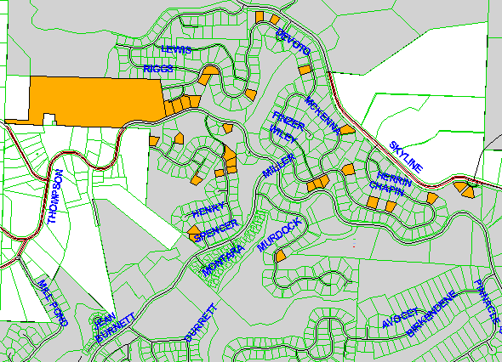

 | State ID | Property Tax Number | City Lien Number | Legal Description | Lot | Actual Area | Assessed Area | Project Share | Recording | Final Assessment
1 | 1N1W23C 800 | R961230300 | 109627 | Section 23 1N 1W |  | 791,493 | 457,879 | $1,157,468.01 | $ 28.00 | $1,157,496.01
2 | 1N1W23CD 2700 | R291786400 | 124262 | FOREST HTS ESTATES NO 6 | 342 | 14,932 | 14,932 | $ 37,746.49 | $ 28.00 | $ 37,774.49
3 | 1N1W23CD 2800 | R291786380 | 124261 | FOREST HTS ESTATES NO 6 | 341 | 14,038 | 14,038 | $ 35,486.56 | $ 28.00 | $ 35,514.56
4 | 1N1W23CD 2900 | R291786360 | 124260 | FOREST HTS ESTATES NO 6 | 340 | 13,226 | 13,226 | $ 33,433.91 | $ 28.00 | $ 33,461.91
5 | 1N1W23CD 3000 | R291786340 | 124259 | FOREST HTS ESTATES NO 6 | 339 | 15,053 | 15,053 | $ 38,052.37 | $ 28.00 | $ 38,080.37
6 | 1N1W23CD 3300 | R291786280 | 124256 | FOREST HTS ESTATES NO 6 | 336 | 11,442 | 11,442 | $ 28,924.15 | $ 28.00 | $ 28,952.15
7 | 1N1W23CD 3400 | R291786260 | 124255 | FOREST HTS ESTATES NO 6 | 335 | 14,146 | 14,146 | $ 35,759.57 | $ 28.00 | $ 35,787.57
8 | 1N1W23DC 1200 | R291780420 | 109551 | Forest Hgts Estates No 2 | 71 | 12,142 | 12,142 | $ 30,693.67 | $ 28.00 | $ 30,721.67
9 | 1N1W23DC 4100 | R291786120 | 124248 | FOREST HTS ESTATES NO 6 | 328 | 11,985 | 11,985 | $ 30,296.79 | $ 28.00 | $ 30,324.79
10 | 1N1W23DC 5900 | R291785800 | 124232 | FOREST HTS ESTATES NO 6 | 312 | 10,897 | 10,897 | $ 27,546.45 | $ 28.00 | $ 27,574.45
11 | 1N1W23DC 6800 | R291786900 | 124287 | FOREST HTS ESTATES NO 6 | 367 | 8,263 | 8,263 | $ 20,887.98 | $ 28.00 | $ 20,915.98
12 | 1N1W23DC 7000 | R291786860 | 124285 | FOREST HTS ESTATES NO 6 | 365 | 10,385 | 10,385 | $ 26,252.16 | $ 28.00 | $ 26,280.16
13 | 1N1W26AA 2000 | R291783880 | 124332 | FOREST HTS ESTATES NO 4 | 225 | 11,355 | 11,355 | $ 28,704.22 | $ 28.00 | $ 28,732.22
14 | 1N1W26AA 2900 | R291784500 | 124323 | FOREST HTS ESTATES NO 4 | 256 | 12,948 | 12,948 | $ 32,731.15 | $ 28.00 | $ 32,759.15
15 | 1N1W26AA 3100 | R291784460 | 124321 | FOREST HTS ESTATES NO 4 | 254 | 11,136 | 11,136 | $ 28,150.61 | $ 28.00 | $ 28,178.61
16 | 1N1W26AA 400 | R291784620 | 124355 | FOREST HTS ESTATES NO 4 | 262 | 12,072 | 12,072 | $ 30,516.72 | $ 28.00 | $ 30,544.72
17 | 1N1W26AA 500 | R291784640 | 124356 | FOREST HTS ESTATES NO 4 | 263 | 12,333 | 12,333 | $ 31,176.50 | $ 28.00 | $ 31,204.50
18 | 1N1W26AB 1300 | R291784600 | 124328 | FOREST HTS ESTATES NO 4 | 261 | 14,438 | 14,438 | $ 36,497.71 | $ 28.00 | $ 36,525.71
19 | 1N1W26AB 5400 | R291780260 | 109543 | Forest Hgts Estates No 2 | 62 | 8,148 | 8,148 | $ 20,597.27 | $ 28.00 | $ 20,625.27
20 | 1N1W26AB 5500 | R291780280 | 109544 | Forest Hgts Estates No 2 | 63 | 8,450 | 8,450 | $ 21,360.69 | $ 28.00 | $ 21,388.69
21 | 1N1W26AB 5600 | R291780300 | 109545 | Forest Hgts Estates No 2 | 64 | 8,944 | 8,944 | $ 22,609.47 | $ 28.00 | $ 22,637.47
22 | 1N1W26AC 1400 | R291784940 | 124221 | FOREST HTS ESTATES NO 5 | 275 | 10,780 | 10,780 | $ 27,250.68 | $ 28.00 | $ 27,278.68
23 | 1N1W26BA 1600 | R291782240 | 110068 | Forest Hgts Estates No 3 | 151 | 9,442 | 9,442 | $ 23,868.36 | $ 28.00 | $ 23,896.36
24 | 1N1W26BA 2100 | R291782160 | 110066 | Forest Hgts Estates No 3 | 147 | 11,033 | 11,033 | $ 27,890.24 | $ 28.00 | $ 27,918.24
25 | 1N1W26BA 3000 | R291782500 | 110073 | Forest Hgts Estates No 3 | 164 | 9,792 | 9,792 | $ 24,753.12 | $ 28.00 | $ 24,781.12
26 | 1N1W26BA 4700 | R291781940 | 110063 | Forest Hgts Estates No 3 | 136 | 13,309 | 13,309 | $ 33,643.72 | $ 28.00 | $ 33,671.72
27 | 1N1W26BA 4800 | R291781920 | 110062 | Forest Hgts Estates No 3 | 135 | 9,598 | 9,598 | $ 24,262.71 | $ 28.00 | $ 24,290.71
28 | 1N1W26BA 4900 | R291781900 | 110061 | Forest Hgts Estates No 3 | 134 | 7,875 | 7,875 | $ 19,907.15 | $ 28.00 | $ 19,935.15
29 | 1N1W26BA 6300 | R291783100 | 110089 | Forest Hgts Estates No 3 | 194 | 7,858 | 7,858 | $ 19,864.18 | $ 28.00 | $ 19,892.18
30 | 1N1W26BA 6400 | R291783080 | 110088 | Forest Hgts Estates No 3 | 193 | 9,457 | 9,457 | $ 23,906.28 | $ 28.00 | $ 23,934.28
31 | 1N1W26BA 700 | R291783200 | 110094 | Forest Hgts Estates No 3 | 199 | 8,690 | 8,690 | $ 21,967.39 | $ 28.00 | $ 21,995.39
32 | 1N1W26BA 9100 | R291782540 | 110075 | Forest Hgts Estates No 3 | 166 | 7,175 | 7,175 | $ 18,137.63 | $ 28.00 | $ 18,165.63
 |  |  |  |  |  | 1,132,835 | 799,221 | $2,020,343.91 | $ 896.00 | $2,021,239.91

