September 14, 2020

To: Portland City Council

From: Mike Houck, Urban Greenspaces Institute

Re: LU 20-102914, DZM ADGW Alamo Manhattan River Blocks 41 & 44

and Greenway

Mayor Wheeler and Commissioners,

We have testified three times at the Design Commission to express our concerns about the development as proposed. We appreciate the fact that City Council is paying attention and scrutinizing what will be a significant development on the banks of the Willamette River with equally significant impacts to the Willamette Greenway.

In our opinion the project continues to meet the bare minimum standards which do not warrant the greenway bonus. This is one of two remaining segments of the Willamette Greenway trail on the west side of the river. City Council should insist that the Greenway design be exemplary, not minimal. We are adamantly opposed to issuance of FAR bonus based on the applicant’s proposed additional “public space.” Both from the applicants graphics and interactions between the applicant’s team and the Design Commission our take away was the project as proposed does not approach the level of “public benefit” that would warrant the generous bonus of additional 125 feet of height.

The applicant’s decision to retain the compromised concrete wall is unfortunate. Information we have received from the city staff indicates the wall is severely compromised and provides a safety hazard. Additionally, leaving the wall in place makes restoration of the river bank in that area impossible. We urge that you require removal of the cement wall and restoration of the bank.

We have also written Prosper Portland and Portland Parks and Recreation urging them to provide funds so the Greenway design can be improve beyond the minimum standards. Our understanding is that funds were offered but refused by the development proponents. These funds would make it possible for the applicant to remove the cement wall and increase vegetation along the Greenway.

Finally, our biggest concern is the provision in the Design Commission’s recommendation that the developers have a four year window within which they may implement the Greenway. This leads to our opposing approval of the project as proposed. The Design Commission’s final recommendation states, as a condition of approval: “*Prior to occupancy of the first building permit on the site, all greenway improvements approved under this review must be installed in conformance with Exhibits C.259 through C.266.* ***Or if improvements are deferred, a performance guarantee must be provided per 33.510.253 D.4.b and all improvements must be installed within 4 years of occupancy of the first building*** *on site. Note: LU 17-160442 LDS, condition C.2 requires the applicant to install at a minimum one of the required greenway trails prior to occupancy of buildings on Lot 1 and 4 (Blocks 41 and 44)*.”

City Council should require the developer to install the Greenway, with enhanced design, to be completed concurrent installation of the full Greenway plan with occupancy of the first building. As we have stated repeatedly in our earlier testimony to the Design Commission, the Willamette Greenway is not an “amenity”, an “add on”, to be completed on a delayed time table after occupation of the buildings.

Respectfully,

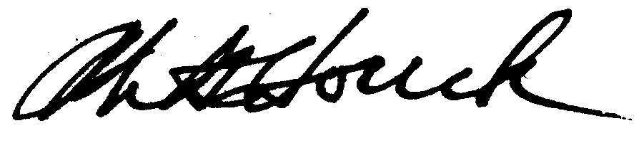

Mike Houck, The Urban Naturalist