 June 10, 2020

*In Livable Cities is Preservation of the Wild*

P.O. Box 6903 l Portland, OR 97228-6903 l 503.319.7155 l **www.urbangreenspaces.org**

**STAFF**

**Ted Labbe**

*Executive Director*

**Mike Houck**

*Urban Naturalist*

**OFFICERS**

MJ Cody

*Chair*

Mike Faha

*Vice-Chair*

Bob Wilson

*Secretary-Treasurer*

**BOARD**

Daniela Brod

Steffeni Mendoza Gray

Mel Huie

Tom Liptan

Kelly Punteney

Nadja Quiroz

Jim Rapp

Ruth Roth

Judy Bluehorse Skelton

To: Portland Design Commission

From: Mike Houck

Re: Comments, LU 20-102914 DZM GW, Alamo Manhattan

Chair Livingston and Commissioners,

I am writing on behalf of the Urban Greenspaces Institute to provide our input on the current iteration of the proposed Alamo Manhattan project. We appreciate the fact that the applicant has responded positively to many of our earlier objections regarding the Greenway design. Specifically, we are pleased that trees have been added to subarea two and subareas 1 and 2. The staff report states that the additional trees were in accordance with the city’s Urban Forester. We will assume that means the applicant intends to provide larger form trees and native species.

That said, I want to reiterate our earlier position that the Greenway design be equal in quality and performance to that of the Greenway to the north at South Waterfront. The Greenway is not an “amenity.” It’s an essential element of the city’s infrastructure and a resource of regional significance. This leads to our outstanding concern, which results in our opposing approval of the project as proposed in the staff report. On page 41 of the staff report, staff indicates as a condition of approval: D.2, *Prior to occupancy of the first building permit on the site, all greenway improvements approved under this review must be installed in conformance with Exhibits C.259 through C.266. Or, if improvements are deferred, a performance guarantee must be provided per 33.510.253.D.4.b and all improvements must be installed within 4 years of occupancy of the first building on the site*.

Not withstanding the staff note: *Note: LU 17-160442 LDS, condition C.2*

*requires the applicant to install, at a minimum, one of the required greenway trails*

*prior to occupancy of buildings on Lots 1 and 4 (Blocks 41 and 44),* granting a four year delay in installation of the Greenway is unacceptable. As we have stated repeatedly in our earlier testimony, the Greeway is not an amenity, an “add on”, to be completed on a delayed time table after occupation of the buildings. We request the Design Commission deny approval of the project unless there is concurrent installation of the full Greenway plan with completion of the buildings.

During exchanges between Commissioners and applicant at earlier hearings it was suggested the Commission might approve the height bonus contingent on the applicant’s initially installing a “base line” Greenway design and commit to an “enhanced” design at some point in the future. We would oppose such an arrangement. If the bonus is granted based on an “enhanced” Greenway and additional public benefit the design should be installed up front, not at an uncertain future date.

This raises another issue we addressed in earlier testimony as well. Our understanding is Prosper Portland continues to express an interest in a partnership agreement that would provide additional funding to allow for an enhanced Greenway. We continue to support that effort and hope the applicant will engage with Prosper Portland, Portland Parks and Recreation, and urge the Design Commission to press the applicant on this issue.

Additional concerns we ask the Commission to address:

1. Building 41 continues to abut the Greenway to closely. Planters, which are meant to define public from private space, encroach into the Greenway setback in the SE corner.
2. While the applicant plans to screen the concrete pier we continue to feel the pier represents a hazard that should be removed not merely screened.
3. With regard to vegetation we are pleased that the applicant has agreed to respond positively to the city’s Urban Forestry Division with regard to substituting larger form trees, use of species listed by Forestry, and the addition of 14 additional trees in Subarea 2 and 10 trees in subarea It is not clear, however, whether the applicant has responded to Commissioner Santner’s recommendation to beef up the shrub layer with larger form shrubs to create a “layering” effect from the larger form trees to multiple layers of shrubs and ground cover that would be more diverse in diversity of species and form. However, the landsape graphics are confusing in that there is no legend that provides information on what the different colors represent e. g. pink and lavender in particular.
4. Pilings: In addition to removal of the wooden pier, it’s unclear whether the applicant will remove all pilings which we have requested in earlier comments.

Respectfully,

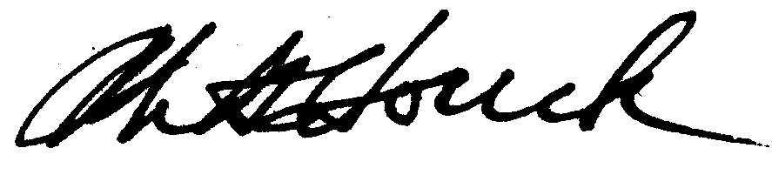

Mike Houck