June 10, 2020

Re: 20-102914 DZM GW Alamo Manhattan

Members of the Design Commission:

Completion of the 40 Mile Loop, including the Willamette Greenway Trail in Southwest Portland has been a goal shared by the City of Portland and our organization for nearly 40 years. The 40 Mile Loop Land Trust enthusiastically supports completion of the Willamette Greenway Trail at the Alamo Manhattan project. Between downtown and the Sellwood Bridge only two gaps remain in the Greenway Trail and this project will close one of them. As has occurred with other developments along the Willamette, **we urge that all Greenway improvements be completed as a condition of occupancy and not be deferred under any circumstance**.

We also understand that the developer has not yet committed to the removal of the relic concrete structure fronting the River. The removal of the structure is essential both from a public safety perspective and from a broader perspective of years of efforts made by the City and other property owners to reclaim and restore the Willamette Greenway at the River’s edge. We ask that the developer work with the City as a partner to make this happen.

Respectfully,

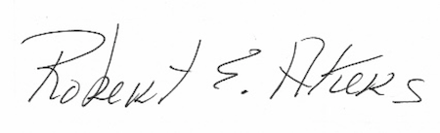

Robert “Bob” Akers, President

40 Mile Loop Land