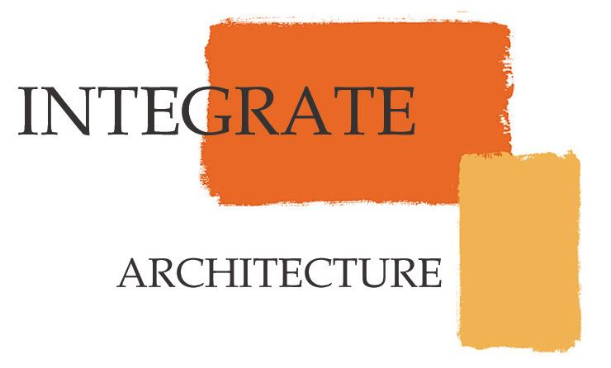

Saint Andrews Condominiums
January 3, 2008

Meeting #1 –Project Introduction and Initial Structural Design Meeting

John Reilly
Bill Hawkins
Phil Sydnor
Greg Vickers – Vickers Nelson Associates
Josh Richards – KPFF

- Preliminary structural design discussion
  - Basement/ First Floor – Concrete Structure
  - Post-tensioned concrete floor slabs
  - Steel framing 2nd floor through 6th floor
  - Shell – 1” thick stone veneer supported with 6” cmu

- Site Conditions to consider
  - Stable Basalt Rock which can be excavated
  - One sided form work on basement level
  - Contact Civil engineer - PSI

- Sound Attenuation
  - Consider triple glazed windows on facade facing highway and windows closer to highway on front and back facades
  - CMU block behind stone will assist in blocking out highway noise
  - Contact “Listen Acoustics” – Toban Cooley
  - Exterior Water features at outdoor areas
  - Tempered Glass on Roof Terrace Parapet Walls

- Architectural
  - Thermal/Moisture – third party consultant/ review?
  - Review stairs for ADA/ Life Safety Compliance (Area of Refuge Requirement)
  - Roof Terrace may be covered pending Penthouse Client
  - Finalize parking layout
  - Phil to finalize preliminary drawing package and begin 3d site analysis

- Mechanical/ Electrical
  - To be Design Build
    - Oregon Electric
    - American Heating or ??

- NEXT STEPS
  - Finalize design consultants fee proposal
  - Project goals
  - Project roles – define Client, Architect, Construction Manager
  - Confirm date and agenda for meeting #2
  - Finalize preliminary drawing package
  - Begin 3d site analysis

