Get to know the
Comprehensive Plan Map App

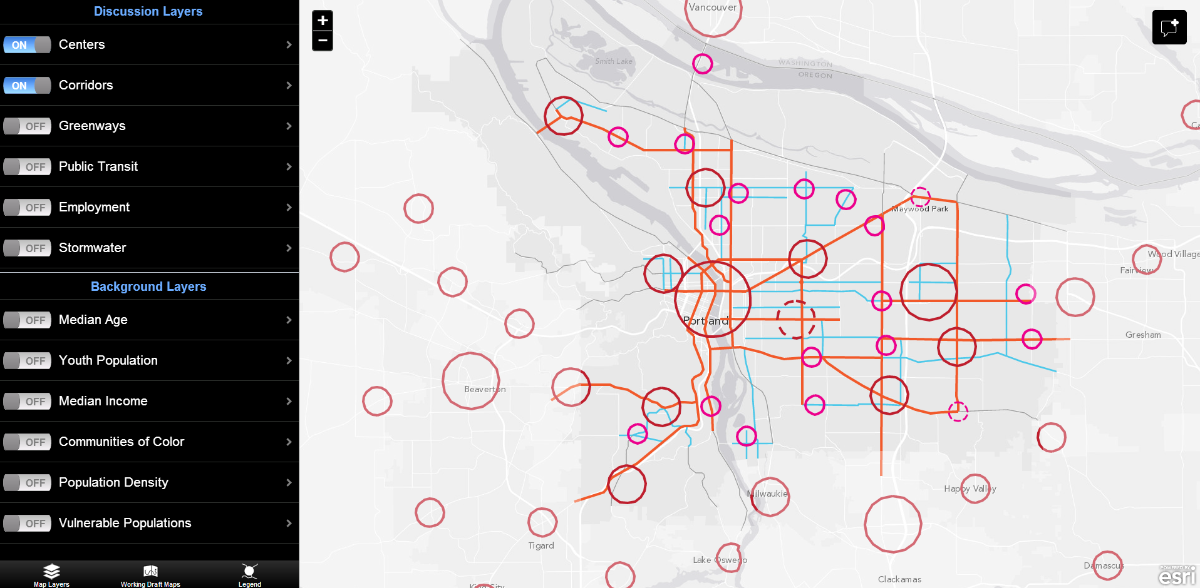
This interactive online tool allows people to explore the city geographically, and learn about a variety of different topics and areas of the city, as shown through map “layers.” Layers include anticipated new housing or job development and where the City may want to invest in new infrastructure, like water and sewer facilities and parks and streets, to name a few. It also includes maps of current conditions.

Discussion Layers include new ideas that could change the Land Use Map, inform the Urban Design Framework or inform a change to the Goals and Policies or Citywide Systems Plan. Each layer has a legend and background information. Background Layers show existing conditions.

You can explore and comment on the Map App at http://www.portlandoregon.gov/bps/pdxcompplan/mapapp.

The layers in the Map App will be used to create:
- The Land Use Map
- The Urban Design Framework
- Maps in the Citywide Systems Plan and the Transportation System Plan

Comments on the maps will also lead to revisions to the Goals and Policies developed in the Working Draft Part 1.

The Map App provides a way for everyone with access to a computer or tablet—in your home, at your school, or at a Multnomah County Library—to explore maps of the city and help determine what Portland could look like and how it should grow over the next 20 years.

Don’t have access to a computer or tablet? Call or visit the Bureau of Planning and Sustainability to review paper copies of the maps.

Map App Layers

Discussion Layers
Centers
Central City and Regional Centers
Town Centers
Neighborhood Centers
Corridors
Civic Corridors
Neighborhood Corridors
Employment
Central City Industrial
Prime Industrial Land
Columbia Harbor New Industrial Land
Dispersed Employment Land
Campus Institutions
Multimodal Freight Corridors and Terminals
Public Transit
Transit Station Areas
Streetcar Corridors
High Capacity Transit Corridors and Stations
City Greenways
Urban Habitat Corridors and Areas
Stormwater Management Challenges
Water Investments
Sewer/Stormwater Investments
Parks and Recreation Improvements (Desired)
Transportation Investments

Background Layers
Median Age
Youth Population
Median Income
Communities of Color
Population Density
Vulnerable Populations
Gentrification Risk
Neighborhoods & Pattern Areas
Business Associations
Economic Dev
Employment Areas
Park Access
Natural Area Access
Tree Canopy
Watershed Health
Complete Neighborhoods
Employment Access
Transit Access
Bicycle Access
Flood Hazard
Parks
Zoning
Earthquake Hazard
Landslide Hazard
Natural Resources
Connectivity
Cultural Resources

Working Draft Maps
UDF (Urban Design Framework)
The Urban Design Framework illustrates Portland’s future intended physical form, highlighting areas of growth and change. The framework focuses growth in centers and corridors, identifies key connections, fosters a system of habitat corridors, and recognizes Portland’s five major pattern areas with unique characteristics and assets.
Land Use Changes
This map identifies land use changes being considered as part of the Comprehensive Plan Update, including 1) changes that will advance Comprehensive Plan policy direction; 2) parcel-specific changes evaluated through formal public processes but not adopted; and 3) potential changes identified through community discussions, but which would require further analysis, broader public discussion and property owner notification prior to adoption.
Land Use Requests
This map shows a variety of potential parcel-specific land use and zoning changes requested by individuals and organizations. New requests will be added to this map over time. These requests have not been evaluated by staff.
Future Study Areas
This map shows some initial, generalized areas where either community discussions or staff analysis points towards a need to consider land use changes to better achieve community aspirations and City goals. Resolving these issues is not included in the scope of the Comprehensive Plan Update.

