Appendix A1 – Contractor Letter

CITY OF

PORTLAND, OREGON

PORTLAND HOUSING BUREAU
Nick Fish, Commissioner
Traci Manning, Director
421 SW 6th Avenue, Suite 500
Portland OR 97204
(503) 823-2375
Fax (503) 823-2387
www.portlandonline.com/PHB
May 31, 2012

Re: FY 2012-13 PHB Proposed Contract and Budget Process

To: Name
Organization
Street Address
City, State Zip

Dear Name:

This letter covers three important topics:

- Year-end billing requirements for your current contracts;
- Time-sensitive budget information concerning FY 2012-13 contracts;
- Introduction to contractual changes to align with PHB’s Equity Agenda.

1. Year-End Billings and Closeout
The City’s 2011-12 fiscal year ends June 30, 2012. The deadline for submitting your final bill for the current fiscal year is MONDAY, July 9, 2012, 5:00 PM. PHB must receive billings on time in order to include all fiscal year expenditures in the year-end closeout and audit. Even if your contract is extended into the 2012-13 fiscal year, you still need to meet the July 9 deadline for all 2011-12 expenses.

2. Beginning the Process for Completing Contracts
We look forward to contracting with you, our community partner, to provide quality housing and effective, culturally competent services to low-income Portland residents for the coming year.

The table below lists preliminary financial information for the contract you oversee, based on our current budget information. Please visit www.tinyurl.com/dyka4s for the most current City Council budget schedule. Final amounts will be confirmed by your contract manager as soon as PHB has them.

Contract Manager | Phone | Email
Name | Number | Email Address

Program Title | Budgeted Amount | Fund Source
Program Title | $0.00
Program Title | $0.00
Contract Total | $0.00

Please complete the following attachments and return them to your contract manager no later than June 22nd, 2012, close of business. Late submissions may result in delayed processing of your contract, delayed payments and/or a potential reduction or loss of funding. Contact your PHB contract manager well in advance of the deadline if there are significant reasons why you are unable to submit all required documents on time.

3. Introduction to Contract Changes Aligned to PHB’s Equity Agenda
PHB has launched our equity agenda. On May 17th we held a meeting with all of our contractors where we introduced three changes that will be included in every contract.

- PHB’s Guiding Principles on Equity and Social Justice
PHB’s Guiding Principles were developed from input from community members and in collaboration with our equity business plan consultant. They build on the work of PHB’s equity and diversity council who developed our Statement on Equity and Social Justice.

The Guiding Principles are the next iteration of that document. The purpose of the Guiding Principles is to clearly communicate PHB’s Equity and Social Justice values that we hold for ourselves and to set expectations for our partners. (See attached.)

The Guiding Principles will become part of every communication and public document published and utilized by PHB starting with our contracts in FY 2012-13.

- New Participant Demographics Report
As part of PHB’s Equity Agenda and to better support our strategic plan and budget we are working to refine our data collection and reporting systems. This will enhance our ability to work with data and to drive decision-making that supports PHB and community goals.

Beginning in FY 2012-13 every sub recipient contract will include a new Participant Demographics Report. (See attached.) The report form is provided here and as an exhibit to the contract for reference. This new format is compatible with HMIS (Service Point), and aligns with what Multnomah County is asking of its contractors.

The new report will allow for greater flexibility in reporting people who identify as multi-racial and includes clear instructions on how to report the people you serve.

- Goal Setting Process
PHB has initiated the inclusion of equity access goals across all of its business lines and program areas. Equity goals are a vital tool in PHB’s efforts to distribute PHB resources to communities with the highest needs and the least historical access to those resources.

To set individual contract access goals, we are asking all of our contractors to do the following:

- Review your organizations’ service levels by race and ethnicity for the last fiscal year.
- Share with PHB any work your organization is undertaking to support equity and inclusion by responding to the questions in Section 8 Diversity and Equity, of the Contractor Proposal Cover Sheet.
- Develop access goals for FY 2012-13 by race and ethnicity to be incorporated into your contract by the end of the first quarter.
Together, your City Contract managers, PHB Program Managers, and PHB Leadership team will evaluate the proposed goals across programs and work closely with your agency to establish goals put in place by the end of the first quarter in FY 2012-2013.

We look forward to partnering with you in the months and years ahead to advance greater equity in housing in our communities.
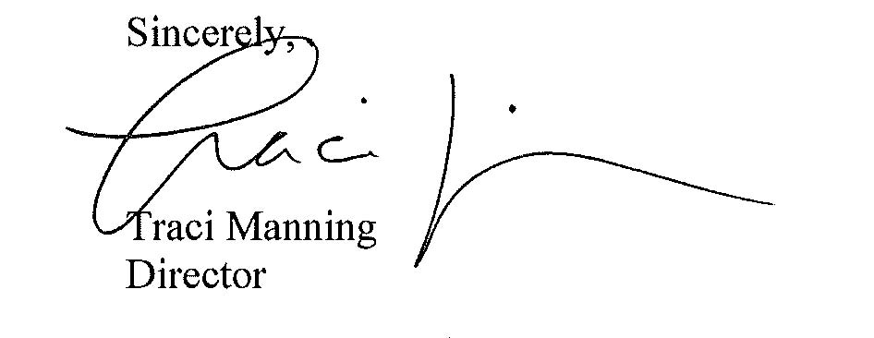

Encl

