Multnomah County: Portal to the Region

“Migration is the most complex and volatile demographic
variable …More educated and more adventuresome people
are more likely than other people to move … [They] are
more likely to move at certain stages of their lives,
especially when they marry, divorce, or retire.”
(McFalls, Population: A Lively Introduction, 4th ed.; p. 14,
Population Reference Bureau, 2003)



Multnomah County contains the largest population of all counties in Oregon, within the smallest geographic area. This small territory acts as the gateway to the metropolitan region, attracting nearly a third of all people -- domestic and foreign -- migrating to the region. Within the region, migration flows outward from Multnomah County, which sends nearly twice as many people to neighboring counties as it receives from them.

While Americans in general tend to be settling down, Multnomah County’s population is more restless. The majority of people who lived in Multnomah County in 2000 moved sometime in the five years prior. It is a magnet for highly educated, young singles from around the U.S. Even though Multnomah County attracted many new residents, it was the only county in the region where people arriving from within the U.S. did not keep pace with people leaving the county. Immigrants from abroad helped to stabilize Multnomah County’s population, erasing the loss.

Partially as a result of migration patterns within the U.S., Multnomah County has the lowest percentage of families with children in the region -- a trend that appears to be continuing. Many of Multnomah County’s young families with children tend to move to the surrounding counties, particularly if they are in the upper income range. In concert with this finding, Multnomah County gained large numbers of singles while losing married couples. At the same time, it posted big gains in renters, while losing almost as many homeowners.

Census migration data reveal several trends about Multnomah County and the region [See back for data notes.]:

A boom in 20-29 year olds
- More than one-third of all newcomers to Multnomah County were in their twenties. This group accounted for 51% of Multnomah County’s resident 20-29 year-olds in 2000.
- In the flow of population between the U.S. and Multnomah County, 20-29 year-olds was the only age group in the County that had a net gain in population.
- Despite these gains in young adults, Multnomah County lost population to the other counties in the region in every age group except 20-24 year-olds.
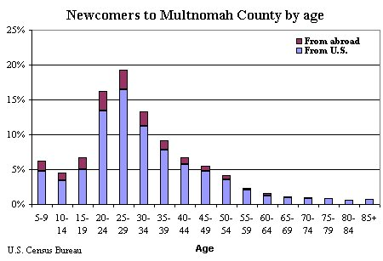
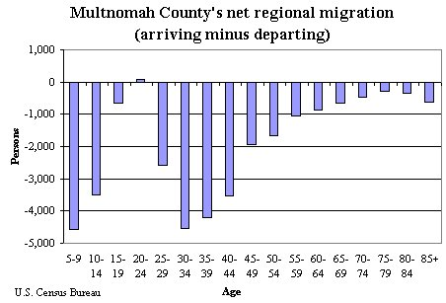

Families with children, who have the means, tend to move to neighboring counties
- More families with children left Multnomah County than moved in. No other county in the region had a net loss of families with children.
- Sixty-seven percent of the County’s net loss of population within the region was from the age groups that most represent families with children (5-19 and 30-44).
- Multnomah County had net population losses with its regional neighbors in every household income group, including wealthier families with children.
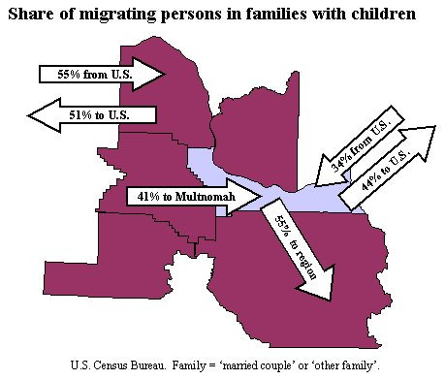

Movers from abroad kept Multnomah County growing
- Sixty percent (15,020) of the people who migrated to Multnomah County from abroad were in a family with children under 18, compared to 36% (44,570) of people who moved to Multnomah from elsewhere in the U.S.
- Movers from abroad showed two distinct patterns of educational attainment: those who didn’t complete high school, and those with a graduate degree or higher. If it weren’t for these immigrants, Multnomah County would have posted a decline in residents with graduate or professional degrees. On the other end of the spectrum, 34% of immigrants to Multnomah County had less than a high school diploma.
- Multnomah County received 8,510 people in poverty from abroad.
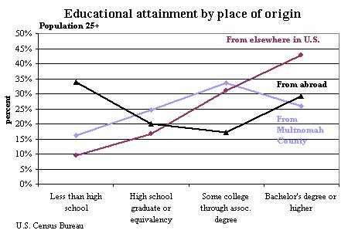

Level of educational attainment influences mobility
- Persons on either end of the educational attainment spectrum were more mobile than those in the middle.
- Level of attainment also affected the distance of the move -- 47% of people who moved to Multnomah County from outside of the region had a BA or higher, while 32% of those who moved to Multnomah County from one of its neighboring counties had a BA or higher. The same ratio holds true for out-migrants (38% with a BA or higher moving out of the region vs. 30% moving from Multnomah County to a regional neighbor).
- Those who moved within the county had the lowest percent with a BA or higher (26%) -- lower than both non-movers and movers from abroad (around 29% each).

People in poverty from outside the region most often arrived in Multnomah County, while its residents in poverty were more likely to move into the other counties of the region
- Nationally, Multnomah County posted a net gain of 1,080 people in poverty from outside the region.
- More persons in poverty left Multnomah County for its regional neighbors than came in to Multnomah from the region (-1,552 net); in addition, of the people who moved within their own county, those in poverty were more mobile in Multnomah County than those within other regional counties.
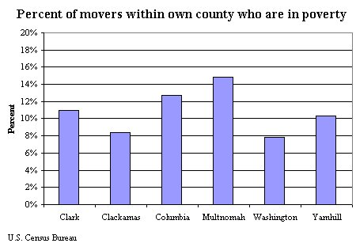

Multnomah County draws young migrants who are just starting careers, homes, and families. Several cautionary trends are revealed by the data that need further investigation, including the displacement of the poor within the County and the loss of families with children.

To learn more about the region, the Progress Board, or to receive notification of further reports and analytical pieces on demographic topics that are shaping our community, please visit our web site: http://www.p-m-benchmarks.org

About the Progress Board
The Portland Multnomah Progress Board was established in 1993 to develop a vision for our community and establish benchmarks that measure our progress toward that vision. The Board tracks benchmarks representing issues such as:
Civic Participation Governance
Economy Health & Families
Education Public Safety
Environment Urban Vitality
In addition to regular updates on benchmark trends, the Progress Board conducts more in-depth analyses of particular benchmarks. These studies are intended to provide a deeper understanding of the forces affecting our community. By identifying the best strategies for improving benchmarks we can achieve a better community.

The Portland Multnomah Progress Board is comprised of community leaders from local government, business, education, and non-profit organizations.
The Progress Board is co-chaired by the Mayor of the City of Portland and the Chair of the Multnomah County Board of Commissioners.

The Portland-Vancouver Primary Metropolitan Statistical Area (PMSA)
In this report the term ‘region’ represents the Portland-Vancouver PMSA, a federally designated labor market. The PMSA is comprised of five counties in Oregon and one in Washington. It is important to note that Multnomah County’s population is twice the size of both Clackamas and Clark Counties, and one-and-a-half times the size of Washington County’s.
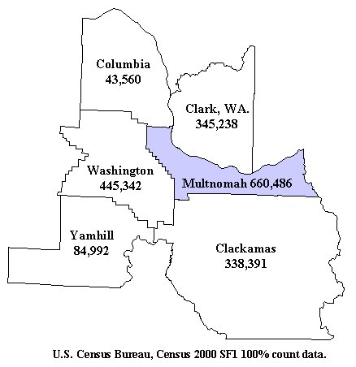

Data Notes
The data for this report are from the U.S. Census Bureau’s Migration Files. They are derived from a two-part question on the Census 2000 long form, asking the respondent if she lived in the same house or apartment 5 years ago, and if not, where did she move from. The universe is the population age 5 and above, except for educational attainment (25 and above). For population living in households (i.e., family data) the Census Bureau rounded data to the nearest 10.
Definitions
Migrants: people who moved across some jurisdictional boundary between 1995 and 2000.
In-migrant & out-migrant: people who moved within the U.S. between 1995 and 2000.
Net migration equals in-migrants minus out-migrants.
Immigrants: people who moved here from abroad (i.e., a resident of Multnomah County in 2000 who lived outside of the U.S. in 1995).

