Are we making progress?

1999 Summary

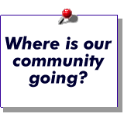
We want a thriving region that allows our citizens to lead fulfilling lives in safe and caring communities. The job of the Portland Multnomah Progress Board is to help achieve that vision.

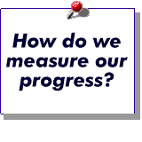
The Portland Multnomah Progress Board, established in 1993, created 76 benchmarks that gauge the conditions in our community. We use the benchmarks to measure progress toward our community's vision.

~~~~~~~~~~~~~~~

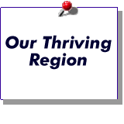
The local economy has been strong and expanding. The number of jobs grew over the past ten years and unemployment is down. But average pay for a job in Multnomah County has not kept pace with pay elsewhere in the region.
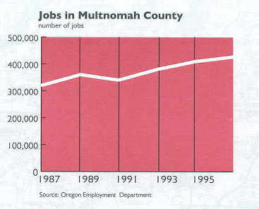

Conservation, environmental programs and regulations have contributed to some improving trends in our natural environment, but the region still faces challenges. Residential water consumption, energy use and solid waste have declined since the early 90s. While air quality has significantly improved in the region since the mid-1980s, automobile use has increased carbon dioxide and ozone levels.

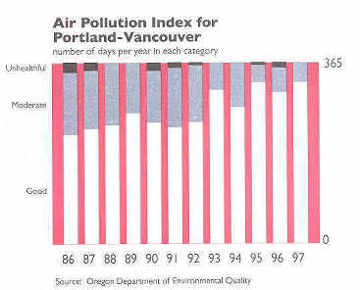

Urban development is affecting natural habitats by increasing sediments and pollutants in our streams. As a result, the region is searching for solutions to improve its watersheds and restore native salmon populations.

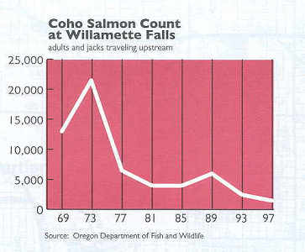

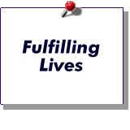
Our citizens are becoming better educated. The percent of Multnomah County residents with an associate or baccalaureate degree increased from 22% to 29% in the past six years. Reading skills and math skills of students have generally increased.
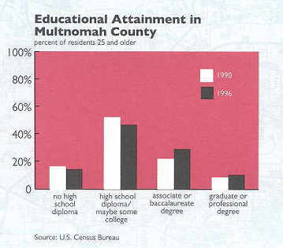

The health of citizens in Multnomah County has also improved, with health care available to about 90% of them, up from 84% just two years ago.

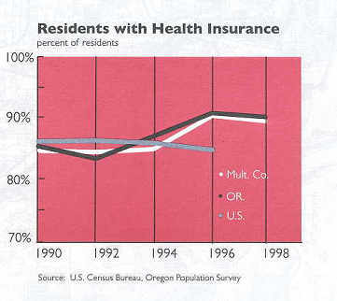

Some families continue to be buffeted by economic and social forces. More people live in poverty now than in 1980, many of them children. Domestic violence also continues to exact a toll on children and families. Drug use among students is no longer declining and, for younger age groups, is beginning to increase. In addition, drug-related deaths more than doubled in the past six years.

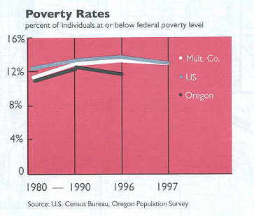

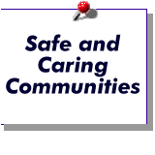
Citizens are generally safer, and they feel safer, in our community. Reported crimes against people are declining and property crimes are steady. Since 1993, citizens in Multnomah County feel increasingly safe on their neighborhood and downtown streets.
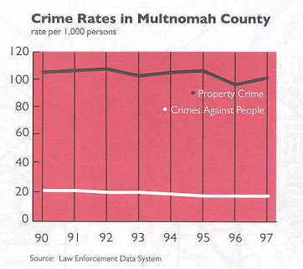

Citizen ratings of their neighborhood livability continue to climb, but ratings of local government services dipped slightly after four years of improvement. Citizens have voted to invest for the future with large capital efforts for parks, transit, libraries, and other improvements. At the same time the general burden of local taxes has declined since 1987 due to citizen initiated property tax limits, which has reduced school funding.

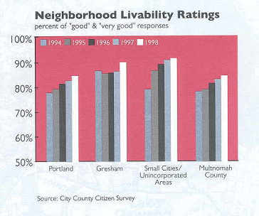

Major Challenges for our Community

Economy
Our local economy has prospered through most of the past ten years. During that time our timber-based economy has been shored up with many more diverse industries. This diversity gives us greater resilience when particular economic sectors suffer. While per capita income is up, this strong economy has not produced any substantial reductions in the number of people living in poverty. In addition, our position may worsen if the recent financial problems of our trading partners in Asia do not improve. The quality of our workforce, the quality of life in our region, and the entrepreneurial spirit of our business leaders are our greatest resources.

Education
Our education system must become the best at preparing students to participate fully in the economy of our community. The Oregon Educational Act for the 21st Century sets clear and measurable standards of student achievement and goals for what we teach our children to meet the needs of the next century. Yet we face grave concerns in our community about the funding to achieve this vision. Sustaining adequate and stable funding is essential for local schools to succeed. In addition, post-secondary education funding must be sufficient to provide for the changing skills and research needed in the future. Parents, community leaders, public officials, and students are bringing these issues to the public's attention.

Environment
The natural riches of our region – ocean, forests, mountains, desert – are just a short distance from our doorstep. Our community is the first major urban area in the nation directly affected by the Endangered Species Act. The decline in salmon and steelhead populations here, and throughout the Pacific Northwest, is the result of many activities that are part of our daily lives – electricity from dams, forestry, agriculture, roads, industry, and urban development. The Governor’s Salmon Plan is a means for all of us to share in solutions to preserve our natural riches.

Urban Vitality
The livability of our region attracts many new residents who contribute to the richness and diversity of our community. This population growth puts demands on our transportation, housing, water, and other services that are reaching the limits of their capacity. Healthy growth ensures that all residents can live in affordable housing, in caring communities, with efficient transportation and parks and open spaces nearby. We face the challenge of continuing to make the right decisions to preserve the livability of our community and ensure access to the natural riches of our environment.

