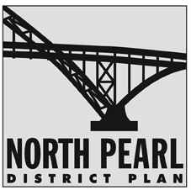
North Pearl District Plan
Recommended Zoning Code Amendments to City Council
October 2008

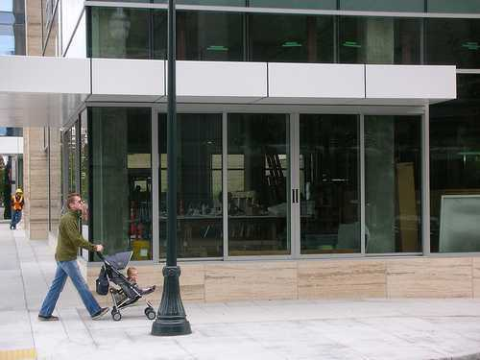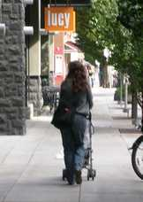



The Bureau of Planning is committed to providing equal access to information and hearings. If you need special accommodation, please call 503-823-7700 (TTY 503-823-6868).

For more information on the North Pearl District Plan please contact:

Troy Doss, Senior Planner, Project Manager
Portland Bureau of Planning
1900 SW 4th Ave, Ste 7100
Portland OR 97201

Phone: 503-823-7700
Internet: www.planning.ci.portland.or.us
Email: pdxplan@ci.portland.or.us

Acknowledgements

Portland City Council
Tom Potter, Mayor
Sam Adams, Commissioner
Nick Fish, Commissioner
Randy Leonard, Commissioner
Dan Saltzman, Commissioner
Portland Planning Commission
Don Hanson, President
Amy Cortese, Vice President
Michelle Rudd, Vice President
André Baugh
Catherine Ciarlo
Howard Shapiro
Jill Sherman
Irma Valdez
Portland Design Commission
Lloyd Lindley, Chair
Jeffery Stuhr, Vice Chair
Tim Eddy
Andrew Jansky
Ben Kaiser
Guenevere Millius
David Wark

Bureau of Planning
Gil Kelley, Planning Director
Joe Zehnder, Principle Planner
Project Management Team
Troy Doss, Project Manager - Bureau of Planning
Steve Shain, Project Lead - Portland Development Commission
Steve Iwata, Project Lead - Portland Office of Transportation
Project Staff
Kara Fioravanti, BDS
Mauricio Leclerc, PDOT
Douglas Hardy, BDS
Jeff Joslin, BDS
Phil Nameny, Planning
Carmen Piekarski, Planning
Mark Raggett, Planning
Nicolas Starin, Planning
Kim White, Planning
Ningsheng Zhou, PDOT

Project Advisory Group
Jeff Bacharch, Riverscape
Robert Ball, Pearl Real Estate
John Bradley, Northwest Neighborhood Association
John Cusack, Pearl District Business Association
Scott Davies, R&H Construction
Jillian Deleuw, Hoyt Street Properties
Mark Edlen, Gerding Edlen Development
Patricia Gardner, Pearl District Neighborhood Association
Ben Gates, Central City Concern
John Hirsch, Pearl District Neighborhood Association
Kirsten Lee, Pearl District Neighborhood Association
Ed McNamara, Turtle Island Development
John Meadows, BOORA Architect
Tamara Paulat, Pearl Resident
Tad Savinar, Property Owner
Al Solheim, Property Owner
Tanya Starr, Pearl Resident/Port of Portland
Barbara Storrs, Bridgeport Brewery
Tiffany Sweitzer, Hoyt Street Properties

Additional Acknowledgements
Eric Sten, Past Commissioner
Jim Middaugh, Commissioner Sten’s Office
Paul Schlesinger, Past Planning Commission President
Mike McCulloch, Past Design Commissioner Chair

Amendments to Title 33, Planning and Zoning

This document presents the Planning Commission recommended amendments to the Portland Zoning Code, Title 33, to implement elements of the North Pearl District Plan. This package of amendments also includes proposed amendments offered to City Council that are supported by staff. Any additional amendments made by Council will be included in a final version of these amendments reflecting the Council adopted package.
Generally the amendments create a new subarea of the Central City Plan District. This new subdistrict is called the North Pearl Subarea which would replace and amend the boundaries of the existing Northwest Triangle Subarea, which is in the River District Subdistrict. The existing development standards of the Northwest Triangle Subarea are not proposed to be amended; however, additional development standards in this subarea are proposed. These amendments implement the proposed policies of the North Pearl District Plan.
Commentary is included throughout this document that addresses specific amendments. Existing code sections where no change is being made have not been included unless the information they contain is needed for better understanding of the amendments being made in other sections.
Code language to be added is underlined. Code language to be removed is shown in strikethrough.

CHAPTER 33.293
SUPERBLOCKS

33.293.020 Where the Superblock Regulations Apply

A. Central City plan district.

References to the Northwest Triangle in this section, and in all other sections of the Zoning Code, are to be changed to reference the North Pearl Subarea.

CHAPTER 33.293
SUPERBLOCKS

33.293.020 Where the Superblock Regulations Apply
Superblocks are subject to the regulations of this chapter as stated below.

A. Central City plan district. The superblock regulations apply to all new development and major remodelings on sites that include 5,000 square feet or more of vacated street. The regulations apply in all of subdistricts of the Central City plan district except the Downtown and Northwest Triangle subdistricts and North Pearl Subarea.

Chapter 33.510
Central City Plan District

The Table of Contents page for this chapter is being changed to reflect:
- A name change for the Northwest Triangle Subarea to the North Pearl Subarea
- The addition of a new section to the Central City Plan District which identifies additional standards specific to the North Pearl Subarea. These additional standards are described in detail later in this document. This section also contains the North Pearl Subarea Open Area and Waterfront Development standards.

CHAPTER 33.510

CENTRAL CITY PLAN DISTRICT

Sections:

General
33.510.010 Purpose
33.510.020 Where the Regulations Apply
33.510.030 Application of Regulations Along Proposed Rights-of-Way and Accessways

Use Regulations
33.510.100 Vehicle Repair Uses
33.510.105 Vehicle Sales or Leasing
33.510.110 Mixed Use Waterfront Development
33.510.112 Commercial Parking
33.510.113 Retail Sales And Service and Office Uses in the IG1 Zone
33.510.114 Exemptions for Portland State University
33.510.115 Additional Uses Allowed in the Open Space Zone
33.510.116 Retail Sales And Service Uses for Specified Sites in the CX and EX Zones
33.510.117 Retail Sales And Service and Office Uses in the RX Zone
33.510.118 Use Regulations for Specified Sites in the West End Subarea
33.510.119 Retail Sales And Service and Office Uses in Specified Historic Resources in the IG2 and IH Zones
Development Standards
33.510.200 Floor Area Ratios
33.510.205 Height
33.510.210 Floor Area and Height Bonus Options
33.510.215 Required Building Lines
33.510.220 Ground Floor Windows
33.510.221 Required Windows Above the Ground Floor
33.510.223 Exterior Display and Storage
33.510.224 Mechanical Equipment along the Portland Streetcar Alignment
33.510.225 Ground Floor Active Uses
33.510.226 Minimum Active Floor Area
33.510.230 Required Residential Development Areas
33.510.240 Drive-Through Facilities
33.510.242 Demolitions
33.510.245 Northwest Triangle Open Area Requirement
33.510.250 Northwest Triangle Waterfront Development
33.510.251 Additional Standards in the North Pearl Subarea
33.510.252 Additional Standards in the South Waterfront Subdistrict
33.510.253 Greenway Overlay Zone in the South Waterfront Subdistrict
Development Standards

33.510.200 Floor Area Ratios

C. Limit on increased floor area.
The Zoning Code typically limits the amount of additional floor area that can be achieved on a site either through bonus, transfers, or a combination of both, to 3:1 over the base floor area ratio (FAR) allowed by right. Throughout the portions of the North Pearl subarea located south of the railroad right-of-way, the base FAR will be either 4:1 or 5:1 as a result of the amendments proposed by the North Pearl District Plan (see Map 510-2). Thus, there exists the potential for sites with a base entitlement of 4:1 to be increased to 7:1 and those with a base entitlement of 5:1 may be able to be increased to 8:1 if specific conditions are met.
The primary method for earning additional FAR is through the use of development bonus or development transfer provisions. During the development of the North Pearl District Plan (NPDP) stakeholders expressed an interest in adding additional bonus and transfer provisions to the NPDP plan area (explained in more detail later in this document) which are intended to create public amenities, create a diversity of housing, and to preserve historic resources in the Pearl District. The basis for these additional provisions is to ensure that some level of public benefit to the Pearl District is derived from the granting of additional development potential in the district.
Thus, the amendments to Section 33.510.200 are proposed to allow development bonus and transfer provisions to be used to earn additional FAR on sites within the NPDP plan area. However, because there is concern that buildings could become too massive or tall if too much FAR is made available, projects are limited to a maximum utilization of 9:1 FAR through a combination of base entitlements, development bonuses, and transfer provisions. In limited situations, FAR above the 9:1 limit may be earned if FAR is earned through Central City Master Plan provisions or through the transfer of FAR from designated historic resource sites within the Pearl District.
To ensure that buildings do not become too massive, height and building massing provisions are also proposed for the North Pearl Subarea. These development standards are intended to guide how additional floor area and height can be used in a manner that protects views, provides access to light and air in the public realm, and generally protects and enhances the pedestrian environment in the district.
Setting a limit to FAR utilization in the plan area is also important to ensure that the transportation system serving the plan area can handle the additional capacity/demand that would be created due to new development. Also, within the portion of the plan area located south of Naito Parkway, no maximum height limit is proposed for projects that use development bonus and transfer provisions to exceed the maximum height of the plan area (100 feet or 225 feet depending on location), thus the maximum FAR available to a project becomes the limiting factor to how tall a building may ultimately be constructed.

Development Standards

33.510.200 Floor Area Ratios

A.-B. [No Change]

C. Limit on increased floor area.

1. Generally. Except as provided under C.2 through C.5, 3. and 4., below, increases in FAR, whether by transfers of floor area or bonus floor area options, of more than 3 to 1 are prohibited.

2.-4. [No change.]

5. North Pearl Subarea. In the North Pearl Subarea bonus options target area, shown on Map 510-4, the following applies:

a. An FAR increase of more than 3 to 1 may be earned on a site through the following provisions. However, the total floor area on a site, may not be more than 9 to 1, except as allowed under 5.b. below. Adjustments to the regulations of this paragraph are prohibited:

(1) Floor area bonuses;

(2) Transfers from the site of a historic resource meeting Subsection H., below.

b. The total floor area on a site, including bonus floor area and transferred floor area, may be more than 9 to 1 if the floor area above the 9 to 1 ratio is transferred from the site of a historic resource as specified in Subsection H. below.

D.-G. [No Change]

33.510.200 Floor Area Ratios (cont.)

H. Transfer of floor area from Historic Resources in specified areas.
During the development of the North Pearl District Plan, stakeholders expressed a concern that various older buildings, buildings typically smaller than new development and of an architectural character that reflects the districts industrial past, could be lost as redevelopment continues in the Pearl District. These buildings are prized because of their local architectural and historic significance and also because they help to break up the urban form that may result if all sites in the district fully use the development entitlement and bonus provisions available.
Thus, a new development transfer provision is proposed that could be used only for sites located within the Pearl District. Through this provision, floor area can be transferred from sites designed as a historic landmark, contributing structure in a historic district, or ranked historic resource to development sites within the Pearl Development Transfer Opportunity Area (see new Map 510-20 at the back of this document).
Within this area, floor area can be transferred only from and to sites within the Pearl District if the floor area originates at a site designated as a contributing structure in a historic district or ranked historic resource. Floor area from designated historic landmarks can be transferred within the Pearl Development Transfer Opportunity Area or to sites outside of the area, as is currently allowed by the Zoning Code. In short, these provisions extend the ability to transfer floor area from landmarks to other structures or sites of historic importance within the NPDP plan area.
The ability to transfer floor area from landmarks to sites outside the Pearl Development Transfer Opportunity Area has been retained so as not to disrupt the existing practice and intent behind these provisions. However, the existing and new provisions will be further examined during the development of the Central Portland Plan to determine their applicability to other subdistricts of the Central City Plan District.

33.510.200 Floor Area Ratios

H. Transfer of floor area from Historic Resources in specified areas.

1. Where these regulations apply. These regulations apply to sites located in the Pearl Development Transfer Opportunity Area on Map 510-20.
2. Sites eligible to transfer floor area. Sites eligible to transfer floor area must be located within the area shown on Map 510-20 and must contain:
a. A landmark
b. A contributing resource in a Historic District; or

c. A Rank I, II, or III resource listed in the City’s Historic Resource Inventory.

3. Sites eligible to receive floor area. A site within the area shown on Map 510-20 is eligible to receive floor area from the historic resources listed above in H.2.

4. Covenants. The owners of both the sending and receiving sites must execute a covenant with the City that is attached to and recorded with the deed. The covenants may not be revoked or rescinded. The covenants must include the following:

a. Both sites. The covenant for each site must reflect the respective increase and decrease of potential floor area. The covenant must meet the requirements of Section 33.700.060, Covenants with the City.

b. Sending site. The covenant for the sending site must state that the owner will not demolish or relocate the historic resource unless the City approves the demolition or relocation through demolition review.

5. Exception for Landmarks. Landmarks located in the Pearl Development Transfer Opportunity Area on Map 510-20 may elect to transfer floor area to a receiving site outside of the area on Map 510-20 if they meet the standards of 33.130.205.C or 33.140.205.C.
6. Adjustments. Adjustments and modifications to these regulations are prohibited.

33.510.200 Floor Area Ratios (cont.)
I. Neighborhood facilities within the North Pearl Subarea
As noted earlier in this document, the NPDP proposes changing the name and boundary of the existing Northwest Triangle Subarea to the new North Pearl Subarea. The new boundary includes lands north of NW Lovejoy in the Central City Plan District and extends north to the riverfront. Along the riverfront the boundary for this subarea extends between the Fremont and Broadway Bridges (See Map 510-1). The existing development standards specific to the Northwest Triangle Subarea (sections 33.510.245-250) remain in effect for the subarea but have been moved to a new section (33.510.251). A few additional standards intended to implement the NPDP will also be adopted.
One of the new provisions proposed addresses the need to develop specific community-supportive public amenities in the Pearl District. These amenities are deemed critical in the development of a sustainable and livable high-density neighborhood in the Central City as they provide basic services typical in other neighborhoods of the city. These amenities include a K-8 public school, community center, daycare facilities, and public library.
Many if not all of these uses are small enough that they could be incorporated into a mixed-use residential or commercial project within the plan area. A typical block in the Pearl is approximately 40,000 sq. ft. in area, and many recent projects in the Pearl have developed using approximately 280,000 to 320,000 sq. ft. or 7:1 to 8:1 FAR on a 40,000 sq. ft. site. The largest of the targeted facilities, a K-8 public school, could be built using between 60,000 and 80,000 square feet. Thus, a school would require an FAR of between 1.5:1 to 2:1. Other amenities such as daycare could be built using much less floor area.
To encourage the creation of these amenities as part of a mixed-use project, Section 33.510.200.I, provides that if one or more of the targeted amenities identified above are included within a project or on a site in the plan area, the FAR used to construct the amenity is not counted against the FAR used to develop the sites. The following two examples describe how these provisions could be used:
Example 1: Imagine a site that has a base FAR of 5:1 and an additional 3:1 FAR is earned through development bonuses or transfers (8:1 FAR total) to construct a mixed-use residential project on the site. As part of the project the developer proposes building a K-8 public school that would require an additional 2:1 FAR to develop (bringing the total use of FAR on the site to 10:1). The developer would only need to provide or earn the 8:1 FAR required to build the portion of the project that did not include a school.
Example 2: A developer provides a site to build a public school as a stand-alone project. Let’s say the site had a base entitlement of 4:1 FAR and the school requires 2:1 FAR to develop. In this case the developer could arrange to have the base entitlement of 4:1 transferred for use on other sites in the plan area.
[Continued on next commentary page…]

33.510.200 Floor Area Ratios

I. Neighborhood Facilities within the North Pearl Subarea

1. Purpose. This regulation encourages creation of facilities to serve those who live and work in the North Pearl Subarea. These facilities are necessary elements of a neighborhood.

2. Standards. In the North Pearl Subarea, floor area used for specified neighborhood facilities is not counted towards maximum FAR for the site. The specified neighborhood facilities are public schools, public community centers, daycare facilities for children, and public libraries. To qualify for this provision, the following requirements must be met:

  - Schools. Floor area to be used for public schools does not count towards maximum FAR for the site if the school will be operated by or for a public school district.
  - Daycare. Floor area to be used for daycare facilities for children does not count towards maximum FAR for the site. Applicants may choose to either earn bonus FAR under 33.510.210.C.2, or to have the daycare not counted towards maximum FAR for the site under this subsection. Both provisions may not be used on a site.
  - Libraries. Floor area to be used for public libraries does not count towards maximum FAR for the site if the library will be operated by the Multnomah County Library or does not charge membership fees.

33.510.200.I Neighborhood facilities within the North Pearl Subarea (cont.)

Public Community Centers
Lastly, public community centers are intended to mean uses such as community centers ran by Portland Parks and Recreation and those ran by private or non-profit entities such as the Zimmerman Community Center, Friendly House, the Boys and Girls Club, etc. A public community center may provide spaces for active recreation, meetings, special events, or other recreational or community gathering functions. They may serve children, families with children, residents of all ages or seniors. These centers should be open to the general public whether for free or a fee, but are not intended to serve primarily residents or tenants of the buildings they located within.
For example, common rooms are often developed in some larger residential and office projects. These would not qualify as a public community center. Further, uses developed as an accessory use to a Group Living facility also would not qualify as these uses primarily serve the residents of the facility, not the broader community. In short, this provision is intended to create a public amenity that serves the Pearl District at large and not an individual site. It is in return for this public benefit that the floor area used to create the amenity is not counted against the project housing the amenity. If the use created primarily serves the residents or tenets of the site, unless the amenity is a stand along project, then the floor area used to create the use should be counted against the site.

  - Public community centers. Floor area to be used for community centers does not count towards maximum FAR for the site. Public community centers are not for exclusive use by residents of a site and their guests.
  - All facilities. All neighborhood facilities must meet the following:
(1) The floor area of the facility must be reserved for the exclusive use of the neighborhood facility for at least 10 years from the date a certificate of occupancy is issued for the qualifying floor area. No uses other than those listed in this subsection are allowed.
(2) The applicant must document that there is a binding agreement with an operator for each facility. This documentation must be submitted with the application for design review; and
(3) The property owner must execute a covenant with the City which is attached to and recorded with the deed of the site. The covenant must ensure that the owner will reserve the floor area as specified in I.2.e.(1). The covenant must comply with the requirements of Section 33.700.060.
33.510.205 Height

E. Open space height transfers.
References to the Northwest Triangle in this section, and in all other sections of the Zoning Code, are to be changed to reference the North Pearl Subarea.

Also, this subarea is no longer subject to these height transfer provisions, rather the new regulations of Section 33.510.205.H now regulate how additional height is earned in the subarea. These new provisions are less restrictive in terms of the methods in which height may be earned.

33.510.205 Height

E. Open space height transfers.

1. Purpose. These regulations provide an incentive for the creation and development of needed open space in the Central City plan district.

2. Requirements for open space areas eligible for the height transfer.

a. The proposed open space area must be in the Central City plan district outside of the South Waterfront Subdistrict. If the open space is at a Proposed Open Space location, as shown on the Central City plan map, the site is eligible by right. If the site is not a Proposed Open Space location, the site is subject to the review requirements stated in Paragraph 4., below. Open space sites resulting from the Northwest Triangle North Pearl Subarea open area requirement are not eligible for the height transfer.

b. The area designated for the open space must be dedicated to the City as a public park. The minimum size of the open space must be a full block at least 35,000 square feet in size. However, the open space may be 20,000 square feet in size if located along the alignment of the North Park Blocks.

c. All park improvements must be made by the applicant prior to dedication to the City. The improvements to the park are subject to a major design review using the specific area's design guidelines. The Parks Bureau will provide advice to the Design Commission.

3. – 4. [No change.]

33.510.205.H North Pearl Subarea Height Opportunity Area
INTRODUCTION
During the development of the NPDP, stakeholders expressed a desire to allow the development of taller buildings within the plan area, so long as:
- taller buildings would be built in a manner that protected the pedestrian realm;
- buildings granted more height and/or FAR are of a high design quality;
- buildings do not become so massive that they are completely out of character with the Pearl District; and
- building heights along the greenway is set to maintain views and protect the pedestrian experience along the greenway.
- that be a public benefit is derived when additional height and/or floor area is granted to developers both by right and through the use of development bonuses.
To address these desires, the North Pearl height opportunity area was proposed as an area where bonus height may be granted when: 1) bonus height is approved as a modification through design review; 2) the floor area used in the portion of the building subject to bonus height has been earned via development bonuses or FAR transfers using the Central City Master Plan provisions or Pearl District historic resource provisions (33.510.200.H); and, 3) specific building façade length and floor plate dimensions are met.
Within the height opportunity area bonus height is granted when FAR bonus and transfer provisions are used to create the floor area that will occupy the portion of the building subject to bonus height. This ensures that a public benefit is derived as each of the bonus and transfer provisions used result in the creation or preservation of amenities that the community has deemed important (such as family housing, public open space, green roofs, or the preservation of historic structures).
HEIGHT OPPORTUNITY AREA
Map 510-16 (page 47) illustrates the boundary of the height opportunity area. It should be noted that these provisions regulate height differently east of Naito Parkway / Front Avenue than they do west of the right-of-way. Specifically, east of the right-of-way the regulations allow for an additional 75’ in height (allowing buildings up to 175’ maximum); however, the portion of buildings taller than 100’ is limited to floor plates of 12,500 sq. ft. maximum and facades no longer than 120’. Facades up to 150’ maximum are possible if approved as a modification through design review.
In the area west of the right-of-way the base height is generally 100’; however, a number of parcels adjacent to the Tanner Creek park blocks have a base height of 225’. In this area there is a two tiered approach to granting bonus height. Buildings between 101’ and 175’ have no maximum floor plate requirement but the facade above 100’ may be no longer than 150’. Facades greater than 150’ may be approved as a modification through design review up to a maximum of 180’. A second approach allows buildings taller than 175’, or 225’ when this is the base height, so long as the portion of buildings taller than 100’ is limited to floor plates of
(Continued on Page 18)
H. North Pearl Subarea height opportunity area.

1. Purpose. In the North Pearl Subarea, additional building height may be appropriate to support the goals of the North Pearl Plan. The regulations of this subsection:
- Promote the use of development bonus and transfer provisions to create and support a range of community amenities to serve the diversity of residents and employees in the Central City;
- Create a skyline and urban form that is visually permeable by providing visual access to locations within and beyond the subarea;
- Encourage the development of taller buildings that may accommodate a range and diversity of land uses;
- Result in a dynamic and varied skyline and urban form that contributes to the health, vibrancy, and livability of urban living;
- Shape building massings that allow light and air to penetrate to the street level, enhance pedestrian scale, and create a pleasant, versatile, and active public realm; and
- Provide flexibility to allow a range of uses and building types to be developed in a manner that fulfills the design objectives of this purpose statement.
Additionally, along the waterfront of the North Pearl Subarea the regulations of this subsection also:
- Increase access to sunlight along the greenway and within public and private open space areas developed along the waterfront;
- Develop a dense, active urban waterfront with a vibrant public realm;
- Work with the open area and waterfront development provisions of the North Pearl subarea in the creation of well designed public and private urban open space amenities;
- Facilitate visual and physical access to and along the riverfront for all members of the public;
- Create expanded opportunities for views of the river as viewed from Naito Parkway and Front Avenue, landward portions of the subarea, and locations west of the subdistrict.
- Ensure bonus height granted to sites adjacent to the Fremont Bridge does not significantly affect views of or diminish the aesthetic qualities of the bridge or it’s iconic stature in the Portland skyline.

12,500 sq. ft. maximum and facades no longer than 120’. And once again, facades up to 150’ maximum are possible if approved as a modification through design review.
PURPOSE STATEMENT
As noted in the purpose statement, these regulations are intended to result in taller, more slender buildings by restricting tall building walls or facades that expand an entire block length and the full height of a building. The basis for this is that tall full block development can have a negative impact on urban form and livability if not properly designed. Specifically, tall, bulky buildings can significantly block views through the district, can prevent sun and air from penetrating the street level, and negatively impact pedestrian scale and the public realm.
It is hoped that by allowing more opportunities to use height, developers and architects will choose to use the FAR they have available to them to build taller and sleeker buildings as well as buildings with more complex massings that help to enhance the skyline and add diversity and variety to the urban form of the district. However, it will not be possible in all cases for buildings to comply strictly with the dimensional standards of these provisions so there exists the ability to modify these standards when necessary to address site constraints or essential building programming needs so long as they resulting in a building design that on balance is consistent with the various provisions of the purpose statement.
BUILDING MASSING PROVISIONS
The provisions regulating maximum building façade lengths are intended to set a baseline for all development. Specifically, one subsection of the regulations state that buildings between 100’ and 175’ in height are subject to a maximum façade length of 150’ for the portion of the building above 100’. The intent behind this is to prevent long and tall building walls that may impact views, shade the public realm, or may have a negative impact on pedestrian scale. However, in some situations it may be advisable to allow longer building walls or larger floor plates when necessary to make specific land uses or building types feasible.
Specifically, in some situations it may be advisable to allow modifications to these requirements so that certain building efficiencies can be achieved that may be necessary to make a commercial development, mixed use development, affordable housing, family housing, or senior living project feasible. In some cases longer linear floor plate configurations than the regulations allow, may be necessary to realistically make a project feasible. In many other situations design solutions may exist that would not require a modification. Therefore, modifications to the maximum façade length requirements should only be considered when it is necessary to allow uses envisioned for the plan area but for which design solutions are not possible without a modification.
Furthermore, although the provisions allow for modifications, adjustments to the development standards should not be granted in all situations. Modifications should be granted when design solutions that comply with the standards are not available to address site conditions, programming needs, or other significant constraints. Modifications should not be granted to make development conditions simply more tolerable or comfortable for developers. Thus, the burden of proof falls upon applicants seeking a modification to these provisions and applicants must demonstrate why each additional linear foot of façade length is necessary. In other words, just because longer facades can be approved, the granting modifications to the full length achievable should not be done without just cause.

2. Additional building height above the maximum height limits shown on Map 510-3 may be approved as a modification through design review if H.2.a and b are met, and either H.2.c or d. Except as specifically allowed, adjustments and modifications to this paragraph are prohibited.

a. The site must be in the height opportunity area shown on Map 510-16;

b. The floor area of the building above the maximum height limit shown on Map 510-3 must be:

(1) Earned through bonus FAR provisions;

(2) Transferred by a Central City Master Plan; or

(3) Transferred from a Historic Resource in conformance with 33.510.200.H. Transfer of floor area from Historic Resources in specified areas.

c. The regulations of this subparagraph apply to sites northeast of SW Naito Parkway. Building heights may be increased to 175 feet in the height opportunity area if the following are met:

(1) The floors of the building above 100 feet are limited to 12,500 square feet in area or less; and

(2) The length of any façade above 100 feet may not exceed 120 feet. However, a dimension of up to 150 feet may be requested as a modification through design review.

d. The regulations of this subparagraph apply to sites southwest of SW Naito Parkway. For sites in the height opportunity area where the maximum height allowed for the site by Map 510-3 is 100 feet, applicants may choose to increase height using one of the options of this subparagraph.

(1) Option One: The height may be increased to 175 feet if the length of any façade above 100 feet in height does not exceed 150 feet. However, a dimension of up to 180 feet may be requested as a modification through design review; or

(2) Option Two: There is no maximum height limit if the following are met:

• The floors of the building above 100 feet are limited to 12,500 square feet in area or less; and

• The length of any façade above 100 feet may not exceed 120 feet. However, a dimension of up to 150 feet may be requested as a modification through design review.
33.510.210 Floor Area and Height Bonus Options

C. Bonus floor area options.

1. Residential bonus option.
The residential bonus option has been used successfully to create a tremendous number of housing units in the Pearl/River District over the last decade. However, the majority of this housing consists of studio and 1-bedroom units. Only 25 to 30 percent of the housing in the district is made up of units with 2 bedrooms or more. As the population of the Pearl District continues to diversify there will be a demand for more 2-bedroom and larger units. This is especially true for the growing number of existing residents who are beginning to have children in the district.
Thus, the NPDP proposes that the ability to use the residential bonus option within the plan area be limited to a maximum FAR utilization of 2:1. Currently this provision can be used to earn 3:1 FAR.
The plan further recommends that portions of the plan area within the residential Bonus Options Target Area (see Map 510-4) and the Required Residential Development Area (see Map 510-5) be removed from these areas. The basis for this is that projects within the residential Bonus Options Target Area are required to use the residential bonus option to earn the first 1.5:1 additional FAR before other development bonus options can be used. Additionally, projects within the Required Residential Development Area are required to develop one dwelling unit for every 1,000 sq. ft. of site area. These two provisions were adopted over a decade ago and were intended to result in the production of housing. Now that residential development has taken place in the district, the need for these provisions has passed.
By removing the requirement to build dwelling units, while at the same time removing the requirement to use the residential bonus option before all other provisions, it is hoped that other development bonus and transfer provisions intended to result in new community amenities, a diversity of housing options, and historic resource protection will be more fully utilized in the plan area.

33.510.210 Floor Area and Height Bonus Options

C. Bonus floor area options. Additional development potential in the form of floor area is earned for a project when the project includes any of the specified features listed below. The bonus floor area amounts are additions to the maximum floor area ratios shown on Map 510-2.

1. Residential bonus option.

a. In specified areas, the CX and EX zones outside of the South Waterfront Subdistrict, projects providing housing proposals that include Residential uses receive bonus floor area. New development and alterations to existing development are eligible for this bonus.

(1) In the CX and EX zones outside of the South Waterfront Subdistrict and the North Pearl Subarea, Ffor each square foot of floor area developed and committed as housing, a bonus of 1 square foot of additional floor area is earned, up to an additional floor area ratio of 3 to 1. Sites in the required residential opportunity areas are eligible for this bonus.

(2) In the CX and EX zones in the North Pearl Subarea, for each square foot of floor area developed and committed as housing, a bonus of 1 square foot of additional floor area is earned, up to an additional floor area ratio of 2 to 1.

b. through d. [No Change]

2. - 18. [No Change]

33.510.210 Floor Area and Height Bonus Options (cont.)

C. Bonus floor area options.

19. Efficient family size unit housing bonus option.
As noted earlier in this document, the majority of dwelling units in the Pearl District consists of studio units and 1 bedroom units with, approximately, only 25 to 30 percent of the housing in the district being made up of units with two bedrooms or more. Because the birth rate of families in the Pearl has increased dramatically over the last 10 years and due to the fact that studio and 1-bedroom units are not compatible with the needs of families with children, many more 2-bedroom or larger units will be necessary as the population of the district continues to grow.
Therefore, a new development bonus option is proposed that is intended to create a critical mass (at least 20 units at sites that use this bonus option) of 2- and 3 bedroom units to ensure that enough units of this size are created to be available to families with children as well as residents who seek units with more than 1 bedroom. These units are required to remain relatively small to ensure that this provision could be used to create both market-rate and affordable housing.
Additionally, when this option is used, applicants are required to develop common interior and exterior spaces on sites to allow for residents, especially families with children, to gather and play on site. Such spaces would become extensions of the home especially when units are of a smaller size. These spaces should be designed as a secondary use as part of a storage area or exterior parking or vehicle use area. Rather, the should be design to with the singular objective of providing a safe play for residents to gather and play in a well designed and safe environment that facilitates the its intended purpose.
In exchange for developing these types of units, additional floor area would be earned at a sliding scale. Specifically for every sq. ft. of 2-bedroom units created an additional 2:1 FAR is earned and for every sq. ft. of 3-bedroom units created an additional 3:1 FAR is earned. This bonus option is intended to serve as an alternative to the existing residential bonus option.

33.510.210 Floor Area and Height Bonus Options

C. Bonus floor area options.

19. Efficient family size unit housing bonus option. In the North Pearl Subarea shown on Map 510-1, new development that is designed for family housing receives bonus floor area. Adjustments and modifications to these standards are prohibited.
a. Number of units. The proposal must include at least 20 efficient family size units.
b. Size and bonus. The bonus earned varies with the size of the unit, as follows:
(1) Units with three bedrooms that have no more than 1,200 square feet of floor area earn an additional 3 square feet of floor area for each square foot of area in the unit.
(2) Units with two bedrooms that have no more than 1,000 square feet of floor area earn an additional 2 square feet of floor area for each square foot of area in the unit.
c. Outdoor play area. The proposal must include an outdoor play area that is at least 1,400 square feet in area and is designed so that a 25-foot x 25-foot square will fit entirely within it. No portion of this area may be shared with any vehicle area. Outdoor play areas may be sited within plazas, courtyards, rooftop gardens, or similar open area features and may contain play equipment, sports courts, hard or soft surface areas, or other features that accommodate or facilitate play.
d. Indoor common rooms. The proposal must include at least 400 square feet of indoor occupiable common space that is provided in one or more rooms that are not used for mechanical equipment or storage. These rooms must be accessible to all residents and each room must at least 200 square feet in area.

33.510.251 Additional Standards in the North Pearl Subarea

A. Special building height corridors and building step-backs.

During the development of the NPDP, stakeholders noted that the pedestrian scale of development along NW 13th Avenue should be preserved and enhanced as redevelopment continues in the portions of the Pearl located north of NW Lovejoy Avenue. Thus a new provision requiring that the portion of buildings constructed within the first 20 feet of the right-of-way be limited to a maximum height of 75 feet. This provision is intended to ensure that the scale of development immediately along the street enhances the pedestrian environment by allowing access to sunlight, and that the overall scale of development is not imposing upon the streetscape, allowing the streetscape to be the primary driver of character and urban form along this street. This scale of development combined with the right-of-way standards for the street—which call for the development of loading docks and pedestrian stairs in-lieu of sidewalks—creates a character and urban form unique to this area.
B. Northwest Triangle / North Pearl Subarea Open Area Requirement.
The amendment on the following page would change the name of the Northwest Triangle to the North Pearl Subarea. This amendment also moves existing section 33.510.245 and places it in new section 33.510.251. The provisions of this section would remain the same; however, the boundary of the subarea would be modified as illustrated on Map 510-1 at the back of this document.

33.510.251 Additional Standards in the North Pearl Subarea Sites in the North Pearl Subarea south of the Fremont Bridge must meet the following standards:

A. Special building height. A special building height corridor shown on Map 510-19 is designated along NW 13th Avenue. In this corridor the portion of a building that is within 20 feet of the property line along NW 13th Avenue may be no more than 75 feet in height. Adjustments and modifications to this requirement are prohibited.

B. Open area requirement.

1. Purpose. The open area requirement promotes adequate amounts of light and air, year-round opportunities for outdoor active and passive recreation, visual relief from the built environment, and facilitates circulation for pedestrians to and throughout the Northwest Triangle North Pearl subarea. The open area requirement is intended to produce open areas at a scale comparable to what large sites would have if divided by the 200 foot street grid pattern.

2. The open area requirement.

a. On sites over 40,000 square feet in the Northwest Triangle North Pearl subarea, a minimum of 30 percent of the area over 40,000 square feet must be devoted to open area. The boundaries of the subarea are shown on Map 510-1 at the end of this chapter.

b. Sites where at least one-half the site area is in industrial use are exempt from the open area requirement. However, changes resulting in more than one-half of the site area being in non-industrial uses require compliance with the open area requirement.

c. Open areas may include parks, plazas, covered or uncovered walkways, public fountains, and landscaped features or areas. Open areas do not include areas used for parking or loading, or landscaping within parking areas.

d. Developments which utilize the Central City master plan option may consolidate the required open area of this section and locate it within the boundary of the master plan.

C. Northwest Triangle / North Pearl Subarea Waterfront Development Requirement.
The amendment on the following page would change the name of the Northwest Triangle to the North Pearl Subarea. This amendment also moves existing section 33.510.250 and places it in new section 33.510.251. References to NW Front Avenue would be changed to Naito Parkway because the name of Front Avenue was changed to Naito along sections of the right-of-way several years ago.
Note:
It should be noted that neither the North Pearl Subarea Open Area nor Waterfront Development requirements apply to lands north of the Fremont Bridge. The basis for this is two fold. First, these regulations have never been applicable to the area north of the Fremont Bridge. Second, the waterfront parcels north of the bridge are regulated by a set of “conditions of approval” established during an earlier land division process. These conditions were modeled on the prior NW Triangle Open Area and Waterfront Development requirements and they better meet the intent of these standards as they were crafted to address on-site conditions specific to this area.

C. North Pearl Subarea Waterfront Development

1. Purpose. These standards are intended to assure both frequent views of the river and physical connections to the river and its activities.

2. Where these standards apply. This section applies only to lands between Naito Parkway and the Willamette River.

3. Development standards:

a. View corridors. At least 25 percent of the width of the site (as measured along NW Front Avenue Naito Parkway) must be maintained as a view corridor or corridors. Buildings and covered structures are not allowed in the view corridor.

b. Setbacks for all development from the Willamette River. The minimum setback for all development from the Willamette River is regulated by the Greenway Overlay zones; see Chapter 33.440. In addition, buildings or portions of buildings over 35 feet in height must be set back from the Greenway setback line 1 foot for every 1 foot of height above 35 feet.

c. Maximum building dimension. The maximum building dimension is 200 feet. This standard applies to both building length and depth.

d. Public access. As part of each development, public access for pedestrians must be available and clearly posted between NW Front Avenue Naito Parkway and the Greenway trail.

33.510.265 Parking in the Goose Hollow Subdistrict, Lower Albina Subdistrict, Central Eastside Subdistrict, and River District Sectors 1 and 2.

A. Growth Parking - Table 510-16

Table 510-16 is proposed to be amended to reduce the maximum parking ratios for River District Sectors 1 and 2. Specifically, the ratios would be reduced to allow 2 parking spaces for every 1,000 sq. ft. of net building areas creating an office use. This reduction brings the ratios to a level consistent with the rest of the River/Pearl District including areas more heavily developed with office uses. The basis for this reduction is to ensure that the existing transportation system can handle the growth of additional office uses in the district, which typically produce more peak hour trips than other uses allowed in the plan area. Also, this supports some of the sustainability goals of the North Pearl District Plan that call for a reduction in the total number of vehicle trips to and from the plan area and greater reliance on transit, pedestrian, and bicycle commute trips. It should be noted that the existing ratios were set at a time when the area was primarily a mix of light and heavy industrial sites and was zoned for intense uses, less access to transit was available and fewer pedestrian and bicycle connections existed to the plan area. Recent and future proposed transit and transportation enhancements reduce the need to promote vehicle trips to the plan area.

E. Residential/Hotel Parking.

This amendment is intended to set maximum parking ratios for residential development in the plan area consistent with the ratios used else where in the River/Pearl District. The basis for this amendment is to support some of the sustainability goals of the North Pearl District Plan that call for a reduction in the total number of vehicle trips to and from the plan area and greater reliance on transit, pedestrian, and bicycle trips. It should be noted that the existing ratios were set at a time when the area was primarily a mix of light and heavy industrial sites and was zoned for intense uses, less access to transit was available and fewer pedestrian and bicycle connections existed to the plan area. Recent and future proposed transit and transportation enhancements reduce the need for vehicle trips to the plan area.

Table 510-16
In the Goose Hollow Subdistrict, Lower Albina Subdistrict, Central Eastside Subdistrict, and River District Sectors 1 and 2
Growth Parking: Maximum Number of Parking Spaces Per 1,000 Square Feet of Net Building Area in Office Use
District/Sector (See Map 510-8):
Central Eastside 2 and 3 | Central Eastside 1, 4, 5 and 6 | Goose Hollow | Lower Albina | River District 2 | River District 1
2.5 | 3.4 | 2.0 | 2.5 | 2.5  2.0 | 3.4 [1]  2.0
[1] The maximum ratio for Preservation Parking in River District 1 is 4.1.

E. Residential/Hotel Parking. The regulations of this subsection apply to Residential/Hotel Parking.

1.-2. [No Change]

3. Maximum ratios. There are no maximum ratios., except in River District Sectors 1 and 2 where the maximum ratio is 1.7 spaces for each dwelling unit.

Map 510-1

Central City Plan District and Subdistricts

The Northwest Triangle Subarea of the River District has been renamed and reconfigured. The new North Pearl Subarea includes all of the Northwest Triangle Subarea except for that area south of NW Lovejoy Street, and adds an area north of Lovejoy Street between NW 12th Avenue and I-405. The areas to be brought into the subarea were previously excluded because they were at the time Industrial Sanctuary and not subject to redevelopment efforts now occurring in this area. The areas removed by this amendment have recently been developed and no further significant redevelopment potential exists at these sites.

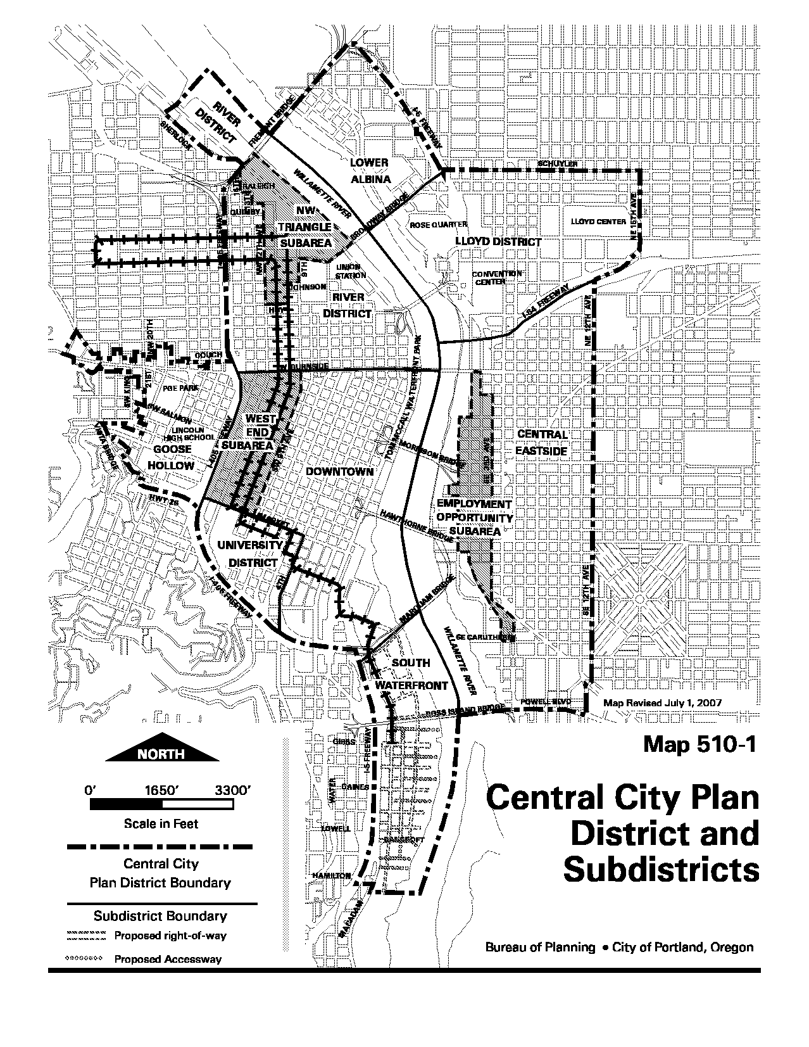
Existing Map:
Proposed Map 510-1
Central City Plan District and Subdistricts

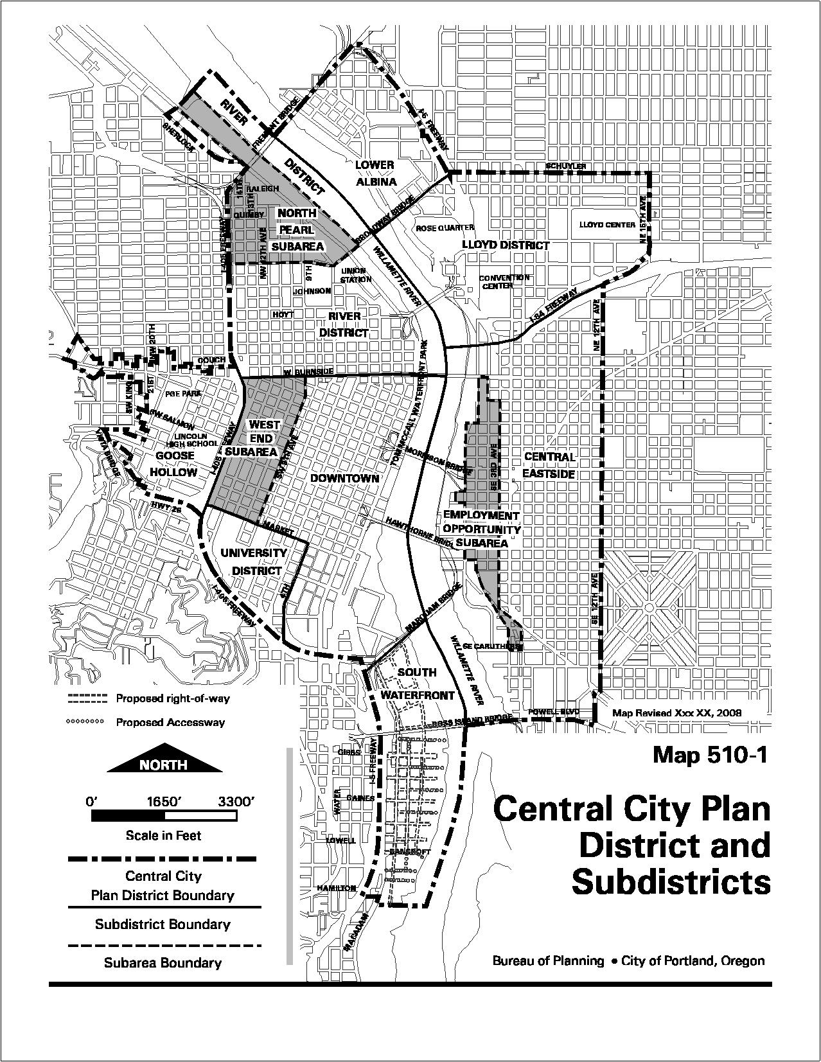
Map 510-2
Floor Area Ratios (Map 1 of 2)

EXISTING MAP:
In March 2005, the Portland City Council adopted a series of Zoning Code and Comprehensive Plan Map amendments applicable to a limit area within the River District that immediately surround the three parks identified by the 2001 River District Park System Urban Design Framework (also known as the Walker Master Plan). These amendments emerged from the Bureau of Planning’s North of Lovejoy planning effort completed the third in a series of refinements to Pearl District development entitlements and standards.
One of the primary changes emerging from this effort was to increase of development capacity of a limited number of parcels that were intended to be developed with residential land uses. These parcels had a base floor area ratio (FAR) of 2:1. However, estimates demonstrated that 1:1 FAR on a typical downtown Portland block (40,000 sq. ft.) generates on average 25 housing units. Thus a 2:1 ratio would only produce about 50 units which is far lower than what is intended for this part of the Central City. The amendments adopted by Council increased maximum FAR to 4:1 for a limited number of parcels. The remainder of the Pearl north of Lovejoy was to be reviewed through a more comprehensive planning effort that considered overall neighborhood and community development and a thorough analysis of transportation impacts associated with increasing FAR entitlements in this area. The North Pearl District Plan constitutes this larger effort called for by the North of Lovejoy Plan.
Map 510-2
Floor Area Ratios (Map 1 of 2)

Existing map:
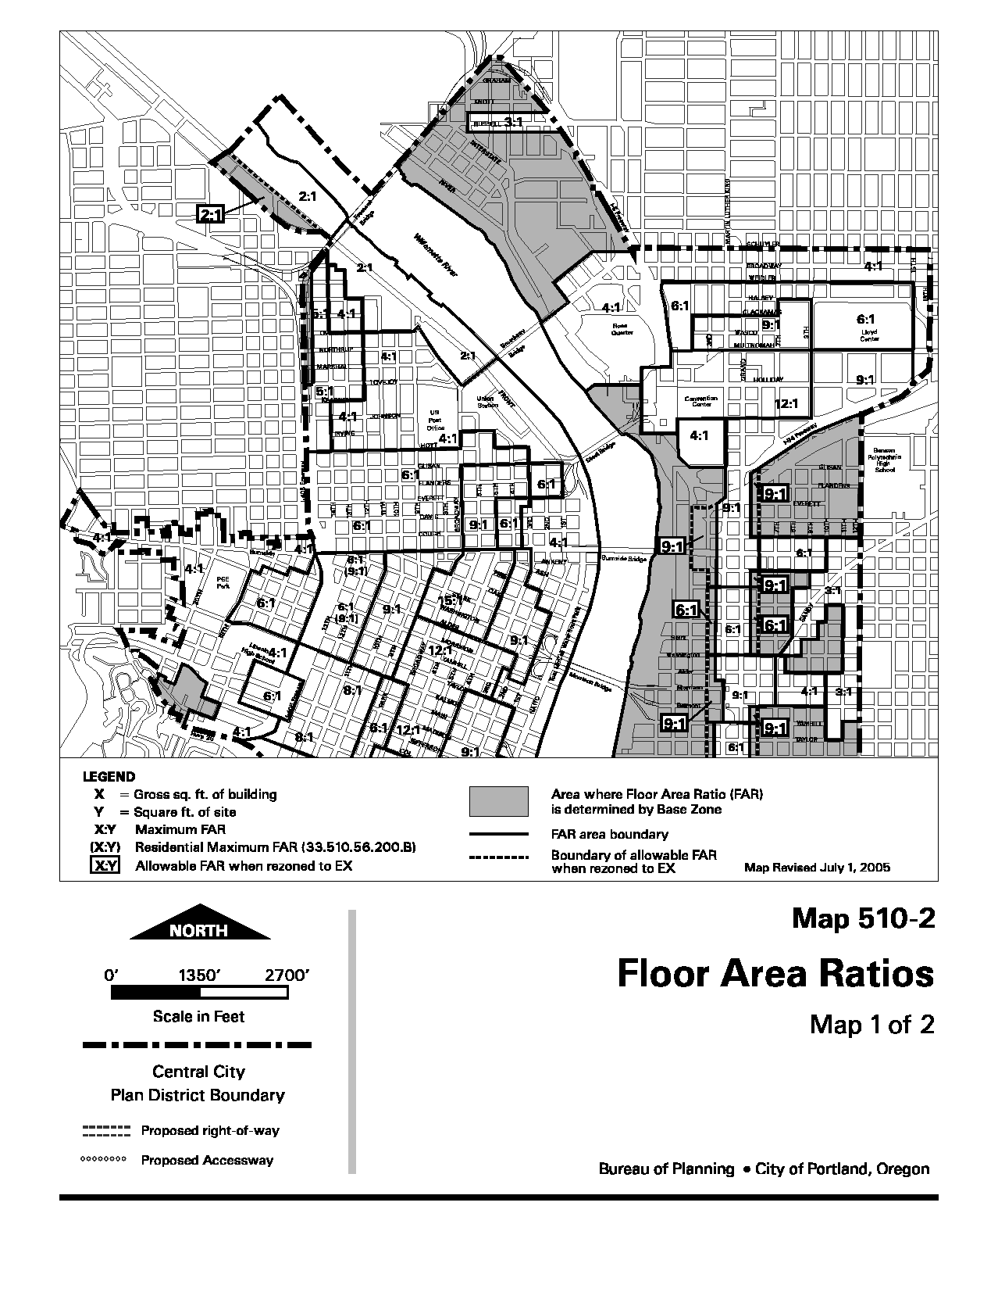
Map 510-2
Floor Area Ratios (Map 1 of 2)

PROPOSED MAP
One of the primary changes emerging from the North Pearl District Plan is a proposal to increase the base FAR of the remainder of the Pearl District located south of the railroad right-of-way from 2:1 to 4:1. These blocks are 40,000 sq. ft. on average and this will allow housing densities of 100 to 175 units per block when bonus FAR is also earned to increase development capacity. Further, this increase allows a continued pattern of residential and mixed-use residential projects to continue throughout the north end of the district.
Additional increases to base FAR considered for properties fronting Naito Parkway were rejected at this time. This was in part due to transportation impacts identified by PDOT. Also, conceptual modeling analysis identified potential impacts to urban form and character that could result if development capacity is increased at this time. Specifically, the relatively large size of these sites and built form that results from the North Pearl Subarea waterfront and open area development standards create a situation whereby even the existing amount of development potential currently available to these sites could result in buildings far out of scale from that envisioned for the plan area.
Thus, the Planning Commission has directed further analysis to be conducted as part of the Central Portland Plan to consider how FAR and height could be increased at these sites along Naito Parkway. This analysis will consider how to address transportation capacity constraints and potential new master planning procedures to ensure that increases in development potential have a positive affect on urban form and demonstrate a public benefit in exchange for increased development capacity.

Proposed Map 510-2
Floor Area Ratios (Map 1 of 2)

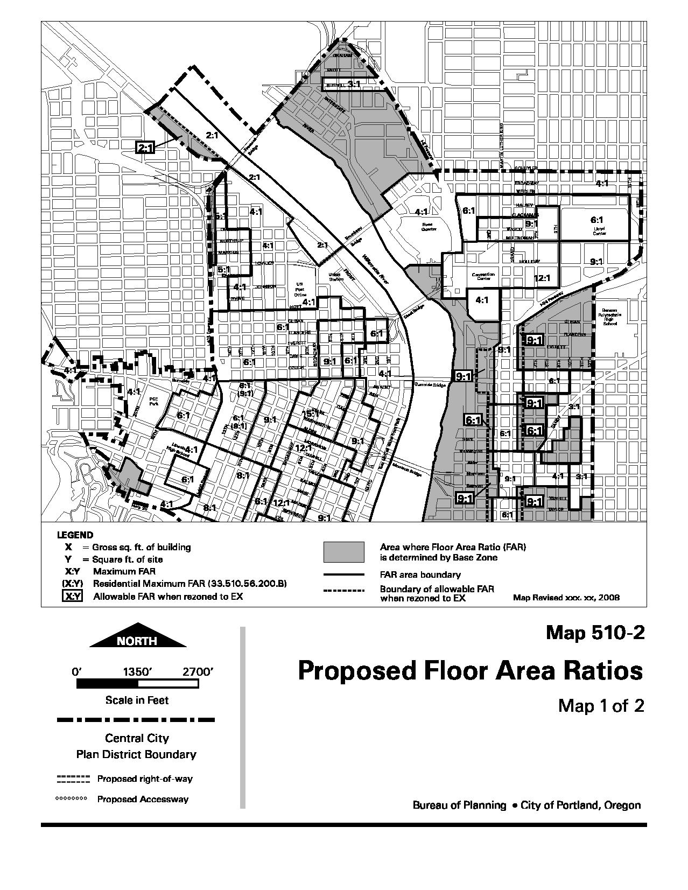
Map 510-3
Maximum Heights (Map 1 of 3)

Map 510-3 is proposed to be amended to implement the intent behind the amendments to Sections 33.410.205.E and H, as well as 33.510.210.

Existing map:

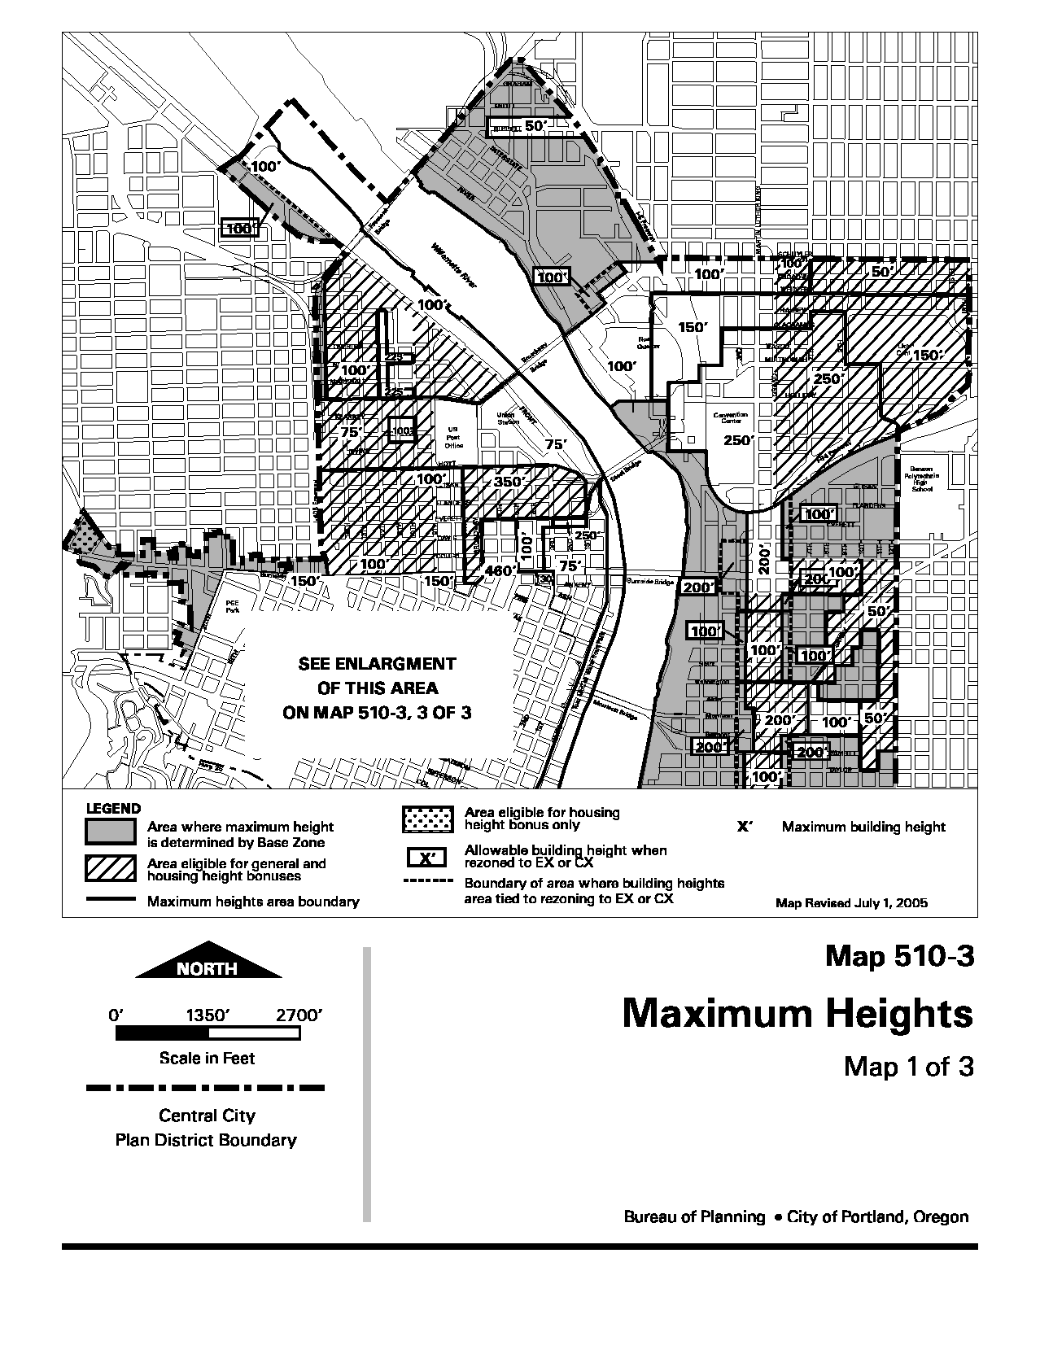
Proposed Map 510-3
Maximum Heights (Map 1 of 3)

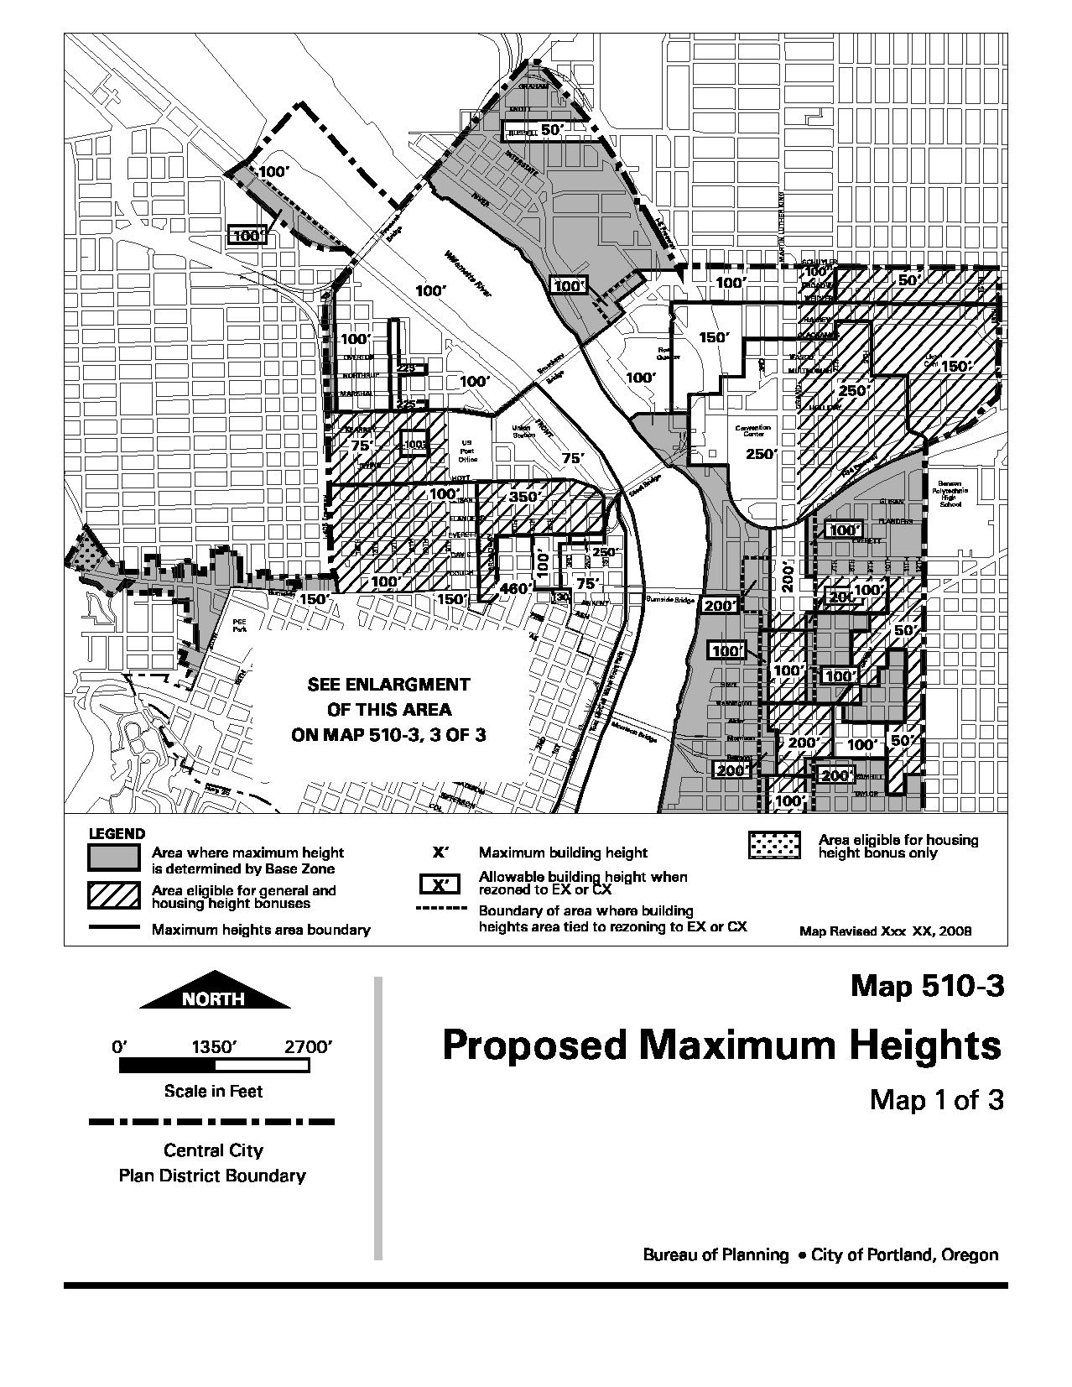
Map 510-4
Proposed Bonus Options Target Areas (Map 1 of 2)

Map 510-4 is proposed to be amended to implement the intent behind the amendments to Section 33.510.210.C. The Residential Bonus Target Area has been removed from other portions of the River District as these areas are either built out or housing is not desired as the primary use. Map 510-4 would also be amended to identify portions of the North Pearl Subarea where bonus or transferred floor area, in excess to the 3:1 maximum, could be earned consistent through amended code Section 33.510.200.C.
Existing map:
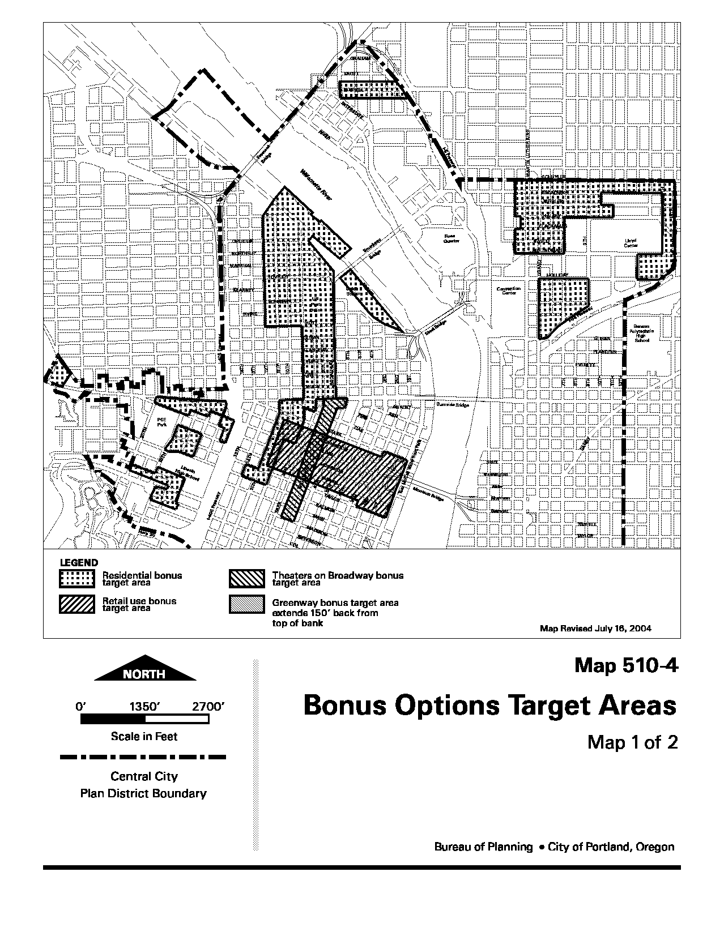
Proposed Map 510-4
Bonus Options Target Areas (Map 1 of 2)

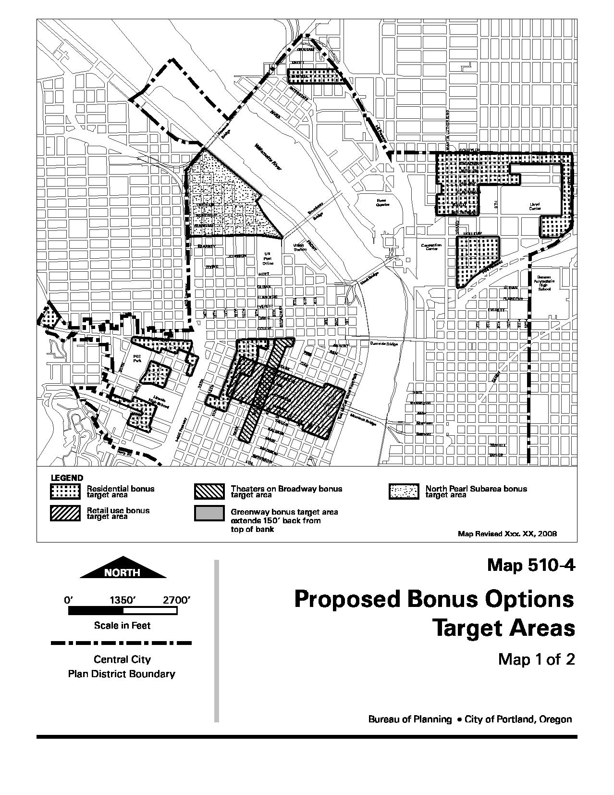
Map 510-5
Required Residential Development Areas (Map 1 of 2)

Map 510-5 is proposed to be amended to implement the intent behind the amendments to Section 33.510.210.C. The Required Residential Development Area has been removed from other portions of the River District as these areas are either built out or housing is not desired as the primary use

Existing map:
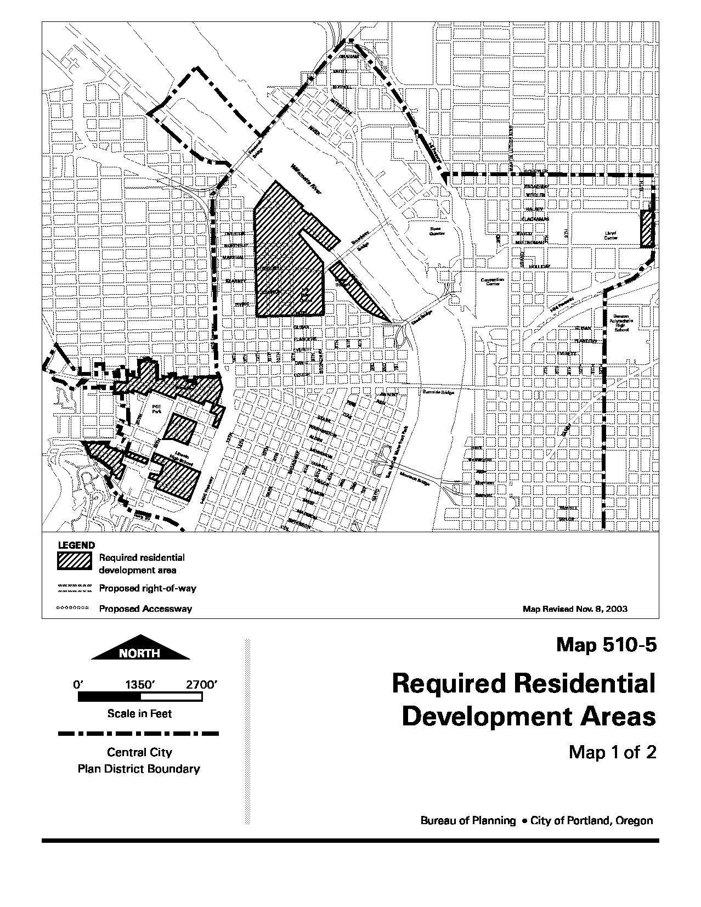
Proposed Map 510-5
Required Residential Development Areas (Map 1 of 2)

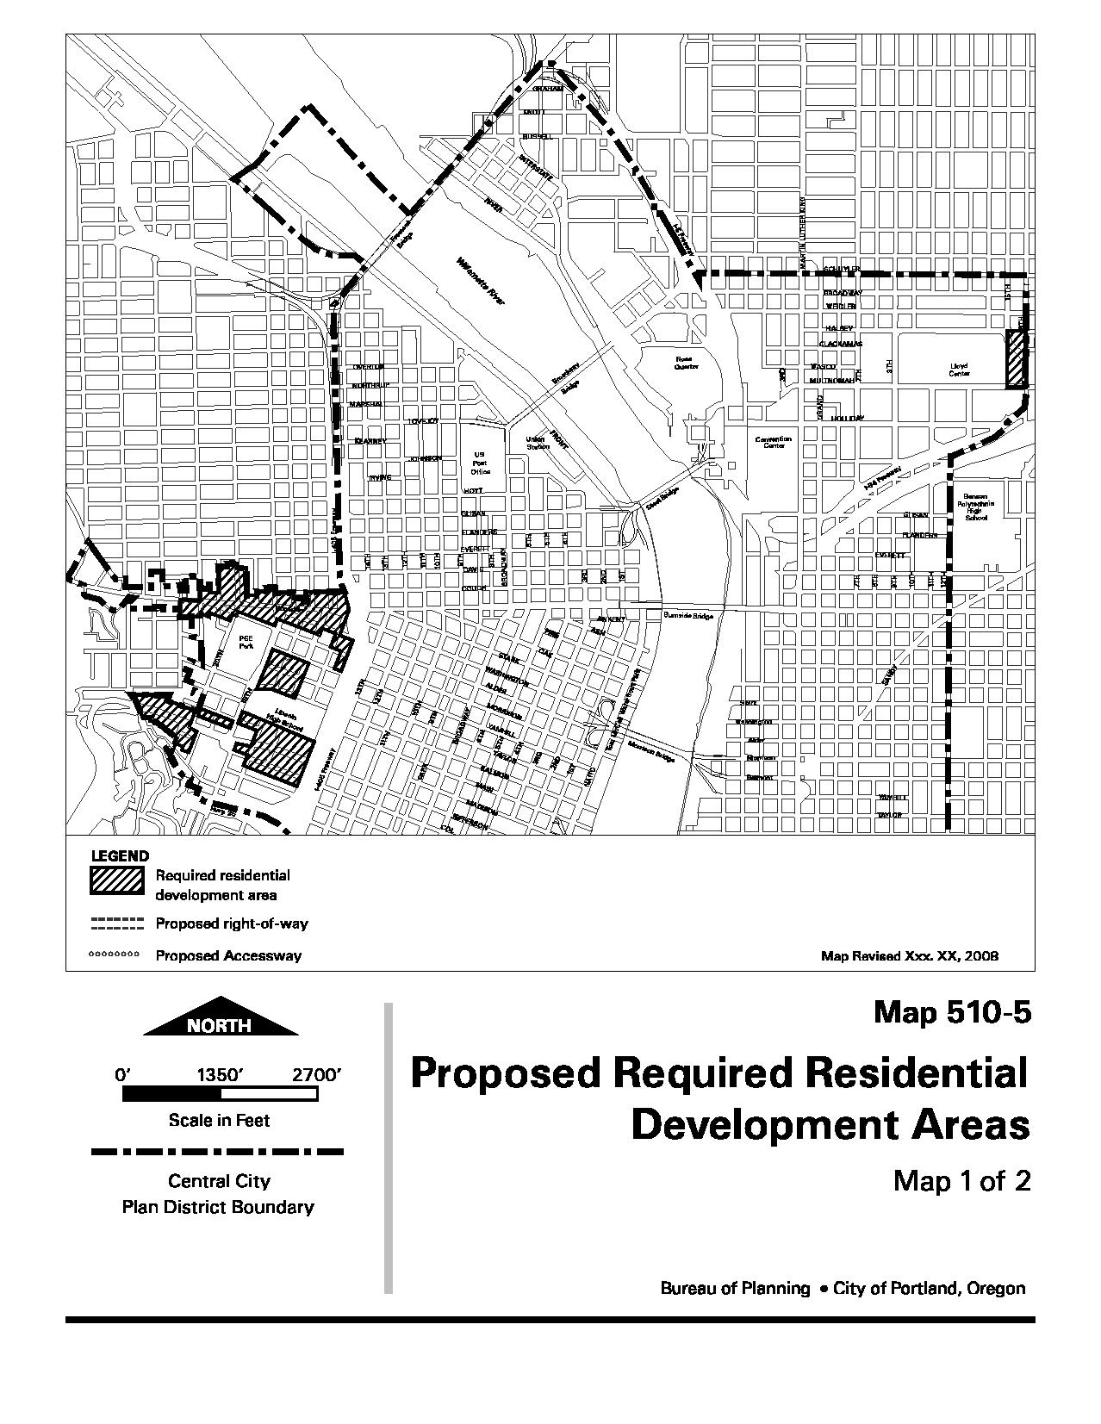
Map 510-10
Areas Where Additional Uses are Allowed in the OS Zone

All references to the Northwest Triangle Subarea in the Zoning Code have now been changed to North Pearl Subarea.

Existing map:
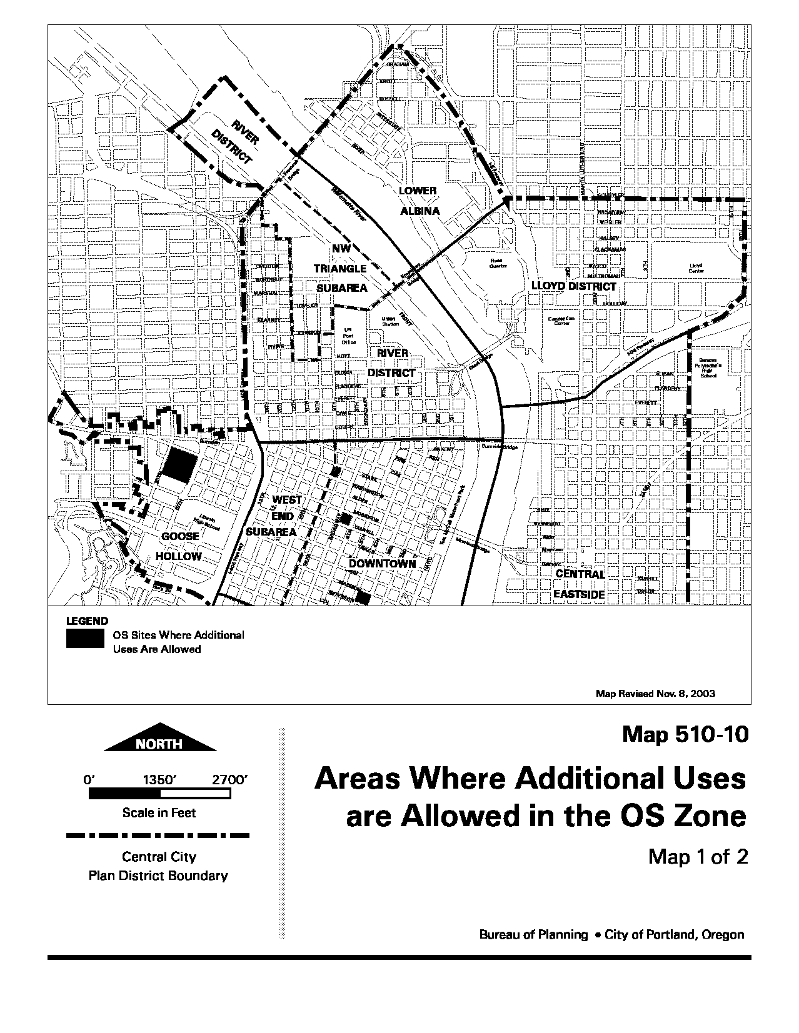
Proposed Map 510-10 (Map 1 of 2)
Areas Where Additional Uses are Allowed in the OS Zone

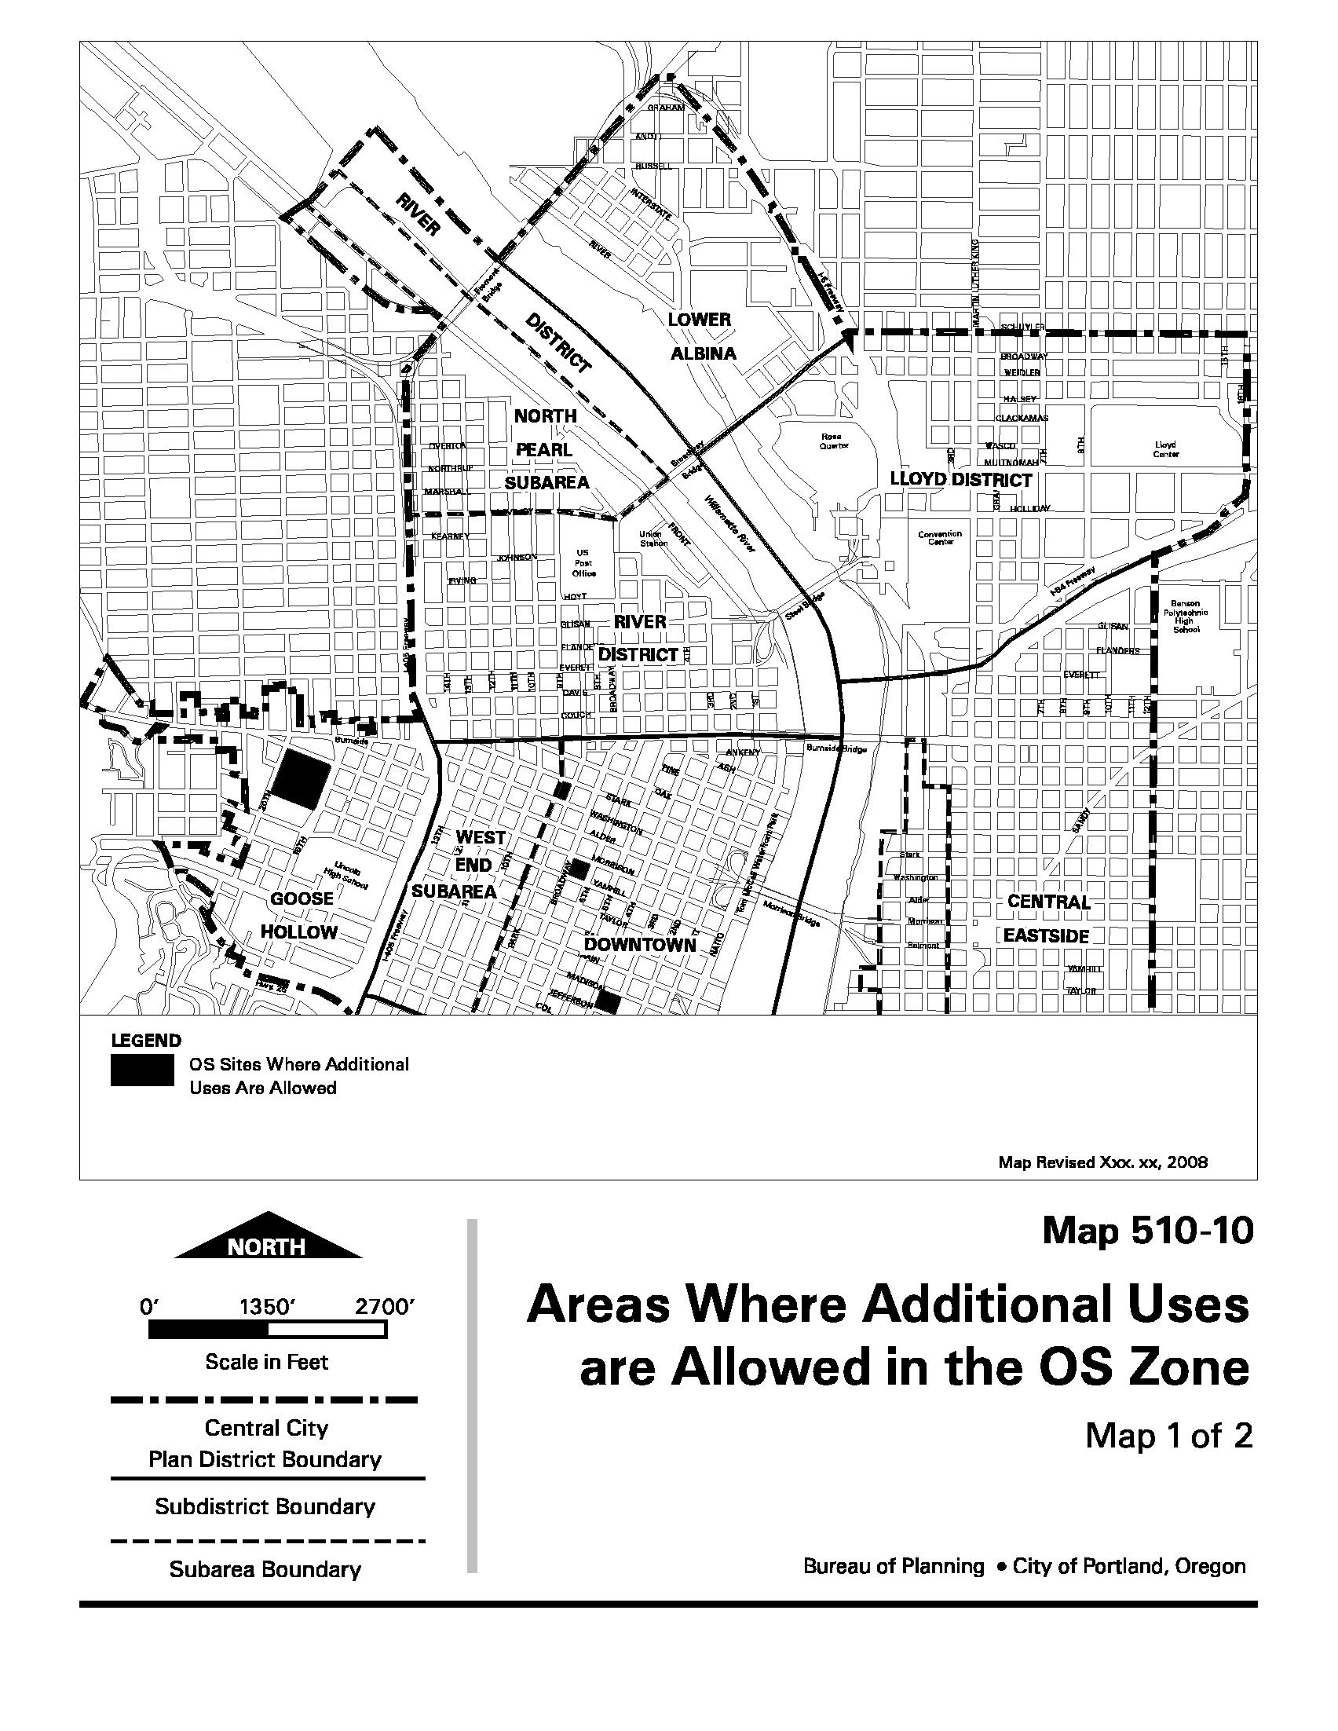
Map 510-12
Streetcar Alignment

All references to the Northwest Triangle Subarea in the Zoning Code have now been changed to North Pearl Subarea.

Existing map:
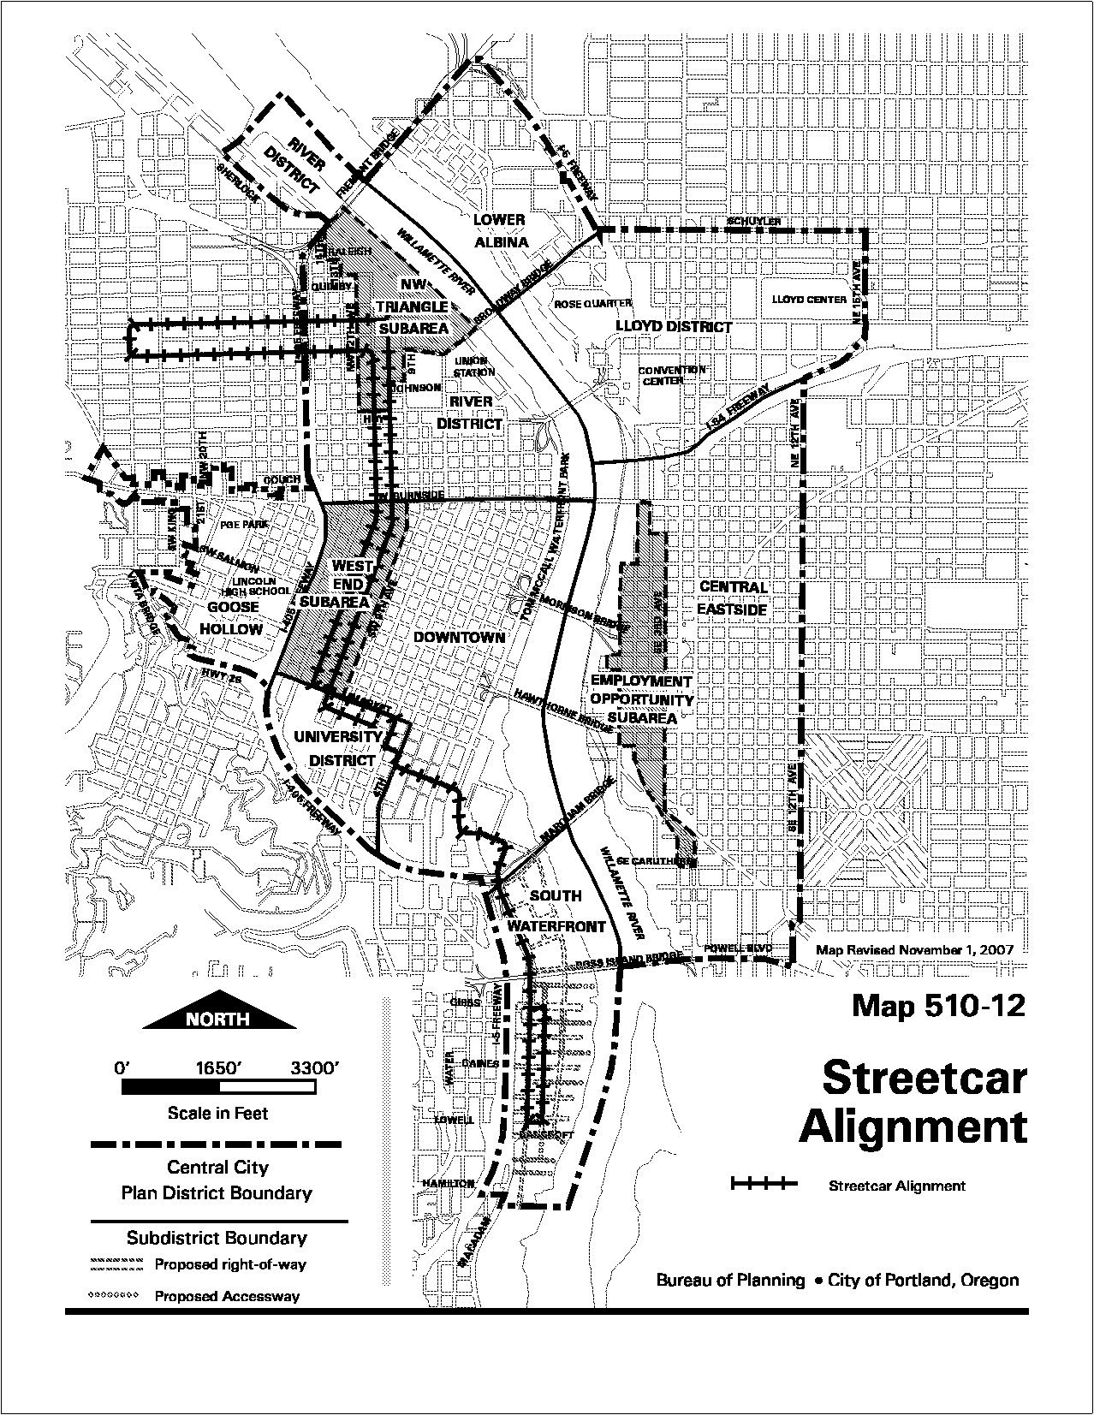
Proposed Map 510-12
Streetcar Alignment

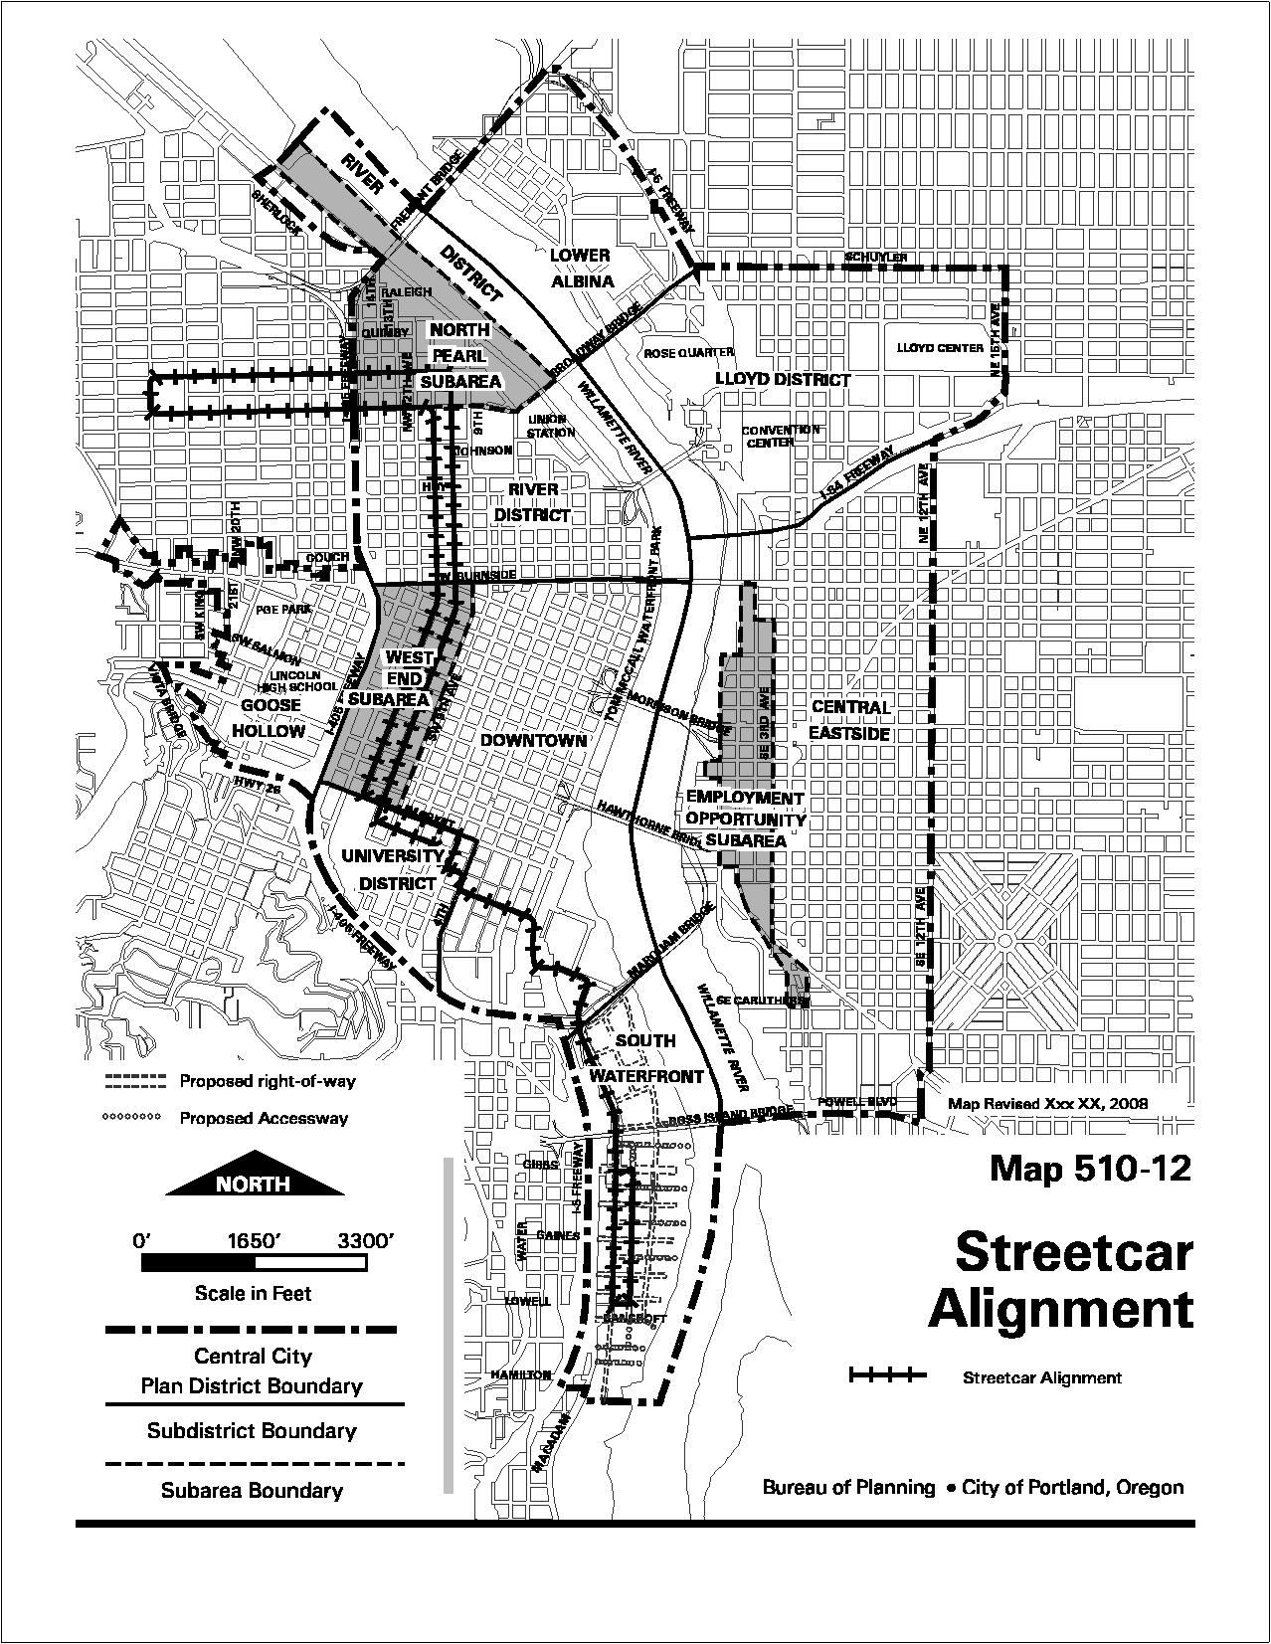
Map 510-16 (1 of 2)
Height Opportunity Area North Pearl

A new map, Map 510-16, illustrates the proposed Height Opportunity Area for the North Pearl Subarea, as described in proposed Section 33.510.205.H.
Proposed New Map 510-16 (1 of 2)
Proposed Height Opportunity Area North Pearl

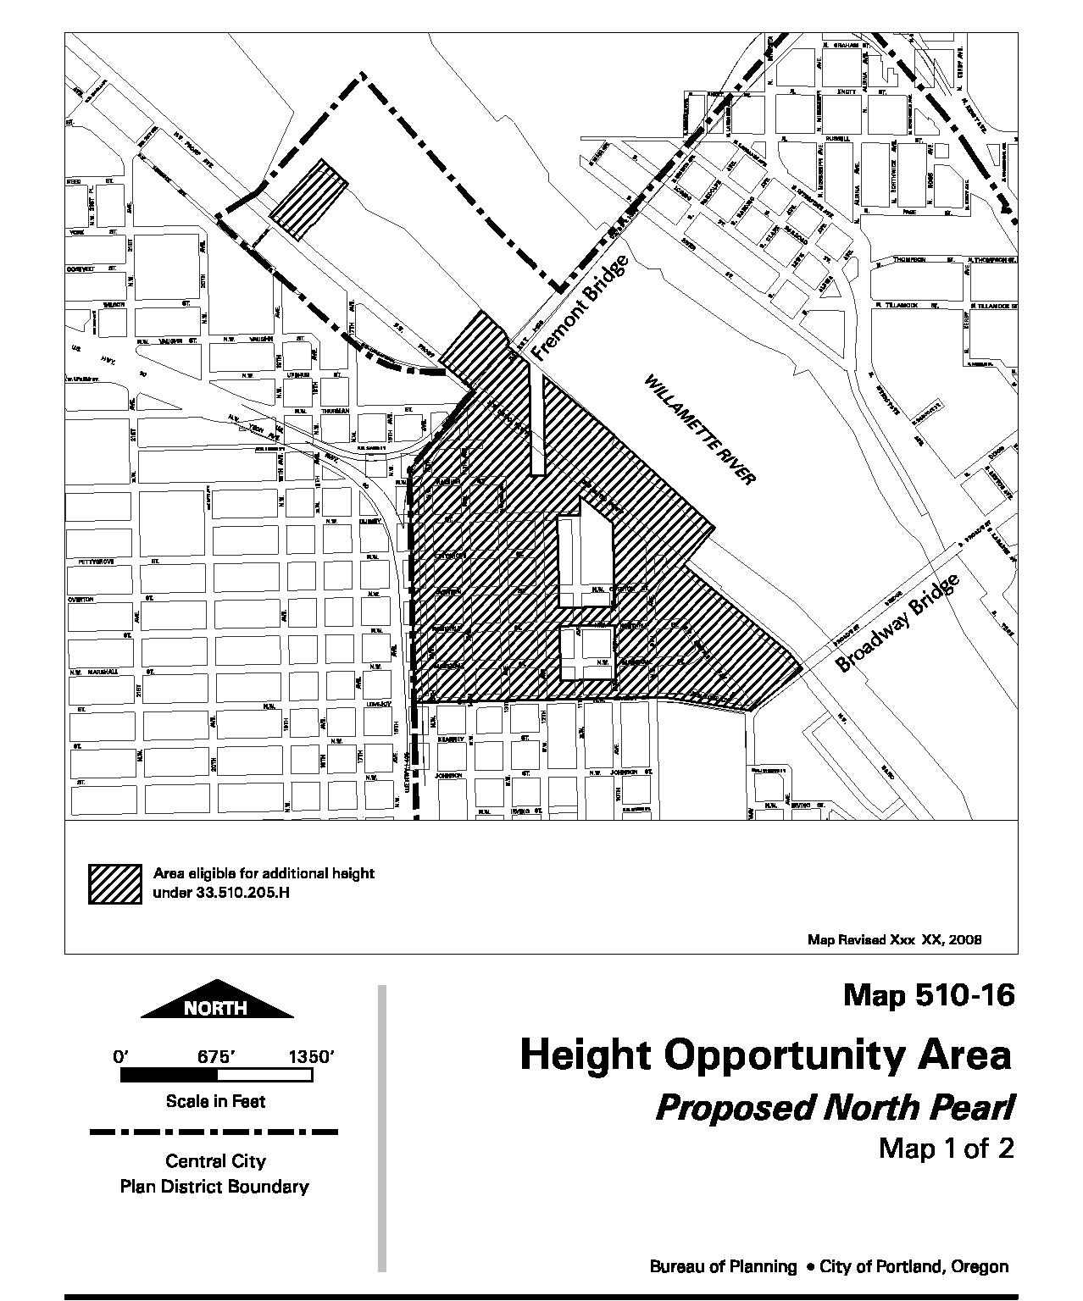
New Map 510-19
North Pearl Subarea Special Building Height Corridor

This new map reflects the building height corridor along 13th Avenue from NW Lovejoy St to the southern edge of the intersection of NW Savier and NW 13th Avenue as required by Section 33.510.251.A.

Proposed New Map 510-19
North Pearl Subarea Special Building Height Corridor

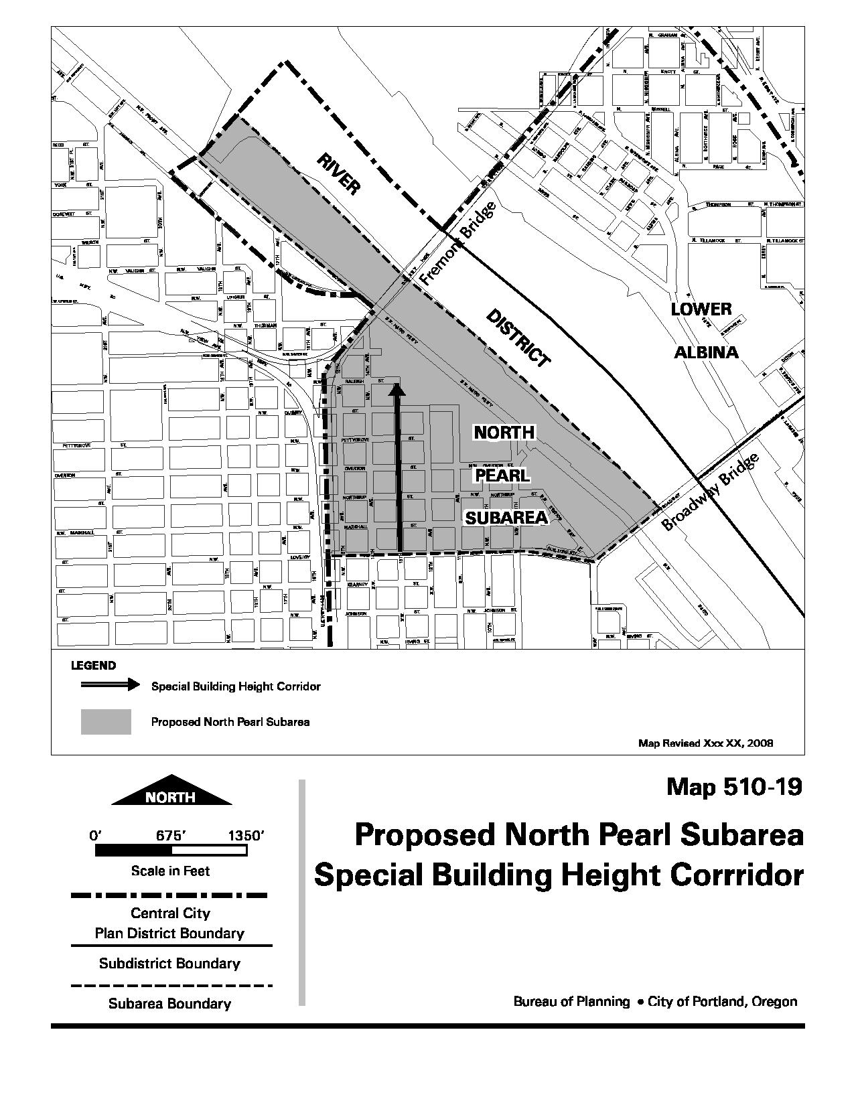
New Map 510-20
Pearl Development Transfer Opportunity Area

Map 510-20 illustrates the propose Pearl Development Transfer Opportunity Area, as described in proposed Section 33.510.200.H

Proposed New Map 510-20
Pearl Development Transfer Opportunity Area



