Photovoltaic Project Agreement

Between

Energy Trust of Oregon, Inc., _______, L.L.C

and City of Portland Parks Department

This Photovoltaic Project Agreement ("Agreement") is executed by ENERGY TRUST OF OREGON, INC. ("Energy Trust"), Commercial Solar Ventures, LLC, including LLC’s successors-in-interest and permitted assigns in accordance with Section 13 of this Agreement (”LLC”), and the City of Portland, by and through its Bureau of Parks and Recreation (“Host”). Energy Trust, LLC, and Host are organized under the laws of the State of Oregon. Energy Trust, LLC, and Host may also be referred to individually as "Party" and together as "Parties."

RECITALS

WHEREAS, LLC intends to install, operate and maintain a solar electric, photovoltaic system and associated hardware and equipment ("Solar Facility") on a site owned by Host, located at Host Site;
WHEREAS, LLC will be the owner and operator of the Solar Facility after it is installed for a period of twenty (20) years.
WHEREAS, Energy Trust, a non-profit corporation created to invest "public purpose funding" in, among other things, the above-market costs of new renewable energy resources, has determined that funding the above market costs of the Solar Facility is consistent with Energy Trust’s purposes;
THEREFORE, the Parties enter into the following Agreement.

AGREEMENT
1. Term

This Agreement is effective as of __________ (“Effective Date") and will continue for a period of twenty (20) years from the Commercial Operation Date unless terminated earlier pursuant to section 18.B of this Agreement.

2. Definitions

A. “Commercial Operation Date” or “COD” will be the third (3rd) day following the LLC’s delivery of notice to the Host that the Solar Facility is ready for commercial operation, in accordance with the separate Solar Facility License Agreement entered into between LLC (“Seller”) and Host (“Buyer”).

B. “Commercial Operation” means that: (i) one hundred percent (100%) of the nameplate capacity has been installed; (ii) testing indicates that the Solar Facility is capable of producing Energy at no less than the nameplate capacity; (iii) the Solar Facility has operated for a period of not less than five hours at capacity without experiencing any abnormal or unsafe operating conditions; and (iv) all permits necessary to authorize the production, sale and delivery of Energy in the intended amounts have been acquired. (see Solar Facility License Agreement §7.1)

C. “Environmental Attributes” means any and all environmental, power source, and emission characteristics, credits, reductions, offsets, allowances, and benefits, including Green Tags and RECs, howsoever entitled, directly or indirectly attributable to the generation of electricity from the Solar Facility. Environmental Attributes include but are not limited to (i) any benefit accruing from the renewable nature of solar PV-generated energy; (ii) any avoided emissions of pollutants to the air, soil, or water (such as sulfur oxides (SOx), nitrogen oxides (NOx), and carbon monoxide (CO)); (iii) any avoided emissions of carbon dioxide (CO2), methane (CH4) and other greenhouse gases (“GHGs”) that may contribute to the actual or potential threat of altering the Earth’s climate by trapping heat in the atmosphere; (iv) any property rights that may exist with respect to the foregoing attributes, howsoever entitled, (v) displacements of energy generation by fossil-fuel-consuming or GHG-emitting generation resources; and (vi) any reporting rights to these avoided emissions, such as Green Tag Reporting Rights.

D. “Green Tag” means a commercially recognized unit representing the value or amounts of Environmental Attributes.

E. “Green Tag Reporting Rights” means the right of a green tag buyer to report the ownership of accumulated green tags in compliance with federal or state law, if applicable, to a federal or state agency or any other party at the green tag buyer’s discretion. Such rights include without limitation those green tag reporting rights accruing under Section 1605(b) of The Energy Policy Act of 1992 and any present or future federal, state, or local law, regulation or bill, and international or foreign emissions trading program.

F. “Host Site” means the property located at 740 SE 106th Ave., Portland, OR.

G. “Solar Facility” means a solar electric, photovoltaic system and associated hardware and equipment, as described in Schedule D.

H. “Solar Facility License Agreement” means that certain Solar Facility License Agreement concerning the Solar Facility located at the City of Portland’s East Portland Community Center, located at 740 SE 106th Ave., Portland, OR , and such agreement being by and between LLC and Host dated as of ____________.

3. Installation of the Solar Facility

A. LLC will purchase and install the Solar Facility at the Host Site and will ensure that the Solar Facility reaches Commercial Operation Date by December 31, 2008. LLC is responsible for all contractors, all subcontractors, project financing and any and all items relating to the building, operating and maintaining of the Solar Facility.

B. LLC will use an Energy Trust Solar Electric Program Trade Ally Contractor to install the Solar Facility in accordance with federal, state, local and utility specifications and requirements to have the capacity to produce approximately 88,700 kWh of electricity per year, subject to climate variations and ordinary system degradation, and in accordance with Energy Trust's standard Solar Electric Program requirements as detailed in the Energy Trust's Solar Electric Program Guide and Solar Electric System Requirements, Schedule A.

C. The Solar Facility shall be net-metered and grid-tied, and shall be installed at a nameplate capacity of at least 88.7 kilowatts (kW).

4. Inspection

LLC and Host shall allow Energy Trust and its representatives reasonable access to the Host Site and the Solar Facility to perform any required inspection contemplated under the terms of this Agreement, including an inspection to determination whether the Solar Facility is Commercially Operating. Energy Trust's inspection shall not be deemed a code inspection, and no warranty is implied.

5. Incentive Payment to LLC

A. Within thirty (30) days of the Commercial Operation Date, LLC shall provide documentation evidencing the actual purchase and installation costs of the Solar Facility and providing invoices and receipts demonstrating payments of such costs. Within thirty (30) days of receipt of such documentation, Energy Trust will recalculate the portion of the above-market costs of the Solar Facility. If the actual costs as recalculated are less than $8.50 per installed Watt, then Energy Trust may reduce the incentive consistent with its above market cost calculation processes.
After final recalculation based on actual purchase and installation costs as described above, Energy Trust will pay LLC an incentive of not more than $157,500. If LLC wishes to assign the payment to Host or another party, it shall provide prior notice to Energy Trust in writing. Energy Trust will make payment to such assignee.

B. If the Solar Facility does not achieve Commercial Operation by December 31, 2008, Energy Trust shall have no further obligation to pay any incentive under this Agreement.

C. Regardless of whether LLC assigns the incentive payment to Host or another payee, LLC will be the sole responsible party for performing all of LLC's obligations hereunder, including but not limited to any repayment obligations.

D. If Energy Trust does not pay the incentive, LLC and Host shall have no further obligation to Energy Trust under this Agreement.

6. System Operation and Maintenance

A. LLC will install, own, operate and maintain the Solar Facility consistent with equipment specifications and the solar resource at the site during the term of this agreement, such that it is capable of generating at approximately 88,700 kWh of electricity per year, subject to climate variations and ordinary system degradation, during the term of this Agreement. LLC will make repairs in a timely fashion.

B. LLC and Host will use their best efforts to maintain the solar envelope over the Host Site so that the Solar Facility’s access to sunlight remains comparable to that contained in the sun chart attached as Schedule B. During the term of this Agreement, neither LLC nor Host will remove the Solar Facility from service or the Host Site without the prior written consent of Energy Trust, or the LLC will be subject to the repayment requirements set forth in Section 7 below.

C. In case the Solar Facility or any supporting structure (e.g., the roof) requires significant repair, LLC and Host must notify Energy Trust of the start date of the repairs. The Solar Facility must be re-installed and re-inspected by Energy Trust within the 90 day time period described in Section 7, below, or LLC will be subject to the repayment requirements set forth in Section 7.

D. If Host decides at any time during the term of this Agreement to sell the Host Site, Host must notify both LLC and Energy Trust prior to the sale so that the Parties can work together to arrange for continued operation of the Solar Facility at the Site. If a satisfactory agreement is not reached prior to sale, LLC will be subject to the repayment requirements of Section 7, below.

7. Repayment of Energy Trust Incentive Funds

A. After Energy Trust pays the incentive to LLC under section 5, if the Solar Facility or the Host Site is (i) sold, assigned or transferred to any entity other than Host without Energy Trust’s prior consent, OR (ii) repossessed, shutdown or does not otherwise produce electricity for 90 consecutive days in a given calendar year, then LLC will immediately repay (in the form of a cashiers check payable to Energy Trust of Oregon, Inc.) a portion of the incentive funds amount to Energy Trust, calculated as follows:

Incentive amount paid to LLC multiplied by the fraction of: [20 minus the number of anniversaries of the Commercial Operation Date] divided by 20

B. If ownership of the Solar Facility is transferred from LLC to Host, all of LLC’s obligations to Energy Trust, including repayment of the incentive payment, will be assigned to Host at that time and Host will assume such obligations.

- If the incentive payment is repaid in accordance with this Section 7, then LLC and Host shall have no further obligations to Energy Trust pursuant to this Agreement.

8. Damages
In the event LLC breaches Section 7, LLC shall pay to Energy Trust liquidated damages in an amount equal to (a) one hundred percent (100%) of the incentive amounts provided by Energy Trust, and (b) reasonable costs, including any attorney’s fees, incurred by Energy Trust in enforcing the requirement.

9. LLC Representations and Warranties:

A. LLC has obtained written consent from Host to install, operate and maintain the Solar Facility at the Host Site for the duration of the term of this Agreement;

B. The execution, delivery and performance of this agreement is within LLC’s powers, has been duly authorized by all necessary action and does not violate any of the terms and conditions in its governing documents, any contracts to which it is a party or any law, rule, regulation, order or the like applicable to it;

C. LLC has all authorizations necessary for it to legally perform its obligations under this agreement;

D. This agreement, and any other document executed and delivered in accordance with the agreement, constitutes a legally valid and binding obligation enforceable against LLC in accordance with its terms, subject to any equitable defenses;

E. LLC has sufficient financial stability to perform its legal obligations under this agreement; and

F. There is not pending, or to its knowledge, threatened against LLC, any legal proceedings that could materially adversely affect its ability to perform its obligations under this agreement.

10. Host Representations and Warranties:

A. Host has given written consent to LLC to install, operate and maintain the Solar Facility at the Site for the duration of the term;

B. Host has all authorizations necessary for it to perform its obligations under this agreement;

C. This agreement, and any other document executed and delivered in accordance with the agreement, constitutes a legally valid and binding obligation enforceable against Host in accordance with its terms, subject to any applicable defenses;

D. Host has sufficient financial stability to perform its legal obligations under this agreement; and

E. There is not pending, or to its knowledge, threatened against Host, any legal proceedings that could materially adversely affect its ability to perform its obligations under this agreement.

11. Treatment of Information

The Parties shall clearly identify any submitted sensitive financial or proprietary information which it wishes the other Party to keep confidential as "Confidential Information." LLC agrees that the following information will not be considered confidential and Energy Trust may include the following information in reports or other documentation submitted to the Energy Trust Board of Directors, the Oregon Public Utility Commission, the Oregon Department of Energy, Oregon Housing and Community Services, or the Oregon Legislature: (i) their respective names; (ii) a description of the Solar Facility and its general location; (iii) a description of the Energy Trust services provided; (iv) the amount of any Energy Trust incentives reserved or paid; and (v) the amount of the Solar Facility's energy generation and/or any resulting energy savings. The Parties acknowledge that Host is a public entity subject to the Oregon Public Records Law, which may require it to disclose information that would otherwise be deemed "confidential" under this provision.

12. Intellectual Property, Marketing and Media

A. No Party will acquire by virtue of this Agreement, implementation of this Agreement, or any public communications concerning the Solar Facility, any rights whatsoever to any trade name, service mark, trade mark, logo, and intellectual property right belonging to any other Party.

B. Host, LLC and Energy Trust will work cooperatively to support promotion of the Solar Facility, including with publicity releases, press events, case studies, web identification and other opportunities to highlight and promote the success of the Solar Facility. In marketing materials describing the Solar Facility, each Party will use reasonable efforts to acknowledge the other Parties as well as Commercial Solar Ventures, Portland General Electric, Bonneville Environmental Foundation and ________________ in any marketing or promotional materials regarding the Solar Facility, except if such parties do not want to be mentioned. Such attribution will include use of the logos of the parties involved in the project in all written promotional materials, where appropriate and space permits. Each Party hereby consents to the use of its logo, as depicted and described in Schedule E herein, in such promotional materials.

13. Assignment of Agreement

A. This agreement is specific to the parties and can not be assigned by LLC or Host to any other party without Energy Trust's express written consent; EXCEPT LLC may assign the agreement to Host or to the City of Portland without Energy Trust's consent pursuant to section 7(B) and consistent with this section 13.

B. If LLC and Host determine, at any point during the 20-year term, to transfer ownership of the Solar Facility to Host, both LLC and Host will notify Energy Trust prior to any such transfer and provide Energy Trust with a copy of a written assignment agreement demonstrating that LLC has assigned and Host has assumed all of LLC's rights and obligations under this Agreement.

C. Energy Trust may, at any time, assign its rights and obligations under this agreement to a third party if requested to do so by the Oregon Public Utility Commission.

14. Insurance

A. LLC will maintain the following minimum types and amounts of insurance during the term: (1) Workers' Compensation insurance in compliance with statutory requirements; (2) occurrence-based Commercial General Liability insurance of at least $1,000,000 per occurrence and aggregate; and (3) All-Risk Property insurance covering the replacement value of the Solar Facility. If Host acquires the Solar Facility pursuant to section 11.8 of the “Solar Facility License Agreement,” Host will assume responsibility for maintaining required insurance for the remainder of the term of this “Photovoltaic Project Agreement.”

B. LLC and Host shall ensure that they are in compliance with the insurance requirements set forth in this agreement. Energy Trust recognizes that Host may be self-insured and/or have blanket coverage. Energy Trust will accept such self-insurance or blanket coverage as long as Host meets the levels of insurance required herein. Energy Trust may request proof of any of the required insurance coverages from LLC and/or Host at reasonable times during the term, and LLC and/or Host shall promptly supply such proof.

15. Environmental Attributes

A. Energy Trust shall possess all ownership rights of one hundred percent (100%) the Environmental Attributes associated with the Solar Facility for a twenty (20) year period, calculated as beginning on the Commercial Operation Date and running for a time period ending at 11:59:59 pm (Pacific time zone) on the day before the twentieth anniversary of the Commercial Operation Date (the Energy Trust Environmental Attribute Ownership Period). LLC and Host understand and agree to the Environmental Attributes ownership arrangement as set forth herein and will fully comply with such ownership arrangement in consideration of the incentives provided pursuant to this agreement. During the Energy Trust Environmental Attribute Ownership Period, LLC and Host will not (i) sell the Solar Facility's Environmental Attributes to any other party, or (ii) assert any claim to the Environmental Attributes or assert any claim that the Solar Facility possesses or is otherwise receiving or using the Environmental Attributes.

B. During the Energy Trust Environmental Ownership Period, LLC will cooperate fully with Energy Trust to (i) register or otherwise perfect Energy Trust's rights in the Environmental Attributes, and (ii) report such rights. Within the 2 week time period following each anniversary of the Commercial Operation Date, the LLC will complete and submit to Energy Trust a Certification and Attestation Form for Environmental Attributes/Non-Energy Attributes (in substantially the form of the attached Schedule C).

16. Self-Direction

If the Host Site uses 8,760,000 kWh (1 aMW) or more in electricity in a year, then Host may be eligible to "self-direct" the portion of the public purpose charge that Energy Trust receives. This means that the Energy Trust incentive will be subject to self-direction policy (Eligibility of Self-Direct Businesses for Energy Trust Incentives). Specifically:

A. Host shall not claim self-direction credits within the 36 months of the Commercial Operation Date and receive an Energy Trust incentive for the Solar Facility; and

B. Host shall not use any self-direction credits associated with its renewable public purpose charge at the Host Site for a minimum of 36 months from the Commercial Operation Date.

C. If Host begins self-directing the renewable portion of its public purpose charge during this 36-month period, then (i) Host must provide Energy Trust and LLC with not less than 60 days' advance notice, and (ii) LLC shall promptly repay (in the form of a cashiers check payable to Energy Trust of Oregon, Inc.) a pro-rated amount of the incentive funding up to a maximum of 50% of the amount of the Energy Trust incentive paid, determined by the following formula:

0.5 times A times B, where A is total amount of incentives paid; and B is the fraction [36 minus the number of months elapsed since Commercial Operation Date], divided by 36.

D. If Host (City) begins to self-direct under this Agreement and if that self-direction causes the LLC to incur any obligation to repay Energy Trust incentive funds, Host will indemnify and compensate LLC for such payment.

17. Access and evaluation

A. Energy Information Release. Host authorizes Energy Trust to reasonably access the energy usage data for the Solar Facility’s specified electric accounts at the Site. Host agrees to provide all other reasonable assistance to Energy Trust to obtain such information.

B. Access and Evaluation. Energy Trust conducts ongoing evaluations of its programs and projects to determine effectiveness. During the term of this Agreement, LLC and Host will provide Energy Trust and its representatives with reasonable access to the Solar Facility and to the Host Site in order to: (i) read or check on the operation of the meter(s); (ii) inspect and review the project during and after completion; and/or (iii) evaluate the operation of the Solar Facility. In addition, Energy Trust may contact LLC or Host from time to time via a telephone call, mail or e-mail to request meter information directly from LLC or Host, and LLC and Host agree to provide meter information in response to Energy Trust’s reasonable requests.

18. Miscellaneous

A. Severability. If any provision of this agreement or the application of any such provision to a party or circumstances shall be determined by any court of competent jurisdiction to be invalid, illegal or unenforceable to any extent, the remainder of this agreement shall remain in full force and effect, unless such construction would be unreasonable.

B. Termination; Survival. Upon 60 days' written notice, Energy Trust may terminate this agreement in the event that the Grant Agreement with the OPUC is terminated. In the event that Energy Trust terminates the Agreement pursuant to this section 18B, LLC and Host shall have no further obligations to Energy Trust under this Agreement. Unless stated otherwise in this Agreement, the terms and conditions of this Agreement shall survive the completion of any incentive payments provided hereunder.

C. Headings; Counterparts; Non-Waiver. The headings in this agreement are for reference only and shall not affect the meaning, construction or interpretation of this agreement. This agreement may be executed in one or more counterparts, all of which taken together will constitute one and the same agreement. The failure or refusal of a party to enjoin any breach or violation of any provision of this agreement will not be a waiver of, consent to, or excuse for any other, different or subsequent breach or violation of the same or any other provision.

D. Integration and Amendment. This agreement supersedes all other agreements between the parties and contains their entire understanding as to its subject matter. No amendment to this agreement will be effective unless it is in writing and duly executed by authorized representatives of the parties. This agreement will not be varied, supplemented, qualified or interpreted by any prior course of dealing between the parties or by any usage of trade.

E. No Third-Party Beneficiaries. This agreement is made and entered into for the sole protection and legal benefit of the parties, and no other person shall be a direct or indirect legal beneficiary of, or have any direct or indirect cause of action or claim in connection with this agreement.

F. Disclaimer of Warranties. LLC and Host hereby acknowledge and agree that Energy Trust has not made any representations and has specifically DISCLAIMED any and all warranties, express or implied, with respect to the Solar Facility to be installed or the Trade Ally Contractor, including but not limited to Trade Ally Contractor's experience, qualification, or background, the amount of any energy savings or energy generation, if any, to be realized by Host from use of the Solar Facility, the quality of specific materials, components, or workmanship utilized in the installation, or the nature of or whether building permit(s) or governmental approval(s) may be required.

G. Force Majeure. Notwithstanding anything contained in this agreement to the contrary, neither party will be deemed liable or to be in default for any delay or failure in performance under this Agreement deemed to result from acts of God, acts of civil and military authority, acts of public enemy, war, or any like cause beyond the parties' reasonable control.

H. Forum.
Any litigation between the Parties arising under this Agreement shall occur, if in the state courts, in the Multnomah County Court having jurisdiction thereof, and, if in the federal courts, in the United States District Court for the District of Oregon.

I. Negotiation, Mediation and Arbitration.
Regarding any dispute or claim that arises out of or that relates to this Agreement, or to the interpretation or breach thereof, or to the existence, scope, or validity of this Agreement, an attempt may be made by the Parties to negotiate a solution to such dispute or claim. Following any unsuccessful attempt at negotiation, the Parties may use local mediation services to further attempt resolution of such dispute or claim. If neither negotiation nor mediation is successful, the Parties may attempt to resolve the dispute or claim using local arbitration services. If at all possible, these attempted dispute resolution strategies will be coupled with the Multnomah County Court System in the State of Oregon.

I. Governing Law. The agreement shall be exclusively governed by and construed in accordance with the laws of the state of Oregon, without regard to any conflicts of laws rules thereof.

J. Hazardous Materials. Energy Trust and its representatives shall have no responsibility for the discovery, presence, handling, removal, or disposal of or exposure of persons to hazardous materials of any kind in connection with Host's facility, including without limitation asbestos, asbestos products, PCBs, or other toxic substances, except to the extent that the presence, handling, removal, disposal or exposure of persons to such hazardous materials is caused by the negligent acts or omissions of Energy Trust committed on the Site. Without limiting Energy Trust's liability for its acts or omissions, Host and LLC will advise Energy Trust of the type and location of any hazardous materials known to be on the Site.

K. Limitation of Liability. Energy Trust's liability to LLC and Host is limited to recovery of amounts due for the incentive payment described and under no circumstances will Energy Trust be liable for any further amount whatsoever. While Energy Trust may provide incentive funding pursuant to this agreement, Energy Trust is not supervising the installation or performance of the Solar Facility, nor is Energy Trust responsible in any way for the completion of that work. In no event will Energy Trust be liable pursuant to this agreement, to LLC, Host or any third party for any damages, whether characterized as general, special, direct, indirect, punitive, consequential, or otherwise, except as provided by section 18N of this Agreement (“Indemnity.”)

L. Tax Liability. Energy Trust is not responsible for any tax liability which may be imposed as a result of payment of any incentives. Energy Trust is not providing tax advice, and any communication by Energy Trust is not intended or written to be used, and cannot be used, for the purpose of avoiding penalties under the Internal Revenue Code.

M. Relationship of the Parties. Nothing in this agreement is intended to, nor shall be construed as creating a joint venture, partnership or similar arrangement between Energy Trust, LLC or Host, and no party shall be deemed, or hold itself out to be the agent of any other party.

N. Indemnity.

i. LLC and Host’s Indemnity to Energy Trust.
LLC and Host, to the extent allowed by law and, with respect to Host, subject to the limitations of the Oregon Tort Claims Act, agree that they will defend, indemnify and hold harmless Energy Trust and its permitted successors, assigns, subsidiaries, directors, officers, members and employees (collectively, the “Energy Trust Indemnified Parties”) from and against any and all damages and expenses incurred by the Energy Trust Indemnified Parties arising from or out of the following: (a) the claim against LLC or Host by any third person that an injury or death, or a loss or damage to property was caused by LLC or Host, or any agent, subcontractor or component supplier of LLC or Host relating to the installation or operation of the Solar Facility, or (b) the claim that the Solar Facility infringes on patents or improperly uses proprietary rights. LLC and Host are excused from any indemnity obligation to the Energy Trust Indemnified Parties and are not required to reimburse or indemnify and Energy trust Indemnified Party for any claim to the extent such claim is due to the negligence or willful misconduct of any Energy Trust Indemnified Party.

ii. Energy Trust’s Indemnity to LLC and Host
Energy Trust will indemnify and hold harmless LLC and Host and their permitted successors and assigns, and their respective subsidiaries, directors, officers, members, shareholders and employees (collectively, the “LLC or Host Indemnified Parties”) from and against any and all actions, claims, losses, damages and expenses incurred by the LLC or Host Indemnified Parties arising from or out of the activities or conduct of Energy Trust at the Premises. Energy Trust is excused from any indemnity obligation to the LLC or Host Indemnified Parties and is not required to reimburse or indemnify any LLC or Host Indemnified Party for any claim to the extent such claim is due to the negligence or willful misconduct of any LLC or Host Indemnified Party.

ENERGY TRUST OF OREGON, INC.
By:
Margie Harris, Executive Director

__________________________________, LLC

By:_______________________________
Name: ____________________________
Title:______________________________

CITY OF PORTLAND

By:_______________________________
Dan Saltzman, Commissioner

Approved as to Form

________________________

Chief Deputy City Attorney

Schedule A: Energy Trust Installation Requirements

Schedule B: Sun Chart

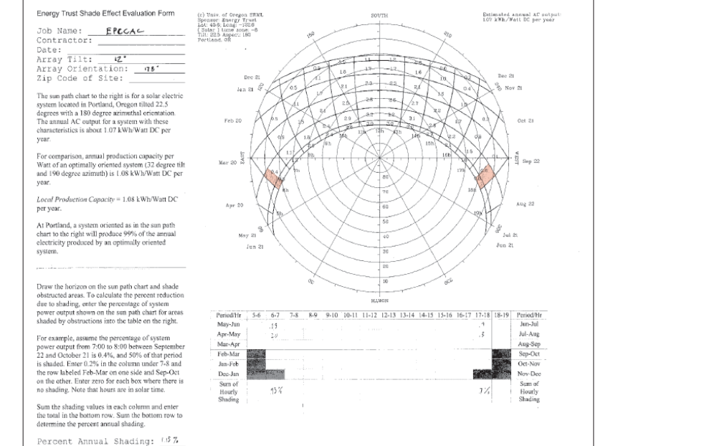
    - Schedule C: Certification and Attestation Form for Environmental Attributes/Non-Energy Attributes

This certification and attestation is a part of the reporting requirements that you agreed to when you executed an agreement with the Energy Trust of Oregon, Inc. to receive incentive funding for your renewable energy generating system (the Agreement). In order for Energy Trust to record how many Environmental Attributes (also referred to in some Agreements as Non-Energy Attributes) were generated by your System, you must complete and return this form to Energy Trust in accordance with the schedule required by your Agreement with Energy Trust. Capitalized terms used herein are defined terms that have the specific meaning assigned to them in the Agreement.
Please complete and return this form to the attention of Energy Trust's Renewable Energy Program Coordinator. If you have any questions, please contact us at (503) 459-4075.

PARTICIPANT INFORMATION
Site Owner/ Host Name
System Owner Name: (if different than Site Owner name above):
Site Address (System location) |  |  |  | City |  |  |  | State |  | Zip
Contact Person: |  |  |  | Title:
Telephone |  |  | office  cellular | Email Address:
SYSTEM INFORMATION
System Commercial Operation Date (per Agreement)
Current System Meter Reading |  | Date
Last System Meter Reading |  | Date
Difference: (Please insert this number in the appropriate blanks below. Energy Trust may request additional documentation to verify reported generation information.)
DECLARATION
I hereby declare that the meter readings set forth herein are true and accurate and therefore indicate that (indicate quantity) kilowatt hours of Environmental Attributes/Non-Energy Attributes were produced by the System from (date) to (date) . This amount of Environmental Attributes/Non-Energy Attributes represents all of the Environmental Attributes/Non-Energy Attributes produced by the System during this period.
I further declare that all of the Environmental Attributes/Non-Energy Attributes that are the subject of this attestation:
(1) were transferred exclusively to Energy Trust pursuant to the aforementioned Agreement;
(2) were not sold, marketed, or otherwise claimed by a third party;
(3) were transferred once and only once to Energy Trust; and
(4) the electricity that was generated with the Environmental Attributes/Non-Energy Attributes was not separately sold, marketed or otherwise separately represented as renewable energy and was not used to meet any federal, state or local renewable energy requirement, renewable energy procurement, renewable portfolio standard, or other renewable energy mandate.

By my signature below, I hereby certify that I am properly authorized to sign this form and attest that the information provided on this form is true and correct to the best of my knowledge and belief.
Printed Name |  | Title
Signature |  | Date

Schedule D: Solar Facility Description

The Solar Facility will consist of an approximately 88.7 kilowatt photovoltaic solar power system with an associated six panel thermal hot water system located on the newly constructed building (“Premises”) located at 740 SE 106th Avenue, Portland, Oregon 97216 (the “Site”), which is owned by the City of Portland, through the Portland Bureau of Parks and Recreation.

1. Site Name: East Portland Community Center (“EPCC”)

2. Site Address: 740 SE 106th Ave., Portland, OR

3. Site Legal Description: COMMUNITY CENTER EASTSIDE PORTLAND, LOT 1
4. Premises: Premises means the building at the Site on which the Solar Facility lies.

5. Portland Parks and Recreation Bureau emergency contact:

PPR Switchboard: 503-823-2223

6. LLC emergency contact:

CSV contact: Sandra Walden – 503-241-5918

_____________________, LLC contact (if Agreement has been assigned):
Bonneville Environmental Foundation - Main line: (503) 248-1905
Main contacts: Bryce Smith or Angus Duncan

7. Solar Facility System Specifications and Description: 460 PV Panels installed at a 12 degree 178 degree orientation and affixed directly to the roof as depicted in this Schedule D, section 10 (PV Panel Design). Six hot water panels and associated piping and storage tanks as depicted in this Schedule D, section 11 (Solar Hot Water Schematic)..

Description of Educational Display Kiosk) – A freestanding kiosk located in the Courtyard Foyer next to the door to the courtyard against the window from which the site can be viewed. The kiosk will be connected by the Community Center wireless network to the internet and to the output of the Hot Water and Solar installation to show the production history and a description of the system.

Estimated Costs of Solar Facility Equipment and Installation: $900,000

8. On- site Educational Programming. LLC and Host shall make best endeavors to coordinate the provision of structured educational programs designed to further the conservation of energy. All educational programs will be coordinated through the Director of the East Portland Community Center

9. Standard Access and Security Procedures: Standard procedures to be provided by EPCC Director or Parks Property Manager.

10. PV Panel Design

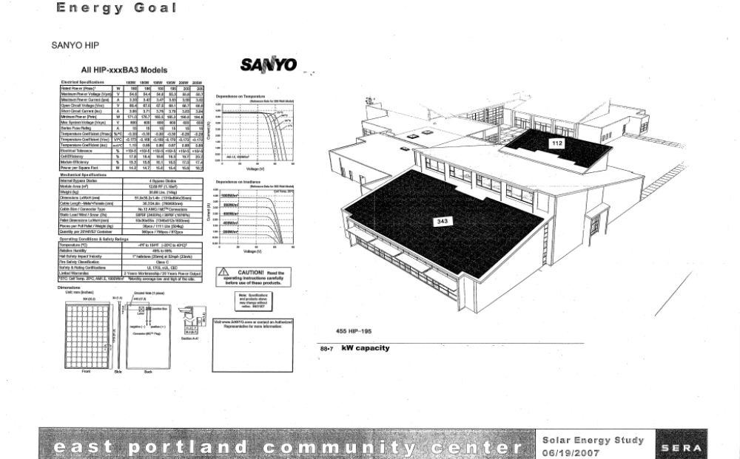

11. Solar Hot Water Schematic

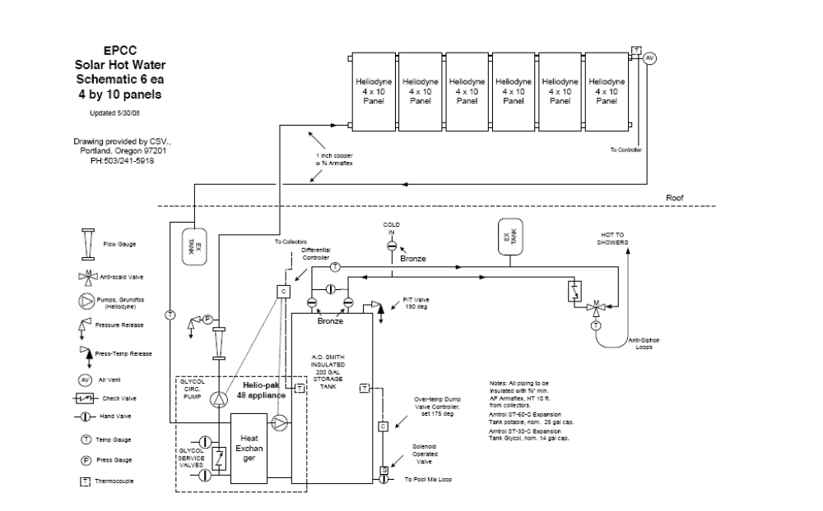

Schedule E: Party and Party-Affiliate Logos



