Attachment B

INTERGOVERNMENTAL AGREEMENT
Columbia Slough (3/1/08-6/30/09—16 months)
This Intergovernmental Agreement (IGA) is entered into by and between the City of Portland (CITY) acting by and through its Bureau of Environmental Services, hereafter called BES and the State of Oregon, acting by and through its Oregon Department of Fish and Wildlife, hereafter called ODFW.
This IGA is authorized pursuant to ORS 190.110 and becomes effective upon full execution of this document.
PURPOSE
BES and ODFW desire to work together to conduct field investigations of aquatic species and habitat in certain Portland waterways, analyze those data and report them to BES, and collect fin samples from salmonids that BES can archive for genetic analysis, for the purposes of furthering BES’ implementation of the Portland Watershed Management Plan.
By this IGA, ODFW agrees to provide the necessary personnel, equipment and expertise to collect and analyze data necessary to calculate an Index of Biological Integrity, along with additional specific data requested by BES and identified in the Statement of Work and Budget attached hereto as Exhibits A and B, and BES agrees to reimburse ODFW for costs associated with the provision of these services as described in this document.
GENERAL PROVISIONS
- Effective Date and Duration. This IGA is effective on March 1, 2008 or the date of execution by both parties, whichever date occurs first. Unless earlier terminated or extended, this IGA shall expire when ODFW’s completed performance has been accepted by BES or June 30, 2009, whichever date occurs first.
- Statement of Work. The statement of work, (the “Work”) including the delivery schedule for such Work, is contained in Exhibit A and B. ODFW agrees to perform the Work in accordance with the terms and conditions of this IGA.
- Consideration. BES agrees to pay ODFW a sum not to exceed $52,455.00 as allocated in Exhibit B.
- Project Representatives. Each party has designated a project manager to be the formal representative for this project. All reports, notices, and other communications required under or relating to this IGA shall be directed to the appropriate individual.
BES Project Manager ODFW Project Manager
Kaitlin L. Lovell Christine Mallette
City of Portland Oregon Department of Fish and Wildlife
1120 SW Fifth Ave., Suite 1000 17330 S.E. Evelyn Street
Portland, OR 97204 Clackamas, OR 97015
Phone: (503) 823-7032 Phone: (971) 673-6053
Fax: (503) 823-6995 Fax: (971) 673-6073
Email: Kaitlin.lovell@bes.ci.portland.or.us Email: Christine.mallette@state.or.us
- Subcontracts. ODFW shall not enter into any subcontracts for any of the work scheduled under this IGA without obtaining prior written consent from the BES Project Officer.
- IGA Documents. This IGA consists of the following documents, which are listed, in descending order of precedence: This IGA less all exhibits, attached Exhibit A, Statement of Work, and Exhibit B, Budget. All attached Exhibits are hereby incorporated for reference.
- Amendments. The terms of this IGA shall not be waived, altered, modified, supplemented, or amended, in any manner whatsoever, except by written instrument signed by both parties.
- Reimbursement.
A. ODFW shall submit itemized invoices to BES for reimbursement of services performed; noting the project and City IGA number and the allocation of costs in accordance with line items identified in Exhibit B.
- Costs incurred for travel shall be reimbursed to the extent that they do not exceed on a daily basis per diem rates in effect at the time of travel as set forth in the Federal Travel Regulations and all travel has been approved by the BES Project Manager and identified in Exhibit B.
- Non-itemized or incomplete billings shall be detained for payment processing until ODFW has supplied correct information to BES.
- ODFW shall submit to BES a quarterly invoice for costs incurred during the preceding quarter period no later than 45 days following the end of that performance period. BES shall not be liable for reimbursement of costs after that date.
- Invoices shall be submitted in duplicate, identifying the City IGA number to:
Kaitlin Lovell
City of Portland, Bureau of Environmental Services
1120 SW Fifth Avenue, Room 1000
Portland, OR 97204
BES shall pay all approved invoices within 30 days.
- All non-expendable property, including computer hardware and related software, acquired in the provision of these services are the sole property of BES and shall be surrendered upon completion of services or termination of this IGA.
- The parties recognize and agree that some of the activities and obligations for reimbursement addressed in this IGA have or will commence or arise prior to the effective date of this IGA.

- Termination.
- The parties may agree to an immediate termination of this IGA or at a time certain upon mutual written consent.
- Either party may terminate this IGA effective not less than 30 days from delivery of written notice.
- Either party may terminate this IGA effective not less than 10 days from written notice or at such other date as may be established by both parties under any of the following conditions:
- If funding is not obtained and continued at levels sufficient to allow for purchase of the specified services. When possible, and when agreed upon, the IGA may be modified to accommodate a reduction in funds.
- If federal or state regulations or guidelines are modified, changed or interpreted in such a way that the services are no longer allowable or appropriate for purchase under this IGA, or are no longer eligible for the funding proposed for payments authorized by this IGA.
- Either party may terminate this IGA in the event of a breach by the other party. Prior to such termination, however, the party seeking termination shall give the other party written notice of the party’s intent to terminate. If the party has not cured the breach within 10 days or a longer period as granted in the cure notice, the party seeking compliance may terminate this IGA.
- Funds Available and Authorized. Both parties certify that at the time the IGA is written that sufficient funds are available and are authorized or will be authorized through the annual budget approval process, for expenditure to finance costs of this IGA within either party’s current appropriation and limitation. Both parties understand and agree that payment of amounts under this IGA attributable to work performed after the last date of the current budget period is contingent on either party receiving appropriations, limitations, or other expenditure authority.
- Captions. The captions or headings in this IGA are for convenience only and in no way define, limit or describe the scope or intent of any provisions of this IGA.
- Choice of Venue. Oregon law shall govern this IGA and all rights, obligations and disputes arising out of the IGA. Venue for all disputes and litigation shall be in Multnomah County, Oregon.
- Severability/Survival. If any of the provisions contained in this IGA are held unconstitutional or unenforceable, the enforceability of the remaining provisions shall not be impaired. All provisions concerning the limitation of liability, indemnity and conflicts of interest shall survive the termination of this IGA for any cause.
- Ownership of Work Product. All work products, including reports, research data in hard copy or electronic form that result from this IGA, and any biological samples collected, are the exclusive property of BES. However, ODFW reserves the right to retain copies of such items for its records and BES agrees to share any later analysis, including but not limited to genetic testing, conducted on the biological samples.
- Access to Records. Both parties and their duly authorized representatives shall have access to the books, documents, papers, and records which are directly pertinent to the specific IGA for the purpose of making audit, examination, excerpts, and transcript.
- Compliance with Applicable Law. Both parties shall comply with all federal, state, and local laws, regulations, executive orders and ordinances applicable to the Work under this IGA. Without limiting the generality of the foregoing, parties expressly agrees to comply with: (I) Title VI of Civil Rights Act of 1964; (ii) Section V of the Rehabilitation Act of 1973; (iii) the Americans with Disabilities Act of 1990 and ORS 659.425; (iv) all regulations and administrative rules established pursuant to the foregoing laws; and (v) all other applicable requirements of federal and state civil rights and rehabilitation statutes, rules and regulations. Both party's performance under this IGA is conditioned upon either parties compliance with the provisions of ORS 279.312, 279.314, 279.316, 279.320, and 279.555, which are incorporated by reference herein.
- No Third Party Beneficiary. The BES and ODFW are the only parties to this IGA and as such, are the only parties entitled to enforce its terms. Nothing contained in this IGA gives or shall be construed to give or provide any benefit, direct, indirect, or otherwise to third parties unless third persons are expressly described as intended to be beneficiaries of its terms.
- Indemnification. Within the limits of the Oregon Tort Claims Act, codified at ORS 30.260 through 30.300, each party agrees to indemnify and defend the other and its officers, employees, agents and representatives from and against all claims, demands, penalties and causes of action of any kind or character relating to or arising from this IGA, including the cost of defense, attorney fees arising in favor of any person on account of personal injury, death or damage to property and arising out of or resulting from the negligent or other legally culpable acts or omissions of the indemnitor, its employees, agents, subcontractors or representatives.
- Merger Clause. This IGA constitutes the entire agreement between the parties. No waiver, consent, modification or change of terms of this IGA shall bind either party unless in writing and signed by both parties. Such waiver, consent, modification or change, if made, shall be effective only in the specific instance and for the specific purpose given. There are no understandings, agreements, or representations, oral or written, not specified herein regarding this IGA.
- BES Accounting Data. This amount is to be distributed equally over FY 2007-2008 and FY 2008-2009
Vendor Number 31967 GL Fund Number _151_ Account 529000
Center Code 14532041 Amount $52, 455
PTS: ______/_______/______/_______
Proj. Org. TW CC

Executed in triplicate by the duly authorized representatives of the parties.

CITY OF PORTLAND OREGON DEPARTMENT OF FISH
AND WILDLIFE

Elected Official or Delegate Date Laurie Byerly Date
Deputy Director for Administration

Approved for Legal Sufficiency,
Bureau Director Date by William Cook,
Assistant Attorney General, via e-mail dated February 14, 2008

City Auditor Date Tax ID No. 930655103__________

Approved as to form Date
by City Attorney:

Exhibit A

STATEMENT OF WORK

Overview
This statement of work provides the methods and budget for a survey of seasonal species composition, and distribution of fish in the Columbia Slough, Portland, Oregon. The Columbia Slough is a series of lakes and waterways that parallel the Columbia River for approximately 29 km through heavily developed, both industrial and residential, neighborhoods. The Lower Columbia Slough is tidally influenced and feeds into the Willamette River. The Middle and Upper portions of the Columbia Slough are not accessible to salmon and are within a highly managed drainage district. Findings from the proposed survey may be used to guide planning decisions; and because of this, may provide immediate benefits to local aquatic fauna.
Eight survey sites in the lower 14-km of the Columbia Slough will be decided upon by City of Portland (COP) and Oregon Department of Fish and Wildlife (ODFW) staff, and will include at least the mouth (confluence with the Willamette) and Ramsey refuges. Several native species of interest are known to inhabit other streams and waterways in the Portland Metropolitan Area, including parts of Columbia Slough (Ward 1995; Tinus et al. 2003; Friesen et al. 2007; C. Baker, Ducks Unlimited, personal communication); however, the extent that they may use the proposed survey area is still relatively unknown. Salmonids, some protected under Endangered Species Act (ESA) regulations, may use the lower Columbia Slough as rearing or refuge habitat. In addition to salmonids, multiple species of lamprey, listed as sensitive by the State of Oregon, have been noted in other nearby waterways (Tinus et al. 2003), and have been documented using limited portions of the Columbia Slough and Smith and Bybee Wetlands (C. Baker, Ducks Unlimited, personal communication).
The lower Columbia Slough is tidally influenced for approximately 14.5 km, up to where the slough is diked and managed by the Multnomah County Drainage District. Past work indicated that ESA-listed salmonid species were captured as far as Wapato Wetland (approximately 5.6 km upstream from the mouth of the Columbia Slough (City of Portland, unpublished data). A portion of the lower slough has been sampled in 2006 and 2007, and a determination through genetic sampling was made that interior Columbia Basin summer/fall, lower Columbia River fall, tule, and upper Willamette River spring Chinook salmon are using the lower slough (C. Baker, Ducks Unlimited, personal communication).
The COP would like to build on previous work to determine the identity and extent of usage by ESA-listed salmonid species. The proposed fish inventories will: provide needed information on the seasonal use and distribution of fish within the lower Columbia Slough; demonstrate upstream distribution of ESA-listed salmonids in the lower slough; and will further the COP’s understanding of this local wetland area. Additionally, results obtained through this work may lead to increased coordination between jurisdictions for protection of ESA-listed and Oregon sensitive species and restoration of their habitat throughout the area.

Objective and Tasks
Objective. Evaluate seasonal shifts in the community assemblage and upstream distribution of fish inhabiting the lower 14.5 km of the Columbia Slough, Portland, Oregon.
Task 1: Use modified Alaska style hoop traps to collect fish at six to eight sites in the lower 14.5 km of the Columbia Slough in the spring, summer, fall, and winter 2008.
We will use modified Alaska style fish traps, sampling each site once per season for a five day period for one year, beginning in spring 2008. Sampling one season only will likely be inadequate to relate salmonid production to habitat. Nickelson et al. (1992) found that production of wild coho salmon was probably limited by availability of adequate winter habitat, and habitat factors such as the amount of woody debris have been strongly correlated to the survival of over-wintering juvenile salmonids (Quinn and Peterson 1996). Sampling will be limited to one year; however, with careful sample-site selection, determination of baseline seasonal fish distribution should be possible.
Modified Alaska style fish traps (Figure 1) will be our primary sampling technique. Depth and size of the area precludes backpack electrofishing and lack of suitable access points and necessary ESA authorization precludes boat electrofishing. Additionally, flow and debris concerns have precluded the use of fyke and standard hoop nets. Stationary rigid traps have been used in other community assemblage and salmonid monitoring studies (LaPointe et al. 2006; Roth and Orvos 2006; Hans and Wenzel 2005). The fish traps proposed for use in this study are approximately 2.7-m long with a diameter of 1.1 m, have a rigid frame, and plastic mesh body (mesh is 5-mm diameter). They are suitable for a variety of habitat types and flow regimes and have proven effective at characterizing species composition in other low gradient water bodies in western Oregon (Hans and Wenzel 2005; Hans and Wenzel 2006), however, should these traps prove ineffective at sampling the Columbia Slough fish community we will reassess our sampling protocol. At least one trap will be used at each sampling location. Because traps are a passive sampling gear, i.e., they depend on fish swimming into them, they will need to be fished for several days in order to adequately characterize the community assemblage at a given location (Hubert 1996). Traps will be in water (Figure 2) for a period of five (5) days per sampling location and checked at least every 24-hours, or more frequently if needed. A minimum of two people are required to deploy and check traps, and to process any catch. A three to four person crew may be necessary at certain times of year.
Products: Quarterly fishing of modified Alaska style fish traps at each selected site within the lower 14.5 km of the Columbia Slough. Documentation and enumeration of fish species present, and corresponding biological data (e.g., lengths, fin clips, tag numbers), at each sampling event. Additionally, observations of other species of interest (e.g., Western painted turtles Chrysemys picta bellii) present at the sites or in the trap and any easily discernable diseases, physical impairments, or deformities observed on captured fish will be noted. Written report on the seasonal species composition and distribution of fish sampled during the study period.
Schedule: All stream lengths to be surveyed during spring, summer, fall and winter 2008. We will be able to effectively sample three (3) to four (4) sampling locations per week; therefore, we will be sampling “in-water” for 2 weeks per season. Final Report will be completed by March 31, 2009.

Task 2 Collect fin clips from salmonids during fish trapping efforts for future COP genetic evaluation.
We will collect fin clips from trapped salmonids for the purpose of genetic evaluation. In each season we will collect uniquely marked fin samples from salmonid species for analysis by the COP.
The purpose of future COP genetic evaluation will be to determine stock of origin and genetic diversity of salmonids encountered. This analysis may be used to determine if federally listed anadromous salmonids, e.g., Snake River fall Chinook salmon, Willamette River Spring Chinook salmon, are present in the study. The genetic laboratory to perform the work will be determined, and contracted with separately by the COP. We will attempt to collect fin clips from all marked captured salmonids; however, should clipping fins from all salmonids in the sample cause undue stress on captured fish we may sub-sample the collection to reduce holding time.
Products: Unique fin clips from captured salmonid species will be collected for genetic analysis. Documentation of fin clips and corresponding biological data will be provided to the COP.
Schedule: All genetic samples will be collected and delivered to either the COP or their designee by 31 January 2009.

References

Friesen, T.A., J.S. Vile, A.L. Pribyl. 2007. Outmigration of juvenile Chinook salmon in the lower Willamette River, Oregon. Northwest Science 81:173:190.
Hans, K., and D. Wenzel. 2005. Presence/Absence Monitoring of Fish Assemblages in Smallman Creek, Sucker Slough, and Bear Branch near Scio, OR. ODFW 2005 Shelburn Area Stationary Trap Report.
Hans, K., and D. Wenzel. 2006. Presence/Absence Monitoring of Fish Assemblages in Nobel Slough and Ames Creek. ODFW 2006 South Santiam River Tributaries Stationary Trap Report.
Hubert, W. A. 1996. Passive capture techniques. Pages 157 – 192 in B. R. Murphy and D. W. Willis, editors. Fisheries techniques, 2nd edition. American Fisheries Society, Bethesda, Maryland.
LaPointe, N. W., L. D. Corkum, and N. E. Mandrak. 2006. A comparison of methods for sampling fish diversity in shallow offshore waters of large rivers. North American Journal of Fisheries Management 26:503-513.
Nickelson, T. E., J. D. Rodgers, S. L. Johnson, and M. F. Solazzi. 1992. Seasonal changes in habitat use by juvenile coho salmon (Oncorhynchus kisutch) in Oregon coastal streams. Canadian Journal of Fisheries and Aquatic Sciences 49:783-789.
Quinn, T. P., and N. P. Petersen. 1996. The influence of habitat complexity and fish size on over-winter survival and growth of individually marked juvenile coho salmon (Oncorhynchus kisutch) in Big Beef Creek, Washington. Canadian Journal of Fisheries and Aquatic Sciences 53:1555-1564.
Roth, R. N., and D. R. Orvos. 2006. A modifed box trap design for sampling emigrating salmonid smolts from small streams. North American Journal of Fisheries Management 26:170-174.
Tinus, E. S., J. A. Koloszar, and D. L. Ward. 2003. Abundance and distribution of fish in City of Portland streams. Final Report by ODFW to the City of Portland, Oregon.
Ward, D. L. 1995. Distribution of fish and crayfish, and measurement of available habitat in the Tualatin River basin. Final Report by ODFW to the Unified Sewerage Agency, Hillsboro, Oregon.

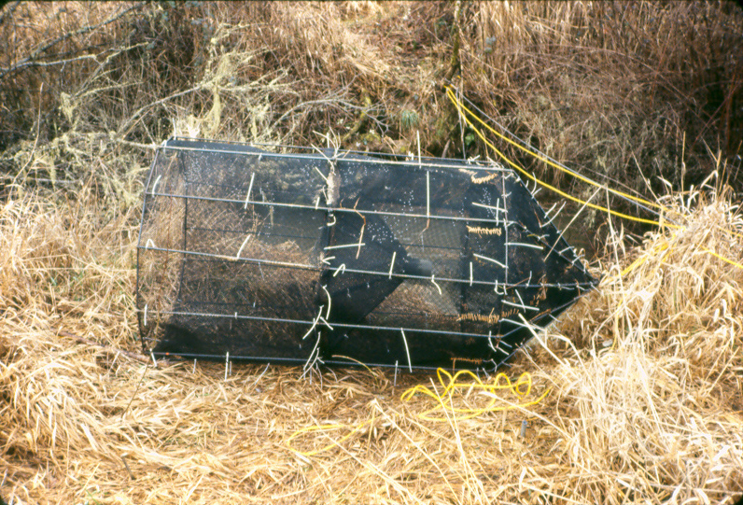
Figure 1. Modified Alaska style rigid hoop trap out of water.

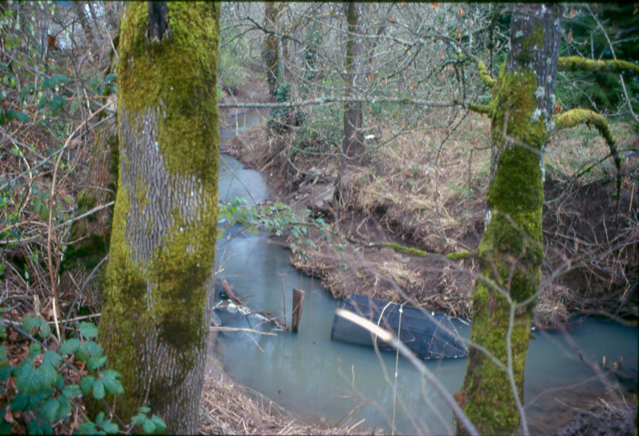
Figure 2. Modified Alaska style rigid hoop trap “in-water”.

Exhibit B

Budget (3/1/08-2/28/09—12 months)
A. PERSONNEL | Salaries |  |  |  |  | Fringe
NRS4-M | 1 | months @ | $5,809 | $5,809 |  | $2,805
NRS1 | 2 | months @ | $2,840 | $5,680 |  | $3,692
EBA | 2 | months @ | $2,535 | $5,070 |  | $3,528
EBA | 2 | months @ | $2,388 | $4,776 |  | $3,658
 |  |  |  | $21,335 |  | $13,683
Total Personnel |  |  |  |  |  | $35,018
B. NON-EXPENDABLE PROPERTY
Total Non-expendable property |  |  |  |  |  | $0
C. SERVICES AND SUPPLIES
TRAVEL:
Vehicle Rental, 3/4 ton PU | 2 | months @ | $600 |  |  | $1,200
Subtotal Travel |  |  |  |  |  | $1,200
SUPPLIES:
Office Supplies | 7 | FTE months @ | $15 |  |  | $105
Sampling Equipment | 8 | Sample sites @ | $50 |  |  | $400
Field Supplies | 6 | FTE months @ | $150 |  |  | $900
Subtotal Supplies |  |  |  |  |  | $1,405
SERVICES:
Photocopier and Fax Rent | 1 | months @ | $300 |  |  | $300
Cellular Phone Service | 2 | months @ | $20 |  |  | $40
Boat operation and maintenance | 10 | days @ | $131.50 |  |  | $1,315
Subtotal Services |  |  |  |  |  | $1,655
Total Services and Supplies |  |  |  |  |  | $4,260
E. DIRECT COST |  |  |  |  |  | $39,278
F. INDIRECT COST |  |  |  |  |  | $13,177
G. CAPITAL COST |  |  |  |  |  | $0
H. TOTAL PROJECT COST (Direct COP Cost) |  |  |  |  |  | $52,455

