COOPERATIVE IMPROVEMENT AGREEMENT
NE 33rd Avenue over Lombard Street and
UPRR Partial Bridge Replacement Project
City of Portland

THIS AGREEMENT is made and entered into by and between the STATE OF OREGON, acting by and through its Department of Transportation, hereinafter referred to as "State"; and the CITY OF PORTLAND, acting by and through its elected officials, hereinafter referred to as "Agency."

RECITALS

- By the authority granted in ORS 190.110, 366.572, 366.574 and 366.576, State may enter into cooperative agreements with the counties, cities, and units of local governments, for the performance of work on certain types of maintenance or improvement projects with the allocation of costs on terms and conditions mutually agreeable to the contracting parties.

- The 2001 Oregon Transportation Investment Act Program, hereinafter referred to as the “2001 OTIA Program”, provides funding for preservation and modernization projects chosen by the Oregon Transportation Commission. The Oregon Transportation Commission selected the projects to be funded under the 2001 OTIA Program at its January 16, 2002 meeting. This selection included Agency’s project, NE 33rd Avenue over Lombard Street and UPRR (Union Pacific Rail Road) Partial Bridge Replacement, as further defined in STATE Agreement No. 19475.

- The purpose of this Agreement is to address the construction and maintenance responsibilities of a horseshoe shaped water quality swale (swale).

- A swale is defined as a wide shallow depression in the ground to form a channel for storm water drainage.

NOW THEREFORE, the premises being in general as stated in the foregoing recitals, it is agreed by and between the parties hereto as follows:

TERMS OF AGREEMENT

- Under such authority, State and Agency agree to construct and address maintenance responsibilities of a swale, hereinafter referred to as “Project”. Said Project is as shown on the map marked Exhibit "A", attached hereto and by this reference made a part hereof.

- Agency is responsible for all costs associated with the Project.

3. This Agreement shall become effective on the date all required signatures are obtained and shall remain in effect for the purpose of ongoing maintenance responsibilities for the useful life of the facilities constructed as part of the Project. This Agreement may be modified by mutual consent of both parties and upon execution of amendments to this Agreement stating said modifications.

AGENCY OBLIGATIONS

- Agency shall perform the work described in Exhibit B, attached hereto and by this reference made a part hereof.

- Agency shall conduct the necessary preliminary engineering and design work required to produce final plans, specifications and cost estimates for the Project; obtain all required permits; perform all construction engineering, including all required materials testing and quality documentation; prepare all bid documents; advertise and award all contracts; pay all contractor costs, provide project management services and other necessary functions for sole administration of the construction contract entered into for this Project.

- Agency shall conduct the necessary field surveys, environmental studies, traffic investigations, identify and obtain all required permits, and perform all preliminary engineering and design work required to produce plans, specifications and cost estimates for Project.

- Agency shall provide final plans, prepare contract and bidding documents, advertise for construction bid proposals, award all contracts, pay all contractor costs, furnish all construction engineering, technical inspection, and project manager services for the administration of the contract for Project.

- Agency shall be responsible for the costs of locating, constructing, installing, maintaining, repairing, operating or using the facility, or performing miscellaneous operations and of any other expense whatsoever incident to the facilities or operations authorized by the permit, including any complaints, from the public regarding the Project.

- All costs described in Paragraph 5 of Agency Obligations shall be the responsibility of Agency as long as the Project exists on State property.

- If State terminates this Agreement, Agency shall, at no cost to the State, restore the right-of-way back to the original condition prior to this Agreement. Agency shall be responsible, at no cost to the State, for all piping removal into and out of the right-of-way, and the Project will return back to its present condition prior to this Agreement, a mowable grassy slope.

- Agency shall not enter into any subcontracts for any of the work scheduled under this Agreement without obtaining prior written approval from State.

- Agency shall comply with all federal, state, and local laws, regulations, executive orders and ordinances applicable to the work under this Agreement, including, without limitation, the provisions of ORS 279C.505, 279C.515, 279C.520, 279C.530 and 279B.270 incorporated herein by reference and made a part hereof; Without limiting the generality of the foregoing, Agency expressly agrees to comply with (i) Title VI of Civil Rights Act of 1964; (ii) Title V and Section 504 of the Rehabilitation Act of 1973; (iii) the Americans with Disabilities Act of 1990 and ORS 659A.142; (iv) all regulations and administrative rules established pursuant to the foregoing laws; and (v) all other applicable requirements of federal and state civil rights and rehabilitation statutes, rules and regulations.

- Agency shall perform the service under this Agreement as an independent contractor and shall be exclusively responsible for all costs and expenses related to its employment of individuals to perform the work under this Agreement including, but not limited to, retirement contributions, workers compensation, unemployment taxes, and state and federal income tax withholdings.

- All employers, including Agency, that employ subject workers who work under this Agreement in the State of Oregon shall comply with ORS 656.017 and provide the required Workers’ Compensation coverage unless such employers are exempt under ORS 656.126. Agency shall ensure that each of its subcontractors complies with these requirements.

- Agency shall, to the extent permitted by the Oregon Constitution and the Oregon Tort Claims Act, indemnify, defend, save, and hold harmless the State of Oregon, Oregon Transportation Commission and its members, Department of Transportation, its officers and employees from any and all claims, suits, and liabilities which may occur in the performance of this Project.

- Notwithstanding the foregoing defense Agency Obligations under paragraph six (6) above, neither Agency nor any attorney engaged by Agency shall defend any claim in the name of the State of Oregon or any agency of the State of Oregon, nor purport to act as legal representative of the State of Oregon or any of its agencies, without the prior written consent of the Oregon Attorney General. The State of Oregon may, at anytime at its election assume its own defense and settlement in the event that it determines that Agency is prohibited from defending the State of Oregon, or that Agency is not adequately defending the State of Oregon's interests, or that an important governmental principle is at issue or that it is in the best interests of the State of Oregon to do so. The State of Oregon reserves all rights to pursue any claims it may have against Agency if the State of Oregon elects to assume its own defense.

- Agency shall construct the Project in accordance with the requirements of ORS 276.071 including the public contracting laws within ORS Chapters 279A, 279B and 279C.

- If Agency chooses to assign its contracting responsibilities to a consultant or contractor, Agency shall inform the consultant or contractor of the requirements of ORS 276.071, to ensure that the public contracting laws within ORS Chapters 279A, 279B and 279C are followed.

- Agency or its consultant shall acquire all necessary rights-of-way according to the Uniform Relocation Assistance and Real Property Acquisition Policies Act of 1970, as amended, ORS Chapter 35 and the State Right of Way Manual. Certification of right of way acquisition work must be made by the Agency (or on behalf of its consultant) doing the work. If Agency acquires the right of way, they shall provide a letter from Agency’s legal counsel certifying that 1) the right of way needed for the Project has been obtained and 2) right of way acquisition has been completed in accordance with the right of way requirements contained in this Agreement. The certification form shall be routed through the ODOT Region 1 Right of Way Office for co-signature and possible audit. If Agency elects to have ODOT perform R/W functions, a separate agreement shall be executed between Agency and ODOT R/W, referencing this Agreement number.

- Agency agrees and understands that Agency will comply with the Uniform Relocation Assistance and Real Property Acquisition Policies Act of 1970, as amended, ORS Chapter 35 and the State Right of Way Manual if right-of-way acquisition is necessary.

- Agency shall require its contractor to indemnify State and name State as a third party beneficiary of the resulting contract and shall carry at a minimum personal injury and property damage insurance with a single limit of $1,000,000 for all claims arising out of a single accident or occurrence. Agency shall also insure that the contractor also provide an additional $1,000,000 excess insurance coverage over the basic $1,000,000 coverage. Each annual aggregate limit shall not be less than $2,000,000 when applicable. The contractor shall include Agency and State as named insured on policies issued for this Project, or shall furnish an additional insured endorsement naming the same as additional insured to the contractor’s existing public liability and property damage insurance. The certificate of insurance shall include the State of Oregon, Transportation Commission and its members, Department of Transportation, officers and employees as additional insured. Agency shall provide a copy of the certificate to State prior to construction of the Project. The insurance coverage shall not be amended, altered, modified or cancelled insofar as the coverage contemplated herein is concerned without at least 30 days prior written notice.

- Agency’s Project Manager is: Paul Gornick, Project Manager, Bridge and Structures Section, City of Portland, 1120 SW Fifth Avenue, Room 800, Portland, OR 97204-1971, phone: 503-823-7060.

STATE OBLIGATIONS

- State hereby grants Agency the right to enter onto and occupy State right-of-way for the performance of necessary field work, swale construction, and installation of the drainage equipment. State also grants Agency the right to enter onto and occupy State right-of-way for the purpose of providing maintenance to Project.

- State shall perform no maintenance or construction on the Project.

- State shall not be responsible for any actual costs incurred for work performed under this Agreement.

- State assumes no responsibility for any damage to the Railroad property or track system as a result of the water discharged from this swale onto Railroad property on this Project.

- State's Project Manager for this Agreement is: Larry Olson, District 2B Manager, 9200 SE Lawnfield, Clackamas, OR 97015; 503-653-3086.

GENERAL PROVISIONS

- State may terminate this Agreement effective upon delivery of written notice to Agency, or at such later date as may be established by State, under any of the following conditions:

- If Agency fails to provide services called for by this Agreement within the time specified herein or any extension thereof.

- If Agency fails to perform any of the other provisions of this Agreement, or so fails to pursue the work as to endanger performance of this Agreement in accordance with its terms, and after receipt of written notice from State fails to correct such failures within 10 days or such longer period as State may authorize.

- If federal or state laws, regulations or guidelines are modified or interpreted in such a way that either the work under this Agreement is prohibited or State is prohibited from paying for such work from the planned funding source.

- Any termination of this Agreement shall not prejudice any rights or obligations accrued to the parties prior to termination.

- If State terminates this Agreement, Agency shall, at no cost to the State, restore the right-of-way back to the original condition prior to this Agreement. Agency shall be responsible, at no cost to the State, for all piping removal into and out of the right-of-way, and the swale will return back to its present condition prior to this Agreement, a mowable grassy slope.

- Agency acknowledges and agrees that State, the Secretary of State's Office of the State of Oregon, the federal government, and their duly authorized representatives shall have access to the books, documents, papers, and records of Agency which are directly pertinent to the specific Agreement for the purpose of making audit, examination, excerpts, and transcripts for a period of three years after final payment. Copies of applicable records shall be made available upon request. Payment for costs of copies is reimbursable by State.

- This Agreement and attached exhibits constitute the entire agreement between the parties on the subject matter hereof. There are no understandings, agreements, or representations, oral or written, not specified herein regarding this Agreement. No waiver, consent, modification or change of terms of this Agreement shall bind either party unless in writing and signed by both parties and all necessary approvals have been obtained. Such waiver, consent, modification or change, if made, shall be effective only in the specific instance and for the specific purpose given. The failure of State to enforce any provision of this Agreement shall not constitute a waiver by State of that or any other provision.

IN WITNESS WHEREOF, the parties hereto have set their hands as of the day and year hereinafter written.

On June 18, 2003, the Oregon Transportation Commission approved Delegation Order No. 4 which delegates to the Director, Deputy Director, Highways, Deputy Director, Central Services and Chief of Staff the authority to approve and execute agreements up to $75,000 not included in the Statewide Transportation Improvement Program or not included in a line item in the biennial budget approved by the Commission.

On August 2, 2005, the Director, Deputy Director, Highways and Chief Engineer approved Subdelegation Order No. 5, in which the Director, Deputy Director, Highways and Chief Engineer delegate authority to the Region Managers to approve and sign intergovernmental agreements up to $75,000 not included in the Statewide Improvement Program (STIP) or not included in a line item in the biennial budget approved by the Commission, provided that engineering sufficiency is recommended by the Technical Services Manager/Chief Engineer.

SIGNATURE PAGE TO FOLLOW

CITY OF PORTLAND, by and through its elected officials  By _______________________________  Date _____________________________  By _______________________________  Date _____________________________  APPROVED AS TO LEGAL SUFFICIENCY  By _______________________________  Counsel  Date _____________________________  Agency Contact:  Mr. Paul Gornick, Project Manager  Bridge and Structures Section  City of Portland  1120 SW Fifth Avenue, Room 800  Portland, OR 97204-1971  Phone: 503-823-7060 | STATE OF OREGON, by and through  its Department of Transportation  By _______________________________  Date _____________________________  APPROVAL RECOMMENDED  By _______________________________  Date ____________________________  By _______________________________  Date _____________________________  APPROVED AS TO LEGAL SUFFICIENCY  By_______________________________  Assistant Attorney General  Date:_____________________________

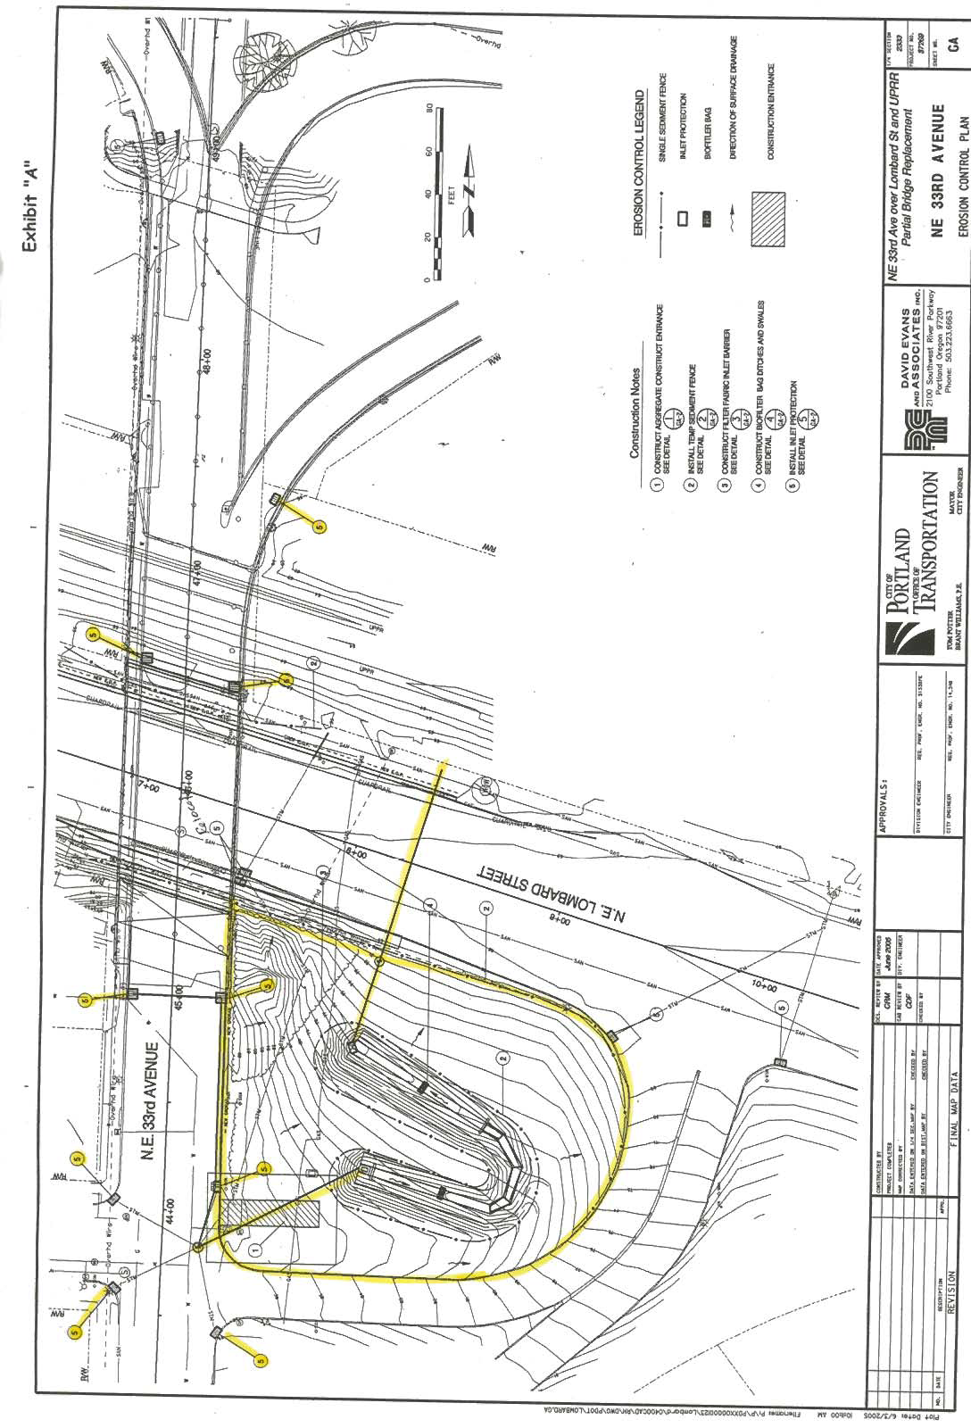

1. Agency shall construct a horseshoe shaped water quality swale with a stepped concrete drop structure. Construction of the swale shall include:

- Construction of a horseshoe shaped water quality swale with a stepped concrete drop structure.
- Inlet piping to extend from an existing manhole at NE 33rd Ave and Dekum Street to the upper end of the swale.
- Outlet piping to extend from a new inlet at the lower end of the swale across NE Lombard St. to an existing ditch.
- Outlet piping to extend from a new inlet at the lower end of the swale across NE Lombard St. to an existing ditch.
- Moving an existing ODOT inlet from the existing curb to the new curb on the south side of NE Lombard St.

2. Agency shall, for as long as the Project is located on State property, maintain this site identified in this Agreement, Exhibit A - including swale all drainage pipes and structures into and out of this facility and all plantings. Maintenance of the plantings will include the control of volunteer vegetation.

3. Agency shall be responsible, at no cost to the State, for all clean-up of contaminated soil resulting from the drainage into this swale.

4. Agency shall be responsible for any damage to NE Portland Highway resulting in failure to maintain this swale.

5. Agency shall continue to maintain the grassy area around the Project, as identified in Exhibit A, and Recitals, Paragraph 1 and 4 of Page 1, for as long as the facility remains on State property.

6. Agency shall, at no cost to the State, respond to inquiries, including any complaints, from the public for any issues within the limits the Project.

7. State assumes no responsibility for any damage to the Railroad property or track system as a result of the water discharged from this swale onto Railroad property.

8. A map attached, Exhibit A, shows the area, including inlets, to be maintained per this Agreement.

