Exhibit A – Map of Parcel

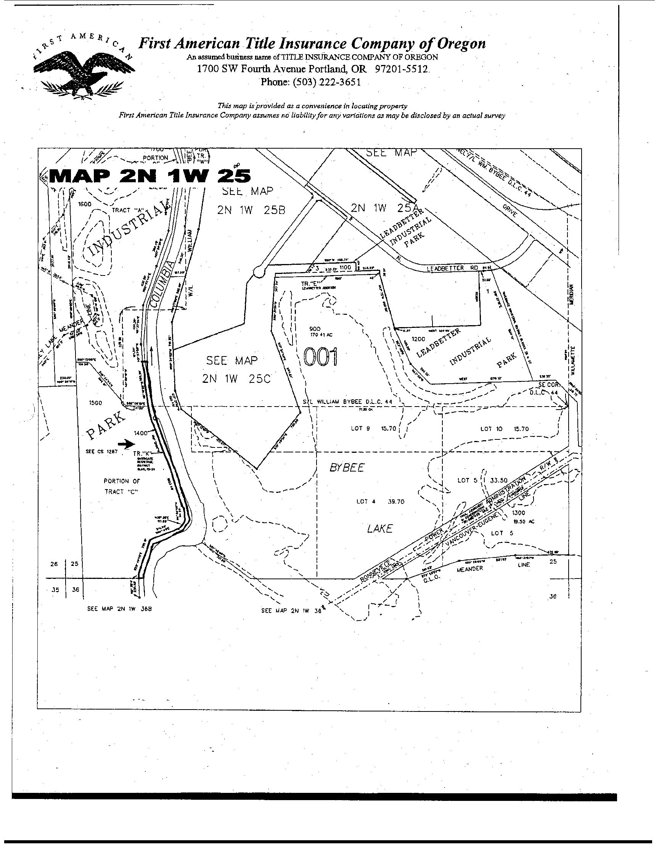
Exhibit B – Map of Parcel

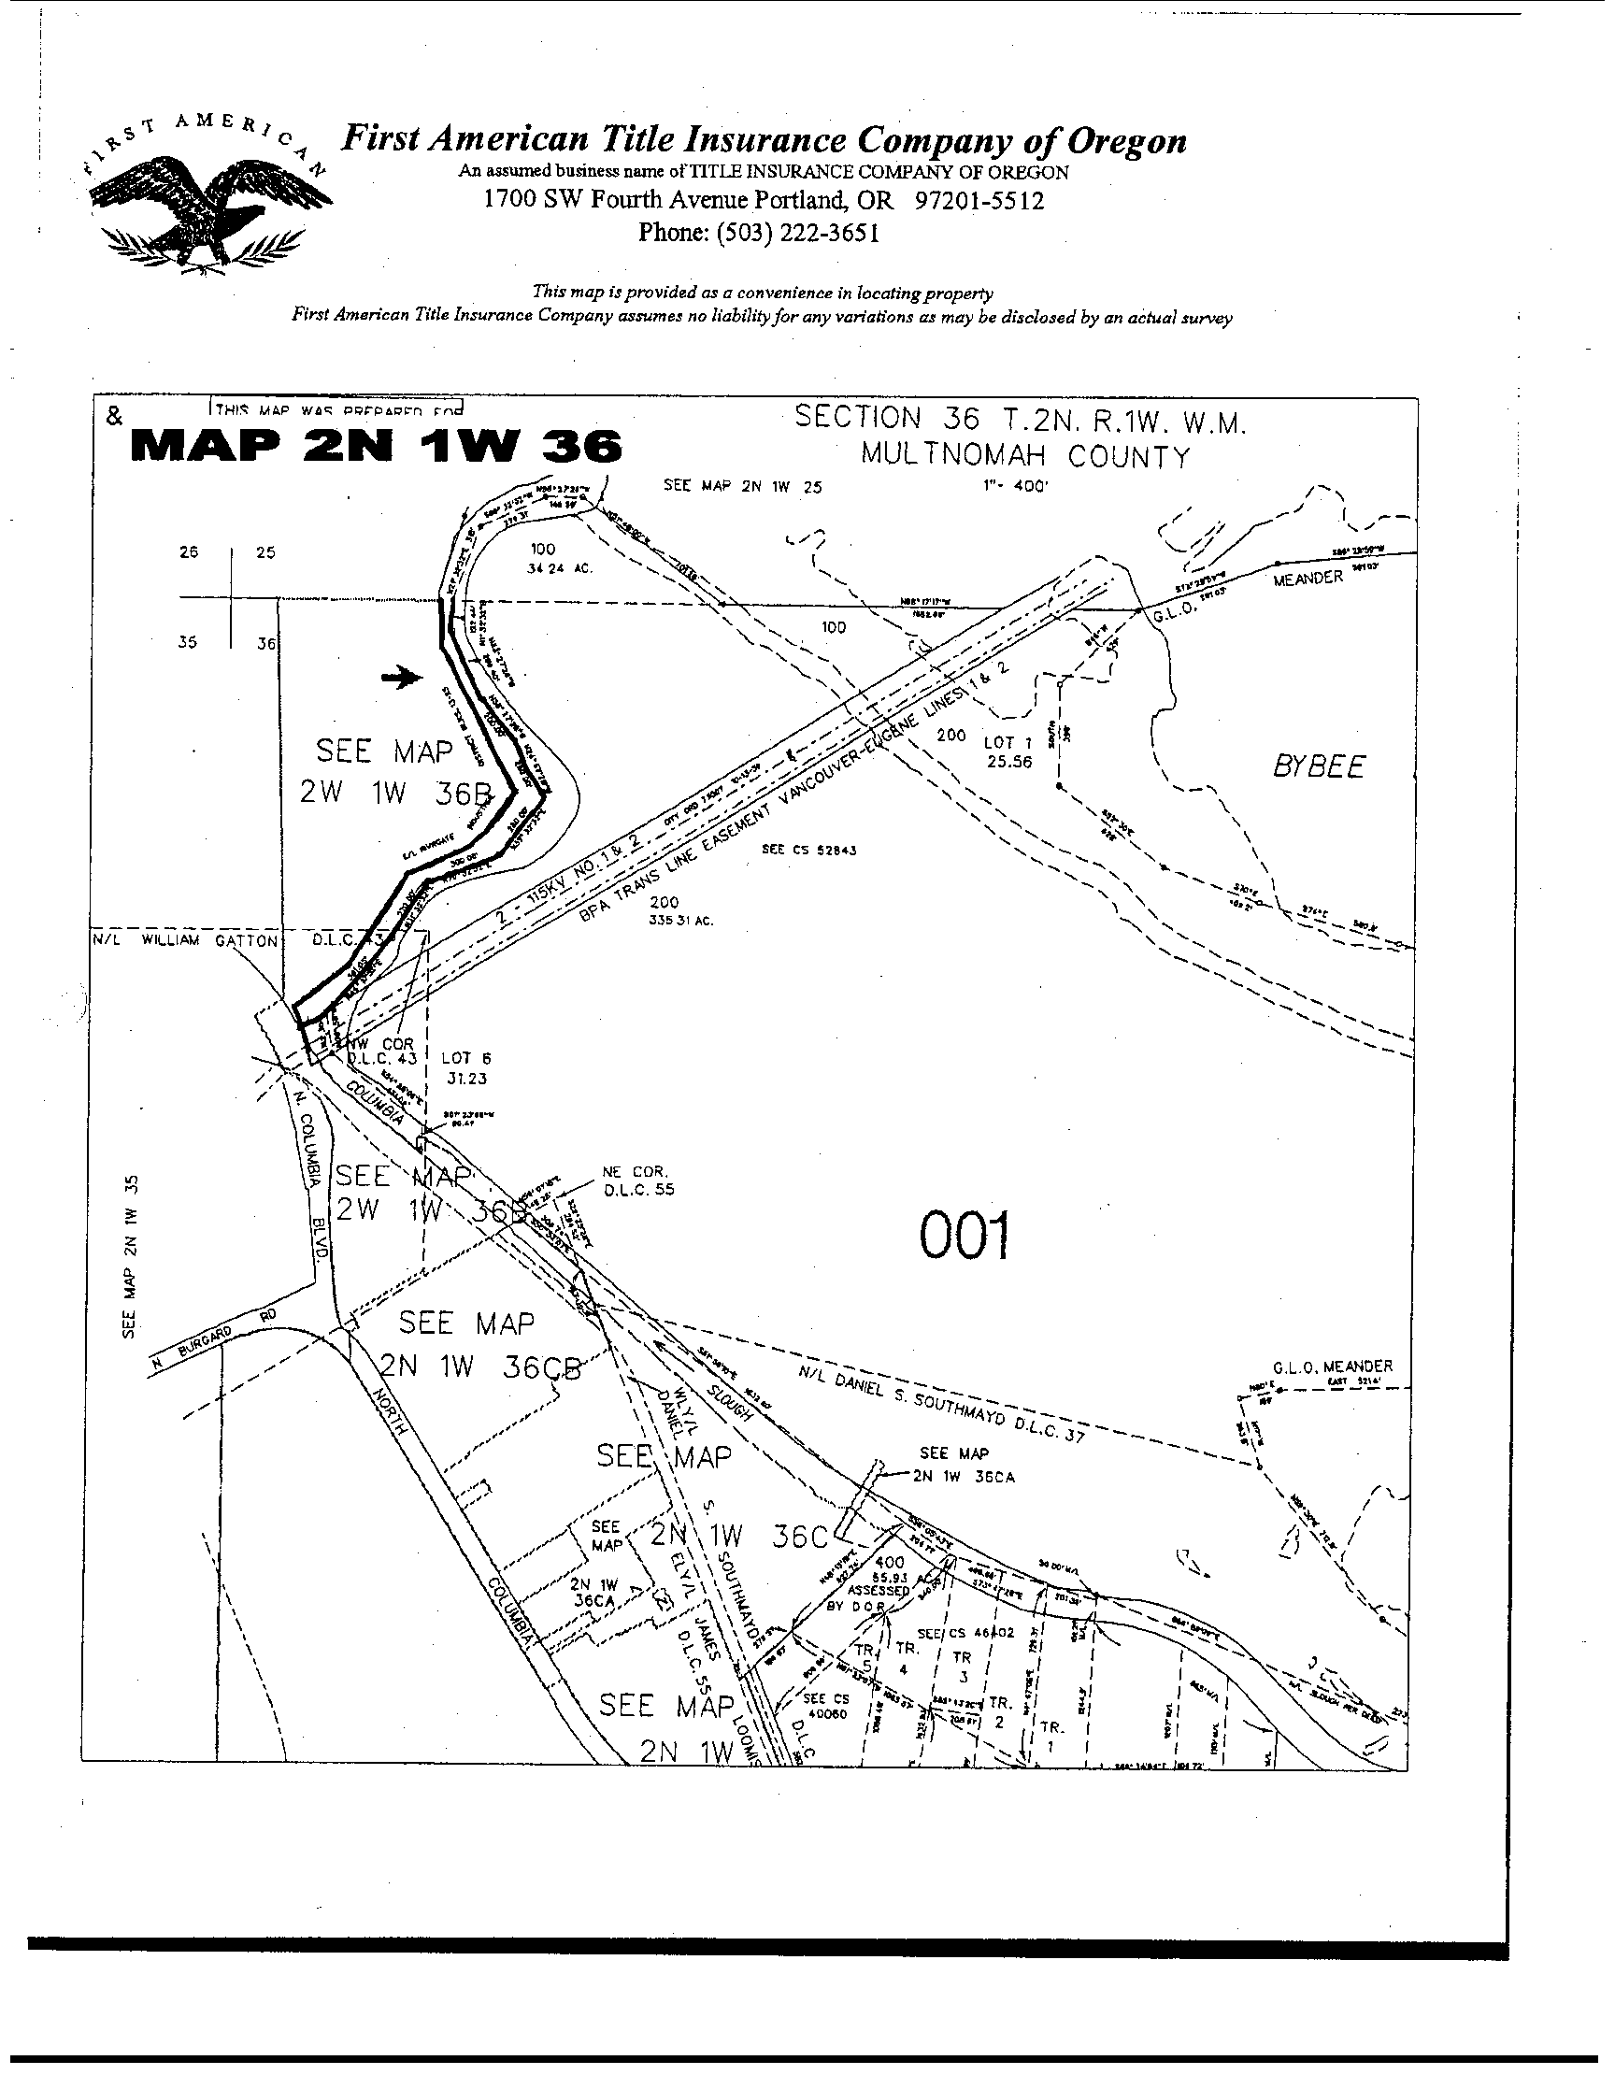

Exhibit C – Legal Description

Track K, RIVERGATE INDUSTRIAL DISTRICT, BLOCKS 13 TO 25, as filed in Plat Book 1207, page 19 in the City of Portland, County of Multnomah and State of Oregon.

Exhibit D – Special Warranty Deed with Restrictive Covenants



