Zoning Code for South Waterfront

Adopted by Resolution # 36111 and Ordinance # 177082

Adopted on November 13, 2002

Effective January 20, 2003



The Bureau of Planning
is committed to providing
equal access to information and hearings.
If you need special accommodation,
please call
503-823-7700
(TTY 503-823-6868).

For more information on the South Waterfront Plan please contact:

Bureau of Planning
1900 SW Fourth Avenue, Suite 4100
Portland, Oregon 97201

Phone: 503-823-7700
Fax: 503-823-7800
Internet: www.planning.ci.portland.or.us
Email: pdxplan@ci.portland.or.us

Zoning Code for South Waterfront

Adopted by Resolution # 36111 and Ordinance # 177082

Adopted on November 13, 2002

Effective January 20, 2003

Includes:
• Zoning Map Amendments
• Zoning Code Amendments

Portland City Council
Vera Katz, Mayor
Jim Francesconi, Commissioner
Dan Saltzman, Commissioner
Erik Sten, Commissioner
Portland Planning Commission
Richard Michaelson, President
Ethan Seltzer, Vice President
Ingrid Stevens, Vice President
Ernie Bonner
Amanda Fritz
Larry Hilderbrand
Ron Sykes
Portland Bureau of Planning
Vera Katz, Mayor, Commissioner-in-charge
Gil Kelley, Planning Director
Betsy Ames, Assistant Director
Deborah Stein, Principal Planner
Joe Zehnder, Principal Planner
Cary Pinard, Principal Planner
Current Bureau of Planning Project Staff
Marie Johnson, Senior Planner, Project Leader
Stevie Greathouse, Senior Planner
Mark Raggett, City Planner
Brad Carter, City Planner
Ronda Fast, Planning Intern
Carmen Piekarski, GIS Analyst
Kevin Martin, GIS Specialist
Ralph Sanders, Graphic Designer III
Lori Hill, Graphic Designer II
Allison O’Dell, Office Support Specialist II
Donah Baribeau, Office Support Specialist III
Lesli La Rue, Office Support Specialist I
Michael S. Harrison, FAICP, Previous Project Leader
Robin McIntyre, City Planner
Barbara Sack, AICP, City Planner
Ellen Ryker, City Planner
Deborah Howes, Associate Planner
Stephanie O’Neill, Community Service Aide
Gary Odenthal, GIS Coordinator
Jim-Ann Carter, Graphic Illustrator
Leslie Wilson, Graphic Illustrator
Other Agency Staff
Interbureau Project Team (Core Group)
Janet Bebb, Bureau of Parks and Recreation
Matt Brown, Portland Office of Transportation
Linda Dobson, Bureau of Environmental Services
Jeff Joslin, Office of Planning and Development Review
Cheryl Twete, Portland Development Commission
Technical Management Team (TMT)
Andre Baugh, Portland Office of Transportation
Janet Bebb, Bureau of Parks and Recreation
Larry Brown, Portland Development Commission
Matt Brown, Portland Office of Transportation
Tami Cabezas, Portland Development Commission
Lizzie Caston, Portland Development Commission
Jim Coker, Bureau of Parks and Recreation
Ross Cornelius, Portland Development Commission
Linda Dobson, Bureau of Environmental Services
Sue Donaldson, Bureau of Parks and Recreation
Abe Farkas, Portland Development Commission
Michael Harrison, FAICP, Consultant
Steve Iwata, Portland Office of Transportation
Alan Johnson, Bureau of Parks and Recreation
Jeff Joslin, Office of Planning and Development Review
Katherine Levine, Portland Office of Transportation
David Knowles, Consultant
Dave Logsdon, Office of Management and Finance
Jim Middaugh, Portland Endangered Species Act Program
Brian McNerney, City Forester
Mike Ogan, Portland Development Commission
Kirby Pitman, Portland Development Commission
Zari Santner, Bureau of Parks and Recreation
Ruth Selid, Office of Planning and Development Review
Charles Sellers, Portland Development Commission
John Spencer, Consultant
Whit Spencer, Portland Development Commission
Beth St. Amand, Portland Development Commission
Cheryl Twete, Portland Development Commission
Fred Wearn, Portland Development Commission
Riley Whitcomb, Bureau of Parks and Recreation
Additional Assistance
Irene Bowers, Mayer/Reed
Kristin Cooper, Office of Planning and Development Review
Andi Curtis, Bureau of Environmental Services
Jane Ediger, Portland Development Commission
Sallie Edmunds, Bureau of Planning
Steve Fancher, Bureau of Environmental Services
Kate Green, Office of Planning and Development Review
Barb Grover, Bureau of Planning
Susan Hartnett, Bureau of Planning
Tim Heron, Office of Planning and Development Review
Roberta Jortner, Bureau of Environmental Services
Sonya Kazen, Oregon Department of Transportation
Steve Kountz, Bureau of Planning
Tom Liptan, Bureau of Environmental Services
Susan McKinney, Office of Planning and Development Review
Art Pearce, Portland Office of Transportation
Lynn Peterson, Tri-Met
Karen Rabiner, Portland Office of Transportation
Jessica Richman, Bureau of Planning
Kermit Robinson, Office of Planning and Development Review
Kia Selley, Portland Development Commission
Dawn Uchiyama, Bureau of Environmental Services
Brant Williams, Portland Office of Transportation

Introduction 1
Zoning Map Amendment 4
Zoning Code Amendments 7
33.272, Public Recreational Trails 9
33.440, Greenway Zones 11
33.510, Central City Plan District 17
General and Uses (33.510.030-33.510.118) 19
Floor Area and Height (33.510.200-33.510.210) 21
Building Lines, Windows, and Active Uses (33.510.215-33.510.226) 41
Miscellaneous Regulations (33.510.230-33.510.252) 47
South Waterfront Greenway Regulations (33.510.253) 55
Parking (33.510.261-33.510.267) 93
Maps (510-1 – 510-15) 119
33.808, Central City Parking Review 147
33.815, Conditional Uses 151
33.851, South Waterfront Greenway Review 155
33.910, Definitions 163

Appendices: Resolution #36111
Ordinance #177082

Introduction to the Documents
The South Waterfront Plan applies to an area previously known as North Macadam. During City Council’s deliberations on the plan and its elements, Council changed the name from North Macadam to South Waterfront to more accurately reflect the area’s relationship to downtown and the Willamette River.
The Bureau of Planning developed separate but interrelated documents as proposals for the South Waterfront Plan area (previously known as North Macadam). These documents were subject to public review and revision by the Planning Commission or the Design Commission. For orientation, the following chart shows how the documents work together as a set.
These documents, adopted by City Council, amend the Central City Plan and update the design guidelines and Zoning Code for South Waterfront. The plan provisions go into effect January 20, 2003. These documents also include policies, zoning code and design guidelines specific to the Willamette River greenway setback for the South Waterfront Plan area.

South Waterfront Plan
Purpose  - Build upon the Framework Plan and the work of the North Macadam Steering Committee  - Respond to new opportunities, issues and information  - Provide detailed information about district concepts  - Amend policies guiding land use processes  - Set City priorities for future land use, transportation and greenway and parks projects  - Identify priority projects and programs for the district | Authority/Review  - Bureau of Planning developed proposal reflecting policy and technical analysis, public input and technical advisors’ recommendations  - Planning Commission made recommendations based on public input and technical advice  - City Council reviewed, revised and adopted the policies and vision by ordinance, based on public testimony and technical advice  - City Council reviewed, revised and adopted the action items and other implementing measures by resolution, based on public testimony and technical advice  - All other elements are advisory
Zoning Code for South Waterfront
Purpose  Provide land use regulations including development standards regulating:  - Building heights and building form  - Floor area ratios  - Building setbacks from streets and lot lines  - Greenway standards including setbacks, allowed uses and landscaping requirements  - Parking ratios and access limitations | Authority/Review  - Bureau of Planning developed proposal  - Planning Commission made recommendations, based on public and technical input  - City Council reviewed, revised and adopted by ordinance, based on public testimony and technical advice
South Waterfront design guidelines and
greenway design guidelines for south waterfront
Purpose  - Guidelines for district-specific design issues  - Development must also address the Central City Fundamental Design Guidelines |  | Authority/Review  - Bureau of Planning developed proposal  - Design Commission made recommendations, based on public and technical input  - City Council reviewed, revised and adopted by ordinance, based on public testimony and technical advice

Summary
This document includes amendments to the Zoning Map and Zoning Code regulations that apply to South Waterfront (previously known as “North Macadam”); these amendments implement the policies of the South Waterfront Plan. Commentary is included throughout this report that addresses specific amendments. Additional background and discussion of the amendments is included within the South Waterfront Plan document.

This report reflects the culmination of an iterative planning process that involved review by the Portland Planning Commission and Portland City Council. For a more complete record of the development of these amendments see, “Proposed Zoning Code for North Macadam, April 24, 2002” and “Recommended Zoning Code for North Macadam, September 10, 2002.” This report incorporates all amendments adopted by the Portland City Council at a series of hearings beginning on October 9, 2002.

Existing boundary
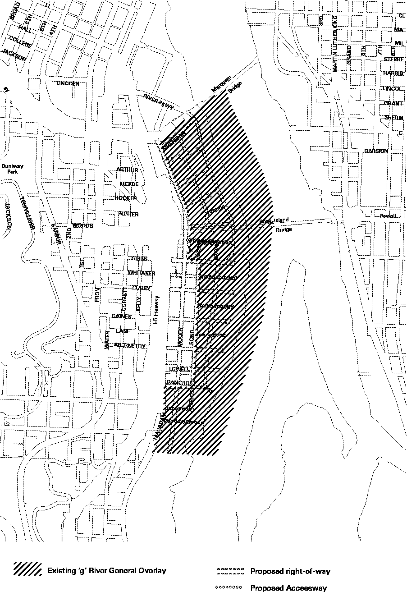
The “g” (River General) overlay zone, currently indicates which portion of the South Waterfront subdistrict is subject to the special regulations of Chapter 33.440, Greenway Zones, including greenway review and the greenway design guidelines. The existing boundary includes some property that does not have frontage on the greenway; the greenway regulations and greenway review approval criteria that apply in the South Waterfront subdistrict are focused primarily on development adjacent to the greenway.
Amended boundary
The boundary of the “g” overlay zone is amended within the South Waterfront subdistrict to better reflect the focus of greenway regulations within the subdistrict on development near the riverfront. Under the amended Zoning Code, the “g” overlay zone indicates which portion of the subdistrict is subject to the special regulations of Section 33.510.253, Greenway Overlay Zone in South Waterfront Subdistrict, as well as the South Waterfront greenway review.

Proposal will amend or add the following chapters:
Chapter 33.272, Public Recreational Trails
Chapter 33.440, Greenway Zones
Chapter 33.510, Central City Plan District
Chapter 33.808, Central City Parking Review
Chapter 33.815, Conditional Uses
Chapter 33.851, South Waterfront Greenway Review (New Chapter)
Chapter 33.910, Definitions

New code language is indicated with underline.
Code language to be removed is indicated with strikethrough

Note: Existing code sections where no change is being made have not been included in this document unless the information they contain is needed for better understanding of the amendments being made in other sections.

CHAPTER 33.272
Public Recreational Trails
This chapter contains the standards related to construction and maintenance of trails required by the zoning code. Additional standards related to trail requirements along the South Waterfront greenway will be added to Chapter 33.510, Central City Plan District. The South Waterfront-specific standards may be moved back to 33.272 in the future, depending on the outcome of code changes adopted by a citywide river project.

C. South Waterfront subdistrict of the Central City plan district. The paragraph being added will specify development that triggers the required trail improvements in the South Waterfront subdistrict. South Waterfront sites will differ from other sites in the city—in South Waterfront, riverfront sites will be required to provide an easement that will accommodate future trail improvements. Installation of the trail improvements will be administered by parks, and district responsibility for the improvements will be funded through an LID or similar mechanism. See 33.510.253.

E. Prior to certificate of occupancy. Trail improvements in South Waterfront will be made based on the specific timing provisions described under 33.510.253.D.4.

.
CHAPTER 33.272
PUBLIC RECREATIONAL TRAILS

33.272.030 Construction of Trails

A.-B. [No change]

C. South Waterfront subdistrict of the Central City plan district. Sites in the South Waterfront subdistrict must comply with the regulations of Section 33.510.253. The regulations of that section specify when recreational trails must be constructed within the South Waterfront subdistrict.

C.D. [No change]

D.E. Prior to certificate of occupancy. The trail must be constructed prior to the issuance of a certificate of occupancy, unless the site is eligible for the trust fund provisions of 33.515.260.B, or the special timing provisions of Paragraph 33.510.253.D.4.

E.F. Trail standards. A public recreational trail must comply with the standards of Portland Parks and Recreation City standards for recreational trails or, where the trail is located in a public right-of-way, it must comply with the standards of the Portland Office of Transportation.

F.G. [No change]

CHAPTER 33.440
GREENWAY ZONES

This chapter implements the Willamette Greenway Plan and currently applies to all land along the Willamette River covered by a greenway overlay zone. The regulations of this chapter:
- provide development standards for all areas covered by one of the greenway overlay zones;
- require trail and viewpoint improvements called for by the Greenway Plan;
- describe the greenway review process and approval criteria; and
- describe the greenway goal exception process and approval criteria.

In areas of the South Waterfront subdistrict that are covered by the “g” overlay zone, the regulations of this chapter currently apply in addition to the regulations of the “d” overlay zone and the Central City plan district.

Since adoption of the Willamette Greenway Plan, the framework of federal, state, and local policies and regulations that impact lands along the river has changed. This chapter will likely be revised by a citywide Willamette River-focused project in the future.

The South Waterfront plan amendments:
- remap the “g” overlay zone in South Waterfront to better focus the regulations and design guidelines that apply along the greenway;
- incorporate a modified version of the greenway regulations into Chapter 33.510, Central City plan district (See 33.510.253);
- incorporate a modified version of the greenway design guidelines into the South Waterfront subdistrict design guidelines; and
- create a new South Waterfront greenway review, to evaluate modifications to the standards or development riverward of top of bank.

33.440.020 Application of the Greenway Regulations
This amendment will incorporate a cross reference to the South Waterfront greenway regulations that are being added to Chapter 33.510, and will clarify that Chapter 33.440 will no longer apply within the South Waterfront subdistrict.

CHAPTER 33.440
GREENWAY ZONES

33.440.020 Application of the Greenway Regulations
This chapter applies to all land and fills and structures in water within the Willamette Greenway Plan boundary designated on the Official Zoning Maps with River Natural, River Recreational, River General, or River Industrial overlay zones. In addition, the public trail standards of 33.440.240 below apply to all lands designated on the Willamette Greenway Plan with the recreational trail symbol but which are outside of the greenway zones. However, the regulations of this chapter do not apply within the South Waterfront subdistrict of the Central City plan district. Sites in the South Waterfront subdistrict are instead subject to Section 33.510.253, Greenway Overlay Zone in South Waterfront Subdistrict.
Map 440-1
Maps 4 and 5 are being amended to refer to a new map of the South Waterfront greenway that will be included as Map 510-15.

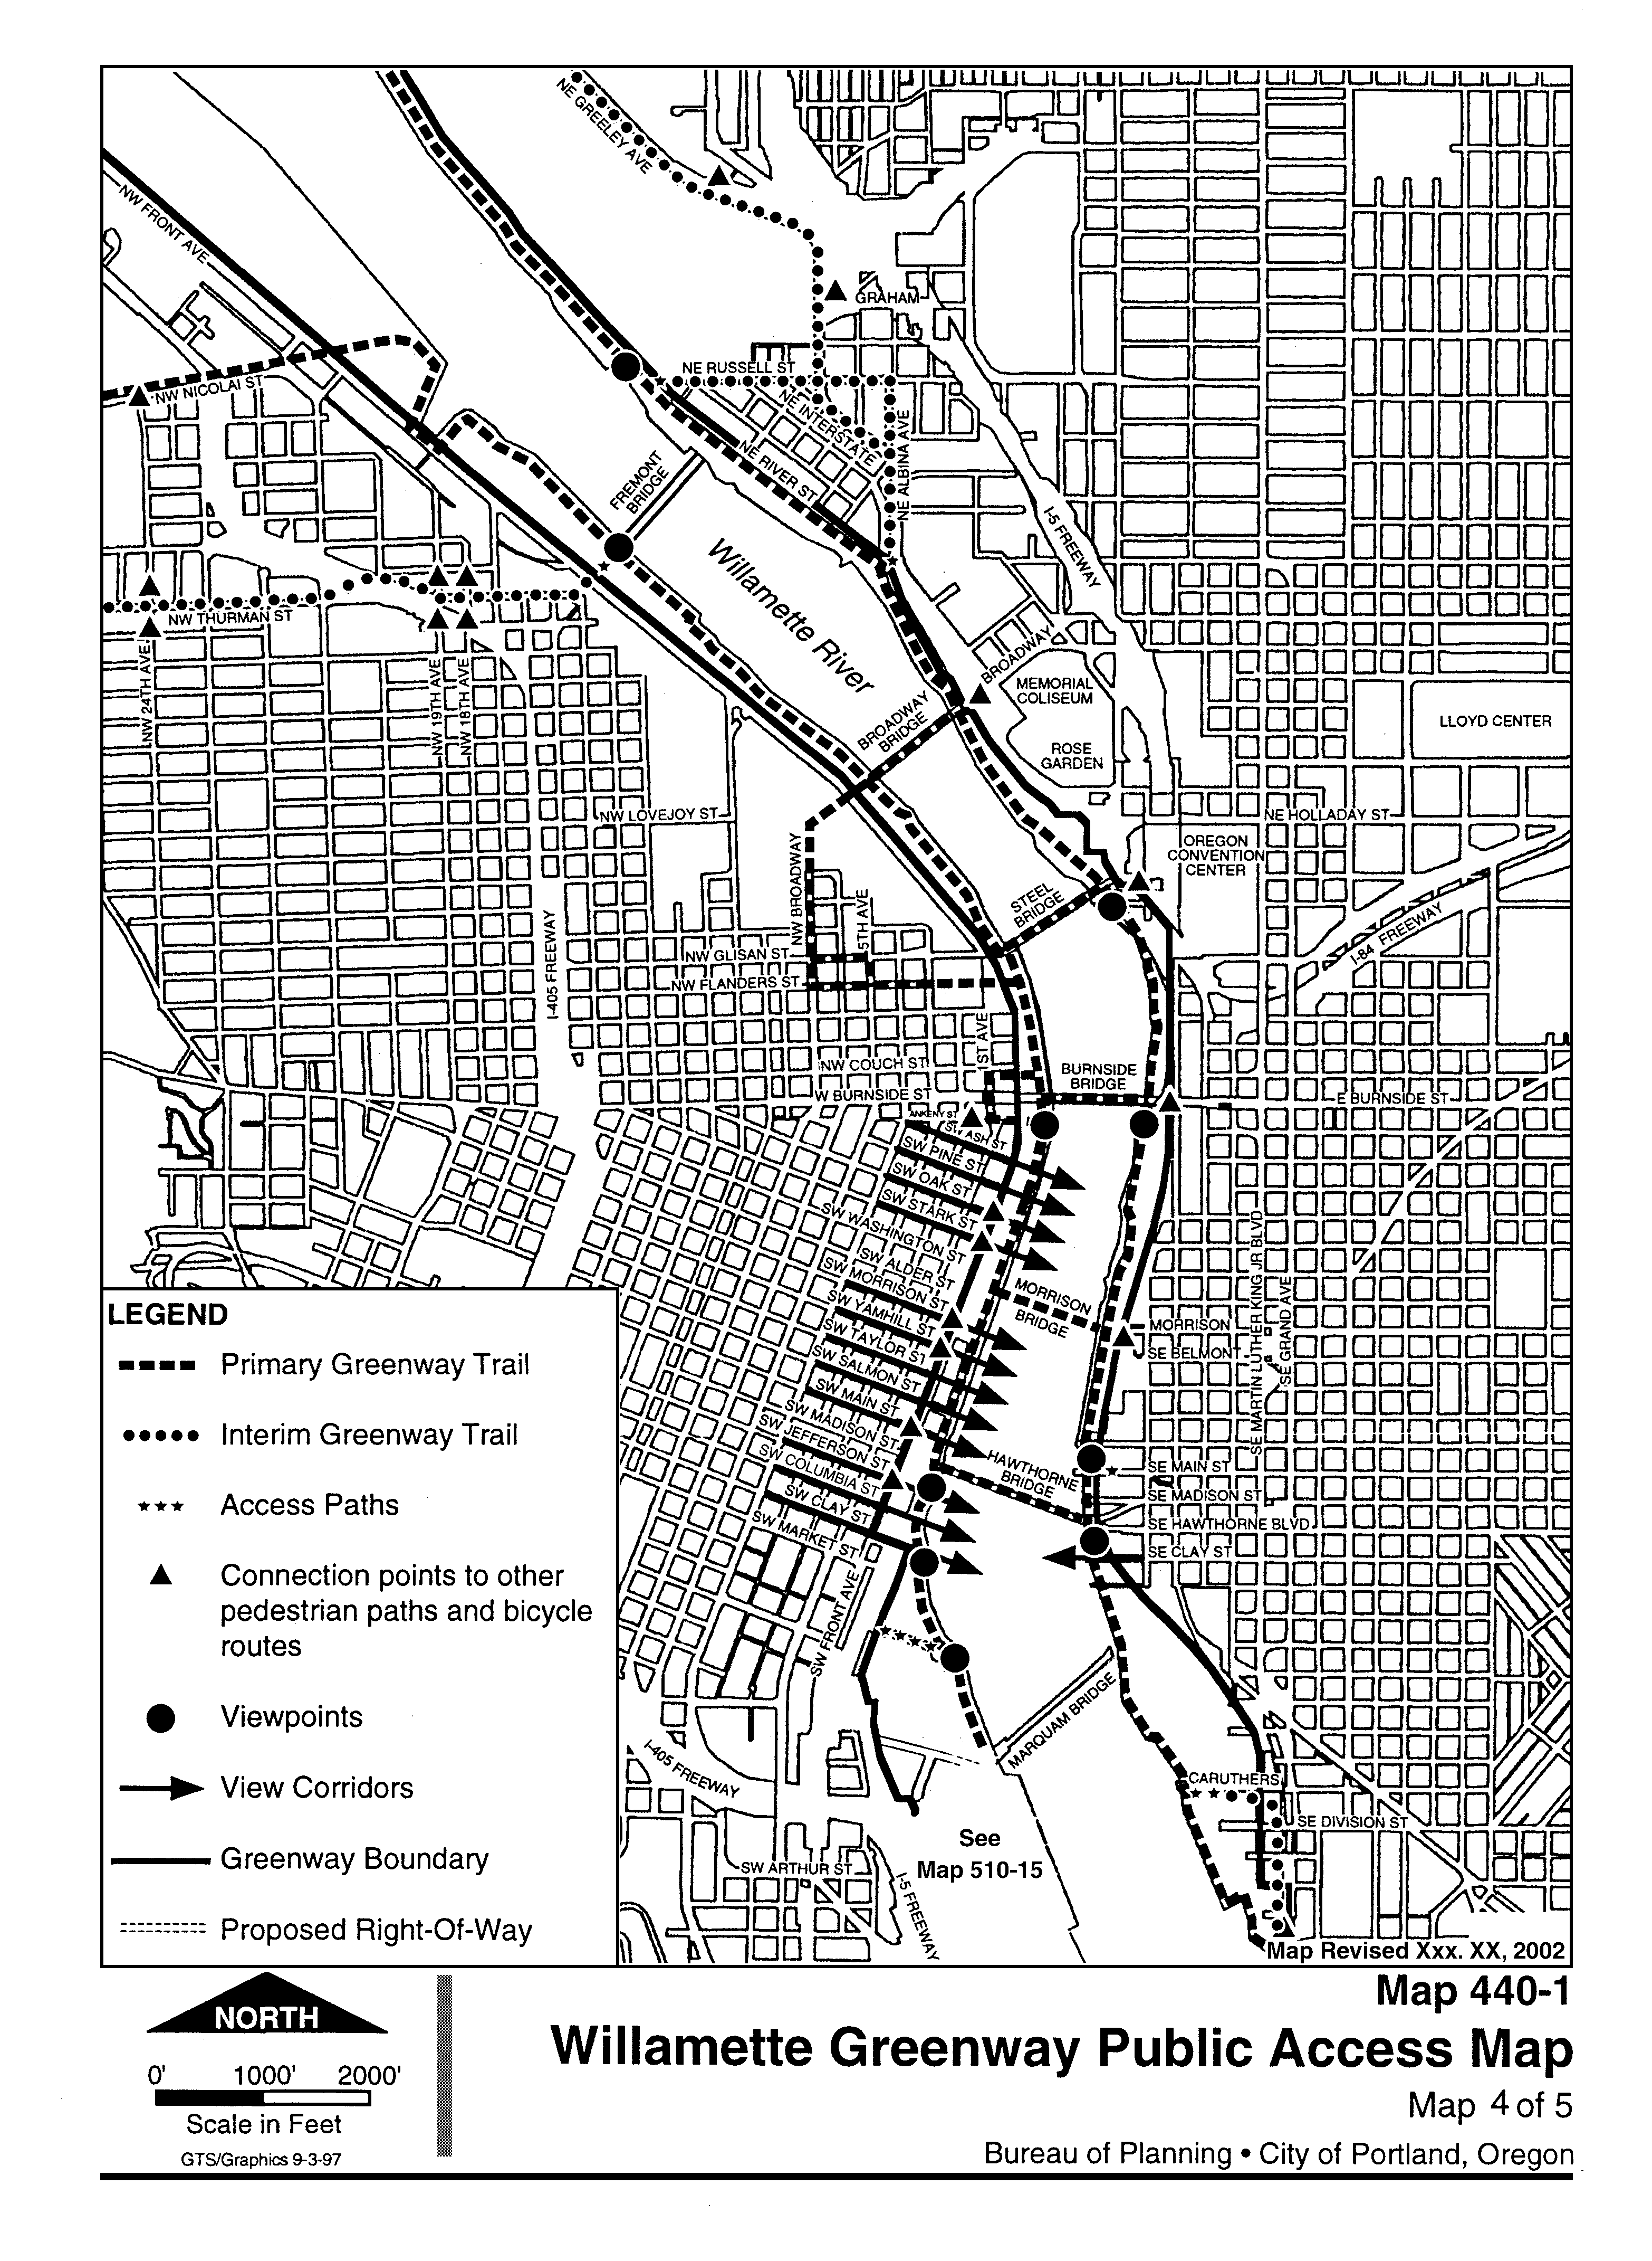

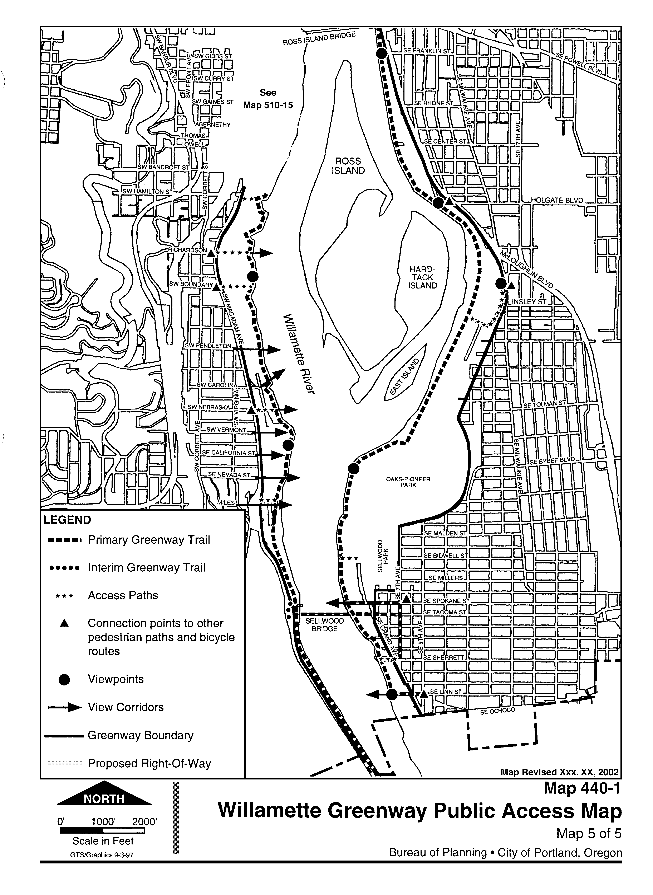

CHAPTER 33.510
CENTRAL CITY PLAN DISTRICT

Most of the new regulations applying in the South Waterfront subdistrict will be incorporated as modifications to the regulations and maps of the “Central City Plan District” chapter, which already applies to the area. The modifications will either:
- move the content of existing regulations from other chapters, such as 33.440, Greenway Zones;
- add South Waterfront-specific regulations;
- expand an existing regulation to apply in South Waterfront; or
- exclude South Waterfront from an existing regulation that currently applies to the area.

The amendments will not change the overall structure of the Central City plan district, and the regulations that apply in South Waterfront will continue to be located by topic throughout the chapter (rather than consolidated into a single section or additional chapter, as proposed previously).

The regulations that apply to the greenway in South Waterfront will be included under a new section of the “Central City Plan District” chapter, 33.510.253, Greenway Overlay Zone in the South Waterfront Subdistrict.
CHAPTER 33.510
CENTRAL CITY PLAN DISTRICT

Sections:
General
33.510.010 Purpose
33.510.020 Where the Regulations Apply
33.510.030 Application of Regulations Along Proposed Rights-of-Way and Accessways
Use Regulations
33.510.100 Vehicle Repair Uses
33.510.105 Vehicle Sales or Leasing
33.510.110 Mixed Use Waterfront Development
33.510.112 Commercial Parking
33.510.113 Retail Sales And Service and Office Uses in the IG1 Zone
33.510.114 Exemptions for Portland State University
33.510.115 Additional Uses Allowed in the Open Space Zone
33.510.116 Retail Sales And Service Uses for Specified Sites in the CX and EX Zones
33.510.117 Retail Sales And Service and Office Uses in the RX Zone
33.510.118 Use Regulations for Specified Sites in the West End Subarea
Development Standards
33.510.200 Floor Area Ratios
33.510.205 Height
33.510.210 Floor Area and Height Bonus Options
33.510.215 Required Building Lines
33.510.220 Ground Floor Windows
33.510.221 Required Windows Above the Ground Floor
33.510.223 Exterior Display and Storage
33.510.224 Mechanical Equipment along the Portland Streetcar Alignment
33.510.225 Ground Floor Active Uses
33.510.226 Minimum Active Floor Area
33.510.230 Required Residential Development Areas
33.510.240 Drive-Through Facilities
33.510.242 Demolitions
33.510.245 Northwest Triangle Open Area Requirement
33.510.250 Northwest Triangle Waterfront Development
33.510.252 Additional Standards in the South Waterfront Subdistrict
33.510.253 North Macadam Interim Transportation Review Greenway Overlay Zone in South Waterfront Subdistrict
33.510.255 Central City Master Plans
33.510.257 Signs for Additional Uses Allowed in the Open Space Zone
Parking and Access
33.510.261 Parking
33.510.263 Parking in the Core Area
33.510.264 Parking in Lloyd District
33.510.265 Parking in the Goose Hollow Subdistrict, Lower Albina Subdistrict, Central Eastside Subdistrict , and River District Sectors 1 and 2
33.510.267 Parking in the North Macadam South Waterfront Subdistrict

General

33.510.030 Application of Regulations Along Proposed Rights-of-Way and Accessways

Adding this language will clarify application of regulations along streets shown on maps 510-1 through 510-15 as “proposed”. The actual locations of these facilities will be determined external to the South Waterfront Plan. (i.e. The actual location of many of the streets in the subdistrict will be determined through individual development reviews and land division reviews against the revised South Waterfront Street Plan that will be finalized by the Portland Office of Transportation and incorporated into the Transportation Element of the Comprehensive Plan in January.)

Map 510-1 Central City Plan District and Subdistricts
Map 510-2 Maximum Floor Area
Map 510-3 Maximum Heights
Map 510-4 Bonus Options Target Areas
Map 510-5 Required Residential Development Areas
Map 510-6 Required Building Lines
Map 510-7 Active Building Use Areas
Map 510-8 Core and Parking Sectors
Map 510-9 Parking Access Restricted Streets
Map 510-10 Areas Where Additional Uses are Allowed in the OS Zone
Map 510-11 Special Areas
Map 510-12 Streetcar Alignment
Map 510-13 Park Blocks Frontages
Map 510-14 Areas Where Additional Uses are Allowed in the RX Zone
Map 510-15 South Waterfront Greenway Public Access Map
Map 510-16 South Waterfront Height Opportunity Area

General

33.510.030 Application of Regulations Along Proposed Rights-of-Way and Accessways
Where Maps 510-1 through 510-16 identify a right-of-way as a “proposed right-of-way” or “proposed accessway,” the location of the right-of-way or accessway on the map represents only a conceptual location. When dedicated or improved, the location of the right-of-way or accessway may vary from the conceptual location shown on these maps. Regulations of this chapter that are based on the location of a proposed right-of-way or accessway apply as follows:

A. If the right-of-way or accessway has been improved or dedicated, the regulation applies based on the actual location of the right-of-way, tract, or easement.

B. If the right-of-way or accessway has not been improved or dedicated, the regulation applies based on the location of the facility as shown on the street plan for the area that has been accepted by City Council. The street plan is maintained by the Portland Office of Transportation and is documented in the Transportation Element of Portland’s Comprehensive Plan.

33.510.116 Retail Sales And Service Uses for Specified Sites in the CX and EX Zones

B. CX Zone limitation. The amendment will limit the size of Retail Sales And Service uses within the South Waterfront subdistrict. Uses larger than 40,000 square feet will be required to go through a conditional use review. (See 33.815.304 for specific approval criteria.) This amendment is intended to allow a small neighborhood-serving grocery store, while limiting retail uses that could overly burden the transportation system.

33.510.200 Floor Area Ratios

B. Floor area ratio standard.

1. This amendment will correct a reference. Maximum floor area will be amended in South Waterfront. See Map 510-2.

4. This provision will provide an incentive for sites in South Waterfront to include parking in automated parking facilities. These facilities, also known as “robotic” parking, allow much less space within the building to be used for parking. This provision will encourage more compact parking structures within the district. (The provision replaces an FAR bonus for automated parking that was included in the proposed draft of the North Macadam Plan.)
33.510.116 Retail Sales And Service Uses for Specified Sites in the CX and EX Zones

A. Purpose. Limits on the size of Retail Sales And Service uses promote neighborhood-serving commercial development and help reduce traffic congestion associated with large-scale retailers.

B. CX Zone limitation. On sites in the CX zone within the South Waterfront subdistrict, Retail Sales And Service uses are allowed up to 40,000 square feet of floor area for each use. Retail Sales And Service uses larger than 40,000 square feet for each use are a conditional use. Retail Sales And Service uses larger than 60,000 square feet for each use are prohibited.

C. EX Zone lLimitation. On sites in the EX zone within the area shown on Map 510-11, Retail Sales And Service uses are allowed up to 40,000 square feet of floor area for each use. Retail Sales And Service uses larger than 40,000 square feet of floor area for each use are prohibited.

Development Standards

33.510.200 Floor Area Ratios

A. Purpose. The maximum floor area ratio (FAR) standards are intended to accomplish several purposes of the Central City Plan. These include coordinating private development with public investments in transportation systems and other infrastructure, limiting and stepping down building bulk to the Willamette River, residential neighborhoods, and historic districts. While consistent with these purposes, the floor area ratios are intended to be the largest in the Portland region.

B. Floor area ratio standard.

1. Generally. The maximum floor area ratios for all sites in the Central City plan district are shown on Map 510-2 at the end of this chapter. Floor area ratios greater than shown on Map 510-2 are prohibited unless allowed by Subsections D., or E., through G. below, or by 33.510.210.

2.-3.[No change]

4. South Waterfront subdistrict. In the South Waterfront subdistrict, floor area used for automated parking is not counted towards maximum FAR for the site. The automated parking facility must rely on a mechanical system instead of a vehicle operator to transport vehicles to a storage space within the facility.
C. Limit on increased floor area.

1. This amendment will correct a reference

3. This amendment will clarify the maximum floor area increases allowed on sites in the South Waterfront subdistrict. In general, if sites took advantage of all floor area bonuses available, the western portion of the subdistrict will be limited to 8:1 FAR and the eastern portion of the subdistrict will be limited to 7:1 FAR.
Additional flexibility could be gained transferring floor area from one site to another, or by taking advantage of an open space or greenway bonus; however, a particular site could not exceed an FAR of 9:1 under the code, unless transferring FAR from the greenway under the provisions of C.3.b. The increase in floor area on a receiving site will be balanced by a decrease in allowed floor area on a sending site.
Note: Sites will be allowed to include the site area contained within the greenway setback in the total site area when calculating allowed floor area. The provisions for transferring floor area from the greenway will apply when the greenway area was being dedicated to the city.

C. Limit on increased floor area.

1. Generally. In situations where FAR increases are allowed, whether by transfers of floor area or bonus floor area options, increases more than 3 to 1 above those shown on Map 510-2 are prohibited, except as allowed in Subparagraph C.2; Except as provided under C.2 and 3, below, increases in FAR, whether by transfers of floor area or bonus floor area options, of more than 3 to 1 are prohibited.

2. In the portion of the West End subarea that is not shown on Map 510-14, the following applies. In situations where FAR increases are allowed, tThere is no maximum on to the amount of bonus floor area that may be earned. However, the total floor area on a site, including bonus floor area and transferred floor area may not be more than 12 to 1. Adjustments are prohibited.

3. In the South Waterfront subdistrict the following applies:

a. Generally. Except as allowed under subparagraphs 3.b. and c, below, no more than 2:1 FAR may be earned on a site through the use of bonuses. There is no maximum to the amount of floor area that may be transferred to a site. However, the total floor area on a site, including bonus floor area and transferred floor area, may not be more than 9 to 1. Adjustments to the regulations of this paragraph are prohibited.

b. An FAR of more than 2 to 1 may be earned on a site through the use of bonuses if at least 1 to 1 FAR is earned on the site through the use of the open space bonus option, open space fund bonus option, or North Macadam Willamette River Greenway bonus option. However, the total floor area on the site, including bonus floor area and transferred floor area, may not be more than 9 to 1.

c. The total floor area on a site, including bonus floor area and transferred floor area, may be more than 9 to 1 if all of the following are met:

(1) The floor area above the 9 to 1 ratio must be transferred from the South Waterfront greenway area; and

(2) The portion of the South Waterfront greenway area that floor area is being transferred from must have been dedicated to the City since September 1, 2002.

G. Transfer of floor area within the South Waterfront subdistrict. This amendment will clarify that floor area transfers could occur relatively freely within the South Waterfront subdistrict. Sending and receiving sites will not need to be abutting and will not be required to be developed jointly. Floor area will be able to be bought and sold among property owners provided no site exceeds an FAR of 9:1 and all buildings continue to meet the maximum height limits.

33.510.205 Height

B. The height standard. The map has been amended in South Waterfront. See Map 510-3.

E. Open space height transfers. This option will no longer be available in South Waterfront. In South Waterfront, sites within a “South Waterfront Height Opportunity area” will instead be able to take advantage of additional height if they received a modification through design review and provided a contribution to an open space fund. (see 33.510.205.G)

D. – F. [No Change]

G. Transfer of floor area within the South Waterfront subdistrict. In the South Waterfront subdistrict, floor area, including bonus floor area, may be transferred between sites. The sites are not required to be abutting; however, both the sending site and the receiving site must be located within the South Waterfront subdistrict. Floor area transfers are subject to the following:

1. Buildings on each site may not exceed the height limit established for that site by the regulations of this chapter;

2. If bonus floor area is included in the transfer, those facilities to be provided in exchange for the bonus floor area must be completed in advance or at the time of issuing any occupancy permit for buildings taking advantage of the bonus floor area; and

3. The property owners must execute a covenant with the City which is attached to and recorded with the deed of both the sending and receiving sites reflecting the respective increase and decrease of potential floor area. The covenant must meet the requirements of 33.700.060.

33.510.205 Height

A. [No Change]

B. The height standard. The maximum building height for all sites in the Central City plan district is shown on Map 510-3 at the end of this chapter. Heights greater than shown on Map 510-3 are prohibited unless allowed by Subsections C. through F. below or by 33.510.210.D., E., or F through G., below.

C. – D. [No Change]

E. Open space height transfers.

1. Purpose. These regulations provide an incentive for the creation and development of needed open space in the Central City plan district.

2. Requirements for open space areas eligible for the height transfer.

a. The proposed open space area must be in the Central City plan district outside of the South Waterfront subdistrict. If the open space is at a Proposed Open Space location, as shown on the Central City plan map, the site is eligible by right. If the site is not a Proposed Open Space location, the site is subject to the review requirements stated in Paragraph 4. below. Open space sites resulting from the Northwest Triangle open area requirement are not eligible for the height transfer.

b.-c. [No change]

3.-4. [No change]

G. South Waterfront height opportunity area. These amendments will allow buildings within the area shown on Map 510-16 to go as high as 325 feet if they meet certain standards, provide a contribution into an open space fund, and the height is approved as a modification through design review.

This approach will allow buildings taller than 250 feet if they:
- support the vision of the district by providing a point tower, or by providing floor-to-floor heights that better supports bioscience development;
- provide adequate tower spacing;
- exhibit design excellence;
- maintain public views; and
- visually enhance the skyline of the district.

Requiring that the additional height be approved through design review will ensure that the impacts of the building are carefully evaluated against the Central City Fundamentals, South Waterfront Design Guidelines, and the purpose statement of the regulations. The applicant will have to demonstrate that the taller building better meet the design guidelines than would a building less than the mapped heights. The approach will also generate additional dollars into an open space fund that could be used to acquire and improve parks in the subdistrict.

F. [No Change]

G. South Waterfront height opportunity area.

1. Purpose. In the core of the South Waterfront subdistrict, additional building heights may be appropriate to support the goals of the South Waterfront Plan. The regulations of this subsection allow for development of buildings that support the economic goals of the South Waterfront subdistrict, provide an exceptional and varied skyline that is appropriate to the district’s setting against the Tualatin Hills, create additional opportunities for visual access through the subdistrict, and continue to maintain all protected public views.

2. Sites eligible for these standards. Sites eligible to earn additional height under these standards are shown on Map 510-16.

3. Standards. Buildings may earn additional height if they meet the requirements of this paragraph. Adjustments to these standards are prohibited.

a. The maximum height of the building does not exceed 325 feet, including projections, roof top mechanical equipment, radio and television antennas, and any other structures that project above the roof of the building.

b. The building meets one of the following:

(1) The average floor to floor height of the building is at least 16 feet; or

(2) No floor of the building above 75 feet is larger than 10,000 square feet in area;

c. The portion of the building that is at least 250 feet in height will be located at least 200 feet from the portion of any other building that is at least 250 feet in height. This spacing requirement applies to both existing buildings and those with an unexpired design review approval;

d. The applicant must contribute 5 dollars in 1990 dollars to the South Waterfront Public Open Space Fund (SWPOSF) for every square foot of floor area over 250 feet. The applicant must submit with the land use review application a letter from Portland Parks and Recreation documenting the amount, in current year and 1990 dollars, that has been contributed to the SWPOSF. Contributions to the fund used to earn bonus floor area under 33.510.210.C.18, Open space fund bonus option, do not count towards meeting this requirement; and

e. The additional building height has been approved as a modification through design review.
6. Sites that have frontage on the river north of Lowell Street will be required to take advantage of the floor area bonus available for providing additional public space along the greenway before they will be able to take advantage of any other floor area bonus. This requirement supports the primary policy goals of the South Waterfront subdistrict. This requirement does not apply to sites south of Lowell Street because of site constraints and the configuration of the ownerships in the southern portion of the district. (See Map 510-4)

C. Bonus floor area options.

In general, the bonuses that will be available in the South Waterfront subdistrict will be carefully targeted to provide for an amenity that is critical to supporting the vision of the district.

The following Central City-wide bonuses will continue to apply in South Waterfront as they do today. (For ease of reading, the full text of these bonus options have not been included in this report):
- Water features or public fountains bonus option. Water features are consistent with the district vision of providing connections between the built environment and natural elements of the greenway and river.
- Eco-roof bonus option. Eco-roofs are consistent with the district vision of providing connections between the built environment and natural elements. Eco-roofs also provide stormwater management benefits in terms of improved stormwater quality and reduce stormwater quantity.
- Middle-income housing bonus option. The Planning Commission recommended that this bonus be revised to require housing units affordable to 120 % of MFI; however, City Council voted to keep the bonus at 150% as it currently is throughout the Central City.
- Affordable Housing Replacement Fund bonus option

1. Residential bonus option. This bonus will no longer be available in the South Waterfront subdistrict. There are several other bonuses and requirements that will continue to support residential development in the district.

33.510.210 Floor Area and Height Bonus Options

A. Purpose. Floor area and height bonus options are offered as incentives to encourage facilities and amenities which implement the Central City Plan.

B. General regulations.

1. The bonus options are only allowed in situations where stated. Only new developments are eligible for the bonuses unless specifically stated otherwise. Exceptions to the requirements and the amount of bonus floor area or height earned are prohibited.

2. Projects may use more than one bonus option unless specifically stated otherwise. Bonuses may be done in conjunction with allowed transfers of floor area.

3. The maximum floor area increase that may be earned through the bonus options must be within the limits for overall floor area increases stated in 33.510.200.C.

4. Buildings using bonus floor area must not exceed the maximum height limits shown on Map 510-3 unless eligible for bonus height.

5. In residential bonus target areas, as shown on Map 510-4, the residential bonus option must be used before any other bonus. A bonus floor area ratio of at least 1.5 to 1 from the residential bonus option must be earned before the project qualifies for other bonus options.

6. If any portion of the site is in the greenway bonus target area, as shown on Map 510-4, the South Waterfront Willamette River greenway bonus option must be used before any other bonus. Bonus floor area of at least 7,500 square feet from the South Waterfront Willamette River greenway bonus option must be earned before the project qualifies for other bonus options.

C. Bonus floor area options. Additional development potential in the form of floor area is earned for a project when the project includes any of the specified features listed below. The bonus floor area amounts are additions to the maximum floor area ratios shown on Map 510-2.

1. Residential bonus option.

a. In the CX and EX zones outside of the South Waterfront subdistrict, projects providing housing receive bonus floor area. New development and alterations to existing development are eligible for this bonus. For each square foot of floor area developed and committed as housing, a bonus of 1 square foot of additional floor area is earned, up to an additional floor area ratio of 3 to 1. Projects in the required residential opportunity areas are eligible for this bonus.

b.-c. [No Change]
2. Day care bonus option. This bonus will no longer be available in the South Waterfront subdistrict.

3. Retail use bonus option. Map 510-4 will be revised to remove this bonus from South Waterfront. Development of retail in the district is supported by requirements for ground floor building spaces that will enable active uses along certain streets. The code seeks to allow neighborhood-serving retail uses rather than encouraging retail that will draw from a larger regional market and impact the transportation system.

4. Rooftop gardens option. This bonus will no longer be available in the South Waterfront subdistrict. However, the bonus for eco-roofs will continue to be available in the district.

6. "Percent for Art" bonus option. This bonus will no longer be available in the South Waterfront subdistrict. Many of the projects anticipated for the South Waterfront subdistrict will be required to provide a percent for art because they will be utilizing public funds.

8. Locker room bonus option. This bonus will be replaced by a requirement for locker rooms and bike parking in larger projects. See 33.510.252.C, Locker rooms and additional bicycle parking.

2. Day care bonus option. In the CX, EX, and RX zones outside of the South Waterfront subdistrict, projects providing day care facilities for children receive bonus floor area. For each square foot of area developed and committed to exclusive use as a day care facility, a bonus of three square feet of additional floor area is earned. To qualify for this bonus, the day care facility must meet all of the following requirements:

a.-c. [No Change]

3. Retail use bonus option. [No change.]

4. Rooftop gardens option. In CX, EX, and RX zones outside of the South Waterfront subdistrict, developments with rooftop gardens receive bonus floor area. For each square foot of rooftop garden area, a bonus of one square foot of additional floor area is earned. To qualify for this bonus option, rooftop gardens must meet all of the following requirements.

a.-b. [No Change]

5. [No Change]

6. "Percent for Art" bonus option. In all zones outside of the South Waterfront subdistrict, new development or alterations to existing development which commit funds to public art receive bonus floor area. Projects which commit 1 percent of their threshold value to public art earn additional floor area equal to the size of the site. Projects committing more than 1 percent to public art earn additional floor area equal to 0.1 of the site area for each additional 0.1 percent of the project's threshold value up to a maximum total floor area increase of 2 times the site area. For new development, threshold value is the sum of all construction costs shown on all building permits associated with the project, including site preparation. Where some or all of the bonus floor area is being transferred, this includes costs for both the lot transferring the bonus and the site receiving the transfer of floor area. For alterations to existing development, the threshold value is the sum of all construction costs as defined above plus the value of existing improvements to the property, as listed in the County Assessor's records. Where some or all of the bonus floor area is being transferred, this includes costs and values for both the lot transferring the bonus and the site receiving the transfer of floor area. To qualify for this bonus, the public art must meet the following requirements.

a.-f. [No Change]

7. [No change.]

8. Locker room bonus option. To encourage bicycling, projects in the CX and EX zones outside of the South Waterfront subdistrict that provide locker room facilities and extra long-term bicycle parking receive bonus floor area. For each square foot of area developed and committed to locker room facilities, a bonus of 40 square feet of additional floor area is earned. To qualify for the bonus, the following must be met:

a.-c. [No Change]
9. South Waterfront Willamette River Greenway Bonus Option. This existing bonus will be amended to clarify the requirements and to better work within the framework of the South Waterfront greenway regulations. In addition, the bonus will be amended to increase the amount of floor area a site will gain through the use of the bonus. Sites with river frontage north of Lowell Street will be required to take advantage of this bonus before they could take advantage of any other bonus.

9. South Waterfront Willamette River Greenway Bonus Option. To complement and enhance the existing public corridor, projects along the Willamette River greenway in the North Macadam South Waterfront subdDistrict, as identified on Map 510-4, that provide open space for public activity will receive bonus floor area. For each square foot of open space, a bonus of one square foot three square feet of additional floor area is earned. The bonus floor area may be used on the site or transferred to another site within the North macadam District subject to the following. Open space that will earn bonus floor area under 33.510.210.C.17, Open Space bonus option, may not be used to earn additional floor area under this bonus. To qualify for this bonus, the following requirements must be met:

a. Location. The open space must abut the South Waterfront greenway area, as shown on Figure 510-2;

b. Size and dimensions. The open space must include at least 2,500 square feet of contiguous area; the north-south dimension of the area must be at least twice as long as the east-west dimension of the area;

c. Connection to the recreational trail. A direct pedestrian connection must be provided between the open space and any required recreational trail or recreational trail easement on the site;

d. Ownership and use. One of the following must be met:

(1) The open space and pedestrian connection must be dedicated to the City; or

(2) A public access easement must be provided that allows for public access to and use of all the open space and the pedestrian connection.

e. Maintenance. The property owner must execute a covenant with the City that ensures the installation, preservation, maintenance, and replacement, if necessary, of the open space features, and that meets the requirements of 33.700.060, Covenants with the City;

f. Landscaping. The open space must be landscaped to meet the requirements of Paragraphs 33.510.253.E.2 and E.7 that apply to South Waterfront greenway subarea 3;

g. Open space features. Public seating such as benches must be provided at a ratio of at least 5 seats per 1,000 square feet of open space; and

h. Timing. The requirements of this paragraph must be met before an occupancy permit for any building using the bonus floor area is issued.

a. Approval process. Approval of this bonus is processed as part of the design review for the development project. It will be approved if it complies with subparagraphs C.9.b. through g. below and if it is consistent with the design guidelines that apply to the site;

b. The building on the receiving site must meet the development standards of the base zone and plan district except floor area ratio. However, adjustments to accommodate the transferred floor area may be requested;

c. A minimum of 2,500 square feet of open space adjacent to the required greenway setback must be deeded as a public easement for public access to the City as part of the Willamette River Greenway for public use;

d. The property owner will implement the North Macadam District Street Plan including required accessways to the Willamette River Greenway;

e. The property owner must execute a covenant with the City that:

(1) Ensures the installation, preservation, maintenance, and replacement, if necessary, of the open space features;

(2) Is attached and recorded with the deed of both the lot transferring and the lot receiving the floor area and reflects the respective increase and decrease of potential floor area; and

(3) Meets the requirements of 33.700.060, Covenants with the City;

f. The additional open space must be provided and the requirements of sub- paragraphs C.9.c and d. above, must be met before a building permit using the bonus FAR is issued for the receiving site; and

g. Within the deeded open space easement, the following amenities must be provided prior to the issuance of a Certificate of Occupancy for development using the bonus FAR:

(1) The dedicated open space must be adjacent and directly connected to the Greenway Trail;

(2) At least 50 percent of the dedicated open space must be planted with native species as identified by the Portland Plant list; and

(3) Public seating such as benches, gazebos, or piers with viewpoints, must be provided at a ratio of at least 5 seats per 1,000 square feet of dedicated open space.
12. Large household dwelling unit bonus option. This new bonus will encourage the creation of dwelling units with more than two bedrooms in South Waterfront. The bonus will support the desire to see a diversity of housing types within the South Waterfront subdistrict. The proposed draft included an amendment that would have expanded the large dwelling unit bonus option under 11, above, to apply in the South Waterfront subdistrict. This new bonus reflects the Planning Commission decision to create a South Waterfront-specific bonus that will encourage the development of housing units better suited for large households.

10. [No change.]

11. [No change.]

12. Large household dwelling unit bonus option. In the South Waterfront subdistrict, new development that includes dwelling units with more than two bedrooms receives bonus floor area. To be counted towards this bonus, a bedroom must be at least 70 square feet in area, have at least one window that can be opened, have at least one closet, and be separated by walls and or doors from kitchen, bath, and garage. In addition, the bedroom may not provide the sole access to any other room except a bathroom. Each dwelling unit with more than two bedrooms receives floor area based on the number of bedrooms in excess of two bedrooms. Each additional bedroom earns 150 square feet of bonus floor area. To qualify for this bonus option, the property owner must execute a covenant with the City ensuring that the units used for bonuses will not be reduced in number of bedrooms. The covenant must comply with the requirements of Section 33.700.060.

12.13. [No Change]

13.14. [No Change]

14.15. [No Change]

15.16. [No Change]

17. Open space bonus option. This bonus will allow sites in South Waterfront to gain bonus floor area in exchange for providing acceptable park space on site. The bonus will support the parks plan for the district.

18. Open space fund bonus option. This bonus will allow sites in South Waterfront to gain bonus floor area in exchange for paying into an open space fund. The fund will be used for acquisition, improvement, and maintenance of parks within the subdistrict and could also be used towards city-sponsored riverbank improvements along the Willamette. The dollar amount has been set at the same value as that required under the affordable housing replacement fund bonus that currently applies throughout the Central City.

17. Open Space bonus option. In the South Waterfront subdistrict, proposals that provide open space that may be used by the public will receive bonus floor area. For each square foot of open space provided, a bonus of one square foot of additional floor area is earned. Open space that will earn bonus floor area under 33.510.210.C.9, South Waterfront Willamette River Greenway Bonus Option, may not be used to earn additional floor area under this bonus. To qualify for this bonus, the following requirements must be met:

a. Size and dimensions. The open space must include at least 2500 square feet of contiguous area;

b. Ownership and use. One of the following must be met:

(1) The open space must be dedicated to the City; or

(2) A public access easement must be provided that allows for public access to and use of all the open space;

c. Maintenance. The property owner must execute a covenant with the City that ensures the installation, preservation, maintenance , and replacement, if necessary, of the open space features, and that meets the requirements of 33.700.060, Covenants with the City;

d. Parks approval. The applicant must submit with the application for land use review a letter from Portland Parks and Recreation stating that the open space features meet the requirements of the bureau, and that the space is acceptable to the bureau; and

e. The bonus floor area may be used only in the South Waterfront subdistrict.

18. Open space fund bonus option. Contributors to the South Waterfront Public Open Space Fund (SWPOSF) receive floor area bonuses. For each $10 in 1990 dollars contributed to the SWPOSF, one square foot of bonus floor area is earned. To qualify for this bonus, the following requirements must be met:

a. The applicant must submit with the application for land use review a letter from Portland Parks and Recreation documenting the amount, in current year and 1990 dollars, that has been contributed to the SWPOSF;

b. The bonus floor area may be used only in the South Waterfront subdistrict; and

c. The SWPOSF is to be collected and administered by Portland Parks and Recreation. The funds collected may be used only within the South Waterfront subdistrict of the Central City plan district, either for acquisition, improvement, or maintenance of public open space or for bank restoration or improvement projects along the Willamette River.
G. Bonus height in the South Waterfront subdistrict. This amendment will allow buildings in South Waterfront to gain additional height if they take advantage of bonus or transferred floor area. Buildings on sites with a base height of 125’ will be able to build to a height of 250’ if they took advantage of bonus or transferred floor area. There is no minimum floor area required to take advantage of this bonus.
The bonus height will not affect the maximum height of buildings in the western portion of the district that are allowed a maximum of 250’ by right. The bonus height also will not affect buildings within 150 feet of top of bank that will be limited to either 125’ or 75’ (see map 510-3).

33.510.215 Required Building Lines

D. Building line standards.

1. In South Waterfront, landscaping will be allowed in the space between the building and the required building line. Allowing landscaping will support the stormwater management goals of the district and will support the urban design goals of the district that encourage landscaping. The L2 standard is a low (less than 3 foot high) screen of shrubs.

D. - F. [No change]

G. Bonus height in the South Waterfront subdistrict. Within the South Waterfront subdistrict, buildings receive bonus height if they include bonus floor area or floor area transferred onto the site. Buildings that include any floor area achieved through bonuses or from transfers onto the site earn a height bonus of 125 feet, up to a maximum building height of 250 feet. The additional height may not be applied to any portion of a building within 150 feet of top of bank.

33.510.215 Required Building Lines

A. Purpose. Required building lines are intended to enhance the urban quality of the Central City plan district.

B. Sites and development subject to the building line standard. Sites subject to this standard are shown on Map 510-6 at the end of this chapter.

C. [No change]

D. Building line standards.

1. New development and major remodeling projects along a frontage containing a required building line must comply with either Subparagraphs a or b below, except where there is also a special building line. Exterior walls of buildings designed to meet the requirements of this Paragraph must be at least 15 feet high.

a. The building must extend to the street lot line along at least 75 percent of the lot line; or

b. The building must extend to within 12 feet of the street lot line for 75 percent of the lot line. Except in the South Waterfront subdistrict, and the space between the building and the street lot line must be designed as an extension of the sidewalk and committed to active uses such as sidewalk cafes, vendor's stands, or developed as "stopping places;" In the South Waterfront subdistrict, the space between the building and the street lot line may contain landscaping if one of the following is met:

(1) The proposed landscaping must meet the L2 standard;

(2) The proposed landscaping must meet the landscaping regulations of 33.510.253.E.7 that apply to subarea 3 of the South Waterfront greenway area. However, trees are not required; or

(3) BES approval. The applicant must submit with the application for a land use review a letter from the Bureau of Environmental Services stating that the landscaping meets the guidelines of the Stormwater Management Manual.

2. [No change]
33.510.221 Required Windows Above the Ground Floor

B. Where this regulation applies. This requirement will be expanded to apply near the streetcar line in the South Waterfront subdistrict. Expansion is consistent with citywide policy and with the specific policy goals of the South Waterfront subdistrict.
Note: The current requirements for ground floor windows will continue to apply. See Section 33.130.230, Ground Floor Windows (CX zone) and 33.510.220, Ground Floor Windows (Central City plan district) of the Portland Zoning Code for more details.

33.510.225 Ground Floor Active Uses

B. Sites and development subject to the ground floor active use standard. This map will be amended to reflect revisions to the street plan in South Waterfront. See Map 510-7.

33.510.221 Required Windows Above the Ground Floor

A. Purpose. Windows on building facades above the ground floor ensure opportunities for active uses, contribute to the skyline, and add interest to the built environment in the area near the streetcar alignment.

B. Where this regulation applies. The regulation of this section applies to sites near the streetcar alignment shown on Map 510-12.

1. In the River District, the regulation applies to the portion of a site within 200 feet of a streetcar alignment, if the site is in the EX zone.

2. In the West End, the regulation applies to the portion of a site within 200 feet of a streetcar alignment.

3. In the South Waterfront subdistrict, the regulation applies to the portion of a site within 200 feet of a streetcar alignment. The regulation also applies to the portion of a site within 200 feet of a proposed streetcar alignment, as shown on the street plan for the area that has been accepted by City Council. The street plan is maintained by the Portland Office of Transportation.

C. Standard. Windows must cover at least 15 percent of the area of street-facing facades above the ground level wall areas. This requirement is in addition to any required ground floor windows. Ground level wall areas include all exterior wall areas up to 9 feet above the finished grade.

33.510.225 Ground Floor Active Uses

A. Purpose. The ground floor active use standards are intended to reinforce the continuity of pedestrian-active ground-level building uses. The standards are also to help maintain a healthy urban district through the interrelationship of ground-floor building occupancy and street level accessible public uses and activities. Active uses include but are not limited to: lobbies, retail, residential, commercial, and office.

B. Sites and development subject to the ground floor active use standard. Ground floor active use areas are shown on Map 510-7 at the end of this chapter. On identified sites, all new development and all major remodeling projects must meet the standard below.
C. Ground floor active use standard. The existing standard will continue to apply.

D. Parking restriction in the North Macadam South Waterfront subdistrict.

2. Regulation. This will be amended to clarify that the requirement applies to the space being created within the building under the provisions of these regulations. This regulation is not intended to prohibit surface parking, or to prohibit parking in the portion of the building outside of the space created for active uses. For example, a building could meet this requirement by wrapping retail or other nonparking floor area around the parking uses on the ground floor.

C. Ground floor active use standard. Buildings must be designed and constructed to accommodate uses such as those listed in Subsection A. above. Areas designed to accommodate these uses may be developed at the time of construction, or may be designed for later conversion to active uses. This standard must be met along at least 50 percent of the ground floor of walls which front onto a sidewalk, plaza, or other public open space.

Areas designed to accommodate active uses must meet the following standards:

1. The distance from the finished floor to the bottom of the structure above must be at least 12 feet. The bottom of the structure above includes supporting beams;

2. The area must be at least 25 feet deep, measured from the street frontage wall;

3. The area may be designed to accommodate a single tenant or multiple tenants. In either case, the area must meet the standards of the Accessibility Chapter of the State of Oregon Structural Specialty Code. This code is administered by OPDR; and

4. The street frontage wall must include windows and doors, or be structurally designed so doors and windows can be added when the space is converted to active building uses.

D. Parking restriction in the North Macadam South Waterfront subdistrict.

1. Purpose. The North Macadam South Waterfront subdistrict is intended to be a multi-modal, mixed-use, pedestrian-oriented neighborhood. Developments are anticipated to include larger site areas than in other parts of the Central City where ground floor active uses are applied. These larger sites afford greater flexibility in the planning and design of ground-level uses. Also, due to the larger block size, the potential impact of less-active uses, such as structured parking, along expanses of street frontage is greater. Disallowing parking in ground floor active use areas lessens this impact. It also encourages either the provision of active building uses at the time of initial construction or a quicker transition from less-active to more active uses. This provision will encourage and maintain a pedestrian-oriented street environment of exceptional quality that is safe, active with uses, and comfortable for residents, visitors, and others moving through the subdistrict.

2. Regulation. The following regulation applies to In the North Macadam South Waterfront subdistrict., Parking is vehicle areas are not allowed in areas the portions of a building that are required to meet the ground floor active building uses standard of Subsection C., above.

E. [No Change]

33.510.230 Required Residential Development Areas

B. Sites and development subject to the required residential standard. The existing mapped area will continue to apply.

C. Required residential standard for new development. This amendment will increase the amount of residential development that will need to be provided in the required residential development area in South Waterfront. The requirement will essentially require residential development at an R1 density on sites within this area. However, the overall floor area allowed will continue to allow for development of commercial floor area on the site, and additional flexibility will be added to allow some or all of the required housing units to be transferred to another site in the subdistrict. Residential uses could be clustered in part of a development site to allow other parts of the site to be used exclusively for nonresidential uses, as long as the residential requirement is met for the entire site.
Providing housing within the district helps limit demands on the transportation system by allowing people to both live and work within the district.

33.510.230 Required Residential Development Areas

A. Purpose. The requirements of this section promote new housing in areas suitable and attractive for housing. The requirement is imposed as an alternative to the creation of exclusively residential zoning. This maintains development flexibility while still promoting the housing objectives of the Central City Plan.

B. Sites and development subject to the required residential standard. Sites subject to this standard are shown on Map 510-5 at the end of this chapter. On identified sites, all new development and building additions must meet the standards below.

C. Required residential standard for new development. New development must include housing at the minimum rate of 1 unit per 2,900 square feet of net site area (15 units per acre). For this standard, net site area is the total site area minus land dedicated to public rights-of-way or public open spaces, or land used for a regional public attraction such as a museum or aquarium.

1. Outside of South Waterfront subdistrict. Outside of the South Waterfront subdistrict, new development must include at least 1 dwelling unit per 2,900 square feet of net site area (15 units per acre). The floor area of the required housing units qualifies for the floor area bonus option stated in 33.510.210.C.1.

2. South Waterfront subdistrict. In the South Waterfront subdistrict, new development must include at least 1 dwelling unit per 1,000 square feet of net site area (43 units per acre).

D. Required residential standard for building additions. Floor area additions which increase the existing floor area by 50 percent or 10,000 square feet, whichever is less, must meet the standard of Subsection C., above.

E. Timing and location of the housing.

1. Generally. Required housing must be located on the site and if developed as part of a mixed-use project must receive an occupancy permit in advance of or at the same time as an occupancy permit for nonresidential portions of the project. Exceptions to this may be approved as part of a Central City master plan. See 33.510.255, Central City Master Plans.

2. South Waterfront subdistrict. In the South Waterfront subdistrict, housing units required by Subsection C., above, may be transferred to another site if the following requirements are met:

a. The receiving site must be located within the South Waterfront subdistrict;

b. The property owners must execute a covenant with the city which is attached to and recorded with the deed of both the sending and receiving sites reflecting the respective increase and decrease of required housing units. The covenant must meet the requirements of 33.700.060. The required housing is not required to receive an occupancy permit in advance of or at the same time as an occupancy permit is issued for non-residential development on the sending site.
33.510.240 Drive-Through Facilities
This amendment will expand the applicability of this prohibition to South Waterfront. Prohibiting drive-through facilities supports the urban design goals of the district, and prevents the district from overly burdening the transportation system by attracting additional auto trips into the district.

33.510.252 Additional Standards in the South Waterfront Subdistrict

A. Special building height corridors and tower orientation.

2. Special building heights. This requirement will enhance several east-west street facilities by limiting the mass of the portion of the building adjacent to specific east-west streets. This allows for additional light and air at the street level, as well as encouraging views through the district down these east-west corridors.

3. Maximum north-south dimension. This requirement will ensure the visual permeability of the district by setting a maximum dimension on building towers as they are viewed from the east or west and requiring a minimum tower spacing on sites. A maximum dimension of 125 feet in tower width will allow for construction of a “point tower” or “blade” tower while limiting the north-south dimension of buildings above 75 feet. The east-west tower dimension will not be limited. Modifications to the standard will be allowed through design review, to allow flexibility on sites within the district to meet the purpose of the regulation through alternate means.
33.510.240 Drive-Through Facilities
Drive-through facilities are prohibited in the Downtown, and Goose Hollow, and South Waterfront subdistricts. In the rest of the plan district, dDrive-through facilities are prohibited on the portion of a site within 100 feet of a light rail alignment. In the River District subdistrict, drive-through facilities are prohibited on the portion of a site within 200 feet of a streetcar alignment. This prohibition includes curb cuts and driveways used to approach and leave the drive-through facility, stacking areas for waiting vehicles, and the facility itself, such as a drive-up window or gas pump island.

33.510.252 Additional Standards in the South Waterfront Subdistrict
Sites in the South Waterfront subdistrict must meet the following standards:

A. Special building height corridors and tower orientation.

1. Purpose. Special building heights along designated east-west corridors and tower orientation standards provide visual access to the greenway from the western edge of the district, provide visual access to the ridge line of the Tualatin Hills from east of the district, provide for additional light along designated streets, and encourage an urban form that is visually permeable and varied.

2. Special building heights. The portion of a building that is within 50 feet of the centerline of a street or accessway designated as a special building height corridor on Map 510-15 may be no more than 50 feet in height.

3. Maximum north-south dimension. The north-south dimension is measured as specified in 3.e., below. See Figure 510-1. Adjustments to this paragraph are prohibited; however, modifications to the standards of this paragraph may be requested through design review. The north-south dimensions of buildings are limited as follows:

a. Less than 75 feet in height. For the portion of a building less than 75 feet in height, there is no limit on the north-south dimension, and no required space between buildings or portions of buildings;

b. 75 feet in height and above. The portion of a building that is at least 75 feet in height may have a north-south dimension up to 125 feet in width;

c. Where there is more than one building on a site there must be at least 50 feet between the portions of the buildings that are at least 75 feet in height. If there is less than 50 feet between these portions of the buildings, the north-south dimension is the total of the north-south dimension of each building and the north-south dimension of the space between them. The total may be up to 125 feet in width;

d. Where a building has more than one element that is at least 75 feet in height, the two elements are measured and regulated as two separate buildings.

e. Measurements for this paragraph. The measurements for the regulations of this paragraph are as follows. See Figure 510-1:

(1) The north-south dimension of a building is measured as follows:

• From the northernmost point of the portion of a building that is at least 75 feet in height, a line is drawn running due east-west;

• From the southernmost point of the portion of a building that is at least 75 feet in height, a line is drawn running due east-west;

• A line drawn at right angles between the two east-west lines is the north-south dimension;

(2) The space between buildings on a site is measured using the east-west lines created under A.3.e(1). A line drawn at right angles between the northern east-west line of one building and the southern east-west line of the other is the distance between the buildings.

Figure 510-1
Measuring North-South Dimension

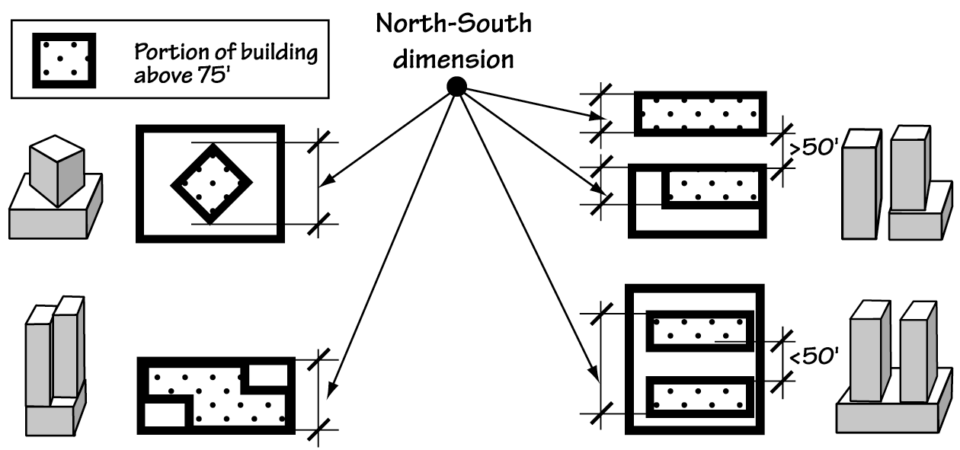
B. Accessways. These regulations will apply to accessways shown on the South Waterfront street plan as providing access from River Parkway to the greenway. The standards will only apply to sites adjacent to the accessways, and not to the accessways themselves. The requirements are intended to provide a continuous building line along these facilities, and to support landscaping that provides a transition from the greenway to the more urban interior of the district. The standards allow views of the greenway down these accessways in certain locations.
These standards strike a balance between various policy goals for these facilities. They include providing pedestrian and bicycle access to the greenway trail, providing a visual transition from the greenway to the rest of the district, providing the opportunity for surface stormwater management, and providing a lively space which functions as an extension of the more human-intensive portions of the greenway.
The regulations rely on the “centerline” of the accessway because these facilities could vary in width to accommodate some vehicle access to the adjacent development.

C. Locker rooms and additional bicycle parking. These amendments will add a requirement for locker rooms and bike parking in larger commercial projects. This requirement replaces an existing floor area bonus in the district and will encourage the use of alternative modes of transportation into the district, supporting the transportation policies of the district.

B. Accessways.

1. Purpose. Accessways provide physical access and connections to the greenway for neighbors, visitors, and residents of South Waterfront who might otherwise be cut off from the Willamette River and the greenway trail. Accessways are generally extensions of existing and planned east-west public rights-of-way, and may or may not provide vehicle access. Accessways provide safe and convenient bicycle and pedestrian connections to and from the greenway trail. Accessways contribute to stormwater management in the subdistrict. They also provide a visual connection to the South Waterfront greenway area and provide a transition from the natural emphasis of the South Waterfront greenway area to the urban emphasis of the rest of the district;

2. Where these regulations apply. These regulations apply to development and landscaping on sites with frontage on accessways that are east of River Parkway;

3. Setback. If the accessway is 60 feet wide or less, buildings must be set back at least 30 feet from the centerline of the accessway. If the accessway is wider than 60 feet, the building must meet the building line requirements of Section 33.510.215 on the accessway frontage;

4. Landscaping. The area between the building and the accessway must meet the landscaping standards of 33.510.253.E.7 that apply to subarea 3 of the South Waterfront greenway area. However, along accessways that are designated as special building height corridors on Map 510-15, trees are not required.

C. Locker rooms and additional bicycle parking.

1. Purpose. These standards support the transportation strategy of the South Waterfront subdistrict by requiring amenities that support the use of alternative modes of transportation, including bicycling and walking;

2. When these regulations apply. The regulations of this subsection apply to proposals that will add at least 100,000 square feet of nonresidential floor area to a site;

3. Locker rooms. At least one locker room facility must be included in the proposal. The facility must include showers, a dressing area, and lockers. The facility must be available for use by all tenants of the building; and

4. Bicycle parking. At least 110 percent of the required long-term bicycle parking for the site must be included in the proposal. The bicycle parking must meet the standards of 33.266.220.B, Long-Term Bicycle Parking.
33.510.253 North Macadam Interim Transportation Review
The specific transportation plan and the zoning code standards being made will replace the need for these interim provisions.

33.510.253 Greenway Overlay Zone in South Waterfront Subdistrict
These amendments modify the way in which development along the Willamette greenway in South Waterfront is regulated and reviewed, modify the level of improvements required along the greenway, and modify the development triggers for these improvements. The amendments enhance existing requirements that apply in the subdistrict today under 33.440, Greenway Overlay Zones. The amendments restructure the code significantly in order to clarify the requirements and to shift some existing review responsibilities. Currently, development within the greenway overlay zones in South Waterfront must meet the regulations of 33.440, Greenway Zones. Depending on the location and type of development being proposed, development proposals may be required under the current regulations to go through a greenway review and meet particular greenway design guidelines; development may also be subject to design review. The amendments include all greenway-related standards that apply in South Waterfront within 33.510.253, and will create a new South Waterfront greenway review (Chapter 33.851). In addition, the greenway design guidelines for South Waterfront will be revised and will be applied as part of design review in the subdsitrict. In general, the regulations of 33.440 and greenway review will no longer apply in the subdistrict. Future citywide revision of Chapter 33.440 could result in a reintegration of the South Waterfront greenway regulations.

A. Purpose. The purpose statement of the Chapter 33.440, Greenway Zones, has been included here and revised to reflect recent policy work such as City Council’s endorsement of the River Renaissance vision in 2001.

B. Where these regulations apply. The greenway overlay zone is being remapped slightly as part of this project. (See Zoning Map Amendment, above). Many of the standards only apply within 150 feet of top of bank; however, development elsewhere on the ownership could trigger improvement requirements and some of the greenway design guidelines are relevant for development further from the bank.

C. Greenway design coordination plan. Parks and Recreation is in the early stages of work to develop a “Design Coordination Plan” for the greenway. The plan will be developed through a public-private partnership and will be able to look at the full extent of the South Waterfront greenway. The details of this plan are still being fleshed out, but, once completed, the plan could offer an option to the prescriptive timing and standards of the code. The code allows the property owner to use a completed Design Coordination Plan to support their request to vary from the standards through South Waterfront greenway review. Based on the outcome of the Greenway Design Coordination Plan process, it may be appropriate for a future legislative planning project to revise these regulations to create a different relationship between the Greenway Design Coordination Plan and the regulations of this title.
33.510.253 North Macadam Interim Transportation Review

[Delete existing Section 33.510.253 and replace with new section, below]

33.510.253 Greenway Overlay Zone in South Waterfront Subdistrict

A. Purpose. The regulations of this section:

1. Protect, conserve, enhance, and maintain the natural, scenic, historical, economic, and recreational qualities of lands along the Willamette River within the South Waterfront subdistrict of the Central City plan district;

2. Increase public access to and along the Willamette River for the purpose of increasing recreational and transportation opportunities;

3. Support the development of the South Waterfront subdistrict as a vibrant mixed-use neighborhood within the Central City plan district;

4. Ensure a clean and healthy river for fish, wildlife, and people;

5. Embrace the river as Portland’s front yard;

6. Enhance stormwater management in the South Waterfront subdistrict;

7. Respond to the federal Endangered Species Act and Clean Water Act; and

8. Implement the Willamette Greenway Plan and State law.

B. Where these regulations apply. The regulations of this section apply to sites within the South Waterfront subdistrict where any portion of the site is in the greenway overlay zone, shown on the Official Zoning Map.

C. Greenway design coordination plan. If the site is included in the greenway design coordination plan, it may be eligible for special provisions for the timing of improvements. See Paragraph 33.510.253.D.4, Timing of improvements. The site may also be eligible for special provisions allowing greenway improvements that would not otherwise meet the standards of Section 33.510.253. See Subsection 33.510.253.H, South Waterfront greenway review.
Figure 510-2
South Waterfront Greenway Area and Subareas

The South Waterfront greenway area coincides with the minimum regulated setback in the subdistrict of 100 feet. The subareas coincide with ecological emphases within the greenway area. Subareas 1 and 2 have the highest level of required landscaping and the least allowance for human activity and nonriver dependent development. Subarea 3 begins 45 feet from top of bank and is where the trail improvements will be located as well as outdoor uses that provide for a transition from the adjacent development and other human activity and the more ecological areas near and on the riverbank. Outdoor uses anticipated in subarea 3 include outdoor cafes, play areas, and outdoor markets.

A Note about top of bank: Top of bank is currently determined on a site-by-site basis based on the definition contained in 33.910. As part of the actions of the South Waterfront Plan, City Council directed Transportation to survey actual top of bank in the district, and directed that the code be amended in the future to reflect a mapped boundary in South Waterfront based on that survey.

D. Required South Waterfront greenway improvements. This subsection describes the circumstances under which required improvements in the greenway are triggered. The property owner is not required to install any of the landscaping or trail improvements described under Subsection E until they trigger one of these thresholds. If the property owner chooses to install the improvements earlier, they will still be required to meet the standards of Subsection E.

1. Landscaping. The landscaping thresholds are based on the development thresholds that apply to required nonconforming upgrades.

Figure 510-2
South Waterfront Greenway Area and Subareas

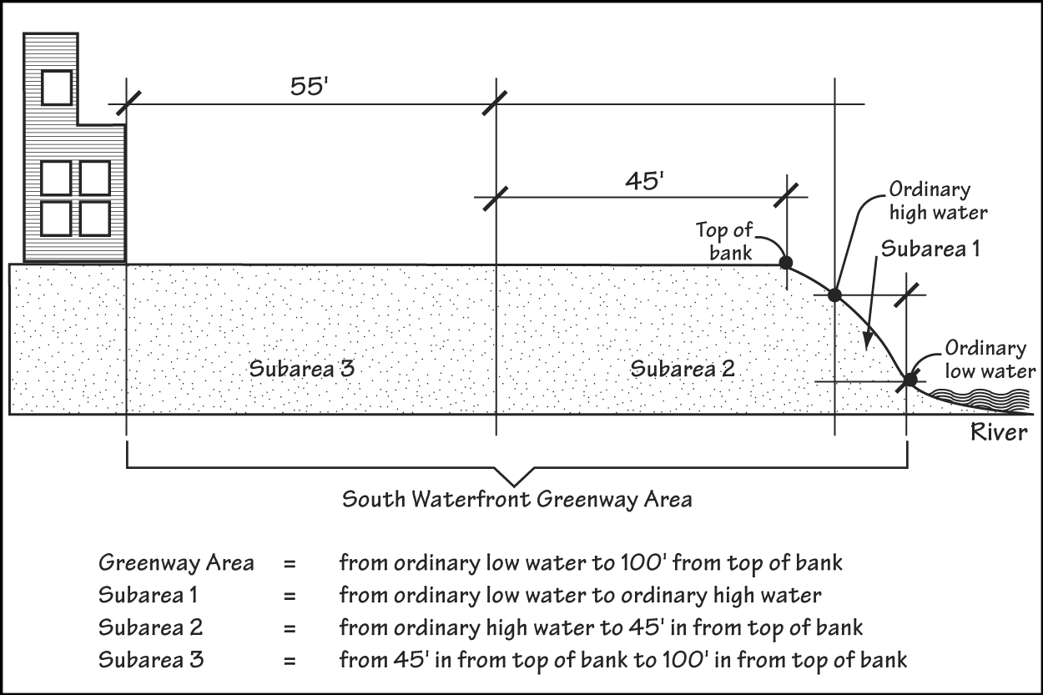

D. Required South Waterfront greenway improvements. Adjustments to this subsection are prohibited.

1. Landscaping. When development on the site, or alterations to structures, the site, or rights-of-way are made which are over the thresholds of this paragraph, the site must be brought into conformance with the requirements of Paragraph E.7 that apply to subareas 2 and 3 of the South Waterfront greenway area. The value of the alterations is based on the entire project, not individual building permits. It is the responsibility of the applicant to document the value of the required improvements.

a. Thresholds. Mandatory improvements for fire, life safety and accessibility do not count toward the thresholds. The thresholds are:

(1) The value of the proposed alterations is 35 percent or greater than the assessed value of all improvements on the site. On sites with multiple tenants in one or more buildings, the threshold applies to any alteration that is 35 percent or greater of the assessed value of all improvements on the site; or

(2) The value of the proposed alterations, as determined by OPDR, is more than $100,000.
b. This language provides a guarantee that the cost of installing landscaping will be proportional with the cost of the proposed development. The priority of landscaping improvements is based on policy discussions that the ecological features of the greenway setback are critical.

2. Bank improvements. The landscaping requirements that apply below top of bank only need to be met if bank work is already being proposed.

b. Caps on the cost of required landscaping. Required landscaping costing more than 10 percent of the value of the proposed alterations does not have to be installed. When all required landscaping is not being installed, the priority for which landcaping is to be installed is:

(1) Trees in subarea 2;

(2) Shrubs in subarea 2;

(3) Ground cover in subarea 2;

(4) Trees in subarea 3;

(5) Shrubs in subarea 3;

(6) Ground cover in subarea 3; and

(7) Other required landscaping;

c. Supplemental application requirement. Where landscaping is required by this paragraph, the applicant must submit a landscape plan to the Bureau of Development Services that shows that the landscaping will grow to meet the landscape standards of Subparagraph E.7, below, within five years. The landscape plan must be certified by a licensed landscape architect, or by a qualified restoration specialist as part of a formal City revegetation project under authority of Portland Parks and Recreation or the Bureau of Environmental Services.

2. Bank improvements. In subarea 1, when there is any regrading, bank stabilization, or other activities affecting the contours and composition of soil, the requirements of Paragraph E.7 for subarea 1 must be met.

3. Trail and pedestrian connections and public viewpoints. Under the amendments, riverfront property owners will be required to provide a public access easement for the trail. The trail itself will be installed through a coordinated public-private effort, and the private costs of installing the trail will be spread throughout the South Waterfront subdistrict through a local improvement district (LID) or similar mechanism.
This approach will allow construction of all segments of the trail to be coordinated through the Greenway Design Coordination Plan. The approach recognizes that the greenway trail in South Waterfront will provide private benefits as a recreational and transportation facility to development within the district as well as public benefits to the community at large.
An LID or similar mechanism will be explored by the City and private property owners to ensure equitable funding of the trail improvements. Responsibility may be assigned based on expectations related to how many trips on the trail will originate in the South Waterfront District, and on transportation assumptions related to the impact of development in the district on trail usage. A funding approach that was included in the Recommended Draft of the Zoning Code assumed that district development will fund approximately 50% of the estimated cost of trail improvements.

4. These regulations provide several options for timing the installation of required improvements.

b. Option 2. Parks and Recreation is in the early stages of work to develop a “Design Coordination Plan” for the greenway. The plan could apply to one or more sites and participation in the plan is voluntary. This option will enable the applicant to defer installation of required improvements until after completion of the plan.

5. Landscaping monitoring and reporting. This will put the burden on the applicant to document that landscaping requirements were being met. The landscaping regulations allow considerable flexibility in the methods of planting as long as the developer adheres to a specified plant list and ensures that the site “grows out” to the standards within five years.

3. Trail and pedestrian connections and public viewpoints. When development on an ownership, or alterations to structures, the site, or rights-of-way are made which are over the thresholds of Paragraph D.1, above, the applicant must provide public access easements that will accommodate a trail, pedestrian connections, and viewpoints that meet the standards of Paragraph E.5, Trail and pedestrian connections; and Paragraph E.6, Public viewpoints;

4. Timing of improvements. The applicant may choose one of the following options for making the improvements required by this subsection:

a. Option 1. Under Option 1, required improvements must be made as part of the development or alteration that triggers the required improvements;

b. Option 2. Under Option 2, the required improvements may be deferred if the following are met:

(1) The applicant must provide the Bureau of Development Services with a performance guarantee for the improvements. See 33.700.050, Performance Guarantees; and

(2) The required improvements must be constructed or installed within 4 years of issuance of the performance guarantee or within the timeline approved through a South Waterfront Greenway Design Coordination Plan, whichever is earlier;

5. Landscaping monitoring and reporting. Monitoring required landscaping is the ongoing responsibility of the property owner. If landscaping is required by this subsection, the owner must submit a report to the Bureau of Development Services documenting that the landscape standards of Subparagraph E.7, below, have been met on the site. The report must be submitted within 5 years of the date that building permits are issued for the development triggering the landscaping requirement.
E. Development standards.

2. These regulations provide a maximum limit for the portions of the greenway area that can be configured for development and surfaces other than landscaping. These regulations provide a minimum area for the landscaping requirements and upper limit for buildings, hardscaping, and other nonlandscaped areas.
The provisions limit site stormwater runoff associated with pervious surfaces, provide landscaping consistent with the policies and objectives of the South Waterfront Plan and support the City’s goals for the Willamette River.

E. Development standards. Development and alterations to structures, sites, and rights-of-way must meet the following standards. Adjustments to this subsection are prohibited; however, development that does not meet the standards of this subsection may be approved through a South Waterfront greenway review.

1. Where these regulations apply. The regulations of this subsection apply in the South Waterfront greenway area as shown on Figure 510-2.

2. Nonlandscaped area. Limiting the percentage of nonlandscaped area allowed in the South Waterfront greenway area ensures that the area will be configured to accommodate a minimum percentage of living plant cover. Nonlandscaped area includes all above-ground structures and paving materials, including permeable paving materials.

a. Subareas 1 and 2. Up to 20 percent of the portion of the site in subareas 1 and 2 may be covered by nonlandscaped area; however, paved surfaces that are required under the provisions of paragraph E.6, Public viewpoints, are exempt from this limitation. Nonlandscaped area is not allowed within 10 feet of top of bank;

b. Subarea 3. Up to 20 percent of the portion of the site in subarea 3 may be covered by nonlandscaped area. However, required trail and pedestrian connection improvements are exempt from this limitation.

3. Buildings. The regulated greenway setback is increased to 100 feet. River-dependent buildings are allowed but will be subject to non-landscaped area limitations. See South Waterfront Plan document for additional discussion of this amendment. Limited modifications to this standard could be requested through South Waterfront greenway review.

a. Buildings in subareas 1 and 2. The amendments have taken an approach which emphasizes the ecological function of these areas

b. Buildings in subarea 3. Only river-dependent/river-related buildings or small buildings, such as coffee kiosks, that support the active outdoor function of the greenway are allowed riverward of the setback line without a South Waterfront greenway review.

3. Buildings. Buildings are allowed within the South Waterfront greenway area if they meet E.3.a. and b. and either E.3.c. or d., below. Other buildings or portions of buildings are not allowed within the South Waterfront greenway area.
a. The site meets the nonlandscaped area requirements under E.2, above; and

b. The building does not obstruct required pedestrian connections and trails; and

c. The building is river-dependent or river related; or

d. All of the floor area of the building is in Retail Sales And Service uses and the following are met:

(1) The building has less than 1,000 square feet of floor area;

(2) The building is entirely within subarea 3; and

(4) The building is located landward of the South Waterfront recreational trail.
4. Fences and walls. In subarea 3 the amendments limit the height of fences and walls and ensure that they do not block pedestrian connections in the greenway area. In subareas 1 and 2 fences and walls are not allowed unless approved as a modification through South Waterfront greenway review.

5. Trails and pedestrian connections. The trail standards require a split trail facility in the subdistrict. The regulations require a trail which consists of two 12-foot wide paths and a landscaped buffer. This type of “split” trail allows for pedestrians and bicycles to safely use the trail. A split trail reduces the risks of collision accidents, and appears “greener” than a single trail because of the landscaped buffer. The code will require riverfront property owners to grant an easement that will accommodate the trail—trail improvements will be made through a collaborative public-private effort. See related commentary under Subsection D., above.

b. Public recreational trails. Under the existing regulations, trails are required to meet “City construction standards.” These standards are administered by Portland Parks and Recreation, and typically require a 12-foot wide trail. The amendments will add more specific dimensional requirements for the required South Waterfront greenway trail. Standards relating to materials, furnishings, and lighting will continue to be administered by Parks, as referenced by 33.272. The trail standards of this subsection could be modified through South Waterfront greenway review—the greenway review will be able to propose alternate trail locations and standards that could be based on a more comprehensive look of at the South Waterfront greenway as a whole through a “greenway design coordination plan.”

4. Fences and walls. Fences and walls are allowed in subarea 3 of the South Waterfront greenway area if they are no more than 3 feet in height and do not obstruct the required pedestrian connections and trails. Fences and walls are not allowed in subareas 1 and 2 of the South Waterfront greenway area.

5. Trails and pedestrian connections.

a. Purpose. Public recreational trails provide public access to and along both sides of the Willamette River. Public recreational trails are one of the tools used to comply with the public access requirements of the Comprehensive Plan and the Willamette Greenway Plan. Pedestrian connections ensure that there is adequate, safe, and direct pedestrian access from the adjacent development and from the district as a whole to the trails.

b. Public recreational trails. Public recreational trails must meet the following standards. When required by Subsection D., sites with a public recreational trail symbol shown on the Official Zoning Maps must provide easements that would accommodate construction, maintenance, and public use of a trail that meets the following standards. See Figure 510-3:

Figure 510-3
South Waterfront Greenway Trail

(1) Location. The preferred location of the trail is within the middle portion of the South Waterfront greenway setback. As shown on Figure 272-1, the trail will not be allowed in the area of the setback closest to the building—requiring space between the trail and development allows space for active transitional uses such as outdoor restaurant seating, outdoor markets, and play areas adjacent to development. While the trail may meander closer to the river, impervious surface requirements will limit the amount of trail that can be constructed within 45 feet of top of bank, to support the primary ecological functions of the area. Because of the possible negative impacts on the primarily ecological portion of the setback, the regulations will require South Waterfront greenway review to propose more extensive trail within 45 feet of top of bank.

(2) Width. The greenway trail in South Waterfront will be a split trail facility consisting of two 12-foot wide paths. The path closest to the river will be used by pedestrians; the path closest to development will be used by bicyclists. Requiring a split trail ensures adequate space for users, minimizes risks related to collisions, and allows the visual impact of the trail to be softened by landscaping.

(3) Landscaped buffer. The area between the bicycle and pedestrian portions of the split trail will be landscaped with plantings to soften the look and feel of the trail and support the habitat and stormwater function of the setback.

(1) Location. The trail must be located in the South Waterfront greenway area shown on Figure 510-2. All portions of the trail must be at least 10 feet and no more than 75 feet from the top of bank; however, any portion of the trail that is within 45 feet of the top of bank is subject to the maximum nonlandscaped area limitations of Paragraph E.2;

(2) Width. The trail must consist of two paths, each at least 12 feet in width;

(3) Landscaped median. The two paths must be separated by a landscaped median at least 6 feet wide. Landscaping within this median must meet the requirements of Paragraph E.7. The landscaping may be interrupted by pedestrian connections between the two paths;

(4) Use. The path closest to the river must be designated for pedestrians only. The path farthest from the river must be designated for bicycles and other nonmotorized transportation modes;

(5) Connectivity.

- The trail or trail easement must connect to the existing trails or trail easements on adjacent sites; and

- The trail or trail easement must connect to the required pedestrian circulation system on the site.

(6) Additional standards. In addition to the standards of this subparagraph, the standards of Chapter 33.272, Public Recreational Trails, must also be met.

c. Pedestrian connections. When a public recreational trail or trail easement is required, at least one pedestrian connection must be provided between the trail easement and any accessway that terminates on the site.

6. Public viewpoints. The amendments identify two types of viewpoint. Major viewpoints are intended to provide resting places along the trail. Minor viewpoints are intended to provide for clearings in the vegetation where trail users and those farther west in the district can see through the ecological areas to the river. Because of the ecological emphasis of the land within 45 feet of top of bank, major viewpoints are not required on every site under the regulations. Additional major viewpoints could be provided through a South Waterfront greenway review.

Figure 510-4
Public Viewpoint View Corridor

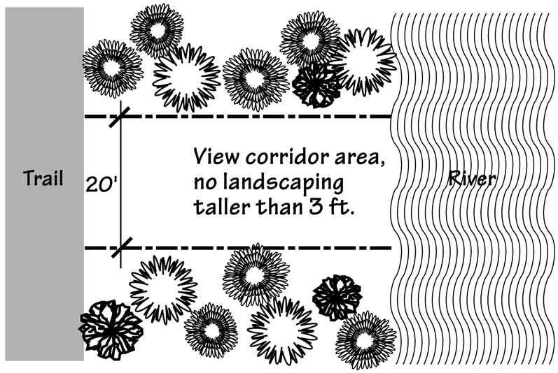

6. Public viewpoints.

a. Purpose. Public viewpoints provide stopping places and clearings along the South Waterfront greenway trail and the Willamette River where the public can view and enjoy the natural and scenic qualities of the greenway and the river. Public viewpoints are one of the tools used to comply with the public access requirements of the Comprehensive Plan and the Willamette Greenway Plan.

b. Viewpoint requirements. A public viewpoint must be provided on sites designated with a viewpoint symbol on Map 510-15. There are two types of viewpoints within the district:

(1) Minor viewpoint. Minor viewpoints are locations along the South Waterfront greenway trail where views of the Willamette River are provided through the use of special landscaping standards. The standards discourage plantings that will grow to block views of the river. Sites with a minor viewpoint designation shown on Map 510-15 must meet the following standards:

- A view corridor at least 20 feet wide must be provided and maintained between the trail and the river. See Figure 510-4;

- If an accessway or street that is mapped as a special building height corridor on Map 510-15 terminates on the site, the view corridor must continue the projected centerline of the accessway or street;

- Within the view corridor, landscaping must be no higher than three feet in height at maturity. The site must continue to meet the landscaping requirements of Paragraph E.7, below.

(2) Major viewpoint. Major viewpoints are locations along the South Waterfront greenway trail where additional space is provided to allow people to safely stop and view the Willamette River and the greenway. Where required by Subsection D., sites with a major viewpoint designation must provide a viewpoint that meets the following standards:

- The viewpoint area must be at least 1,600 square feet in area;

- The viewpoint area must abut the greenway trail or a pedestrian connection must be provided from the greenway trail to the viewpoint area;

- The viewpoint area and any pedestrian connection to the viewpoint area from the greenway trail must comply with the Use of Trail, Hours of Use, Trespass, and Trail Maintenance and Liability sections of Chapter 33.272, Public Recreational Trails;

- Materials, benches, and lighting used in the viewpoint area must meet the requirements of the Portland Bureau of Parks and Recreation; and

- A view corridor must be provided that meets the standards of E.6.b(1), above.

7. Landscaping. The landscaping standards are intended to support the ecological goals of the greenway area while providing the developer with flexible and clear standards.
The standards move away from requiring equally spaced plantings of a particular size, and instead set requirements for percentage cover by various plant types after five years. The applicant will be required to submit a landscape plan certified by a landscape architect. The landscape plan will be required to document that planting on the site will grow out to meet the standards in five years. After five years, the property owner will be required to submit a monitoring report that certifies that the landscaping requirements have been met.
The standards require that most plants be planted from plant lists that are intended to focus on the native species that will grow along the river and will aid in the recovery of ecological function.
Outside of the ecological subareas, a limited amount of nonnative species of trees, shrubs, and grasses are allowed.
The standards and plant lists are derived in part from standards that the Bureau of Environmental Services and Portland Parks and Recreation use for restoration planting in riparian areas.

7. Landscaping.

a. Coverage. 80 percent of the area that is not covered by buildings, trails, or other allowed nonlandscaped area must be covered by shrubs or ground cover, and all trees required by this paragraph must be installed in the ground and healthy;

b. Existing landscaping. Existing plants may be used to meet the standards of this paragraph, if protected and maintained during construction as specified in Section 33.248.065. However, the following plants must be removed:

(1) Plants listed as a nuisance or prohibited on the Portland Plant List;

(2) Plants listed in Table 510-4, South Waterfront Greenway Nuisance Plants.

c. Required landscaping in subarea 1. In subarea 1, the area beginning 3 feet above the ordinary low water line must meet the following requirements:

(1) Shrubs. At least 80 percent of the required landscaped area must be planted in shrubs;

(2) Trees. Trees are not required, but are allowed;

(3) Ground cover. All of the required landscaped area that is not planted with shrubs or trees must be fully covered with ground cover plants;

(4) Plant list. Only plants listed in Table 510-2, Subarea 1 Plant List, may be planted; and

(5) Installation of landscaping. All planting must be of a sufficient size and number to meet the coverage standards within five years. Restoration size plant material, including bare-root, is allowed and recommended. Planting is not required to meet the size and spacing requirements of 33.248.030, Plant Materials. Planting is not allowed during the summer.

d. Required landscaping in subarea 2. In subarea 2 the required landscaping is:

(1) Shrubs. At least 80 percent of the landscaped area must be planted in shrubs;

(2) Trees. At least one tree must be planted for every 400 square feet of landscaped area. Trees may be clustered;

(3) Ground cover. All of the landscaped area that is not planted with shrubs or trees must be fully covered with ground cover plants;

(4) Plant list. Only plants listed in Table 510-3, Subarea 2 and 3 Plant List, may be planted. At least eight different species must be planted; and

(5) Installation of landscaping. All planting must be of a sufficient size and number to meet the coverage standards within 5 years. Planting is not required to meet the size and spacing requirements of 33.248.030, Plant Materials.

e. Required landscaping in subarea 3. In subarea 3, the required landscaping is:

(1) Shrubs. At least 60 percent of the landscaped area must be planted in shrubs. At least 50 percent of the shrubs used to meet this requirement must be listed on Table 510-3, Subarea 2 and 3 Plant List;

(2) Trees. At least 1 tree must be planted for every 1000 square feet of landscaped area. At least 50 percent of the trees used to meet this requirement must be listed on Table 510-3, Subarea 2 and 3 Plant List;

(3) Ground cover. All of the landscaped area that is not planted with shrubs or trees must be fully covered with ground cover plants. At least 50 percent of the ground cover plants must be listed on Table 510-2, Subarea 2 and 3 Plant List;

(4) Plant list. Except as allowed by (1) (2) and (3), only plants listed on Table 510-3, Subarea 2 and 3 Plant List may be planted. The following plants are prohibited:

- Plants listed as a nuisance or prohibited on the Portland Plant List;

- Plants listed in Table 510-4, South Waterfront Greenway Nuisance Plants.

(5) Installation of landscaping. All planting must be of a sufficient size and number to meet the coverage standards within five years. Planting is not required to meet the size and spacing requirements of 33.248.030, Plant Materials.
F. Relationship to other regulations. Development on sites along the river is subject to other regulations at the local, state and federal levels (particularly development occurring below top of bank). Complying with the regulations of the zoning code does not ensure compliance with any other regulations.

8. Other development. Other development is allowed within the South Waterfront greenway area if it meets Subparagraphs 8.a. and b., and either 8.c. or 8.d.

a. The site meets the nonlandscaped area requirements under E.2, above;

b. The development does not obstruct required pedestrian connections and trails; and

c. The development is located in subarea 3; or

d. The development is river-dependent or river-related.

F. Relationship to other regulations. Development within the Greenway Overlay Zone in the South Waterfront subdistrict is also subject to other regulations of the Portland City Code. Development within the Greenway Overlay Zone may also be subject to the regulations and review procedures of state and federal agencies including the Oregon Division of State Lands, the National Marine Fisheries Service, the US Army Corps of Engineers, and the Oregon Department of Fish and Wildlife.
G. Design review. This language clarifies that design review against the greenway design guidelines will be required for development, fill, and other site development activities within the South Waterfront greenway area

H. South Waterfront greenway review. This language clarifies that South Waterfront greenway review will be required to propose development that does not meet the standards of 33.510.253. The language also clarifies that all development below top of bank will continue to be subject to specific approval criteria, as it is today.

I. Exempt from design review and South Waterfront greenway review. This language incorporates existing exemptions from Chapter 33.440, Greenway Overlay Zones.

J. Greenway goal exception. A greenway goal exception will continue to be required for nonriver-related development activities within 25 feet of top of bank. It is unlikely that development activities will trigger this requirement under the regulations; however, these provisions have been included to ensure that the subdistrict continues to comply with Statewide Planning Goal 15, Willamette River Greenway.
G. Design review. Within the South Waterfront greenway area shown on Figure 510-2, all new development, and changes to the land or structures including excavations and fills, bridges, and docks are subject to design review, unless exempted by Subsection I., below.

H. South Waterfront greenway review. Within the South Waterfront greenway area shown on Figure 510-2, South Waterfront greenway review is required for the following:

1. Proposals for new development or exterior alterations that do not meet the standards of Subsection 33.510.253.E., above.

2. New development, or changes to the land or structures, riverward of top of bank, including excavations and fills, bridges, and docks, unless exempted by Subsection I., below.

I. Exempt from design review and South Waterfront greenway review. The following are exempt from design review and South Waterfront greenway review within the South Waterfront greenway area:

1. Changes to the interior of a building where there are no exterior alterations;

2. Normal maintenance and repair;

3. Excavations and fills of less than 50 cubic yards;

4. Dredging, channel maintenance, and the removal of gravel from the river;

5. Emergency procedures necessary for safety or the protection of property; and

6. The placement of up to four single piles, or two multiple-pile dolphins for each 100 feet of shoreline for an existing river-dependent or river-related use.

J. Greenway goal exception. Approval of an exception to Statewide Planning Goal 15, Willamette Greenway, is required to locate development or a right-of-way that is not river-dependent or river-related within 25 feet of the top of bank. A greenway goal exception is not required to add revetments to a riverbank. The approval criteria are in Section 33.440.360, Greenway Goal Exception.
These plant lists supplement the Portland Plant List in South Waterfront. The supplemental plant lists were developed by a group of staff with expertise in riparian restoration planting. The regulations, in combination with the plant lists, are designed to allow limited use of ornamental trees and shrubs and nonnative grasses in subarea 3 of the South Waterfront greenway area.

Table 510-2
Subarea 1 Plant List
Scientific Name | Common Name | Planting Notes
Trees
Populus balsamifera var. trichoarpa | Black Cottonwood | Avoid use where falling limbs could be a safety or maintenance concern.
Fraxinus latifolia | Oregon Ash | Avoid use where falling limbs could be a safety or maintenance concern.
Shrubs
Spirea douglasii | Western Spirea
Cornus sericea spp Sericea | Red-osier Dogwood
Rosa pisocarpa
Salix fluviatilis | Columbia River Willow
Salix lasiandra | Pacific Willow
Salix sitchensis | Sitka Willow
Ground Cover
Carex obnupta | Slough Sedge
Juncus ensifolius | Dagger-leaf Rush
Scirpus microcarpus | Small-fruited Bullrush

Table 510-3
Subarea 2 and 3 Plant List
Scientific Name | Common Name | Planting Notes
Trees
Abies grandis | Grand Fir | Avoid use where security concerns related to thick coverage are an issue.
Acer macrophyllum | Big-Leaf Maple
Alnus rubra | Red Alder
Arbutus menziesii | Pacific Madrone
Crataegus douglasii | Black Hawthorn
Crataegus suksdorfii | Black Hawthorn (upland) | Note limited availability.
Fraxinus latifolia | Oregon Ash | Avoid use where falling limbs could be a safety or maintenance concern.
Malus fusca | Western Crabapple
Pinus ponderosa | Ponderosa Pine
Populus balsamifera var. trichoarpa | Black Cottonwood | Avoid use where falling limbs could be a safety or maintenance concern.
Prunus emarginata | Bitter Cherry
Pseudotsuga menziesii | Douglas Fir
Quercus garryana | Garry Oak
Rhamnus purshiana | Cascara
Salix Lucida ssp. Lasiandra | Pacific Willow
Salix rigida var. macrogemma | Rigid Willow
Salix scouleriana | Scouler Willow
Thuja plicata | Western Red Cedar | Avoid use of large size plant material in hot, exposed location.
Tsuga heterophylla | Western Hemlock
Umbellularia californica | California Laurel | Use primarily in subarea 3.

Table 510-3
Subarea 2 and 3 Plant List , continued
Scientific Name | Common Name | Planting Notes
Shrubs
Acer circinatum | Vine Maple
Amelanchier alnifolia | Western Serviceberry
Berberis aquifolium | Tall Oregongrape
Berberis nervosa | Dull Oregongrape
Ceanothus sanguinens | Oregon Tea-tree
Cornus sericea spp. Sericea | Red-osier Dogwood
Gaultheria shallon | Salal
Holodiscus discolor | Ocean Spray
Mahonia aquifolium | Tall Oregon Grape
Malus fusca | Western Crabapple
Oemleria cerasiformis | Indian Plum
Philadelphus lewisii | Mockorange
Physocarpus capitatus | Pacific Ninebark
Polystichum munitum | Sword Fern
Prunus virginiana | Common Chokecherry
Rhamnus purshiana | Cascara Sagrada
Ribes | Pioneer Gooseberry | Note limited availability.
Ribes sanguineum | Red-flowering Currant
Rosa gymnocarpa | Baldhip Rose
Rosa pisocarpa | Swamp Rose
Rubus parviflorus | Thimbleberry
Rubus spectabilis | Salmonberry
Salix fluviatilis | Columbia River Willow | Suitable for bioengineering.
Salix sessiligolia | Soft-leafed Willow | Suitable for bioengineering.
Salix sitchensis | Sitka Willow | Suitable for bioengineering.
Salix lucida ssp. lasiandra | Pacific Willow | Suitable for bioengineering.
Salix rigia var. macrogemma | Rigid Willow | Suitable for bioengineering.
Salix scouleriana | Scouler Willow
Sambucus mexicana | Blue Elderberry
Sambucus racemosa | Red Elderberry
Spirea douglasii | Douglas Spirea
Symphoricarpos albus | Common Snowberry
Symphoricarpos mollis | Creeping Snowberry
Viburnum edule | Squashberry | Note limited availability.

Table 510-3
Subarea 2 and 3 Plant List , continued
Scientific Name | Common Name | Planting Notes
Ground Cover
Achillea millefolium | Yarrow
Aquilegia formosa | Red Columbine
Arctostaphylos uva ursi | Kinnikinnick
Aruncus sylvester | Goatsbeard
Aster chilensis ssp. hallii | Common California Aster
Aster subspicatus | Douglas’s Aster
Athyrium filix-femina | Lady Fern
Bromus carinatus | California Brome-grass
Bromus sitchensis | Alaska Brome
Calytonia perfoliata | Miner’s Lettuce
Carex obnupta | Slough Sedge
Collinsia grandiflora | Large-flowered Blue-eyed Mary
Collomia grandiflora | Large-flowered Collomia
Elymus glaucus | Blue Wildrye
Epilobium angustifolium | Fireweed
Eriophyllum lanatum | Woolly Sunflower
Eschscholzia californica | California Poppy | Be careful of seed source.
Festuca rubra commutata | Red Fescue
Fragaria vesca | Wood Strawberry
Fragaria vesca var. bracteata | Wood Strawberry
Fragaria virginiana var platypetala | Broadpetal Strawberry
Gilia capitata | Bluefield Gilia
Heracleum lanatum | Cow-parsnip
Iris tenax | Oregon Iris
Juncus ensifolius | Dagger-leaf Rush
Lotus purshiana | Spanish Clover
Lupinus latifolia | Broadleaf Lupine
Lupinus polyphyllus | Bigleaf Lupine
Lupinus rivularis | Stream Lupine
Madia sativa | Chile Tarweed
Mimulus guttatus | Yellow Monkeyflower
Penstemon ovatus | Broad-leaved Penstemon
Polystichum munitum | Sword Fern
Potentilla glandulosa | Sticky Cinquefoil
Prunella vulgaris var. lanceolata | Heal-all
Pteridium aquilinum | Bracken
Ranunculus occidentalis | Western Buttercup
Sidalcea campestris | Meadow Sidalcea
Solidgo canadensis | Canada Goldenrod
Tellima grandiflora | Fringecup
Tolmiea menziesii | Pig-a-back
Vancouveria hexandra | White Inside-Out Flower

Table 510-4
South Waterfront Greenway Nuisance Plants
Scientific Name | Common Name
Agropyron repens | Quack grass
Agrostis capillaris [A. tenuis] | Colonial bentgrass
Agrostis stolonifera [A. alba] | Creeping bentgrass
Anthoxanthum odoratum | Sweet vernalgrass
Arctium minus | Common burdock
Arrhenatherum elatius | Tall oatgrass
Borago officinalis | Borage
Bromus sps. | Annual brome-grasses
Buddleia alternifolia | Fountain butterfly bush
Buddleia davidii | Butterfly bush
Centaurea cyanus | Bachelor buttons
Centaurea diffusa | Diffuse Knapweed
Centaurea maculosa | Spotted Knapweed
Centaurea pratensis | Meadow knapweed
Chrysanthemum leucanthemum | Ox-eye daisy
Chicorum intybus | Chicory
Chondrilla juncea | Rush Skeletonweed
Cyperus eragrostis | Flatsedge
Dactylis glomerata | Orchard grass
Daphne laureola | Daphne
Digitalis purpurea | Foxglove
Dipsacus sylvestris | Common teasel
Euphorbia esula | Leafy spurge
Euphorbia lathyrus | Mole plant
Festuca arundinacea | Tall fescue
Foeniculum vulgare | Fennel
Holcus lanatus | Velvet grass
Hydrilla verticillata | Hydrilla
Hypocharis radicata | Spotted cat’s ear
Juncus effusus v. effusus | European Soft Rush
Lactuca muralis | Wall lettuce
Lactuca seriola | Prickly lettuce
Ligustrum spp. | Privet
Lolium multiflorum | Annual ryegrass
Lolium perenne | Perennial ryegrass
Lotus corniculatus | Bird’s foot trefoil
Matricaria matricariodes | Pineappleweed
Melissa officianalis | lemon balm
Melilotus alba | Sweetclover
Parentucellia viscosa | Perentucellia
Phalaris aquatica | Harding grass
Phlem praetensis | Timothy
Poa praetensis | Kentucky bluegrass
Polygonum cuspidatum | Japanese knotweed
Polygonum polystachum | Himalayan knotweed
Populus alba | White poplar
Prunus avium | sweet cherry
Prunus lusitanica | Portugal laurel
Prunus mahaleb | Mahaleb cherry [rootstock]
Ranunculus ficaria

Table 510-4
South Waterfront Greenway Nuisance Plants, continued
Scientific Name |  | Common Name
Ranunculus repens | Creeping buttercup
Robinia pseudoacacia | black locust
Rosa eglanteria | sweet briar
Rosa multiflora | Multiflora rose
Rumex acetosella | Red sorrel
Rumex crispus | Curly dock
Secale cerale | Cultivated rye
Silene alba | White campion
Sisyrimbium officinale | Hedge Mustard
Sonchus arvensis ssp. arvensis | Perennial sowthistle
Sorbus aucuparia | European mountain ash
Taeniatherum caput-medusa | Medusahead
Tanacetum vulgare
Ulmus pumila | Siberian elm
Verbena bonariensis | Tall verbena
Verbascum thapsus | Mullein
Vicia villosa | Hairy vetch

Parking and Access

In the Central City plan district, parking is regulated by a complex system of regulations that were developed to implement the Central City Transportation Management Plan. The code amendments will bring the South Waterfront subdistrict into compliance with regional requirements for maximum parking ratios, and will enact several provisions supporting the transportation and design goals of the subdistrict. The code amendments will not include any other significant amendments to the parking regulations that apply in the Central City.
.
Parking and Access

Tables 510-1 - 510-15 [Renumber 510-5 - 510-19]

33.510.267 Parking in the North Macadam South Waterfront Subdistrict.
The regulations of this Section apply to the North Macadam South Waterfront subdistrict shown on Map 510-8.

A. Growth Parking. The regulations of this Subsection apply to Growth Parking. Adjustments to the regulations of Paragraphs A.1. through A.4 A.7, below, are prohibited.

1. To determine whether Growth Parking is allowed, prohibited, or subject to Central City Parking Review (CCPR):

a. Determine the use or uses the parking will be created in conjunction with.

b. Determine whether the use the parking will be created in conjunction with is an allowed, conditional, nonconforming, or prohibited use where the parking is proposed. Find the appropriate line on Table 510-1620.

c. Based on the regulations of this Subsection and those in Subsection F, below, determine if the parking itself, or some aspect of it, is allowed, prohibited, or subject to CCPR. Find the appropriate column on Table 510-1620.

(1) If all aspects of a proposal are allowed, then the parking is allowed.

(2) If all aspects of a proposal are allowed or have been approved through an adjustment, then the parking is allowed.

(3) If any aspect of a proposal requires CCPR, then the parking is subject to CCPR.

(4) If any aspect of a proposal is prohibited, then the parking is prohibited.

Table 510-1620
Relationships Among Use Regulations for Growth Parking
If the use is: |  | And if the parking is:
 | Allowed | Subject to CCPR | Prohibited
Allowed, an expansion of a nonconforming use, or a conditional use | The parking is allowed | The parking is subject to CCPR | The parking is prohibited
Prohibited | The parking is prohibited | The parking is prohibited | The parking is prohibited
Note: Some uses require a land use review, such as a Conditional Use or Nonconforming Situation Review. Criteria for those reviews may include consideration of traffic, transportation, design, or other elements that may also be addressed in this chapter. Compliance with the regulations of this chapter does not constitute compliance with those criteria.

A. Growth Parking.

3. Office, College, and Medical Center uses. The current regulations do not include parking maximums for these uses in the South Waterfront subdistrict, but require that the parking be accessory to the uses.
The code amendments will set maximum ratios for office and certain institutional parking, and will allow this parking to be operated as commercial parking, i.e., shared by other uses in the district.
The maximum ratio for permanent by-right parking will be set at 2.4 spaces per 1000 square feet, comparable to other Central City Plan subdistricts with good transit service. If light-rail is extended into the South Waterfront subdistrict in the future, a legislative project should revisit this maximum ratio to ratchet it down to a lower number in all or part of the subdistrict based on the presence of light-rail.
The code also will allow up to an additional 1.0 spaces per 1000 square feet of “supplemental parking” through a Central City parking review. This supplemental parking will be allowed in order to provide an incentive for early development, and to recognize the transit constraints of the district. As the district builds out and becomes more transit-supported, projects will no longer qualify for this supplemental parking. Parking built under this exception will be subject to a Type II CCPR against specific approval criteria related to the impacts of the parking. Surface parking built under this exception will not be subject to the district cap on surface parking, but will be required to be interim through CCPR (See related commentary under 33.808). PDC will work to ensure that supplemental parking in PDC supported projects is utilized, reallocated, or redeveloped appropriately over time.
The ratios are based in part on the “Transit, Transportation Demand Management and Parking Strategies” developed in September 2000 in cooperation with Tri-Met, various city bureaus, and other stakeholders.

2. Parking that is not an allowed use under the regulations of this chapter, and is not otherwise prohibited, is subject to CCPR.

3. Office, College, and Medical Center uses. Parking created in conjunction with Office, College, and Medical Center uses is regulated as follows:

a. Maximum ratios. Except as allowed by A.3.b, parking is limited to a maximum ratio of 2.4 parking spaces per 1,000 square feet of net building area in Office, College, or Medical Center use;

b. Supplemental parking. Up to 1 additional parking space per 1,000 square feet of net building area in Office, College, or Medical Center use may be approved through a CCPR if the site is located at least 1/4 mile from a bus stop with 20-minute peak-hour bus or streetcar service and more than 1/2 mile from a transit station with 20 minute peak-hour light rail service. Peak hour service is measured on weekdays between 7:00 am and 8:30 am and between 4:00 pm and 6:00 pm. Applicants requesting this exception must provide a map identifying the site and all transit stops and stations within 1/4 mile of the site and Tri-met schedules for all transit routes within 1/2 mile of the site.

c. Allowed. Growth parking for Office, College, and Medical Center uses is an allowed use, except as specified in A.3.b.

d. Operation. The parking may be operated as either accessory or commercial parking at all times.
4. Retail Sales And Services. Up to 20 spaces of parking per use will be allowed by right for Retail Sales And Service uses. Additional spaces could be proposed through CCPR.

5. Uses not called out specifically by these regulations. All other uses in the district will be allowed up to 60 spaces of parking per use. Additional spaces could be proposed through CCPR. This is consistent with other parking sectors of the Central City plan district.
4. Retail Sales And Service uses. Parking created in conjunction with Retail Sales and Service uses is regulated as follows:

a. Maximum ratios. There are no maximum ratios.

b. Review required. Up to 20 parking spaces is an allowed use where the total number of parking spaces on the site is less than 21. More than 20 spaces is subject to CCPR.

c. Operation. The parking must be accessory on weekdays between 7:00 AM and 6:00 PM.

5. Uses other than Retail Sales And Service, Office, College, and Medical Center uses. Parking created in conjunction with uses other than Retail Sales And Service, Office, College, and Medical Center uses is regulated as follows:

3.a. Maximum ratios. There are no maximum ratios.

b. Review required. Up to 60 parking spaces is an allowed use where the total number of parking spaces on the site is less than 61. More than 60 spaces is subject to CCPR.

4.c. Operation. The parking must be accessory on weekdays between 7:00 AM and 6:00 PM.
6. These provisions describe how to calculate parking maximums and thresholds and how to determine whether CCPR is required for mixed use projects.

6. Mixed use. Where a proposal includes any of the combinations of uses listed in A.6.a, parking created in conjunction with these uses is subject to the regulations of this paragraph.

a. Combinations of uses:

(1) Retail Sales And Service uses with Office, College, or Medical Center uses;

(2) Retail Sales And Service uses with uses other than Office, College, or Medical Center uses;

(3) Retail Sales And Service uses with Office, College, or Medical Center uses and with uses other than Office, College, or Medical Center uses;

(4) Office, College, or Medical Center uses with uses other than Retail Sales And Service, Office, College, or Medical Center uses

b. Regulations. Parking created in conjunction with any of the combinations of uses listed in A.6.a is regulated as follows:

(1) Maximum ratios. Parking created in conjunction with Office, College, or Medical Center uses is limited to the maximum ratio of A.3.a above. There are no maximum ratios for parking created in conjunction with other uses;

(2) Review required.

• If any of the parking is created in conjunction with Office, College, or Medical Center uses, it is allowed, except as specified in A.3.b. Parking using the provisions of A.3.b is subject to CCPR;

• If any of the parking is created in conjunction with Retail Sales And Service uses, and the total number of parking spaces—of any type—on the site is less than 21, it is allowed. If there are more than 20 parking spaces of any type on the site, the parking is subject to CCPR;

• If any of the parking is created in conjunction with uses other than Retail Sales And Service, Office, College, or Medical Center uses, and the total number of parking spaces—of any type—on the site is less than 61, it is allowed. If there are more than 60 parking spaces of any type on the site, the parking is subject to CCPR;

(3) Operation.

• The parking spaces that are created in conjunction with Office, College, or Medical Center uses may be operated as either accessory or commercial parking at all times;

• The parking spaces that are created in conjunction with uses other than Office, College, or Medical Center uses must be operated as accessory parking on weekdays between 7:00 AM and 6:00 PM;

7. Operation reports. The requirements of this paragraph apply to Growth Parking where there are more than 60 parking spaces on the site.

a. The applicant must have a signed agreement with the Parking Manager to provide the information specified in Subparagraph A.7.b, below.

b. The applicant must provide annual operation reports to the City. The operation reports are based on a sample of four days during every 12-month reporting period, and include information on the following:

(1) Physical: Number of parking spaces, amount of net building area.

(2) Usage: How the parking spaces were used, based on the following categories. Percentage of parking used for:

- Short-term
- Long-term daily (four or more hours) and monthly permit (other than carpool)
- Carpool monthly permit
- Spaces used as accessory parking.

(3) Hours of Operation: What the hours of operation are on weekdays, Saturday, Sunday, and whether the facility is open during special events in the area.

B. Preservation Parking. Preservation Parking is subject to the same regulations as Growth Parking in Subsection A, above.

C. Visitor Parking. The regulations of this Subsection apply to Visitor Parking. Adjustments to the regulations of Paragraphs C.1 through C.5, below, are prohibited.

1. To determine whether Visitor Parking is subject to Central City Parking Review (CCPR) or prohibited:

a. Determine the zone where the parking will be located. Then find the appropriate line on Table 510-1721.

b. Based on the regulations of this Subsection and those in Subsection F, below, determine if the parking itself, or some aspect of it, is allowed, prohibited, or subject to CCPR. Find the appropriate column on Table 510-1721.

(1) If all aspects of a proposal are allowed, have been approved through an adjustment, or are subject to CCPR, then the parking is subject to CCPR.

(2) If any aspect of a proposal is prohibited, then the parking is prohibited.

Table 510-1721
Relationships Among Regulations for Visitor Parking
If the zone is: | And if the parking is:
 | Allowed or Subject to CCPR | Prohibited
I, EX, EG, CX,  CS, CG, or RX | The parking is subject to CCPR | The parking is prohibited
All other zones | The parking is prohibited | The parking is prohibited

2. Maximum ratios. There are no maximum ratios. The appropriate number of parking spaces allowed is determined based on a demand analysis, traffic analysis, and other considerations specified in the approval criteria.

3. Operation. Visitor Parking is operated as commercial parking, except that sale of monthly permits and "early bird" discounts are prohibited. Limitations on operation apply on weekdays between 7:00 AM and 6:00 PM.

4. The applicant must have a signed agreement with the Parking Manager to provide the information specified in Paragraph C.5, below.

5. The applicant must provide operation reports to the City every six months. The operation reports are based on a sample of two days during every six-month reporting period, and include information on the following:

a. Physical: Number of parking spaces

b. Usage: How the parking spaces were used, based on the following categories. Percentage of parking used for:

(1) Short-term

(2) Long-term daily (four or more hours)

c. Hours of Operation: What the hours of operation are on weekdays, Saturday, Sunday, and whether the facility is open during special events in the area.

D. Undedicated General Parking. Undedicated General Parking is prohibited.
E. Residential/Hotel Parking. The parking maximums were informed by the parking strategy developed by the North Macadam Technical Management Team in 2000. The maximums are similar to the maximums in other subdistricts of the Central City plan district. The by-right maximum may allow for parking beyond what is actually needed for a typical residential project; this flexibility is intended to allow developers to construct the number of parking spaces needed to ensure financing for a particular project. Because of the flexibility of the standard, by-right residential spaces are required to be accessory to a residential use at all times, in order to prevent overbuilding of parking which would be incompatible with the transportation goals of the district. The code amendments allow residential parking to be shared as commercial parking if fewer parking spaces will be built, and the parking can meet specified Central City Parking Review approval criteria.

E. Residential/Hotel Parking. The regulations of this Subsection apply to Residential/Hotel Parking. Adjustments to the regulations of this Subsection are prohibited.

1. To determine whether Residential/Hotel Parking is allowed, prohibited, or subject to Central City Parking Review (CCPR):

a. Determine whether the residential use the parking will be created in conjunction with is an allowed, conditional, nonconforming, or prohibited use on the property where the parking is proposed. Find the appropriate line on Table 510-1822.

b. Based on the regulations of this Subsection and those in Subsection F, below, determine if the parking itself, or some aspect of it, is allowed, prohibited, or subject to CCPR. Find the appropriate column on Table 510-1822.

Table 510-1822
Relationships Among Use Regulations for Residential/Hotel Parking
If the residential or hotel use is: | And if the parking is:
 | Allowed | Subject to CCPR | Prohibited
Allowed, an expansion of a nonconforming use, or a conditional use | The parking is allowed | The parking is subject to CCPR | The parking is prohibited
Prohibited | The parking is prohibited | The parking is prohibited | The parking is prohibited
Note: Some uses require a land use review, such as a Conditional Use or Nonconforming Situation Review. Criteria for those reviews may include consideration of traffic, transportation, design, or other elements that may also be addressed in this chapter. Compliance with the regulations of this chapter does not constitute compliance with those criteria.

2. Minimum required parking. There is no minimum parking requirement.

3. Maximum ratios. There are no maximum ratios. Parking is limited to the maximum ratios of this paragraph.

a. New dwelling units. The maximum parking ratio for dwelling units is 1.7 spaces for each new dwelling unit created.

b. New hotel rooms. The maximum parking ratio is 1.0 parking spaces for each new hotel room created.

c. Existing hotels. The maximum parking ratio for existing hotels is 0.7 spaces for each 1,000 square feet of floor area.

4. Parking is allowed for new and existing dwelling units and hotel rooms.

4. Parking is allowed when new dwelling units and hotel rooms are created.

a. Dwelling units are created:

(1) As part of new development;

(2) By adding net building area to existing development that increases the number of dwelling units;

(3) By conversion of existing net building area from nonresidential to residential uses; and

(4) By increasing the number of units within existing net building area already in residential use, for example, by converting a duplex to a triplex.

b. Hotel rooms are created:

(1) As part of new development;

(2) By adding net building area to existing development that increases the number of hotel rooms;

(3) By conversion of existing net building area from non-hotel to hotel uses; and

(4) By increasing the number of hotel rooms within existing net building area already in hotel use, for example, by converting a 10-room hotel to a 20-room hotel.

5. Parking for existing dwelling units. Parking for existing dwelling units is subject to CCPR if the parking area is created through internal conversion of the building, by excavating under the building, or by adding gross building area to the building. Parking for existing dwelling units where the parking area is not created in this manner is prohibited.

6. Parking for existing hotel rooms. Parking for existing hotel rooms is allowed.

5.7. Operation.

a. Residential. Parking spaces created to serve residential uses must be accessory at all hours may be operated as either accessory or commercial parking with the following limitations. Parking spaces may only be used as follows.

(1) The parking spaces may be used by residents of the units the parking was created in conjunction with or may be rented, on a monthly basis only, to residents of the plan district; or

(2) The parking spaces may be used for short-term commercial parking if all of the following are met:

- The parking will be limited to a maximum ratio of 1.3 spaces for each dwelling unit created; and

- The parking is approved through CCPR.

b. Hotel. Parking created to serve hotel uses must be accessory. These limitations apply on weekdays between 7:00 AM and 6:00 PM.
F. All parking.

4. Surface parking lots.

c. This amendment will limit surface parking adjacent to the greenway. Surface parking will be allowed elsewhere in the district if it is within the parking cap described under F.4.d., below.

d. This amendment will cap the amount of new surface parking allowed in the subdistrict. The amendment will also allow for the development of temporary surface parking on undeveloped park sites, while limiting the potential of over-building of surface parking without assurance that it will be replaced later by development. Supplemental growth parking will not be included in the cap.

F. All parking. The regulations of this Subsection apply to all parking.

1. Minimum required parking and maximum ratios. There is no minimum parking requirement. Parking is limited to the maximum ratios of 33.510.267.A-E. Where there is more than one use, the amount of parking allowed is calculated based on the net building area of each use.

2. The applicant has a signed agreement with the Parking Manager to provide the information specified in Paragraph F.3, below.

3. The applicant will provide the following information within 30 days of the date the parking begins operation:

a. The number of parking spaces constructed; and

b. An as-built plan of the parking area, showing the configuration of the parking spaces. At least one copy of the plan must be 8-1/2" x 11" and suitable for microfilming.

4. Surface parking lots.

a. Parking on surface lots where the total surface parking area on the site is up to 40,000 square feet or where the surface parking area covers up to 30 percent of this site—whichever is larger—is allowed. Parking on surface lots where the total surface parking area on the site is larger than 40,000 square feet and where the surface parking area covers more than 30 percent of the site is subject to CCPR.

b. Surface parking is prohibited on the portion of a site within 100 feet of a light rail alignment.

c. Surface parking is prohibited on the portion of a site within 300 feet of top of bank.

d. No more than 200,000 square feet of new surface parking area may be created in the South Waterfront subdistrict after January 20, 2003. Surface parking is prohibited if it will exceed the district-wide limit; however, the following are exempt from the limitations of this subparagraph and are not counted towards the 200,000 square foot total:

(1) Surface parking that is operated by the City on a site to be developed as a park in the future. The property owners must execute a covenant with the City which is attached to and recorded with the deed of the site reflecting the future development and use of the site as a park. The covenant must meet the requirements of 33.700.060; and

(2) Supplemental growth parking allowed through a CCPR.
5. Parking structures.

b. This amendment will require that structured parking developed along the greenway and accessways meet the same landscaping and active use standards that parking along streets is required to meet. Structured parking will not be disallowed in these locations, but will be required to mitigate for its appearance at the ground floor.

c.e Renewal of Central City Parking Review (CCPR) permits for surface parking lots. All CCPR permits for surface parking lots in OS, C, E, and R zones where the total surface parking area on the site is larger than 40,000 square feet in area, approved after January 8, 1996, must be renewed every 5 years. Surface parking lots created in conjunction with a regional attractor are exempt from this requirement.

The renewal is a Type III process; the criteria are in Section 33.808.200, Renewal of Surface Parking Lots in the Central City Plan District. The owner must apply for the renewal within 4-1/2 years of the date of final approval of either the initial approval or the last renewal. If application is not made by that date, the Director of OPDR may initiate reconsideration as set out in Section 33.700.040, Reconsideration of Land Use Approvals.

5. Parking structures.

a. Parking that is in a structure is allowed.

b. Where parking occupies more than 50 percent of the gross building area of a structure:

(1) If the site is within a historic design district, the building coverage of the portion of the parking structure within the district may not be larger than 20,000 square feet.

(2) Street, greenway area, and accessway frontage. Street frontage Building walls that face and are within 50 feet of streets, accessways, or the South Waterfront greenway area, must meet one of these standards:

- Active uses standard. Fifty percent of the street frontage wall must be developed for Retail Sales And Service or Office uses. Areas designed to accommodate these uses may be developed at the time of construction, or may be designed for later conversion to Retail Sales And Service or Office uses. The area designed to accommodate Retail Sales And Service or Office uses must meet the standards of Section 33.510.225, Ground Floor Active Uses; or

- Landscape setback standard. The structure must be set back at least 5 feet and landscaped to at least the L3 standard of Chapter 33.248, Landscaping and Screening. If the structure complies with the landscaped setback standard, it is exempt from the ground floor windows standard of Section 33.510.220.

On sites subject to the Required Building Lines or Ground Floor Active Use standard of Sections 33.510.215 and 33.510.225, the Active uses standard of Subparagraph F.5.c(1) above, must be met; the landscaped setback standard may not be used.
6. Parking access

b. Under the code amendments, this map will be amended to reflect the revised South Waterfront Street Plan.

6. Parking access

a. Parking access near or on a light rail alignment. New motor vehicle access to any parking area or structure is not allowed within 75 feet of a light rail alignment, unless the access is approved through Central City Parking Review.

b. Parking access on other streets. New motor vehicle access to any parking area or structure is not allowed on the streets shown on Map 510-9.

7. Changes from one type of parking to another.

a. Changes from one type of parking to another are regulated as if they were new parking. All current regulations will apply.

b. Visitor Parking must operate as Visitor Parking for at least 10 years before it may be changed to Preservation Parking. Changing Visitor Parking that has been operating for less than 10 years is prohibited.

8. Bicycle parking. Bicycle parking regulations are in Chapter 33.266, Parking and Loading. For Commercial Parking, which includes Visitor and Undedicated General Parking, bicycle parking is based on the number of motor vehicle parking spaces. For other types of development, the bicycle parking requirements are based on the primary use, such as Office or Retail Sales and Service.

G. [No Change]

Delete existing map and replace with new map (shown on next page):
Existing map:
Delete existing map, and replace with new map (shown on next page):
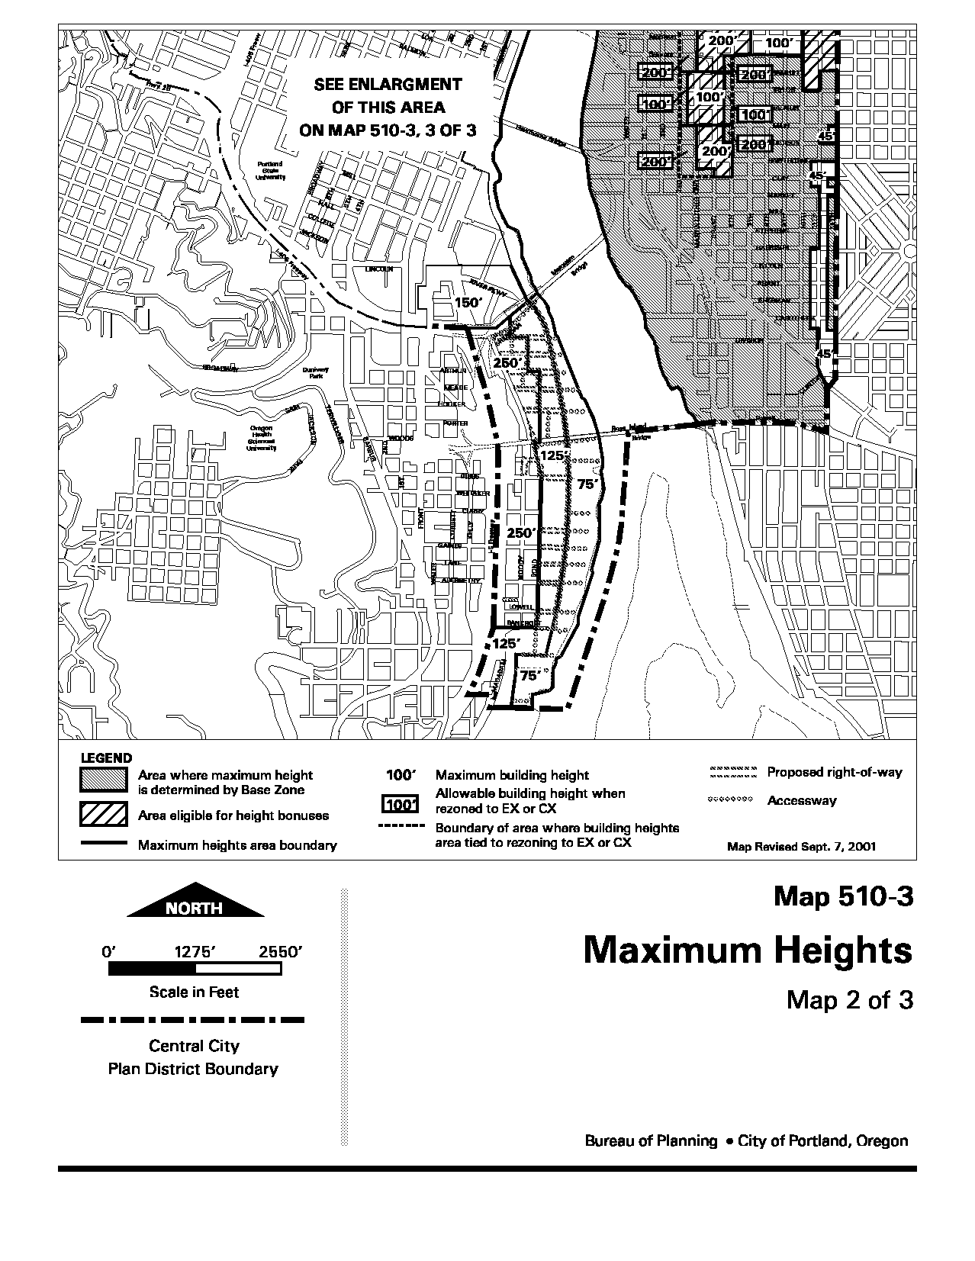
Existing map:
Delete existing map, and replace with new map (shown on next page):
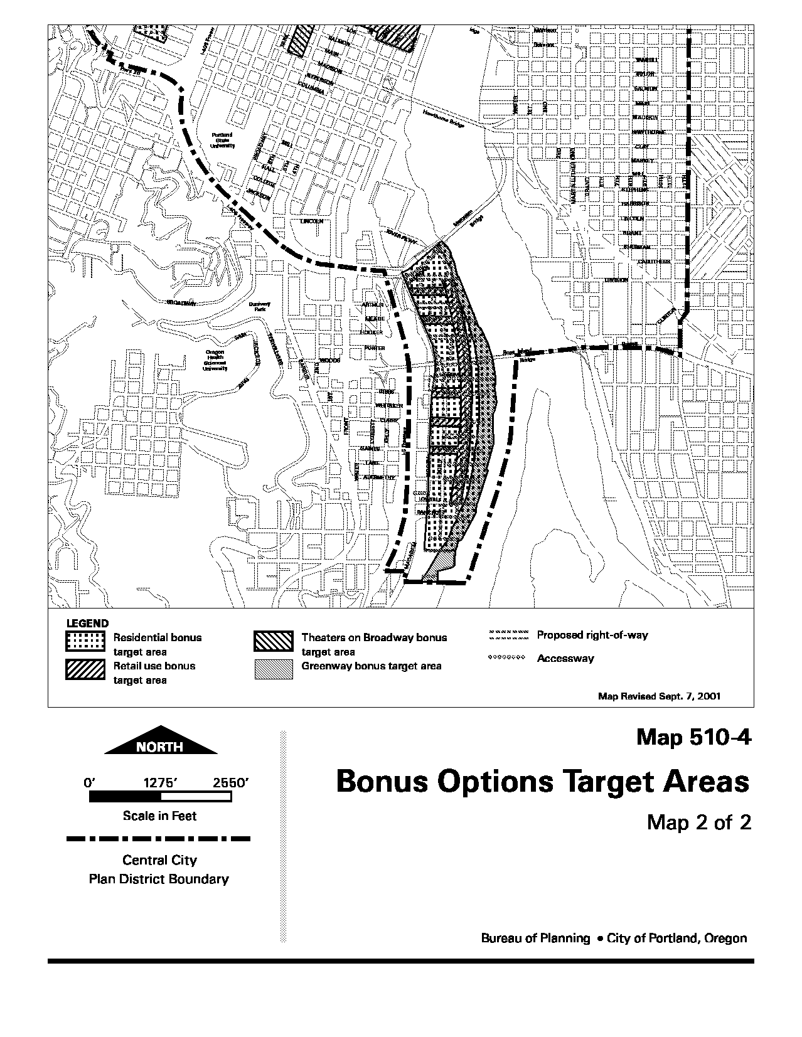
Existing map:
Delete existing map, and replace with new map (shown on next page):
Existing map:
Delete existing map, and replace with new map (shown on next page):
Existing map:
Delete existing map, and replace with new map (shown on next page):
Existing map:
Delete existing map and replace with new map (shown on next page):
Delete existing map, and replace with new map (shown on next page):
Existing map:
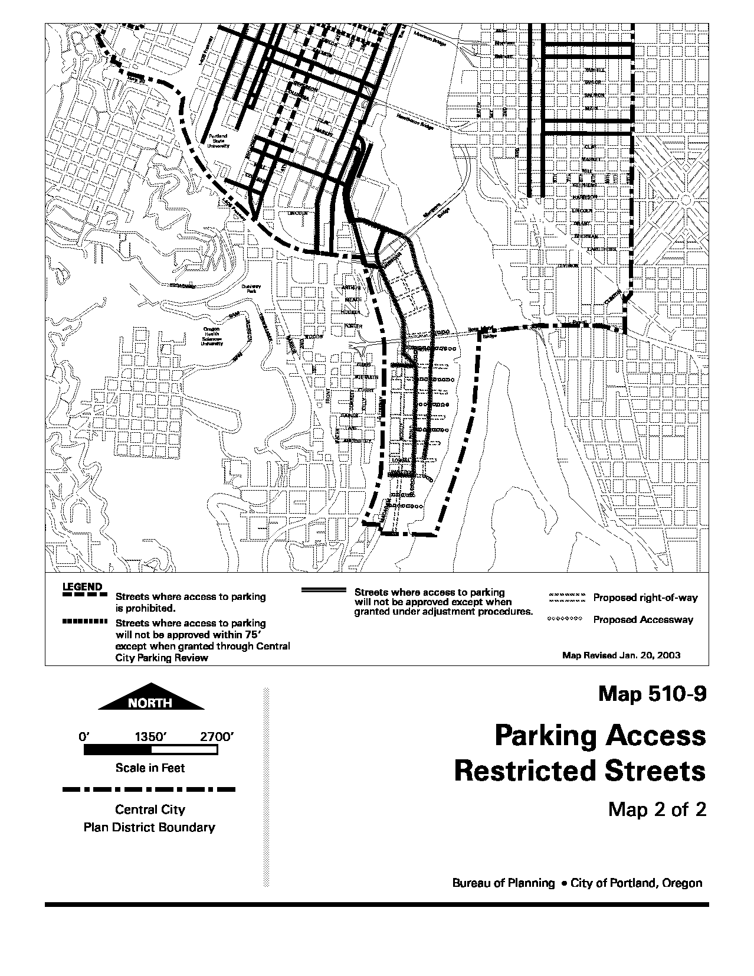
Delete existing map and replace with new map (shown on next page):
Delete existing map and replace with new map (shown on next page):
Add the new map (shown on the next page).
The map includes an updated version of information that is currently mapped on maps 440-1 and 440-2.
Add the new map (shown on the next page).

33.808.100 General Approval Criteria for Central City Parking Review.

The approval criteria of Central City Parking Review will apply to certain parking created in the South Waterfront subdistrict. The parking standards of 33.510.267 identify which parking spaces will be subject to Central City Parking review. See related commentary on page 106 and following.

In general, the code will require Central City Parking Review for the following:
- surface parking lots that are larger than allowed by right under 33.510.267;
- supplemental growth parking spaces (subject to a Type II review);
- residential parking that will be operated as shared commercial parking;
- more than 20 spaces of retail parking;
- more than 60 spaces of other parking affiliated with a commercial use;

The criteria that will apply depend on the type of parking being created. Note: Only the approval criteria that are being amended have been reproduced in this report.

CHAPTER 33.808
CENTRAL CITY PARKING REVIEW

33.808.040 Review Procedures.

A. Type III. Except as specified in Subsection B, r Requests for Central City Parking Review are processed through a Type III procedure;

B. Type II. In the South Waterfront Subdistrict, requests for supplemental growth parking as specified in 33.510.267.A.3.b are processed through a Type II procedure.

33.808.100 General Approval Criteria for Central City Parking Review.
The request will be approved if the review body finds that the applicant has shown that all of the following approval criteria are met:

A.-M. [No Change.]

N. If the site is in the North Macadam South Waterfront Subdistrict and the proposal is for surface parking:

1. If the proposal is for parking on a surface lot where the total surface parking area on the site exceeds the threshold of Paragraph N.2.3, below, criteria N.34.a through N.54.c, below, apply. If the site proposal is in an R, C, E, or OS zone; and is for Growth, Preservation, Visitor, or Residential/Hotel Parking; and is not created in conjunction with a regional attractor, criteria N.34.d through N.84.f, below, also apply.

2. If the proposal is for Growth or Preservation parking on a surface lot, and if the proposal includes supplemental parking as specified in subparagraph 33.510.267.A.3.b, criteria N.4.a through N.4.f, below, apply.

2.3. Threshold: The amount of surface parking area on the site is larger than 40,000 square feet, or the parking area covers more than 30 percent of the site, whichever is larger.

4. Approval criteria.

3.a. There will not be a significant adverse impact on transit operations;

4.b. There will not be a significant adverse impact on operation and safety of vehicle and bicycle circulation;

5.c. There will not be a significant adverse impact on the overall pedestrian, bicycle, and transit environment and safety. A driveway is not automatically considered such an impact;

6.d. Interim use.

(1) If the amount of parking area exceeds the threshold in Paragraph N.2 3, above, the amount of parking area that exceeds the threshold will be an interim use only, as documented by the phased development plan; and

(2) If the proposal includes supplemental parking as specified in subparagraph 33.510.267.A.3.b, the supplemental parking will be an interim use only, as documented by the phased development plan;

7.e. The first phase of development in the phased development plan includes creation of gross building area, and uses other than parking; and

8.f. The phased development plan ensures:

a.(1) That the later phases of development are realistically feasible, taking into account such factors as location of buildings on the site and zoning of the site; and

b.(2) After the final phase is built, the threshold in Paragraph N.23, above, will not be exceeded.

O. If the site is in the South Waterfront subdistrict and the proposal is for residential parking that will be operated as commercial parking, the proposal must meet the approval criteria for Visitor Parking in the South Waterfront subdistrict.

CHAPTER 33.815
CONDITIONAL USES

Sections:
General
33.815.010 Purpose
33.815.020 How to Use this Chapter
33.815.030 Automatic Conditional Use Status
33.815.040 Review Procedures
33.815.050 Loss of Conditional Use Status
33.815.060 Development Standards for Conditional Uses
33.815.070 Sites With Split Zoning
33.815.080 Approval Criteria in General
Approval Criteria
33.815.100 Uses in the Open Space Zone
33.815.105 Institutional and Other Uses in R Zones
33.815.107 Short Term Housing in R Zones
33.815.110 Office and Retail Sales And Service Uses in the RX Zone
33.815.115 Specified Uses in Commercial Zones
33.815.120 Commercial Parking Facilities in the RX, CX, CG, and E Zones, Outside the Central City Plan District, the Columbia South Shore Plan District and the Cascade Station/Portland International Center Plan District
33.815.121 Commercial Parking Facilities in the RX, CS, and CX Zones, in the Hollywood Plan District
33.815.122 Nonresidential Uses on Specified Sites located in the RX Zone within the Central City Plan District
33.815.125 Specified Uses in Industrial Zones
33.815.126 Office Uses in the IG1 Zone in the Central City Plan District
33.815.127 Accessory Offices and Headquarters Offices in the IH Zone in the Guild’s Lake Industrial Sanctuary Plan District
33.815.128 Retail Sales And Service Uses in the EG Zones
33.815.130 Residential Uses in the EG1, EG2, IG1, IG2, and IH Zones
33.815.140 Specified Group Living Uses in the C and EX Zones
33.815.200 Aviation And Surface Passenger Terminals
33.815.205 Detention Facilities
33.815.210 Helicopter Landing Facilities
33.815.215 Major Event Entertainment
33.815.220 Mining and Waste-Related
33.815.223 Public Safety Facilities
33.815.225 Radio Frequency Transmission Facilities
33.815.230 Rail Lines and Utility Corridors
33.815.300 Commercial Parking Facilities in the Columbia South Shore Plan District
33.815.301 Industrial Businesses in the Columbia South Shore Plan District
33.815.302 Professional / Technical Facilities in the Columbia South Shore Plan District
33.815.303 Retail Sales and Service Uses in the Columbia South Shore Plan District
33.815.304 Retail Sales And Service Uses in the South Waterfront Subdistrict
33.815.305 Replacement Parking Facilities in the Central City Plan District
33.815.310 Industrial Uses in the IR Zone

33.815.304 Retail Sales And Service Uses in the South Waterfront Subdistrict
These approval criteria will ensure that Retail Sales And Service uses larger than 40,000 square feet in size are compatible with the policy goals of the district.
33.815.304 Retail Sales And Service Uses in the South Waterfront Subdistrict
For Retail Sales And Service uses in the South Waterfront subdistrict of the Central City plan district with more than 40,000 square feet of floor area, the approval criteria are:

A. The use needs to be located in the South Waterfront subdistrict because it primarily serves those who live or work in the subdistrict;

B. The transportation system is capable of safely supporting the proposed use in addition to the existing uses in the area. Evaluation factors include street capacity and level of service, access to arterials, transit availability, on-street parking impacts, access requirements, neighborhood impacts, and pedestrian safety;

C. The traffic generated by the use will not have significant adverse impacts on the subdistrict’s ability to achieve jobs and housing targets stated in the South Waterfront Plan; and

D. City-designated scenic resources are preserved.

CHAPTER 33.851
SOUTH WATERFRONT GREENWAY REVIEW

The South Waterfront greenway review:

1) Allows property owners the flexibility to develop the greenway in a way that meets the objectives of the South Waterfront Plan, but does not meet the clear and objective standards of 33.510.253.

2) Ensures continued review of development reviewed currently under greenway review. (Note: Development that is currently reviewed only against the greenway design guidelines will be reviewed as part of design review and not as part of South Waterfront greenway review under the revised regulations.)

33.851.200 Notice to State Parks and Recreation Division.
This language incorporates a notice requirement that currently applies citywide under 33.440, Greenway Zones.

CHAPTER 33.851
SOUTH WATERFRONT GREENWAY REVIEW

Sections:
33.851.010 Purpose
33.851.100 Review Procedures
33.851.200 Notice to State Parks and Recreation Division.
33.851.300 Approval Criteria

33.851.010 Purpose
South Waterfront greenway review provides flexibility within the South Waterfront greenway area and ensures that:
• Development will not have a detrimental impact on the use and function of the river and abutting lands;
• Development will conserve, enhance and maintain the scenic qualities;
• Development will contribute to enhanced ecological functions to improve conditions for fish and wildlife;
• Development will conserve the water surface of the river by limiting structures and fills riverward of the greenway setback; and
• Development that does not meet the standards of 33.510.253, South Waterfront Greenway Regulations, will be consistent with the Willamette Greenway Plan and the Central City Plan.

33.851.100 Review Procedures
South Waterfront greenway reviews are processed through a Type II procedure. Greenway goal exceptions are processed through a Type III procedure, and must be approved by City Council. See Section 33.440.360, Greenway Goal Exception, and Chapter 33.850, Statewide Planning Goal Exceptions.

33.851.200 Notice to State Parks and Recreation Division.
OPDR will send a copy of all applications for South Waterfront greenway review to the Parks and Recreation Division of the Oregon Department of Transportation. The applications will be sent certified mail-return receipt requested. The notice of decision on all South Waterfront greenway reviews will also be sent to the Parks and Recreation Division.

33.851.300 Approval Criteria

A. Consistent with purpose. All proposals must be found to be consistent with the purposes of the South Waterfront greenway regulations.

B. Development riverward of top of bank. This approval criterion is a modified version of existing greenway review approval criteria that apply to the district. This approval criterion will need to be updated in the future to reflect the work of a citywide river-focused project.

33.851.300 Approval Criteria
Requests for a South Waterfront greenway review will be approved if the review body finds that the applicant has shown that all of the following approval criteria are met:

A. Consistent with the purpose of the South Waterfront greenway. The following approval criteria must be met for all proposals:

1. When compared to the development required by the standards of 33.510.253, the proposal will better enhance the natural, scenic, historical, economic, and recreational qualities of the greenway;

2. When compared to the development required by the standards of 33.510.253, the proposal will better ensure a clean and healthy river for fish, wildlife, and people;

3. When compared to the development required by the standards of 33.510.253, the proposal will better embrace the river as Portland’s front yard; and

4. When compared to the development required by the standards of 33.510.253, the proposal will better provide for stormwater management.

B. Development riverward of top of bank. If development is proposed riverward of top of bank, the following approval criteria must be met:

1. The riverbank will be protected from wave and wake damage; and

2. The proposal will not:

a. Result in the significant loss of biological productivity in the river;

b. Restrict boat access to adjacent properties;

c. Interfere with the commercial navigational use of the river, including transiting, turning, passing, and berthing movements;

d. Interfere with fishing use of the river;

e. Significantly add to recreational boating congestion; and

f. Significantly interfere with beaches that are open to the public.
C. Proposals that do not meet the requirements of 33.510.253. All proposals that vary from the clear and objective greenway standards will need to implement the key policy objectives of the South Waterfront Plan.

D. Buildings within the South Waterfront greenway area. Any proposal to modify the 100 foot regulated greenway setback will need to demonstrate that it is better meeting the purpose of that regulations by increasing ecological function; the Greenway Design Coordination Plan may also have provided for an alternate setback based on a more comprehensive plan for the greenway.

C. Proposals that do not meet the requirements of 33.510.253.E. If the proposal does not meet all of the standards of Subsection 33.510.253.E, the following approval criteria must be met:

1. The proposal will restore and enhance the natural character of the area adjacent to the river and will allow more significant creation of habitat for fish and wildlife that could aid in supporting the recovery of native species of fish; and

2. The proposal will support or enhance the function of the greenway area as an active and vibrant waterfront and will provide sufficient opportunities for human interaction with the greenway.

D. Buildings within the South Waterfront greenway area. If the proposal includes buildings that do not meet the standards of 33.510.253.E.3, at least one of the following approval criteria must be met:

1. The proposal will increase the area available for riparian plant communities on the site by regrading within the greenway area to decrease the slope of the river bank (i.e. laying back the bank). Proposals meeting this approval criteria must show that the modified slope of the bank will be no steeper than 5:1, and that buildings will be set back at least 100 feet from ordinary high water and at least 30 feet from the modified top of bank;

2. The proposal will compensate for the reduction in setback through near shore and bank treatments that mimic the conditions found in more natural areas of the Lower Willamette River. Proposals meeting this approval criterion must demonstrate the following:

a. Buildings will be set back at least 75 feet from the top of bank;

b. The near shore and bank treatments will be installed riverward of top of bank.

c. The near shore and bank treatments will provide resource enhancement, reestablish multiple riparian functional values, increase near shore or bank complexity, and be appropriate to the specific conditions of the site and the river. The complexity should be able to be maintained over time by natural river processes; and

d. The proposal includes near shore and bank treatments that are valued at 700 dollars or more per linear foot of river facing site frontage.

3. The proposal will set all buildings back an average of 100 feet from top of bank; proposals meeting this approval criteria must show that buildings will be set back at least 75 feet from top of bank, that at least 50 percent of the length of all building walls facing the South Waterfront greenway area will be set back at least 125 feet from top of bank, and that averaging will better enhance the recreational and ecological functions of the greenway area; or

E. Trails, viewpoints, and pedestrian connections. Proposed modifications to the clear and objective standards for trails and viewpoints need to be found to continue to serve these functions and respond to site conditions that require an alternate approach. The greenway design coordination plan may also provide for alternate trails, viewpoints, or pedestrian connections based on a more comprehensive plan for the greenway.

F. Landscaping and nonlandscaped area. Proposed modifications to the clear and objective standards for landscaping and impervious surfaces need to mitigate for any functional losses, and better implement a competing policy goal in the district.

4. The proposal meets all of the requirements of a greenway design coordination plan and a modified setback distance has been identified on the site by the City as part of the plan.

E. Trails, viewpoints, and pedestrian connections. If the proposal will include trails, viewpoints, or pedestrian connections that do not meet the standards of Subsection 33.510.253.E.5 or E.6., the proposal must meet approval criteria E.1. and E.2., and either E.3. or E.4:

1. The proposed trail, viewpoints, and pedestrian connections will safely accommodate expected users;

2. The trail will include one or two paths and the width of the proposed trail, or the combined width of the paths that make up the trail, will be at least 18 feet; and

3. The proposed trail, viewpoints, and pedestrian connections will respond to topographic constraints of the site; or

4. The proposal meets all of the requirements of a greenway design coordination plan and the proposed trail viewpoints and pedestrian connections comply with those identified on the site as part of the plan.

F. Landscaping and nonlandscaped area. If the proposal will include landscaping or non-landscaped area that does not meet the standards of Subsection 33.510.253.E.2 or E.7, the proposal must meet either approval criteria F.1 and F.2, or approval criterion F.3:

1. The proposal will mitigate for any reductions in vegetative cover through the use of methods including near shore and bank restoration work, bioengineering, or green building technologies, including innovative stormwater management, on the site; and

2. The proposal meets one of the following:

a. The proposal will better support the water quality goals of the City’s Stormwater Management Manual;

b. The landscaping standards cannot be met on the site because of existing bank and soil conditions such the presence of riprap or other obstructions;

c. The proposal is necessary to ensure bank stability; or

d. The proposal will allow greater visual access between the trail and other segments of the greenway, and will enhance safety for trail users.

3. The proposal meets all of the requirements of a greenway design coordination plan and modified landscaping or non-landscaped area has been identified on the site by the City as part of the plan.

33.910.030 Definitions

These new definitions are intended to clarify application of approval criteria 33.851.300.D.2, which allows building setbacks to be reduced in exchange for providing near shore or bank treatment.
33.910.030 Definitions

Near shore complexity. A combination of conditions within a river channel that includes at least one of the following: diverse in-water vegetation communities, variations in water flow depth and velocity, and a variety of structural elements such as rocks, logs, and rootwads.

Riparian functional values. The functional values provided along a healthy river shore, including: food and habitat for fish and wildlife; dynamic channel forming processes; cool clean water; an amount and timing of water flow that reflects the natural hydrologic regime; and a microclimate beneficial to fish and wildlife.

River bank complexity. A combination of conditions along a river shore that includes at least one of the following: diverse vegetation communities, variations in bank slope and shoreline roughness, and a variety of structural elements such as rocks, logs, and rootwads.

